Accessible Word Template – The L.I.S.T. Check

Five Steps in creating accessible Word documents:

Structure
- Start by thinking of the structure or outline for your document. Structure is important in helping screen reader users navigate throughout the entire document easier and faster. It will also help you create table of contents for any long documents.
- To add structure or content outline to your Word document: place cursor anywhere in the heading text area, go to Home tab, click the appropriate Heading 1, 2, 3, etc. in the Styles group and start assigning headings to your document. Do not skip any heading order.
- Go to View Tab and check the box next to Navigation pane in Show group, your navigation pane will appear to the left of the document. You can view and verify whether the structure/outline of your document is appropriate in this Navigation pane.

Note: If you note that there are any non-heading texts appearing on the heading list, highlight the text and click Normal in the Style group to remove them from the list.

Links
- If you include any website references in your document, create a title/label or meaning name for your destination web page then select/highlight this web label.
- Go to Insert tab, click Hyperlink from the Links group.
- In Edit Hyperlink window, your web page title/label will appear next to Text to display box on the top, enter url in the box next to Address at the bottom for this webpage title/label.
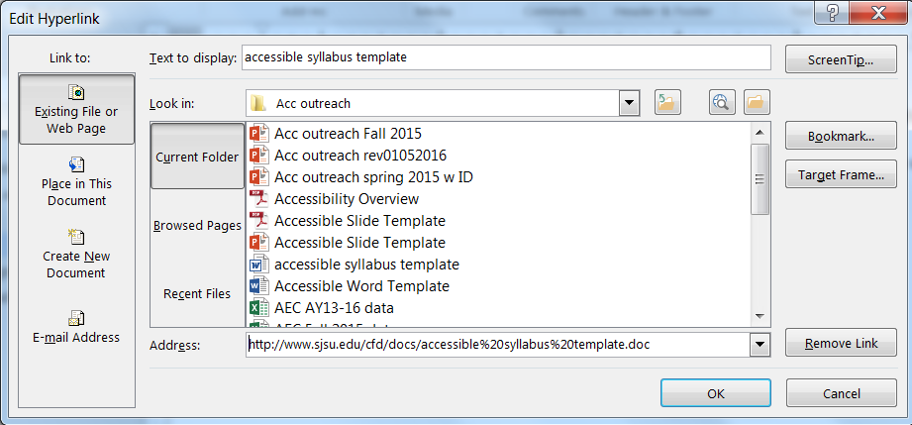
- Include url address in the document if your student may print a hard copy of your document.
- Example: accessible syllabus template at http://stage.sjsu.edu/cfd/docs/accessible%20syllabus%20template%202018.docx

Images, photographs, drawings or graphics
- If you include any important images, drawings, graphics or photographs in your document, add alternative text to describe this non-text image. Screen reading software reads text only and will skip any non-text images or graphics. You can skip the alt text if the images are decorative.
- Right click the image and select Format Picture from a pop-up list.
- A Format Picture pane will appear on the right. Select Layout & Properties icon.
- Click Alt Text and enter your alternative text to describe your image in the Description box.
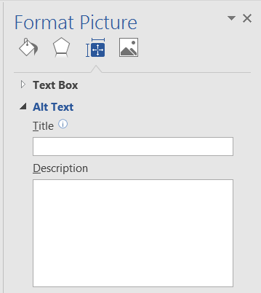

Tables and Reading Order
- If you include any table in your document, go to Insert tab and click Table. Use simple table structure with row and column header information. Avoid any nested table or merged or split cells inside of your table.
- Go to the first cell, press Tab key to see if it moves from one cell to the next in a logical order from left to right, one row at a time from top to bottom.
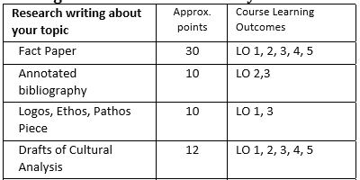
- If your table expands more than one page, include header row and repeat header row on top of each page. Select the entire header row, right click to select Table Properties.
- In Table Properties window, click Row tab, check the box next to Repeat as header row at the top of each page.
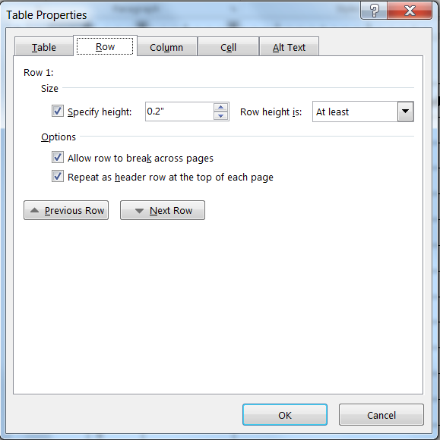

Accessibility Checker
- Word has built-in tool to check on accessibility issues. Go to File menu, click Check for Issues then choose Check Accessibility. It will open another pane to point out any accessibility errors or warning.

Other Reminders
- Avoid using color such as, red, green or highlights as the only way to emphasize your key messages.
- Use true numbered and bulleted lists function instead of typing a number followed by a period.
- Use font size 12 points or higher to ensure visibility.

Note: If you have any questions, contact Elizabeth Tu either by email Elizabeth.Tu@sjsu.edu or by phone at 408 924-3093.

