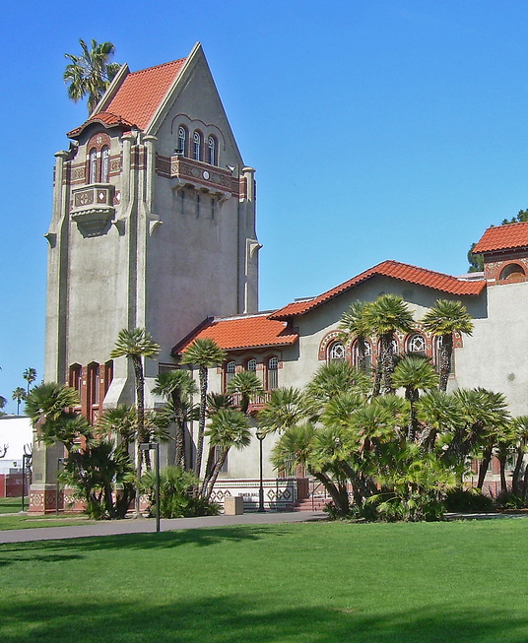
Conference Notebook

Center for Faculty Development
San José State University

Instructions for Using this Conference Notebook

First of all, I want to express my appreciation to Todd Zakrajsek, PhD, faculty development director and conference organizer extraordinaire, for permitting me to “borrow” his idea – and indeed, his template – for a conference workbook. Those of you who have had the pleasure of attending a Lilly Conference on College and University Teaching and Learning will undoubtedly recognize this workbook as a close cousin of the tool he created. Thank you, Todd – your generosity embodies the spirit of collegial collaboration, and I want to be absolutely sure to give credit where credit is due (and deserved!).

A word about the purpose of this workbook. Over the years, I have had the opportunity to attend many, many professional conferences. In some instances, I contributed to the formal program in some way. In others, I had the good fortune to just be there just to learn. In virtually every instance, I did my best to immerse myself in the moment, attending sessions, engaging in animated and thoughtful conversation, taking notes, collecting business cards and handouts. But all too often, the conference “high” dissipated quickly as I returned to business-as-usual. As I look back, one thing is quite clear: regardless of my role or responsibilities at the gathering, I benefitted much more from the experience when I had (read “made”) the time to prepare and follow through. Isn’t this exactly what we encourage our students to do, to get the most out of their educational opportunities?

Fruitful preparation didn’t necessarily take a lot of time: Skimming through the program, making note of sessions I wanted to attend or people I wanted to meet were helpful strategies, to be sure. But it made a huge difference when I spent a few additional minutes thinking through
- why I wanted to attend – that is what, specifically, I hoped to learn and how that would allow me to address goals or challenges in my work; and
- what I could bring to the table – that is how what I did or knew or spent time thinking about might enrich conversations I might have with colleagues.
In the same vein, I gained more from attending conferences where I actually followed through on some of the ideas I’d found so energizing, rather than simply filing them away along with my travel receipts. (Go figure!!).

And so I offer this workbook … designed to help you plan, reflect, and connect. We have created it in Word format, so that you can most easily adapt it to your particular needs. We hope that this tool will help you bring more ideas to share with colleagues at the conferences you attend, and also come away having gained more from the time you are investing in them.

In the spirit of colleagueship,

Amy

Amy Strage, PhD
Assistant Vice President for Faculty Development
Director, Center for Faculty Development
San José State University
Fall, 2017

I - To ensure that you get the most out of the conference,
PREPARE, DO YOUR HOMEWORK, AND BE INTENTIONAL…

Find a quiet place where you can read and think, undisturbed, for a bit. Consider what you hope to gain by attending the conference. Think about research topics you address or that interest you. Think about classes you currently teach, students you currently work with, and situations you wish you had been able to handle more effectively or creatively. Skim through the conference program, undoubtedly posted on-line.

One Minute Paper: Set your phone to the stopwatch function or find a clock with a second hand. Give yourself one minute to write a response to the following:

What do you hope to gain by attending this conference?

Goals and Objectives

Alternatively, or perhaps in addition to your response to the “One Minute Paper” prompt above.

Before you actually attend any of the conference sessions, identify two or three specific goals you hope to achieve at the conference that you can apply this term or this year. These might be:
- addressing challenges with respect to your work,
- learning more about or approaches or topics that you have heard of that interest you, or
- finding colleagues who share a common interest/passion for a specific topic.

By the close of the conference, be sure to make a quick note about information you gained that relates to each of these goals. Also, make a note of the names of any attendees you talked with about topics related to these items and in a few key words, summarize what you discussed.
Brief description:

Goal 1

Notes:

Goal 2

Brief description:
Notes:

Goal 3
Notes:

Brief description:

II – To ensure that you get the most out of the conference,
REACH OUT … DON’T BE SHY… NETWORK…
Conference Workbook
The benefits of attending professional gatherings can be manifold. We expect that the information and ideas you gather will be very helpful to you, as you return to your work. But we also hope that you will be inspired by the people you meet. Try for 5-6 new contacts at this conference. Use the space below to organize information about who they are, how to reach them, and why you want to follow up with them.

Name | Institution/Email/Contact information | Reason for Follow-up

III – To ensure that you get the most out of the conference,
REFLECT AND FOLLOW THROUGH…

Action Items

All too often, we squander the energy and possibilities we generate when we attend professional conferences because we don’t make it a priority to follow up and follow through once we return home. To sustain your momentum, list at least 5 things you will do within 2 weeks of the conclusion of the conference. These may include individuals to contact, resources to order, or materials to develop. BE SURE TO INCLUDE SOMEONE YOU WANT TO TALK TO AT YOUR HOME CAMPUS, with whom you would like to share an idea you had or something you learned at the conference.

To Do List
1.

2.

3.

4.

5.

Thank You Note (You’ve probably already thought to do this, but in case it’s slipped your mind…)

In fiscally restrictive times, it is important that funds are used in ways that best benefit the institution. To encourage the continued availability of funds for future travel to conferences and to acknowledge financial support provided for this trip, we encourage you to send a quick note of thanks to the individual(s) responsible for your attendance. As appropriate, consider including one or two insights you gleaned from the conference, one or two ideas you plan to incorporate into your work, or information pertaining to anything specific you were asked to do, learn or explore. Also, as appropriate, provide details about ways in which you might share what you gained through your attendance at the conference with your campus community.

Take Home Final Exam (To be completed a few weeks after the conference. Set a reminder on your calendar!!)

Review your notes from previous pages, then construct an answer to the following prompts:

- What have you adopted or adapted (or do you plan to change) in your research (or other work, as appropriate) as a direct result of something you learned at the conference? What impact do you anticipate these changes will have, longer term? Try to be as specific as possible.

- Who have you contacted since the conference and what has resulted from those interactions?

- Did you send the thank you note to the person providing support for your attendance at the conference? If not, please send your note of thanks at this time.

