The Living by Matt De La Pena
Matt De La Pena  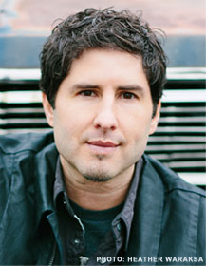  http://mattdelapena.com/  Matt de la Peña is the New York Times Bestselling, Newbery Medal-winning author of six young adult novels (including Mexican WhiteBoy, We Were Here, and The Living) and four picture books (including Love and Last Stop on Market Street). In 2016 he was awarded the NCTE Intellectual Freedom Award. Matt received his MFA in creative writing from San Diego State University and his BA from the University of the Pacific where he attended school on a full basketball scholarship. de la Peña currently lives in Brooklyn NY. He teaches creative writing and visits high schools and colleges throughout the country.  How I Would Teach The Living  This book would be useful in teaching narrative as De La Pena portrays the book as if the reader were inside Shy’s head, thinking his thoughts and feeling his feelings. The book could be presented and used as an example for students to write their own narrative about an influential experience in their life from their own point of view.  The age that this book is most appropriate for is high schoolers age 14-18 as it includes strong language and mature subjects such as death, murder and sex.  The category of books that his novel best fits into is Books About Courage and Survival because the main plot of the story revolves around the courage that is necessary for each character to possess in order for them to survive as a group and face the problems that they are presented with.. | Summary  Shy, a high school student, works on a summer cruise ship to help his family with the bills. His life is turned upside down when a catastrophic earthquake hits his home state of California and subsequent tsunami waves destroy the ship he is on leaving him lost at sea hoping to survive. In the aftermath of the natural disasters a mysterious illness is sweeping across the nation affecting Shy’s family and threatening to destroy the human population. Shy does everything he can to survive in order to help his family survive too.  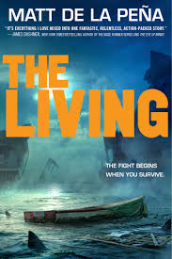  Why Should Teens read this book?  This book would be good for someone who loves apocalyptic, post-apocalyptic, epidemic or survival stories. The novel would appeal to those who like adventure and action and those who also enjoy a good love story. Teens should read this book because it depicts unlikely events that allow the reader to experience something new through the eyes and language of the characters in the novel. I would not give this novel to someone who is experiencing the loss of their home or family due to natural disaster or illness as the plot may be triggering.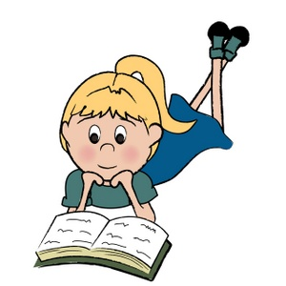 | Quotes  - “Maybe it was because...took after his mom that way (71).”  This quote is significant because it shows Shy’s constant concern and worry about those he loves in this novel as well as his struggle to stay strong in the face of tragedy.  - “He rose to his feet...he was lost before he landed (128).”  This quote is significant because it taps into the theme of humanity and sameness and shows that when faced with catastrophe people become equal and human all the same.  - “The coasts of California...lives probably depended on it (306).”  This quote is significant because it represents the struggle for life and humanity that the characters in the novel are faced with as the future of the world lies in their hands.  Analysis of Text Complexity  Lexile Score = HL700L  Age Range = 14+  This score and age appropriateness is spot on because there are elements in this novel of violence, death and sex that are only appropriate for high school aged students.  ATOS Book Level = 5  Age Level = Grades 9-12  This book level is a bit too young as the book is not appropriate for students younger than 14. Students in 5th Grade would be able to understand and read the language in this novel but the content of the book is too mature and would be better suited for those in grades 9-12.

