Patty Barrera
Professor Warner
English 112B
April 3,2018

Things We Know By Heart
Author:

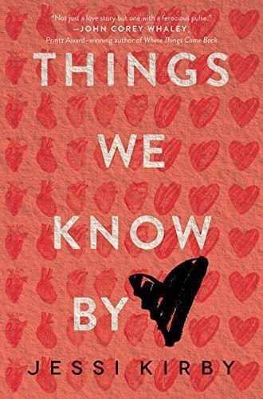
www.jessikirby.com
Jessi Kirby is the author of six novels for young adults, including The Secret History of Us, Things We Know By Heart, and Moonglass, which was nominated for the ABA New Voices award.
Kirby grew up in Mammoth Lakes, California and earned an English degree from Cal Poly San Luis Obispo. She still lives in California with her husband and two kids, where she spends her time enjoying her family, teaching, writing, reading, and running.
Synopsis:
After losing her high school sweetheart in an accident their junior year, Quinn Sullivan, misses out on all the activities of her senior year of high school including applying for college because she is mourning Trent’s death. She writes letters to all of Trent’s donated organ recipients’ and receives responses to all her letters except from the person that has Trent’s heart. Quinn tracks down the heart recipient, nineteen year old Colton Thomas, hoping for some closure.
In their accidental meeting, Colton and Quinn have an instant attraction and they began dating. Colton’s positive attitude towards life helps Quinn start to have a better outlook on her own life. She is finally happy after 400 days of not living. The only problem is the guilt she is having over not telling Colton the truth about their connection. She keeps telling herself to walk away because it’s for the best but she can’t seem to do it since she has fallen in love with Colton and is afraid to lose him.

Quote: “Scientists have identified individual neurons, which fire, when a particular person has been recognized. Thus [it is possible that] when a recipient’s brain analyzes the features of a person, who significantly impressed the donor, the donated organ may feed back powerful emotional messages, which signal recognition of the individual. Such feedback messages occur within milliseconds and the recipient [may even believe] that [he] knows the person.” (20)
“And then, without taking his eyes off me, he stands slowly until we’re face-to-face and I can see the deep green of his eyes as they search mine. His voice is softer almost, tentative, when he finally speaks. “Are you…have you…do I?” (22)
Kirby starts this chapter with a fact about donated organs. In this chapter is the first time Colton and Quinn meet by accident in a café she is sitting in waiting for Colton to arrive at his family’s shop across the way. He happens to stop into the café before work and Quinn recognizes him from his sister’s blog posts. This makes Quinn so nervous she spills her coffee. Colton comes over to help her and seems to be trying to remember if he knows Quinn. Another reason this fact is significant is when Colton shows up at Quinn’s house, he brings her the exact same flower that Trent first gives Quinn on their first date, a sunflower.
Quote: “A breeze rolls softly over my skin, bringing with it the scent of jasmine and a delicate rush of something else. Hope, maybe. Or possibility. I wait until he turns onto the road and disappears to look down again at the sunflower. This time it looks different somehow – less like a painful reminder and more like a sign, maybe that Trent would understand.” (61)
This is a significant quote as it shows the shift in Quinn’s mindset about Trent and feeling guilty that somehow she is betraying him. When Colton first holds out the sunflower it crushes her but here at her second look at the sunflower she doesn’t feel shattered by it. She opens up to the possibility that it may be a sign from Trent that he understands her need to move forward in life.
Quote: “I had a good day. For the first time in a very long time, I really did, which is why I almost don’t want to wash it away tonight. I like the feel of the salt and the sand on my skin, like a reminder that there is a whole world that’s alive and continuing on out there. And that today I was a part of it again.” (119)
After a year of being isolated in her home, Quinn enjoys an entire day out on the beach with Colton kayaking and exploring. She realizes that life has gone on without her and acknowledges this day was her first day joining a world that is still alive.
Category of books:
This book fits into chapter 5 in Adolescents in the Search for Meaning, Books about Facing Death and Loss.
Text Complexity:
Lexile score is 840L, ages 14-17
This age range seems appropriate for this novel. I wouldn’t recommend it for anybody under the age of 14 because of the sexual content.
ATOS book level:
5.0 – 5.9
Why should teens read this book?
- If a teen is struggling with the loss of a friend or family member and is having trouble moving forward.
- The importance of the family bond especially during difficult times.
- Teens that like to read about love and romance

