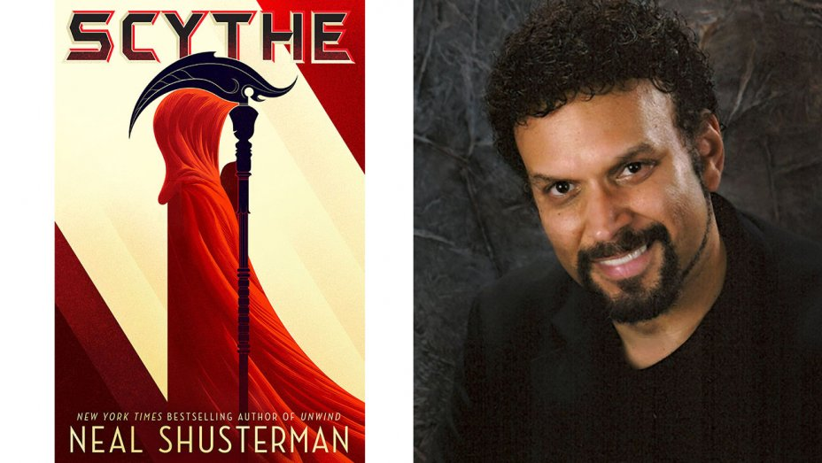
Scythe
By: Neal Shusterman

Author:
Neal Shusterman was born and raised in Brooklyn in the 1960’s. During his last two years of high school, his family live in Mexico City. Shusterman attended University of California, Irvine. Graduating with a double major in psychology and theater, Shusterman went on to become a successful novelist, screenwriter and television writer. He wrote for both “Goosebumps’ and “Animorphs” as well as writing the Disney movie “Pixel Perfect”. In the literary world, Shusterman has written 8 different series. Most notable is the Unwind and Arc of a Scythe series. Scythe was released in 2016 and its sequel, Thunderhead was released in January of 2018.
http://www.storyman.com/

Synopsis:
Thou shalth kill”. These are the words that a Scythe lives by. In the not too distant future, humanity has overcome all obstacles. There is no more disease, no more war, no more hunger. No one is miserable, no one is struggle. With the help of the Thunderhead, an incorruptible AI, humans have managed to overcome death. But with this achievement comes one major consequence. Earth is only so large and overpopulation a real possibility. To combat this, the scythedom was born. Scythes are called to fill the sacred role of gleaning. It is not murder, it is the most noble quest to secure the future of humanity.

Quotations:
- “Why would we compete for something neither of us wants?” Citra asked “Therein Lies the paradox of the profession.” Faraday said. “Those who wish to have the job should not have it… and those who would most refuse to kill are the only ones who should.” (p42)
This quotation from Faraday hits on a major theme of the book. Neither Rowan nor Citra want anything to do with the Scythedom. Both teens are horrified by the idea of killing and strong willed enough to speak that opinion. That combination of strong moral belief and outspokenness is in fact the exact mindset a scythe should. Scythe’s have unparalleled power in this world. Those chosen to become apprentices should therefore understand and respect the true enormity of the task they are being set.

- “The Thunderhead gave us a perfect world… I do not regret the decision but I often wonder if the Thunderhead would have done a better job.” (p 54)
This quotation shows the mindset that many scythes have. It is from the journal of a famous Scythe, H.S. Curie. Curie’s journal is tacked on at the beginning of each chapter, giving the story broader context while showing the internal struggle Curie has over the morality of his job. It also explains how society has collectively decided to give all power over to the Thunderhead while also understanding that gleaning must be a purely human decision.

- “The Scythe Commandments… For to put oneself above all other laws is a fundamental recipe for disaster. (p67-68)
This section explains the rules a scythe lives by. There is a certain logic to all of the rules. The focus on impartiality shows the values this society has decided on. It also explains the regulations it has put forth to ensure the safety those charged with being scythe’s. While the rules do make logical sense, Curie goes on to point out some of the inherent flaws in the system. His comments on this exalted status of scythes parallels the struggles Citra and Rowen are facing while exposing the underlying corruption this status inherently gives.

Teaching Scythe:
Scythe is another example of YA literature that takes modern day issues and pushes them to the extreme in order to discuss the problem in depth. The characters face strong moral and ethical dilemmas and at some points make controversial decisions. While to some, the idea of having young adults read such an intense book might seem unwise, the vary fact that Citra and Rowan end up facing such tough decisions is exactly why students should read Scythe. If taught in the classroom. I would want to discuss the morality of ‘gleaning’ and whether the Scythe Commandments truly allow for the apprentices to have free will in choosing their path. I would also want to have my students talk more broadly about what the book teaches us about what it means to be human with and without death. Finally, I would want to use Scythe as a bridge to discuss issues such as drunk driving and suicide.

How might you use this book in a classroom? Include some ideas for presenting the book. For what age level is the book most appropriate? Why should teens read this book? Which category of books (from Chapters 4-8 in Adolescents in the Search for Meaning: Tapping the Powerful Resource of Story) might this book fit?

Text Complexity:
Lexile: 830L
Ages 12-17

New Dale-Chall Readability Index:
Grade level: Grades 9 - 10

