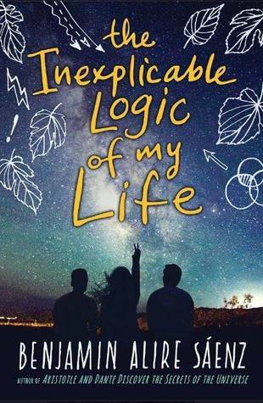  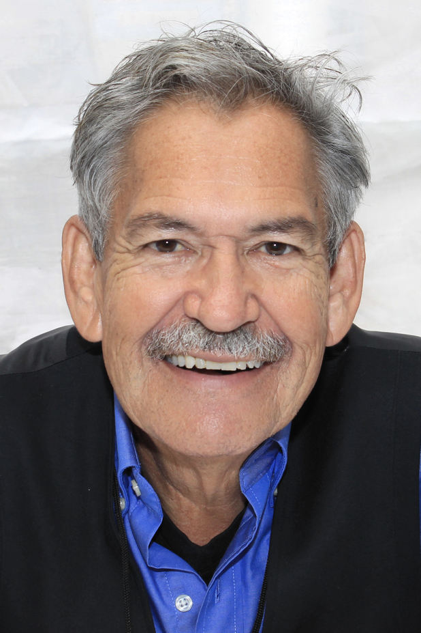  Author Info  Born in New Mexico in 1954, Sáenz is a gay Latin American poet, novelist, and activist.  Book Summary  Sal is entering his senior year in high school and starting to experience the insecurities and doubts that come with early adulthood; But Sal isn’t exactly your average teen. Born to an adoptive gay father, he sometimes wonders what it means to be the white grandchild of a Mexican American family and how much they’ve shaped his personality as opposed to his biological father’s genes. After a sudden series of tragedies, Sal’s questions about life and his place in the universe become ever more difficult to answer as him, his family, and his friends attempt to keep the tapestry of their lives from unraveling.  Textual Analysis  The Lexile® recommended age range for this reading spans the ages 14-17, and its subject matter fits into chapters 4-6 in Adolescents in the Search for Meaning: Tapping  the Powerful Resource of Story. | Detailed Author Biography  ────  Discovering Sexuality Through Teen Lit  ────  El Paso Times Live examines US-Mexico border through art, literature  ────  The Complex Lives of Teens: Chicano Novelist Benjamin Alire Sáenz's Latest Triumph

Quotes
- “’Are you afraid, Mima?’
‘No,’ she said. ‘I’m not afraid.’
…
‘You’re turning into a man.’
I didn’t feel like a man just then. I felt like a five-year old boy who didn’t want to do anything except play in a pile of leaves. A five-year old boy with a greedy heart who wanted his grandmother to live forever.” (102)

These lines introduce the reader to reader to Sal’s reluctance to “grow up,” which is fueled as much by his anxiety toward the uncertainties of life as much as his fear of what person (adult) he’ll grow into.

- “’What do you pray for?’
‘More kindness in the world. And then I pray for you.’
If Dad hadn’t been driving, I would have hugged him. And then I thought: How can this man love me so much? I felt like such an asshole. How could I even think or wonder about the man whose genes I had? What did genetic makeup mean anyway, compared with the man who raised and loved me? I was such an asshole.” (111)

Sal has a very close, loving relationship with his father that brings him guilt whenever he ponders his genetic makeup. He doesn’t realize at this point that his curiosity is normal and has difficulty compartmentalizing.

- “’Sylvia said you are a very sweet boy.’
I shrugged. I tried to imagine Sylvia saying something like that.
I don’t think either one of us knew what to say. We didn’t exactly know each other. It was clear that she knew something about me—but not much. I didn’t particularly care for being reduced to a sweet boy. My father saying things like that to me was one thing, but a stranger? Anyway, it wasn’t true. And why the hell was I thinking this crap while Sam was in the other room with a heart that would never heal. Maybe the hurt would live in her forever. So why in hell was I thinking such stupid and shallow things?” (151)

Part of Sal’s difficulties with compartmentalizing affect the way he views grieving and more importantly how he tackles his own grief. He never knew his biological parents and rather than acknowledge that as a valid trauma, he internalizes his guilt and prevents himself from processing these feelings, learning from them, and moving on.

My Personal Favorite

“Don’t ever underestimate the people who love you.” (116)
Sal’s (adoptive) father says this to him during a discussion about how he was afraid to come out to his family and distanced himself from them to prevent the hurt that comes with rejection, not realizing that they would embrace him.

I love this quote mostly because the public discussion of queer identities has led to a larger acceptance of said identities. It’s still a scary place to wind up in, but sometimes, trying to open a dialogue with loved ones can help foster a closeness that would’ve never been realized without a little leap of faith.

