Night Witches
By Kathryn Lasky
A Presentation by Rodrigo Garcia Padilla
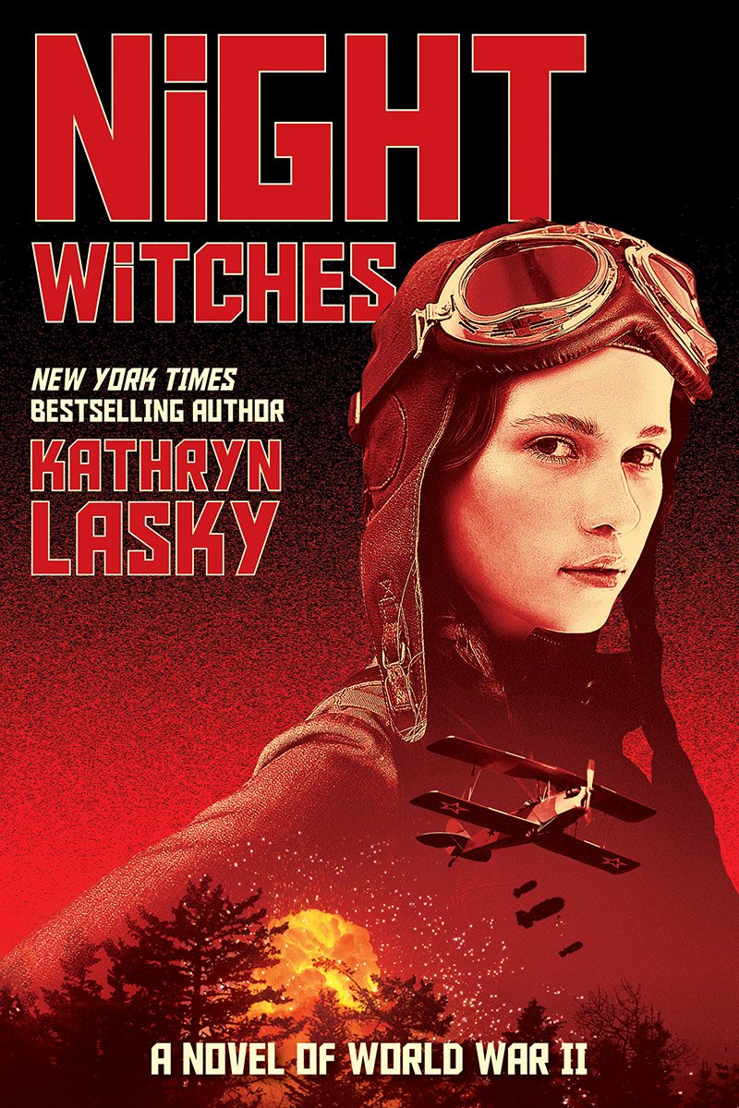
About the Author

https://www.kathrynlasky.com/about

Kathryn Lasky is an American author of Jewish-Russian descent, born in Indianapolis, Indiana. She’s written over 50 books for children and young adults, with her most famous being The Guardians of Ga’Hoole series that had 16 books published from 2003 to 2013.

Synopsis
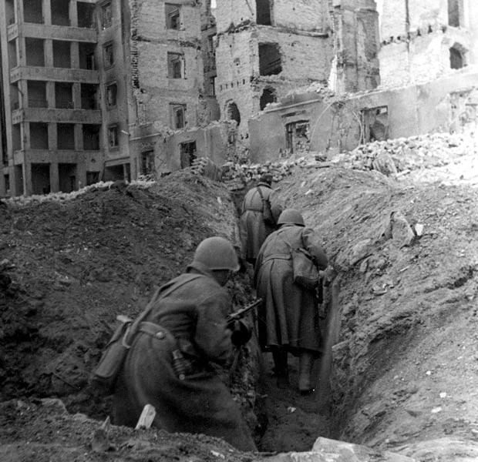
https://en.wikipedia.org/wiki/Battle_of_Stalingrad#/media/File:62._armata_a_Stalingrado.jpg

Valentina is the daughter of a Soviet Union airforce officer and has spent her childhood flying. When Nazi Germany invades the Soviet Union, her older sister Tatyana leaves to volunteer in one of the all-women pilot regiments, and as the Nazis lay siege to her home in Stalingrad, Valentina escapes the city to reunite with her sister and join the Night Witches.

Valentina, at only 16-years-old, becomes a soldier as her country is plunged into total war.

Quotes:
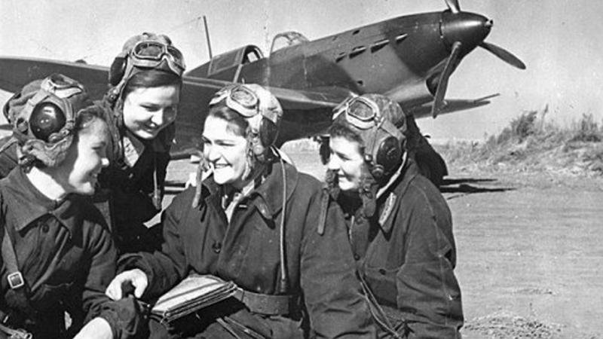
https://curiosity.com/topics/the-night-witches-were-russian-women-who-silently-bombed-nazis-by-night-curiosity/

I feel a flutter in my stomach. I was of course much closer to the enemy when I was in the trenches in Stalingrad. I’ve seen the guns of those panzer tanks close up. I know the cold dark eye of death staring us down. Now I’m thousands of meters in the air. So which way would I prefer to die? Raked from the sky by a Stuka and explode into a burning fireball? Or blown to pieces on Gvardeyskaya Street in Trench 301?
[...]
Still, I can’t keep from grinning as I gain elevation, It feels so good to fly after so long. For the first time since Mama died, I remember what it’s like to feel joy. (p. 71-2)

Flying becomes a way for Valentina to escape the harsh realities of war, and the sky is the only place where she feels in control. Even when she’s flying combat missions, concentrating on flying allows her to forget what’s going on. It’s only when she’s on the ground that she becomes vulnerable.

“Don’t I know it.”She says it so emphatically that my interest is piqued. I raise an eyebrow, and she quickly says, “Oh, I wasn’t exactly a devil. But let’s just say a naughty angel.”
“What does a naughty angel do?”
“Fool around with a lot of boys.”
“Really?”
“Yes, really.”
“You know what’s sad?” I say.
“What?’ She looks at me with those lovely cornflower-blue eyes.
“I haven’t had time to be a naughty angel.”
She smiles sweetly. “You’re still so young. I’m twenty-two. There’s time.”
“Yeah,” I say. “But there’s a war.”
She doesn’t argue, but the wistful look in her eyes says it all. (p. 107)

Valentina constantly laments the fact that her normal life has been turned upside down because of the war going on. It’s only after the Battle of Stalingrad ends that she’s willing to completely open up to her “wing sister” about it. The book is full of quiet scenes where we’re presented with what the characters did outside the war, one of the boys at the trench is a pianist and another Night Witch played water polo in high school, and it shows that they’re not mindless killers, they’re people.

I fall into a strangely dreamless sleep that lasts through the remaining day and into the next night. I fight waking up. [...] When I open my eyes and look out the small window I see it is in fact a moonless night. There’s only starlight. I hear the revving of engines. I reach for my helmet and goggles, put on my boots, and zip up my flight jacket.
There is no time to grieve. Just time to kill. (p. 140-1)

Over the course of the novel, Valentina questions her humanity as she’s forced to kill countless Germans during her bombing missions and losses people around her. In this moment, she’s choosing to let go of her humanity in order to avoid grief. It’s an important moment in her character growth, from naive and immature to a hardened veteran and survivor, but the reader is left questioning the cost.

What to Teach?

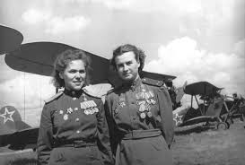

The novel does a great deal of humanizing combatants. The reader is presented with people who are forced by circumstances to dedicate everything to the war effort; there is very little choice for these people. It puts a human face on people caught in a war-torn environment.

On a character level, there’s definitely an arc to Valentina’s character as she progresses from naive, eager, and somewhat spoiled girl who believes her pre-war influence and connections can get her a role as pilot to a competent fighter to a survivor of war and political intrigue.

Exeter Qualities

2) Exciting plots that include secrecy, surprise, and tension brought about through narrative
hooks and a fast pace
4) Characters who go beyond typical experiences so that readers can use the fictional
experiences to learn and develop in their own lives
6) Themes that inform truthfully about the wider world so as to allow readers to engage with
difficult and challenging issues relating to immediate interests and global concerns

Text Complexity

Besides the Russian and more technical details of flying and planes, there’s nothing that stands out as extremely difficult. From a purely language standpoint, the book is at a middle school level, but the themes, messages, and historical context could push the novel to high school.

Scholastic lists it as a 710 on the Lexile Scale (scale that measures difficulty of a work on a scale of 0-2000).

