And Then There Were Four by Nancy Werlin
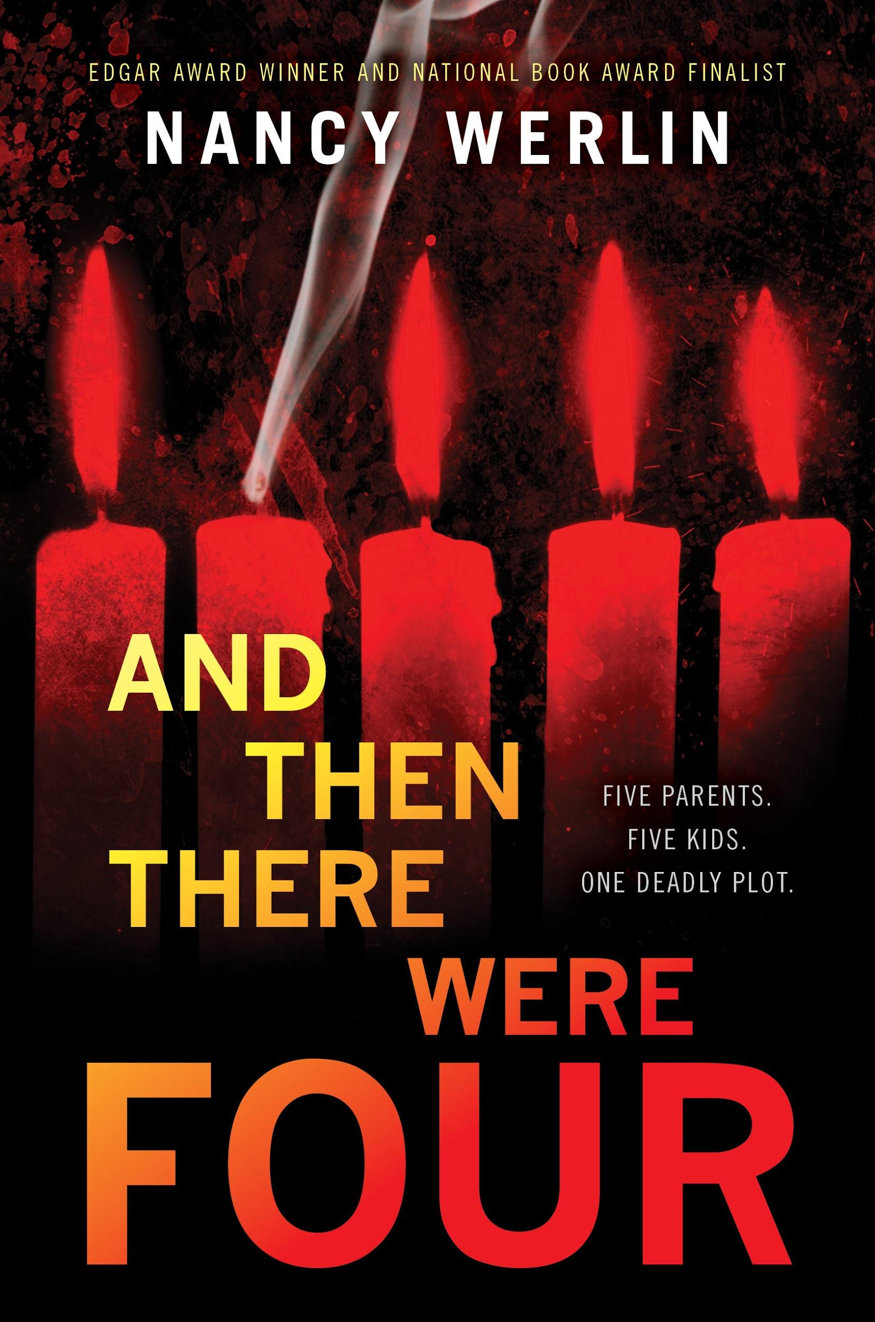

Nancy Werlin - https://nancywerlin.com
- Nancy Werlin is a young adult (YA) fiction and part-time technical writer from Massachusetts, USA
- Knew she wanted to be a writer since the fourth grade, and has since written 10 novels
- Has won the National Book award, became an L.A. Times Book Prize finalist, and written a New York Times bestseller
- “I am drawn to writing about characters in deep trouble and pain, who are pushed kicking and screaming into an experience that transforms them for the good. Uh. After all the bad.” -Nancy Werlin

Synopsis

The meeting place of five high schoolers from a prestigious private school comes crashing down, and they know something suspicious is going on. The five teenagers from various friend groups barely escape death before they can realize why they have been summoned. There is the popular Antoine Dubois, the physically disabled Saralinda de la Flor, the rich Evangeline Song, the gay Martha McKenyon, and the outcast Caleb Colchester Jr, who are all eventually forced to encounter unthinkable scenarios. After getting to know each other and discussing the freak accident that occurred, these students come up with the theory that their parents are plotting to kill them. Is this true? Are all of their parents working together? And if so, why would a parent do such a thing? This mystery-thriller evinces the desperate actions of this group as they struggle to save themselves and one another.

Quotes

- “After all, life is hard sometimes, also surprisingly shocking unfair sweet—all beauty and terror. Our hearts need to be brave however, and what we have to do is put ourselves out there, even if that means we can be crushed. I hope I can be brave like that I don’t know” (139).
  - Significance: This quote from Saralinda indicates her maturity as a character and emphasizes the difficulty of their situation. She comes to this conclusion after Antoine’s death, which brought Evangeline’s true character into light. Up until this point in the novel, Evangeline put on an outward persona “shellacked perfection” (139), and Saralinda sees her vulnerability for the first time. Throughout the entire novel, Saralinda is hopeful and has a surprisingly positive perspective on the bigger picture of things. She encourages her new friends to stay strong and brave despite the harsh reality they face.
- “...You need to absorb something more important. No matter what material things you do or do not have, if you can help someone who needs your help, then you will never be nothing. You used to want to be nothing. You have just been taught better” (248).
  - Significance: This quote is significant because it exhibits Caleb’s growth as a character. Saralinda really brings him out of his shell: he grows from a social outcast with a negative outlook on life to a young man who realizes the beauty of life itself. His conscious realization of how precious life is allows him to start valuing himself and his actions instead of being under his father’s manipulation spell. This quote also emphasizes that these teens are forced to try and survive all on their own with little money, food, or shelter. Caleb realizes how significant friendships and relationships can be on one’s life; although “material things” (248) seem most important in life sometimes, moral values and helping those in need are of much greater importance. Life, after all, is the most precious gift.
- “A fragment a quote a poem from someone somewhere: If you can keep your head when all about you are losing theirs. It sounds so good, so laudable, but I think it is sort of unrealistic. Because no matter how strong you are sometimes you do lose your head, you have nothing left, you don’t know what to do...However if you are lucky there will be somebody who wants to help you...and how odd that now a stranger would be that person for him and me and Kenyon…” (363).
  - Significance: Saralinda’s awareness of human nature reveals her deep complexity as a character. Not only does she face many physical disabilities, but her mother is mentally insane and plotting to murder her. She realizes that it is okay to not be okay sometimes because no one knows what life has in store. At one point or another in the book, each character’s world was turned completely upside down whether they liked it or not. These five friends were forced to roll with the punches since it seemed as if they were not in control of their current situations or where they would end up in the future. This quote also represents the genuine bond and love that these friends shared with one another. They were able to support and confide in one another despite the traumatizing family issues they each faced.

Why Teens Should Read This

- The novel emphasizes how different these five characters are and proves to readers that you do not have to be exactly the same as someone to get along with them. In fact, the different backgrounds and personalities that the characters have is what makes their friendships even more unique and beautiful. Teens would be urged to embrace others despite their differences and flaws.
- This plot touches upon significant difficulties that we all go through in life such as death, fearing the unknown future, and betrayal. The decisions that these characters make and the ways in which they deal with trauma will challenge young adults to see their life problems from new perspectives. Even though challenges vary from person to person, emotion and loss are both unavoidable aspects of life.
- The two love stories in these novels do not unravel in a typical way, but rather through distinct struggles that are anything but ordinary. Young adults should be comfortable building a relationship that might not be another Cinderella story. Because we get insight on both relationships from multiple perspectives, it emphasizes the fact that love is a two-way street: it is key to take one another’s perspectives into consideration while in a relationship.
- Encourages young adult audiences to discover themselves and become independent. Although the majority of young adults will not be thrown into the same extreme family circumstances as these protagonists, learning how to be independent from one’s parents is a huge part of “growing up.” Discovering the power of being on your own in the world as a young adult is critical for self-growth.

Text Complexity

- Qualitative
  - Lexile: Ages 14-17. HL730L.
  - ATOS: 4.7. Interest level: Upper Grades (UG 9-12)
  - Dale-Chall Formula: Raw Score: 3.0723, Final Score: 6.7. New Dale-Chall Readability Index: Readability for Grades 7-8
- Quantitative
  - This novel resonates strongly with Exeter Quality #4: Characters who go beyond typical experiences so that readers can use the fictional experiences to learn and develop in their own lives.
    - It is not common that children are very fearful of their own parents murdering them. The trauma and shock that the protagonists face in this novel is of extremely vile circumstances to say the least. Nonetheless, readers are able to learn from how these characters deal with real-life aspects like friendship, family, and trauma.
  - The plot also embodies Exeter Quality #2: Exciting plots that include secrecy, surprise, and tension brought about through narrative hooks and a fast pace.
    - This novel was a mystery-thriller: it is filled with extravagant plot twists and unexpected endings. Young adults will easily feel compassionate towards the characters and be inclined to find out what happens to them in the end.

Adolescents in the Search for Meaning: Tapping the Powerful Resource of Story

- Chapter 4: Books about Real-Life Experiences (Making Life Choices, Facing Violence or Abuse, and Living through Family and Relationship Issues)
  - Throughout the novel, all the characters have to learn how to deal with the fact that their parents are plotting to murder them. This is an extreme case of violence and abuse within a family, but young adult readers could possibly relate to the abandonment issues that these protagonists face.
  - All of these characters have to make difficult life decisions from deciding to run away from their families, to starting a new relationship. The character development is evident from each of these characters regarding how they approach their past traumas and current situations.
  - The complex characters in this novel encourage readers to be proud for who they are. Even though these friends are so different personality wise, they never pretend to be similar to one another in order to “fit in.” Young adults could thus be encouraged to always be themselves and be proud of their flaws.

Teaching Ideas

- Have students write a creative mystery story that incorporates plot twists and tension in a plot
  - Mystery Lesson Worksheet: https://www.scholastic.com/content/dam/teachers/lesson-plans/migrated-featured-files/janplanmystery.pdf
- Have students free-write about a time when they felt brave. Were they forced into the situation or did they voluntarily participate? What did they learn from this experience physically, mentally, or spiritually?
- And Then There Were Four would pair nicely with a Shakespeare Tragedy like Macbeth or Romeo and Juliet. Students would be able to analyze how these characters and plots are similar or different to one another. Class discussion could include the elements of Shakespearean tragedy in comparison to the elements of Shakespearean comedy. All of these novels deal with major themes like murder, family, relationships, mental health, and trauma.

