RESISTANCE

Written by Jennifer A. Nielsen
Find out more about her at http://jennielsen.com/
Book Talk by Steph Todd

About the Author

Jennifer (Jen) A. Nielsen was born and raised in Utah, and she is best known for her young adult novels. Many of her books involve young adults and children’s fantasy characters. As a child, she grew up reading, acting in local theatre, and arguing in speech and debate programs through her schools. These activities gave her the foundation to tell her characters’ stories. Nielsen has been writing since her elementary school years and continues to publish works often. She is known for a variety of series which include The Underworld Chronicles, The Ascendance trilogy, the Mark of the Thief series, a few standalone novels, and historical fiction novels as well, like Resistance.

Summary of Resistance

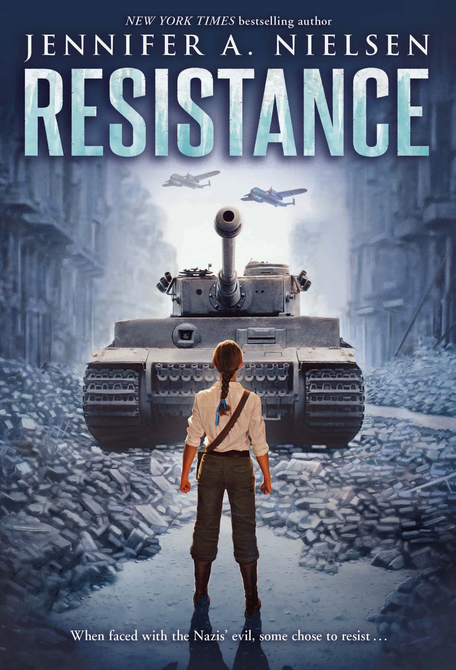
In the early 1940s, Poland has become a Nazi-occupied place where only two options for Jewish people remain: surrender or resist. Chaya Lindner, an Aryan-featured teen who lives among the chaos, volunteers as a courier for the resistance group Akiva to participate in raids and to smuggle food, documents, supplies, and occasionally people, in and out of ghettos. When an important mission goes awry, all contact cuts off within Chaya’s resistance group except for another teen named Esther who informs her that they must venture to Warsaw’s Ghetto to fulfill an impossibly dangerous task. Amidst the worst circumstances imaginable in humanity, Chaya and the other resistance members fight, persist, and showcase to the world that their cause is honorable and that they will not surrender when faced with adversity. Based on real events and people, this novel showcases the bravery, humanity, and brutality the resistance fighters faced to redeem their people’s place in history during the Holocaust.

(Both pictures are from Nielsen’s website: http://jennielsen.com/)
Noteworthy Quotes

“But I’d get in today. And tomorrow I would lie my way into another ghetto, and do the same every tomorrow after that until my last breath, or theirs. After three years of war...I was finally doing something. I was bringing my people a chance to survive” (5). | In such a hopeless time in history, Chaya provides a tremendous amount of hope for the oppressed in the ghettos. She forges her papers and identity to bring items into the ghettos, but her lies help far more people than imaginable. Saving the lives of others helps Chaya conquer her own fears. To live courageously and honorably amid such horrific events means that the efforts of her resistance group do not go down in vain; likewise, their endeavours will hopefully pave the way toward a brighter future for all the suppressed people.
“‘You’re not the only one that anything has happened to. If we’re still alive, then it’s because we all lie, we all steal, we hide the Star of David on our arms when we can and show it when we must. And we’ve all lost people we love. We’ve all lost everything to the point where we have nothing left, so our only choice is to curl up and die, or else to fight back’” (107). | This crucial moment in the book occurs when Chaya relays to Esther that life is beyond unfair. No one can truly escape the horrors of war; therefore, it is unfair to cry too long or complain that one has it worse than another. Chaya understands that loss and deceit affects everyone, and everyone copes differently. Fighting or surrendering are the two choices that anyone in this time period can do, and whichever decision someone chooses cannot prevent the losses that will inevitably follow. It’s a brutal truth, but it’s a truth nonetheless.
“I should have been terrified at the sight of the bomber...But I felt no fear. If we required such a response from the Germans, then this in itself was a victory. Perhaps on our own, the resistance fighters of the Warsaw Ghetto could not get the attention of the world. But we’d certainly demanded the attention of the Nazis...maybe we’d prove to the world that the Germans could be defeated, that this war could be won” (305). | Fear drives everyone in this novel. It can drive someone toward fighting back, or it can drive someone toward surrendering to the enemy. Chaya understands that all the efforts that she and Akiva put forward have made this response happen, for better or for worse. In such a moment of realization that death is knocking at her door, she sees the bomber as a sign of hope: this war is not impossible to win and the Germans, like any other group, have weak spots. With enough effort, the Nazis can eventually be defeated. Their resistance group may not completely overtake the Germans alone, but perhaps their efforts show others that surrendering to fear is not the only viable option.
Resistance in the Classroom

Though this novel falls under chapters five, six, and seven in Adolescents in the Search for Meaning, it is best categorized with chapter seven: Books about Courage and Survival. Chaya epitomizes a character who refuses to surrender but instead chooses to fight in the face of danger.

Teaching Ideas / Presenting the Text

- If possible, see if there are any survivors from WWII who would be willing to talk to the classroom or the school about what the time period was like for them. Otherwise, find an interview(s) online from survivors discussing the wartime.
- Watch the clip from the Band of Brothers miniseries in which the American soldiers discover a concentration camp. This gives context to what resistance fighters like Chaya fought to prevent in regards to her people. Though it does not showcase the ghettos, it provides a visual of the camps’ horrible conditions people often faced after being sent out of the ghettos. (highly graphic, mature content)
- Pair this novel with Anne Frank’s The Diary of a Young Girl or Elie Wiesel’s Night. Both of these works deal with the emotions and the hardships young people face in such a horrific time in history. Unlike Chaya, however, these texts involve the experiences of either hiding in the presence of Nazis or dealing with the conditions within the camps.

Why Should Teens Read this Novel?

- Teens should understand how cruel this world can be to people.
- Teens should understand that when faced with discrimination, surrendering is not the only option.
- Teens should understand that anyone of any age can make a difference.
- Teens should understand how strong human beings can be in the worst of times.

Text Complexity

Quantitative: Lexile Range: 1010L - 1200L (6th grade level reading) | ATOS Level: 5.8
Interest Level: 4th - 8th grade | Flesch-Kincaid Grade Level: 8th grade
Flesch Reading Ease Score: 74.6 (fairly easy to read) | Dale-Chall Readability Index: 8th grade

Qualitative: Resistance follows that of a middle-complexity structure with a fairly chronological event order with only a few flashbacks. The language is straightforward without much ambiguity, but it does have a few instances of German language Chaya uses with the Nazi soldiers, but this language is explained. The novel is set against the backdrop of WWII and assumes readers have a general idea of what was going on at the time. This informational text has explicit statements of purpose, and though this text is fairly easy to read and is recommended for 6th grade level reading, it would be best suited for teens ages 13-15 since the subject matter can be heavy. Resistance qualifies under Exeter Qualities 2, 3, 4, and 6: the plot is tense and fast-paced, the novel has a strong female protagonist, the character(s) go beyond typical experiences, and the readers must engage with difficult and challenging issues.

