Carlos Alonzo Gonzalez
Professor Mary Warner
ENGL 112B
1 October 2022
Ain’t Burned All The Bright
By Jason Reynolds & artwork by Jason Griffin
https://www.jasonwritesbooks.com/
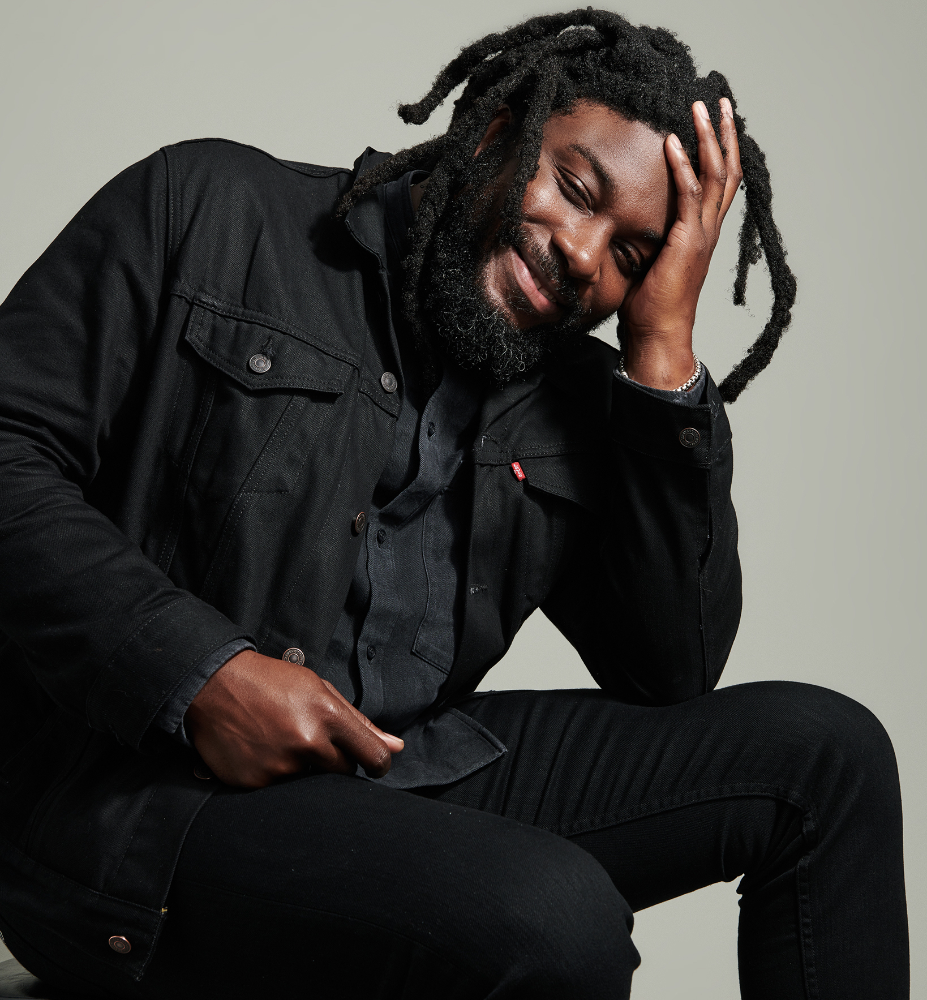
https://www.arts.gov/stories/blog/2020/art-talk-jason-reynolds
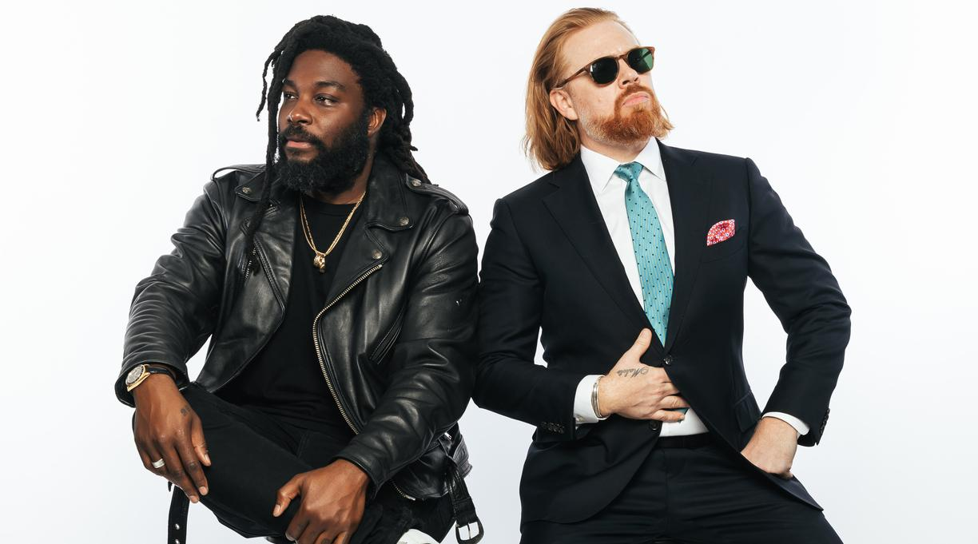
Jason Reynolds’ was born December 6, 1983 in Washington, DC. Reynolds grew up in Oxton Hill, Maryland, a city south of DC with his three siblings. At the age of nine years old, Reynolds began practicing poetry inspired by Queen Latifa’s album “Black Reign ''. Other influences of his include Tupac, Biggie, and the rap genre in general. Reynolds didn’t read books until he was 17. A couple years into college Reynolds discovered his love for African-American Literature while working at a bookstore, discovering authors like Richard Wright, James Baldwin, and Toni Morrison.

While in college, Reynolds met his “best bud” as he notes on his website, Jason Griffin. They would go on to become roommates, and later collaborators on books like SELF, My Name Is Jason, Mine Too.: Our Story, Our Way, and eventually Ain’t Burned All The Bright. https://www.kirkusreviews.com/news-and-features/articles/jason-reynolds-griffin-my-name-is-jason-interview/
Summary
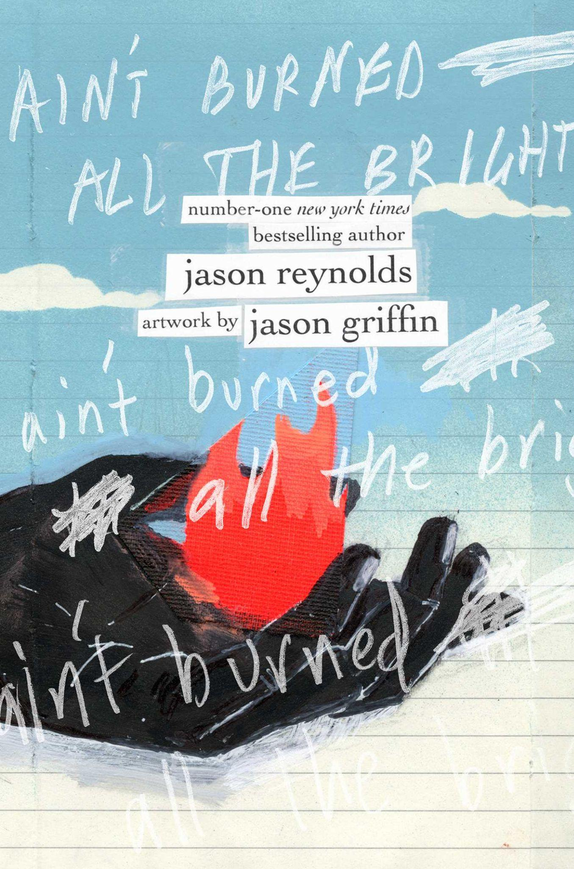
Ain’t Burned All The Bright, is 338 pages long, however the story is told in three long sentences. Three breaths. All, if not most pages are beautifully illustrated. The story is told through the perspective of a young African American boy during the summer of 2020. The book takes place in what can be estimated as an hour, maybe less. The narrator describes as his mother worryingly watches the news, how his sister nervously calls her friend, his brother and his unwillingness to look away from his video game, and his father who is coughing in the other room. The news on TV broadcasts the death of an unnamed man, the protests following the tragic incident, the assaults of unnamed people and the relentless spread of an unnamed disease.
https://www.simonandschuster.com/books/Aint-Burned-All-the-Bright/Jason-Reynolds/9781534439467

Quotes

“And I’m sitting here wondering why my mother won’t change the channel, and why the news won’t change the story, and why the story won’t change into something new, instead of the every-hour return about how we won’t change the world, or the way we treat the world, or the way we treat each other…” (Breath One). | The author thrusts the reader into the narrator’s world. This is the first sentence of the book and it begins with “and” as if we’re entering half way through a story already being told. This sentence expresses desperation. The speaker wants someone to change the channel, someone to change the story, someone to change the world and the way that people treat each other. These few words express the perspective of a child as you can tell that the speaker only wants what is clearly better for the world. For a child the answers to gran-problems are simple.
“...and he is lying in the bed his body an out-of-tune instrument that somehow only plays thunder, and somehow has even become its own rain cloud, and somehow has stormed on him, flooding him in sweat and swelter, and his skin got a dull gleam to it like it’s glowing, like he swallowed the moon and it’s lighting the dark but I know that’s just the fever doing that, and it’s like he’s swallowed the sun and it’s burning bright, and when he coughs again, my mother says not to go in there, so I keep peeking through a crack in the door and when he sees me he smiles because the fever ain’t burned all his bright up yet, and he tells me he will be wonderful in a few weeks, and that we’ll go back to squeeze-hugging and roughhousing and he’ll be able to get through his good-bad jokes without a punchline getting stuck in his throat jabbing and hooking, and he says not to worry..” (Breath Two). | These lines describe the father of the speaker, reminding or giving insight to the reader on the pandemic. These lines are uncertain such as the climate during the height of the pandemic. There’s hope of course, but the speaker still struggles with anxiety over if his father will be alright. These lines also do an amazing job at describing an illness without directly mentioning it. The rain cloud that brings images of flu evolving in only a few words into something that brings sweat and fever is an incredible sequence of words. These lines really show off Reynold’s talents and how he uses allusions to the best of his ability throughout this book. I also chose this line as the last section of it is very sweet, the sweet moments in this book really elevate it. The book is rich with commentary without this, but the act of following a family through the events of the story really makes it feel personal.
I’m still sitting here…when all I want to do is lie down, but I should be standing up looking for an oxygen mask or something, or searching for a sign or a sigh, or something for my lungs to l u n g e toward, because what is life in a house underwater, and what is left when the whole world is wheezing and worry is worn like a knit sweater in summer, and can’t nobody breathe in a knit sweater in summer, a turtle neck wrapped around my whole family our necks caught in a tunnel of too much going on, and it feels like I’m the only person who can tell we’re all suffocating…” (Breath Three) | The speaker expresses how he’s glued to his seat just like his mother. This line expands on how he is unsure why his mother doesn’t get up or change the channel. She’s not the only one stuck, he is too. He knows he should be searching for an “oxygen mask”. He wants to say something, break the silence as implied by the lungs section.  House underwater represents how the lockdown makes him feel isolated. He follows that up by saying how the whole world is wheezing and how nobody can breather referring to the pandemic and the murder of George Floyd. This line ultimately represents how he feels alone.

Classroom Usage
This book can be used to teach various things. On one hand it can teach contemporary history. This book can also be implemented into a poetry unit. Reynolds masterfully builds tone in this text. Themes can also be discussed in a class discussion as well as his use of allusion and the significance of enjambment (continuation of a sentence without a pause). The way I’d present this book would be through a quote followed by an open classroom discussion about what students notice about the word choice and various other aspects of the author's writing.
Category in YA Literature
This book is perfect for early high school students, but this book is great for anyone over the age of twelve, maybe even higher. This book is gruesome and heartbreaking especially when understanding the context of the setting. Without that understanding, most of the images used in the book are also pretty violent. Teens should definitely read this book because of how relatable it is. The book takes place in 2020, the events are recent, but even years from now the book leaves enough things out of its text for it to always be relevant. This book is vulnerable as one of its themes is loneliness and how we could all feel alone in our own little worlds. I think a lot of teens would be able to relate to that. It’s also three sentences long. It’s very accessible and the style is different which can be likely refreshing for teens.
In regards to this book and its place in “Adolescents in the Search for Meaning: Tapping the Powerful Resource of Story” I think this book would fit best in Chapter 6, “Books about Identity, Discrimination, and Struggles with Decisions. This book is told through the perspective of a Black child. It subtly deals with issues pertaining to how one’s family would react to the terrible circumstances of the unjust murder of a Black man, afterall, its hard to change the channel with events that could potentially affect someone you know being streamed on television. Another place where this book would fit perfectly could be in Chapter 4, “Books About Real-Life Experiences” as it deals with a real, historical event and depicts a family that could’ve gone through those exact experiences during that year.

Text Complexity
Lexile Range: 330L-700L (3rd-4th Grade)
Dale-Chall Score:
Raw-9.6328
Adjusted Score: (3.6365 + 9.6328)
Final Score: 13.3
In regards to the diction used in this book, I think a third-grader can read through this book with little issue. This book is most demanding when it comes to the implied themes. The shortness of the words, however, make it easy to pick up for almost any reading level beyond the second grade. The vocabulary can be a little difficult for some readers, but it’s nothing too difficult. The words are easy to read/pronounce, defining them may be another one of the toughest parts for certain readers.Renaissance ATOS Analyzer ranks this book at 2.4 on vocabulary level. So the average first grader could probably read this book.
On a qualitative level, this book would be best understood by high schoolers on any level (9-12). This book deals with themes of Black violence and Covid-19 making it only appropriate on a high school level.

