The Distance Between Us
By Reyna Grande
Book Talk by Evelyn Soriano

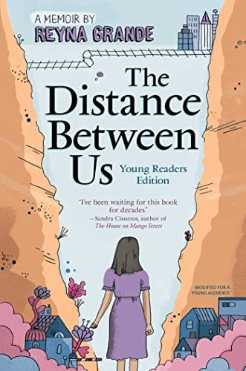
Source: Image link

About the Author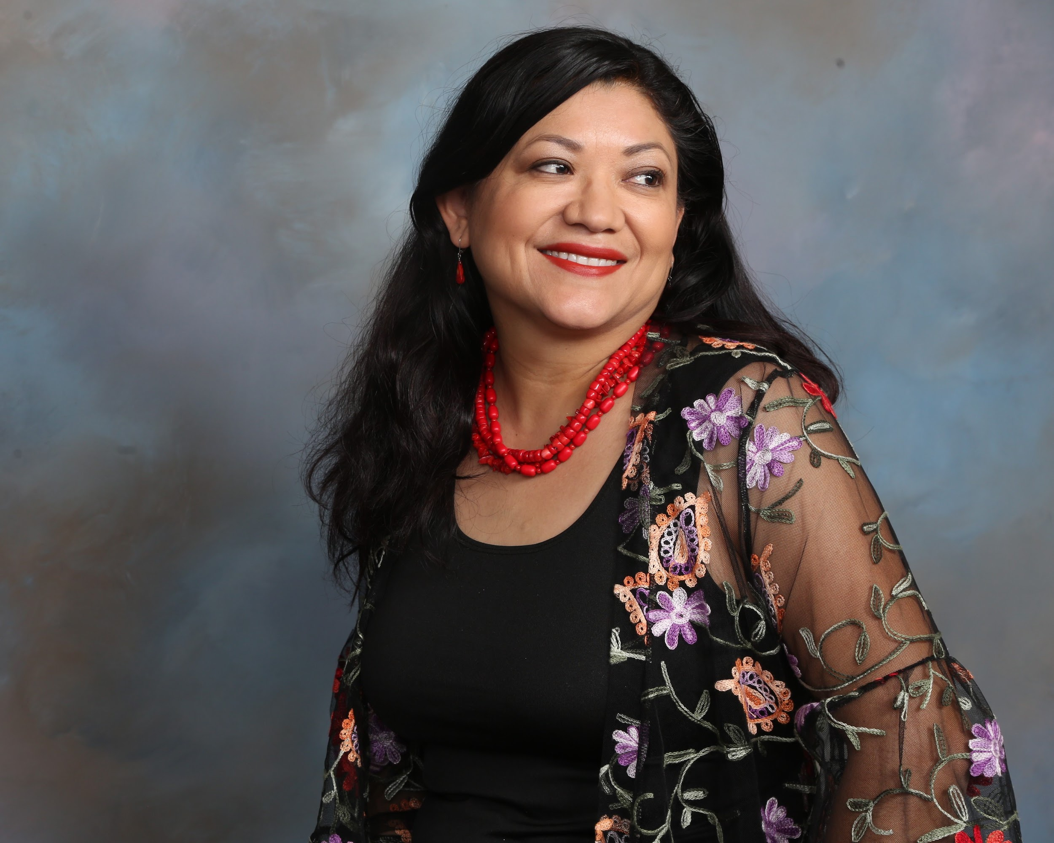
Source: https://reynagrande.com/ (Image taken from author’s website)
About the author:
Reyna Grande was born in Iguala Mexico and was the 3rd out of 4 children her parents had. At a young age, she was left behind in Mexico with her siblings in order for her parents to achieve the American Dream. Grande attended Pasadena community college and transferred after two years to UC Santa Cruz, making her the first person in her family to attend a university. She obtained her B.A. in creative writing from UC Santa Cruz and obtained her master's from Antioch University.

Summary:
Imagine what it must feel like to be separated from your family at a young age from your parents. Grande and her two older siblings had to adapt to life in Mexico without their parents because they came to “el otro lado” to chase the American dream. After years of being away from their parents and being treated unfairly by the people around them, Grande and her siblings decided to join their father in the United States. In Mexico, everyone believed that the United States was the best place to live, and although that is true, Grande and her siblings didn’t have it easy like the rest. While adapting to a new style of living, they faced hardships such as racism and abuse from the people around them. Having to adapt to a new life and culture can be difficult, but how is Grande able to overcome this and show everyone that she is capable of success?

Quotes:
- “But then Mago touched my belly button and said something my mother never said. She said my umbilical cord was like a ribbon that connected me to Mami. She said, ‘It doesn’t matter that there’s a distance between us now. That cord is there forever.’ I touched my belly button, and I thought about what my sister had said. I had Papi’s photo to keep me connected to him. I had no photo of my mother, but now my sister had given me something to remember her by. ‘We still have a mother and a father,’ Mago said. We aren’t orphans, Nena. Just because they aren’t with us doesn’t mean we don’t have parents anymore” (Grande 14).
- At the beginning of the story, we learn that Grande's dad was already in the United States. Grande’s mother decided to stay home to look after the kids, but that did not last long. Her mother made the decision to join her husband because they believed both of them could earn more money if both were working in the United States. When her mother left, Grande felt that she had no type of connection with her mother because she didn’t have an image of her. She had an image of her father, and this made her feel disconnected from her mother. Mago was able to calm her down by letting her know that despite the distance, the umbilical cord was what connected her to her mother. The original plan was to build a home in Mexico and come back to their kids, but not everyone knew that this was the plan. Everyone in their village calls them orphans because their parents abandoned them. This affected all three of them, but as long as they knew the truth, nothing else mattered.
- “After Mami left, Mago once again became our little mother and took care of us all. Betty missed Mami the most. She cried and cried for our mother until one day the crying finally stopped. She wrapped her arms around Mago and clung to her with her chubby hands. I loved my little sister, and I didn’t mind that Mago paid more attention to her than she did to me. Before, I used to think that since Betty had been born in the United States, she was more special to Mami. Now I saw that we were all the same to her. We were all just as easy to abandon” (Grande 83).
- Grande’s mom returned to Mexico with a newborn. Her name was Betty and she was born in the United States. Her parents had problems, which caused her mother to go back to Mexico. Unfortunately, Grande’s mother changed a lot with her kids, and her priorities were now different. Her children weren’t a priority anymore, and she was now focusing on which guy would give her more attention. This allowed Grande to see where her mother's priorities were, and how they were the least of her concern.
- “In June, I became the third person in my family to graduate from high school. Though I was proud of that small accomplishment, it was a bittersweet day for me. It was painful to hear my peers talking about their plans after graduation, such as preparing for going off college, knowing that I might not be going anywhere if I couldn’t convince Papi to allow me to go to UCI. It was also painful to see my family split in half at the Occidental College amphitheater, where the graduation was held. Mago and Carlos sat on one side of the theater, and Papi sat on the opposite side because he still refused to have anything to do with Mago. Mila hadn’t bothered coming and, neither had my mother” (Grande 289).
- After everything that Grande went through, her high school graduation finally arrived. Grande did not attend the university she wished to attend and was forced to attend a community college. Grande’s father felt that he couldn’t trust her going to school because of what her siblings decided to do. The actions of her siblings created family issues that ultimately affected everybody in the family. Grande hoped for a different outcome at her graduation, but she was able to make the most of it despite having a separated family.

Teaching:
- This book mentions many moments where Grande feels like she doesn’t belong. I would give my students a prompt that asks them to write about a time when they felt like an outcast.
- Grande would always cherish her memories. Memories were what kept her going in life and helped her through hardships. As a class activity, I would ask my students to share a memory that they cherish and why they hold on to it. Why does that memory mean so much to them?

Why should teens read this book?
- Students should read this book because it would teach them about the struggles that many people face in order to live a good life. Grande and her family had to come to the United States to have a better life and a better education. This would be a good book for students to learn about immigration and why people decide to immigrate to different countries.

How it fits best in Chapters 4-8 in Adolescents in the Search for Meaning:

Chapter 4: Book About Real-Life Experiences
- Grande and her siblings struggle to live on their own without her parents. Her grandmother doesn’t care enough to feed or look out after them, making them look out for each other. Grande also has to deal with a broken family that now has different priorities.
Chapter 6: Books about Identity, Discrimination, and Struggles with Decisions
- After coming to this country, Grande and her siblings have a hard time trying to find out who they are. They are discriminated against for not speaking English and are constantly called ‘wetbacks’ by their classmates.
Chapter 7: Books about Courage and Survival
- Grande gets the courage to leave Mexico and cross the border with her family. She also faces a lot of abuse but ends up surviving the physical and mental abuse that is endured by her own family.

Text Complexity:
Raw score 1.9129
Adjusted Score: (3.6365 + 1.9129)
Final Score: 5.5
Grade levels 5-6
Recommended level: 9-10th

Lexile Range - 610-800L
(4-5th graders)

Qualitative: The language that is in this book is quite easy to understand, and can be read by a fourth or fifth-grader. The Dale-Chall Formula suggests this book for fourth or fifth graders, but I would suggest this book be better understood by 9th-10th graders because of themes such as abuse and immigration. A fourth or fifth-grader is going to have a hard time understanding these themes because they are not quite mature yet.

