Adora Nguyen
ENGL-112B, Sec 01
Dr. Warner
9 October 2023
Life in a Fishbowl (2017)
By Len Vlahos
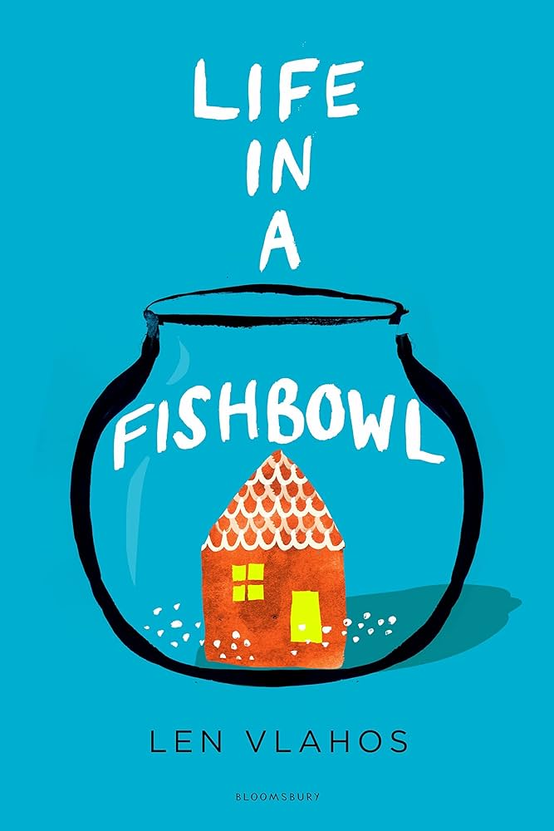

About the Author:
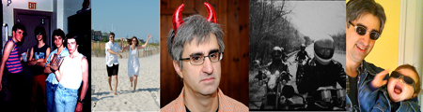
Image Source and Author’s Website: https://lenvlahos.com/about/
Before committing to the world of books and writing, Vlahos was a former student at NYU film school and participated in songwriting and guitar playing for multiple bands, especially Woofing Cookies. He has written four and a half YA novels in total.
Currently, Vlahos is a freelance writer who gravitates toward all inspiration. Life in a Fishbowl is even inspired by a meme where in 2008, Ian Usher listed his life on eBay.

Summary of the Novel:
Fifteen-year-old Jackie Stone loves her father to death. However, when Jared Stone is diagnosed with a fatal brain tumor, she faces the traumatic consequences of her father’s terminal illness savoring away his most precious memories. In a desperate attempt to secure financial stability for his family, Jared decides to auction his life to the highest bidder on eBay. As his children and wife painfully watch him deteriorate, both mentally and physically, four bidders of different backgrounds and morales use the power of the Internet to interrupt their peaceful lives. In an instant, the Stone family become products of a reality TV show to millions of Americans, further exploiting Jared’s condition and the family’s most vulnerable moments of grief.

Quote 1:
“Human Life for Sale. Forty-five-year-old man with four months to live is selling his life to the highest bidder...There is a reserve for this auction” (38, this and all other quotations in this Book Talk are taken from Life in a Fishbowl by Len Vlahos).
Jared’s official eBay listing embodies inhumane circumstances as a whole; his post sets the demoralizing scene of the entire novel. Under immense financial pressure after his death, Jared believes that he needs to sell his life for his family. In listing the extreme and dehumanizing ideas of “slavery, murder, torture” before “pleasant conversation,” the novel demonstrates how Jared recognizes the cruel reality of humanity as he fully prepares himself for the worst, almost as if he is already dead. He reinforces how there is more possibility for evil than good. In an emphasis on the Death with Dignity Act, Life in a Fishbowl explores the meaning of life versus death and how the law subtly underlines more humanity than not.

Quote 2:
“He paddled through unchartered lakes and canals, devouring schools of thought that defied category or explanation...Glio swam on. Or rather Glio swam.” (91).
Jared’s brain tumor, Glio, is personified as a living entity with his own thoughts and intentions through a personal third-person narration. He relives Jared’s most precious memories and experiences for the first time, ranging from the birth of Jackie to Jared’s first kiss. As Glio explores Jared’s vast, complex emotions and passions, the high-grade glioblastoma multiforme signifies how Glio savors the qualities that define Jared as human. Despite being an extension of Jared, Glio feasts upon the wonders and joys of life until Jared’s brain has nothing left to consume. Essentially, the quote’s significance amplifies the underlying torture Jared suffers as he slowly and uncontrollably loses his life in front of his family. Day after day, Jared feels less of a human than Glio, who ironically adds to the novel’s themes of the character's unaware ignorance and selfishness.
Quote 3:
“The silence underscored a tension that had been building between father and daughter, the first in the entire history of Jackie’s life...But she couldn’t. She wouldn’t. Not with them watching” (171).
Jackie Stone, Jared’s oldest daughter and one of the main protagonists, re-establishes the exploitation of their circumstances and how the reality TV show immensely impacts her relationship with her loved ones. She is forced to swallow her own emotions and avoid any conflict with her most significant male figure, essentially having to parent herself. Under the intense pressure of twenty-four-hour surveillance capturing their every move and manipulating them as characters rather than human beings, the novel emphasizes the abuse of money and power that ultimately fuels corruption. The reality show Life and Death borders on the idea of essentially purchasing a human life. By reconstructing and manipulating the family to produce “human” entertainment, the novel signifies how such a dehumanizing show exploits the grief of a man slowly dying in front of his family.

Classroom Use
I would use Life in a Fishbowl to bring light on the Death with Dignity Act, particularly with an emphasis on the value of life and how recent human entertainment demonstrates a demoralizing impediment.
Furthermore, I would use Vlahos’s novel as one of the distinct examples of various character perspectives in a third-person narration. The style and plot structure also amplify the basic elements of fiction that freshmen in high school can assimilate their creative writing toward. The novel itself might best fit with Chapter 5 of Adolescents in the Search for Meaning: Tapping the Powerful Resource of Story: “Books about Facing Death and Loss.” Under the notion of death, characters such as Jackie find meaning and courage in their own actions, thoughts, and words. In contrast, there are also characters who treat people’s life and death as meaningless objects unless deemed beneficial or advantageous.

Teaching Ideas and Introducing the Book:
I would instruct my students to do a variety of relevant projects relating to Vlahos’s novel. I would have a “Film Your Own Reality” video project where students must record and reevaluate their daily lives and encounters. With raw footage, students must compare their lives with one another and reflect on the essence of life and how different cultures and backgrounds affect human nature. An alternative project is to film their reality and compare the footage to an altered, edited version as an homage to The Real Family Stone of Portland, Oregon. Furthermore, I would attempt to rearrange a similar event to the novel’s mention of a social media exchange program. Jackie and Max’s close friendship essentially changed the course of the novel and provided a comforting, wholesome environment when they would communicate online.
I would also use this book as an example of creative writing and assign students to write in the third person narrative, centering on at least four different people’s perspectives. Also, in reference to the personification of Glio, I would have an alternative assignment prompt: in 1-2 pages, explain what body part you would personify. Write from their perspective.

Why should you give this book to teens?
Life in the Fishbowl explores the inhumane reality of popularized media, exploiting the struggles and pains of people’s grief. In contrast to the deceitful notion of reality TV, the novel navigates some of the complex struggles of being a teenager and through this book, young adults can unravel and understand similar experiences:
  - Because teenagers who have lost their loved ones to a terminal illness can find a level of courage, comfort, and closure by the end of the novel
  - Because teenagers who have sibling tensions can find solace in Jackie and Megan’s character development over the course of the novel
  - Because teenagers who struggle to fit into a social setting can find reassurance and determination in the novel’s main protagonists
Aside from the novel’s essential themes and elements of fiction, one of the most significant reasons young adults should read Life in the Fishbowl is because of the novel's exploration of the Internet, the most prominent tool for teens today. Such references may be easily enjoyable for a young adult who does not often read. Vlahos uses recent media such as World of Warcraft, Big Brother, and Hunger Games to gravitate toward his target young readers. Considering how fast entertainment and media can also limit attention span, the novel establishes short sections of different characters' perspectives in six main parts. The novel has seven separate and focused accounts of the characters, perfectly captivating young adult readers.

How it fits best in Chapters 4-8 in Adolescents in the Search for Meaning
Chapter 4: “Books about Real-Life Experiences”
  - Somewhat ironic to the “real-life experiences” is how Vlahos amplifies the cruel and deceitful instances of current reality TV, where teenage daughters like Jackie and Megan Stone are forced to submit to the manipulative ways of human entertainment.
    - Furthermore, although the Internet can be a positive escape, the novel amplifies its brutal, exploitative outcomes.
  - The glioblastoma multiforme tumor remains as the most prominent brain tumor among adults, a fatal and definite cause of death.
    - Simultaneously, the novel presents familial tensions and the fixation on cruel human nature.
Chapter 5: “Books about Facing Death and Loss”
  - Jared’s family suffers as they watch him slowly deteriorate, both mentally and physically. Jackie’s most influential person is her father, yet she is forced to navigate her own feelings of despair and isolation.
    - Jared, too, loses the most precious elements that make him human: his memories and emotions.
    - His outer appearance almost makes him unrecognizable; the loss in weight and hair emphasizes Jared’s fatal demise.
Chapter 6: “Books about Identity, Discrimination, and Struggles with Decisions”
  - Maxim Vasilcinov, Hazel Huck, and Jackie Stone are the most prominent teenagers to revolt against the discrimination and cruelty from Ethan Overbee and the American Television Network.
    - Despite lying about their identities online, Max and Hazel find courage in helping Jackie fight the odds stacked against her and her family.
Chapter 7: “Books about Courage and Survival”
  - In Jackie’s example, she finds the bravery and determination to expose her oppressors’ exploitation and manipulation.
    - She even mentions “if she could survive Ethan Overbee and the American Television Network, she was pretty sure she could survive anything” (297).
Chapter 8: “Books on Allegory, Fantasy, Myth, and Parable”
  - One of the most prominent examples in the novel is the significance of an online game: World of Warcraft, where people roleplay fantasy and mythical characters with one another.
    - World of Warcraft signifies more than just a game; this medium ultimately brings together a community of people with similar experiences or the desire to help others in need.
    - Without the game, Jackie would never have been able to expand a loyal, compassionate group of people who signify the more positive side of using the Internet.

Quantitative:
Word Count: 78,028
Page Count: 336
Lexile: Age: 12-17, 910L
AR: ATOS Book level 6.4, Interest level: Upper Grades 9-12, AR points: 13.0
Dale-Chall: 7-8 grade level, Readability: ages 12-13
Flesch-Kincaid: 7th grade
Overall, I would recommend Life in a Fishbowl to 9th graders.
Qualitative:
Levels of meaning:
  - The novel mentions the abuse of money and power, fueled by corruption and consumerism.
    - With this, the novel goes deeper into the demoralizing, yet uplifting nature of being human.
    - The power of the Internet is both a consequence and a blessing.
  - The significance of life versus death is personified through a glioblastoma multiforme tumor.
Structure:
  - There are six main parts to the novel.
  - Through a third-person narrative, there are primarily seven different accounts of the novel: Jared, Jackie, the four bidders, and Glio (the brain tumor).
    - Other side characters have brief accounts of their own perspective such as Megan and Max.
  - There are memories from the past to reemphasize the character’s thoughts and actions.
    - For example, Jackie realizes the significance of her father’s concern with money after his death; she thinks back to the time when she sacrificed her lemonade stand profit to a man in need.
  - There are a variety of different sentence structures: both short and long as well as blunt and abstract.
Language Conventionality and Clarity:
  - The language is easy to understand and follow.
    - However, there are instances where the reader may have to look up words in the dictionary. These were some examples mentioned in the book: anathema, sordid, vomeronasal, palatial, ebullient, tantamount, and flummoxed.
  - Some figurative devices center around personification, imagery, analogy, and hyperbole.
Knowledge demands:
  - There are truly not many knowledge demands as Vlahos explains the meaning of each significant term he mentions throughout the novel.
    - For example, he thoroughly clarifies the meaning of euthanasia and how it implies the Death with Dignity Act.

