Zuleica-Tania Coronel
ENGL 112B
Warner
October 30, 2023

Writing My Wrongs: Life, Death, and Redemption in an American Prison
By: Shaka Senghor
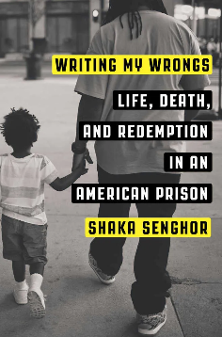

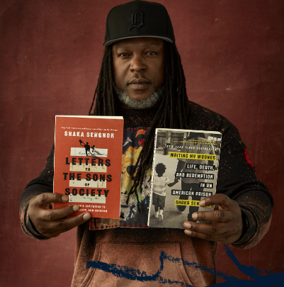
Source: https://www.shakasenghor.com/author
About the Author
https://www.penguinrandomhouse.com/books/538241/writing-my-wrongs-by-shaka-senghor/9781101907313/teachers-guide/
“Shaka Senghor is a leading voice in criminal justice reform and the president and co-founder of #BeyondPrisons, an initiative designed to uplift the voices and the experiences of those impacted by the justice system. He is the recipient of numerous awards, including the 2016 Ford Man of Courage Award, the 2016 NAACP Great Expectations Award, the 2015 Manchester University Innovator of the Year Award, and the 2012 Black Male Engagement (BMe) Leadership Award. Shaka’s 2014 TED Talk received a standing ovation and has been viewed more than 1 .3 million times. He was also recognized by OWN as a “Soul Igniter” in the inaugural class of the network’s SuperSoul 100, a dynamic group of trailblazers whose vision and life’s work are bringing a higher level of consciousness to the world around them and encouraging others to do the same.”
Summary
Writing My Wrongs is a memoir that reflects upon a chain of events that happened throughout Senghor’s life. In the novel, Senghor’s life takes a drastic turn once his parent’s divorce; leaving him with a deep sense of abandonment and resentment. Trying to process his emotions, he soon finds himself in the streets of Detroit, where he is introduced to a world filled with poverty, drugs, and violence. A child who once dreamed of becoming a doctor now finds himself behind bars at the age of nineteen, convicted of second-degree murder.
Quote 1
“Every chance I got, I defied my mother’s authority…I wanted her to hurt in the way that I hurt” (Senghor 30-31).
This particular quote is pretty significant because it highlights the emotional and physical strain of his parents divorce. As an act of retaliation, James turns to the streets to overcompensate for the things that are missing in his life such as, love and acceptance. It is here (streets of Detroit), that James begins to have this sense of belonging as he starts to build “familial” relationships with local drug and gang members that promise to take care of him if he sells drugs for them. However, this sense of loyalty is quickly tested one day when he is robbed at gunpoint and beaten during a drug deal and there is no one there to defend him. Realizing just how brutal the streets can be, James begins to build an emotional barrier and vows that he will do whatever it takes to survive; even if costs someone’s life.

Quote 2
“We all felt the same nervous energy, but we kept it concealed under the stoic masks…we all wear the mask” (17).
This particular quote delves into issues of masculine identity. Here, we have the juxtaposition between what is perceived and what is put on. In this passage, we can clearly see just how scared James is, despite just taking someone else’s life; however he tries his best not to show it. His reaction to the severity of his offense really tends to highlight his naiveté even as an adult, and shows just how much he has become desensitized. As a reader, it makes you wonder just how much control he had over his life. While the possibility of him losing his freedom does scare him, the reality of his situation does not start to set in until, he is convicted and is forced to serve a nineteen-year sentence. It is during this time, that James begins to do the hard work of healing by reflecting on the pivotal moments in his childhood that lead up to his incarceration.
Quote 3
“ And that’s the thing about hope… we can begin to make things right” (263).
Since, the book does focus on redemption; hence the title, I thought it would be important to include a passage that not only focuses on hope, but also focuses on the power of redemption through forgiveness. At this particular point, readers can see just how much Shaka has transformed as a person. He fully understands how his actions have affected him and others. The idea of him getting released soon ultimately gives him hope for the future. To him, being released symbolizes more than just a physical freedom, it is an opportunity to right his wrongs and give back to his community, which he eventually does. And while this quote marks a pivotal point in his life it also serves as a reminder to readers how even our worst deeds do not define us and we have the power to make amends with our past.

Classroom Use
I would use this book along another text that explores similar themes and/or topics. For instance, I think this book would pair well with We Were Here since, both texts deal with issues of substance abuse, violence, and explores themes of identity. Having a book like this would be beneficial in a classroom setting because it allows students to think critically about issues that directly and/or indirectly impact their lives or their peer’s lives. As far as what age group is this book most appropriate for, I would say fourteen years and up since, the book centers on a fourteen-year-old boy, who experiences real life issues.

How it fits best in Chapters 4-8 in Adolescents in the Search for Meaning
Chapter 4: Books about Real-Life Experiences
This book is as real as it can get since; it is based on a true story. In the novel, the protaganist (James) is faced with violence, abuse, and family issues. The main character makes an adult decision that ultimately changes the trajectory of his life. Trying to make amends with his past, James starts to be proactive about his life by becoming an active member in his community.
Chapter 5: Books about Facing Death and Loss
With violence comes loss. James’ early life had been engulfed with death. He had witnessed loss all around him, leaving him completely desensitized. The way he processed the deaths around him reflect much larger issues especially, when it comes to how people process grief.
Chapter 6: Books about Identity, Discrimination, and Struggles with Decisions
In the novel, James constantly has this battle surrounding his identity. By the time he is incarcerated James is convinced that he has completely lost his identity, which is why he believes he is so callous. However, this does not deter him from taking on a new identity of his own once he realizes that he has the power to become anyone he wants to be and even takes on a new identity as, Shaka Senghor. And while my presentation does not focus too much on the discrimination side of the text, it does not take away from the fact that James did face discrimination inside and outside of the prison. In the book, Senghor does highlight police brutality, which brings up issues of institutionalized racism.

Chapter 7: Books about Courage and Survival
The book is the epitome of courage and survival. Aside from surviving the brutal streets of Detroit during the height of the crack epidemic, Shaka demonstrates true resilience of character. Despite his crimes, Shaka reminds reader that our worst deeds do not define us and everyone is redeemable, if we are willing to change.

Quantitative
Dale-Chall:
- Score: 64
-Grade level: 5-6
-Age range: 10-11

ATOS:
- level: 6.32
Instructional Reading
Grade | Bottom  (25th percentile) | Middle  (50th percentile) | Top  (75th percentile)
1 | 1.57 | 2.52 | 3.30
2 | 2.75 | 3.62 | 4.21
3 | 3.89 | 4.69 | 5.14
4 | 4.97 | 5.74 | 6.08
5 | 6.01 | 6.75 | 7.03
6 | 7.00 | 7.74 | 8.00
7 | 7.93 | 8.70 | 8.98
8 | 8.82 | 9.64 | 9.98
9 | 9.67 | 10.55 | 10.99
10 | 10.46 | 11.42 | 12.01
11 | 11.20 | 12.28 | 13.05
12 | 11.90 | 13.10 | 14.10

