Jackeline Ruiz
Eng 112B
Dr. Warner
6 April 2019

Disappeared

By Francisco X. Stork

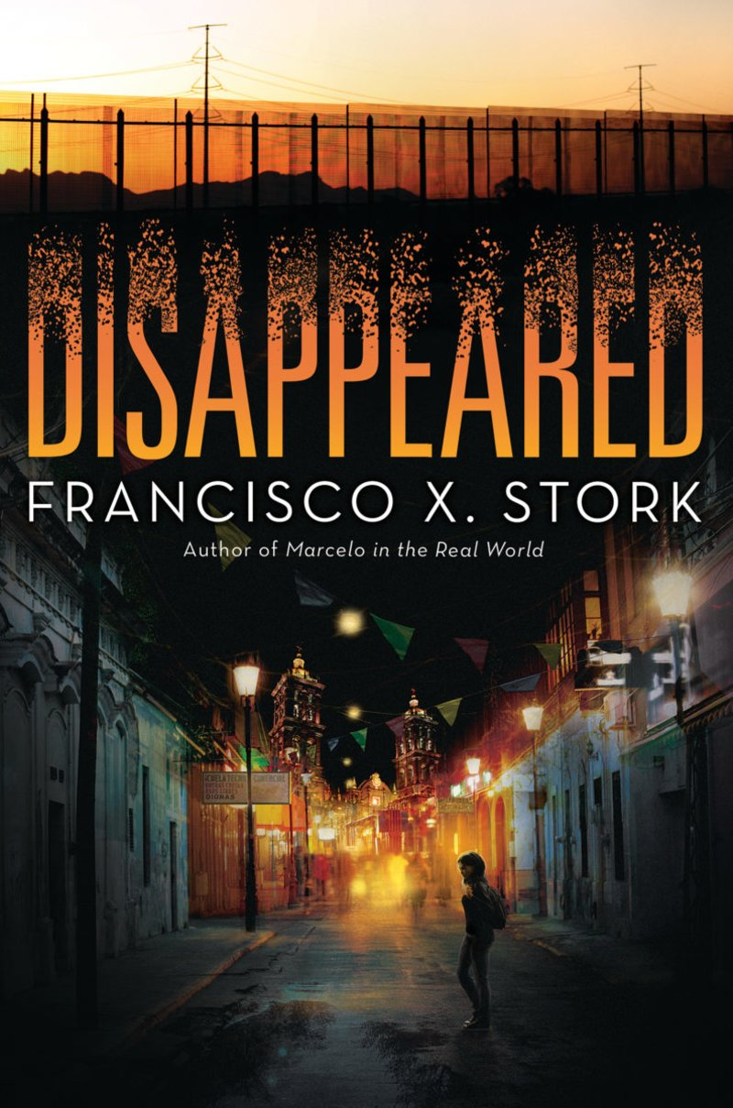

About the Author: Francisco X. Stork

Francisco Stork has an inspiring and unique life story. His parents are from Tampico, Mexico but he was born in Monterrey, Mexico. The reason being is his father sent Stork’s mother to a convent in Monterrey to give birth. She was supposed to give him up for adoption, but changed her mind and kept her baby. After a couple years, his mother married a Dutch man named Charles Stork. Charles Stork adopted Francisco and raised him like his own child. Because Charles Stork was an American citizen, he acquired Francisco and his mother visas and thus moved to El Paso,Texas.

After Charles Stork passed away in an accident, Francisco and his mother decided to remain in America. Francisco Stork excelled academically, and earned an all-expenses-paid scholarship to Spring Hill College. He studied English Literature and Philosophy, and later received another scholarship to attend Harvard University. At Harvard he studied Latin American Literature, but felt dissatisfaction with the curriculum being taught. He then went off to Columbia Law School, and practiced law for 33 years. He retired in 2015, and now resides in Boston where he dedicates his time to writing.

In Disappeared, Stork writes about the themes of parental involvement, family dynamics, and friendship conflicts. Stork mostly writes YA Literature, and some of his other works are: The Way of the Jaguar, Behind the Eyes, Iresis, The Memory of Light.

Author website: (https://www.franciscostork.com/)

Summary
The novel Disappeared takes place in Juarez, Mexico, and shares the hardships of a brother and sister who are targeted by an evil cartel group. Cartels often kidnap women for sex trafficking, thus Juarez has a high rate of missing women. Sara is a young editor at El Sol, a local newspaper company, and has her own column called “Desaparecidas” (The Disappeared). She writes about the missing women in Juarez, and became passionate after her best friend went missing. A cartel group sends her anonymous death threats advising her to not publish anything about her missing friend. Sara’s boss forces her to stop writing about the “Desaparecidas” to avoid any real danger, however Sara remains devoted to finding Linda, which causes problems not just for Sara, but her family as well. Emiliano is Sara’s younger brother, who struggles with the divorce of his parents. When Emiliano was younger, his father promised him to start a business together so that they could be well off. When Emiliano’s father immigrated to America, he felt as if his father abandoned him. Because of this, Emiliano feels as if he needs to be a better man than his father and provide for his family. In order to provide the world for his family, he must decide whether he wants to achieve success the right way or the cartel way. In the end, Emiliano and Sara must face their own fear and do what they think is best for their family.

Text Complexity
Quantitative
Lexile
- Ages: 13-17
- HL710L

Dale-Chall
- Grade Level: 9th-10th
- Raw score: 3.7577
- Final score: 7.4

ATOS
- Level: 4.6
- Interests: 9th-12th
- AP Points: 12
- Rating: 3.5/4 stars

The language in Disappeared is fairly easy. The Lexile exam scored it “High-low,” which is what they label books that are for students who do not care for reading. Stork may have done this on purpose in order to represent teens that are immigrants and may not have a high reading level. The language is definitely simplistic, but the themes discussed in the novel are what elevate the story.

Qualitative
Because Disappeared brings awareness to many drug-related social issues, younger teens may not grasp the complex message Stork writes about. Other topics discussed in the novel include: rape, immigration, addiction, and crime. These themes demand a better understanding of what is going around globally, which is why upper level students will have an easier time connecting with this novel. Compared to a middle school student, an adolescent who is 16 is more likely to deal with problems similar to Emiliano or Sara.

Teaching in the Class
#1: Emiliano’s father sends him a lot of letters since he does not want to talk over the phone. I would have my students write a letter to someone they regret losing – this can be a friend, a lover, a family member, or even a pet. In the letter, I would ask them to try and help the other person see the situation from their perspective. No pointing fingers, no judging, just explaining how they think the situation happened that caused them to stop talking. Then I would ask them to either send the letter to the person, or keep it sealed in an envelope like most of Emiliano’s letters. I think writing is a great form of expressing things that are difficult to verbally state. This assignment can help a lot of students express grief that they feel they cannot verbally say.

#2: Sara is an editor at El Sol, and has her own column “Desaparecidas.” I would ask my students to write their own column on something they are passionate about. I would encourage them to research, just like Sara, in order to learn more information on a topic they like. This is a great way to teach students how to do research, and what sources they should find credible.

#3: The book is written in diary style, and it is over the course of about five days. I would ask my students to keep a journal for five days, and write about difficult decisions they had to make that day. Students face these decisions almost everyday, especially in high school, and this journal would be a great way to keep track of their hard work. I would encourage them to write about family, about friends, and about school. This will help validate students and their everyday struggles.

#4: Brother Patricio presents Sara and Emiliano a map of the national park, which illustrates how to cross the border safely. I would assign students a different location on the school campus (gym, main office, lockers), and ask them to draw a map that guides another student their safely. The trick is they cannot write anything on the map, they could only draw lines or buildings. This is a great way to show students how difficult it must have been for Sara and Emiliano to find their way around the desert.

Applying Adolescents in the Search For Meaning
Chapter 4: Books About Real-Life Experiences
Although many teen readers do not know exactly how dangerous Juarez, Mexico truly is, they can relate to the inner conflicts that Sara and Emiliano battle through. Emiliano feels abandoned by his father when he immigrates to America, and feels like he failed to meet his promises. Many teenagers feel this resentment towards their parents when they divorce because they are too young to comprehend the complexity of marriage. Emiliano depicts the burden that many teenagers carry with them after family separation, and he shows the reader how to grow from that burden.
Sara’s inner conflict is deciding whether or not to follow her instinct. After receiving death threats, Sara must decided whether she stays lowkey or keeps searching for Linda. Everyone, not just adolescents, faces this type of problem at some point. Teenagers learn from Sara’s story how to deal with these difficult decisions, and how to cope with the aftermath of their decision.

Chapter 5: Books About Facing Death or Loss
Sara has lost her best friend, literally. Although Linda does not die, Sara struggles dealing with her disappearance. Sara is a tough situation because the police department in Juarez is corrupt, and ran by the cartel. Instead of Stork depicting her as a depressed person, he portrays her as a strong and devoted woman. Sara never loses hope that her best friend is alive, and is able to prove to everyone that she is right. Her determination inspires the reader to deal with loss in a productive way instead of simply lamenting.
Again, although Emiliano does not physically lose his dad, he does lose the strong relationship he had with his father. Emiliano actually does go down the wrong path, and commits crime as a means of revenge. He joins the boys club “Jiparis,” which guides him through the right path, but because Emiliano does not know how to deal with his loss he steers towards evil. Emiliano portrays to young readers what might happen if they never learn how to deal with loss in a way that is not self-destructive.

Chapter 6: Books About Identity, Discrimination, and Struggles with Decision
Emiliano is hurt by his father’s absence and wants to prove to his family he could be a better man. Through connections, he meets a drug-lord who promises him protection and business. Emiliano dreams of buying his mother a home, and Sara a car so that she can always be safe. However, he knows that working for the cartel is not the correct way of earning money. Because of this, Emiliano struggles with deciding whether or not he truly wants to work for the cartel; he feels pressured to make the right decision. Many teenagers are constantly pressured by parents and peers to make the right decision, and thus can relate to Emiliano’s conflict.
Sara also struggles with decision-making. Sara knows that if she continues to search for clues about Linda, the cartel will find out. She worries that if she goes against the orders of the cartel, her family will be in danger. However, if she stops looking for clues, then her best friend, who can potentially be alive, will die. This struggle is relevant to older teenagers because friendships are so important to them. By choosing her friend, Sara depicts just how important Linda is to her; she is as important as family.

Chapter 7: Books About Courage and Survival
In part two of the novel, Emiliano and Sara are forced to cross the border after the cartel raided their home. In this section of the book, Emiliano grows a lot and takes the lead. He is the one who is experienced at hiking trails near the border, and thus Sara depends on him for safety. Throughout the entire journey of crossing the border, Emiliano gives tips about survival to Sara. He illustrates how to climbs mountains, how to stay hydrated, and how to remain calm. Emiliano definitely embodies courage and survival in part two of the book because of his experience with nature; without him, Sara could have not crossed the border without a coyote.

3 Quotes and Their Significance
#1: “I wanted to talk to you tonight but you didn’t want to come to the phone. I don’t write very good. But I am still your father, even if you don’t think so. Your mother told me about the shoplifting and how you were caught. Why Emiliano? Because you are angry at me? Why do you want to hurt your mother and sister and your future just because of me…” (113).
After Emiliano meets up with Mr. Esmeralda, a drug-lord, he rushes home to open this letter. This is the letter that Emiliano’s dad sent him after he filed the divorce papers. This letter plays an important role for Emiliano because it is the letter that prevents him from committing to the cartel. Emiliano wants to fulfill the promises that his dad did not, which is to buy a house for his mother and protect Sara. He sees the life and riches that Mr. Esmeralda has, and he feels like the only way to fulfill these dreams is by joining the cartel.
However, he knows that working for the cartels would be the dirty way of earning money. The reason why this letter is significant is because Emiliano is trying to look for guidance in order to help him make the right decision. He knows he cannot ask his mother or sister, so he searches for any clue that will reassure him that he should not work for the cartel. This is Emiliano’s turning point because after reading the letter, he grows angrier towards his father. He is angry that his father has put him in a situation in which he has to choose between right and wrong. He is angry that his father did not choose the right thing, and simply left them behind. Without this letter, Emiliano may have agreed to working for the cartel right when he was proposed to.

#2: “Mami shuffles away as fast as she can while Sara puts on her sneakers. She runs to Emiliano’s room. He’s lying on the floor in total darkness. He looks up, shielding his eyes, when she turns on the light. ‘We have to get out of the house! I just got word that the people who threatened me are on their way here,’” (203).
In this scene, Sara has just discovered from Ernesto that the cartel is on their way to raid her house. This is significant because Sara is given no time to think about her next decisions. There is no time to think about anything except where to run. After receiving many death threats, a real one was finally happening to her. I don’t think Sara ever realized just how scary the cartel is until this point because she never anticipates their arrival.
Instead of freezing, and not taking charge, Sara takes the role of a caregiver and protects her family. She stays strong in order to help her family remain calm. This scene also leads to the conversation of immigrating to America. Sara’s mom confesses that she has spoken to their father, and he is willing to find them once they reach El Paso. Texas.

#3: “’Okay,’ he says, tightening the strap that connects his backpack to his waist. ‘I’m going to start walking at a pace that covers four miles per hour while the sun is still low. Then when the sun gets a little stronger, we’ll stop and wait for the sun to go down. We’ll go slowly the first day while your legs get used to walking and your back adapts to the weight of the backpack. Then maybe tomorrow we can go faster. Drink some water. You need to drink a gallon of water each day…’” (260).
This quote comes from part two of the novel. In part two, Emiliano shows tremendous growth and takes the role of a caregiver. Because he has experience with survival, he details to Sara what she has to do in order for them to be successful. Here, Emiliano does not seem afraid of anything, instead he seems fearless. He has learned all of his survival tactics from the “Jiparis” boys club, so his confidence motivates Sara to keep pushing through their journey.
Emiliano’s intelligence makes him seem older than Sara in part two. Sara almost seems like a little girl because she cannot keep up with Emiliano during their walk. I think it’s Emiliano’s burden that forces him to grow at such a young age because he sees how much evil runs the world. When a young person is exposed to that much evil, almost all of their innocence is taken away. His anger towards his father, and the riches he sees with Mr. Esmeralda is what transforms Emiliano from an honest person to a confused soul.

Rationale

Emiliano struggles coping with the divorce of his parents. He blames his dad, and is angry at him for not fulfilling their dreams. Many teenagers relate to this same conflict, especially with how high the divorce rate is in America. Emiliano also feels pressured to join the cartel to provide a better life for his family. Many first generation teenagers also feel this pressure because of all the sacrifices their parents have made to give them a better life. When I was in high school I always felt like it was up to me to be successful to help my family better. Reading Emiliano’s story reminded me of what my goals are, and how I still feel that pressure even though I am an adult now.
Furthermore, Sara embodies hope and devotion. Even though her best friend was kidnapped, Sara never loses hope that she will find her friend one day. Her determination is what helped locate her friend, and is what helped her find the park ranger at the end. She teaches young adult readers how to remain true to oneself by making hard decisions.
Disappeared is one of the most creative novels I have read in a while. I think Stork does a phenomenal job of bringing awareness to issues that young adults might not know a lot about. Cartel crime is still a huge problem the city of Juarez, Mexico faces, and Stork presents those problems in a unique way that helps American teens connect to. Although this story is about two Mexicans who struggle with drug corruption, the characters face many problems that teenagers face in the real world. This book depicts, how even though teenagers are from different countries, everyone goes through similar problems.

