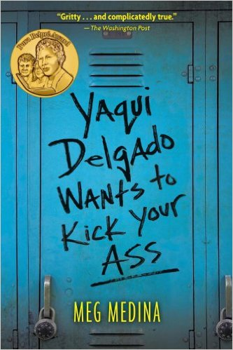
https://static1.squarespace.com/static/53b2d482e4b058cbcb895e6b/58cd6979be6594524c635589/58b0b98759cc684cc86e4bca/1489938582962/yaquidelgado.jpg?format=750w

By Meg Medina
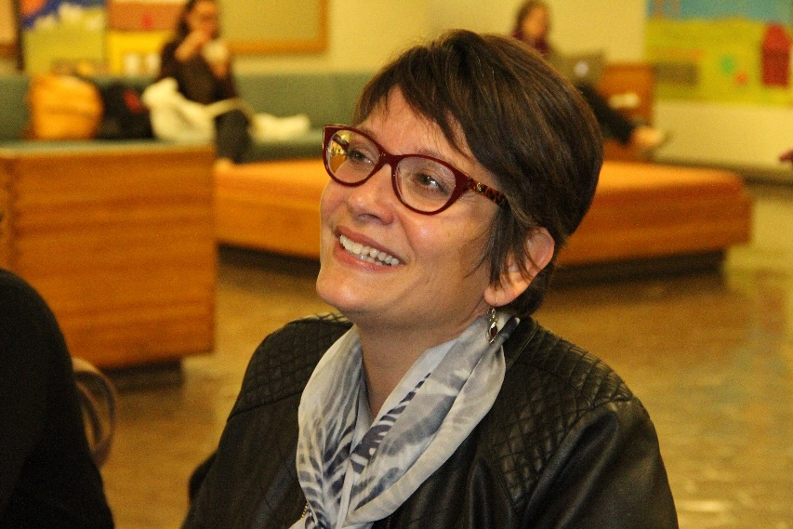
https://megmedina.files.wordpress.com/2017/08/img_6654.jpg

About Meg Medina
Meg Medina is a Cuban-American writer of young adult fiction born in Alexandria, Virginia, but she grew up in Queens, New York. Meg Medina is a Newbery and Pura Belpré award-winning author of picture books, middle grade, and YA fiction. She is the author of Merci Suarez Changes Gears, which won the 2019 John Newbery medal and the 2018 Charlotte Huck honor. Her other books include: Burn Baby Burn, Yaqui Delgado Wants to Kick Your Ass, and The Girl Who Could Silence the Wind. Her picture books include Mango, Abuela and Me, and Tía Isa Wants a Car. For more about her, visit her blog at https://megmedina.com/.

Book Synopsis
This 2013 Cybils and Pura Belpré award-winning novel features 15-year-old sophomore Piedad “Piddy” Sanchez, who has recently moved with her single mother and has to attend Daniel Jones High School in Queens. On top of that, her best friend, and former neighbor, Mitzi has moved to Florida. She is not like the other Dominican or Cuban girls at her school; she is light-skinned, nerdy, and she doesn’t talk like them. Five weeks into the schoolyear, one of the girls there tells her that Yaqui Delgado wants to fight her. She's initially confused, as she doesn’t know who Yaqui is at first. She's informed that Yaqui hates everything about Piddy, as she thinks that she's stuck-up, a show off, and want to steal Yaqui's boyfriend, Alfredo. Yaqui and her friends bully Piddy verbally and physically, to the point that she’s scared to leave her home. Also, Piddy is curious about her father’s identity but since her mom doesn’t want to speak about him, their relationship becomes strained, which makes Piddy feel more alone. Piddy falls for a childhood friend, Joey, who also lives in a troubled home that includes an abusive father. He and her mother’s best friend, Lila, attempt to help her in the only ways they know how. Ultimately, she realizes that she has to make her own decisions and figure out how to deal with her life on her own terms; ending with a hopeful conclusion that one has to read to discover.

Major Quotes
“Ma doesn’t know it, but I’m going to be a scientist. I want to work with animals, big ones like elephants, maybe even live halfway across the world… what kind of decent girl is interested in elephants” (17-18).
Significance: This quote is central to Piddy’s initial feelings about not being able to truly fit in, even when it comes to her mother. She knows that she is smart and driven enough to reach this goal but she knows that her mother will not find it proper to do what she wants to do. This is important because it makes it difficult for Piddy to find herself in a world where she is not even fully accepted or supported by her mom.
“When I was little, I played a private game called Who’s Papi? I could play it anywhere… and ushered me away” (38).
Significance: This excerpt from the novel is significant in that it deals with an issue that is common in many girls in this country. Many children are subject to be raised by a single parent and are left wondering what might have been if the other parent was there too. Especially in a teen like Piddy who is trying to figure out who they are in the world, it is difficult to realize that with one half of their parents missing. This, coupled with everything else Piddy is dealing with, simply complicates her life in a major way.
“’No pierdas la clave,’ she whispers to me… strong and simple, constant and mine” (260).
Significance: This piece from the book includes Piddy’s final remarks as she sets on for a hopeful, happier future. She has concluded a difficult part of her life and although there may be more ahead, she now feels surer of who she is; in large part due to her repaired relationship with her mother. As they dance together, she feels confident and says some of her most optimistic words in the entire novel. She has finally found herself.
In the Classroom
This book would fit best with high school students, especially because the novel is sent at a high school and deals with the troubles of a fifteen-year-old student. As an activity, I may ask students to raise their hands if they have ever been bullied, been the new kid at school, raised in a Latinx home, or has simply felt that they don’t belong. With this as an introduction, I would be able to split these topics up between groups of students and have them find evidence in which these issues surface in the text. Finally, I would bring the class together and see where these themes may overlap.
Teens should definitely read this book because it deals with real-life issues that many teens face on a daily basis. It would fit perfectly with chapter 4 of Adolescents in the Search of Meaning: Tapping the Powerful Source of Story because of the real-life experiences that come through the text. Issues such as bullying, acceptance, isolation, perseverance, and single-parent households are all brought forward in this excellently written novel. Teens may see themselves in Piddy not only because she is Latina, but also because she struggles with the same problems that most kids face.
Text Complexity
Lexile Level: 850L Ages 14-18
This text deals with harsh topics such as abuse, physical violence, and some discrimination as well as vulgar language which may only be suitable for students with a slightly more advanced skill level.
Dale-Chall: 5.7 Grades 5-6
A fifth or sixth grader may read this and understand what the text is saying but might not necessarily understand the depth of the issues at hand in this novel.

ATOS: 4.3 Upper Grades 9-12
The text is easily readable through its somewhat uncomplicated vocabulary but the subject matter is difficult enough for older students to understand and analyze at a much deeper level.

