The Fault in Our Stars  by John Green  From Peter Van Houten...  “Were she better or you sicker, then the stars would not be so terribly crossed, but it is the nature of stars to cross, and never was Shakespeare more wrong than when he has Cassius note, “The fault, dear Brutus, is not in our stars / But in ourselves.” Easy enough to say when you’re a Roman nobleman (or Shakespeare!), but there is no shortage of fault to be found amid our stars” (111-112). | 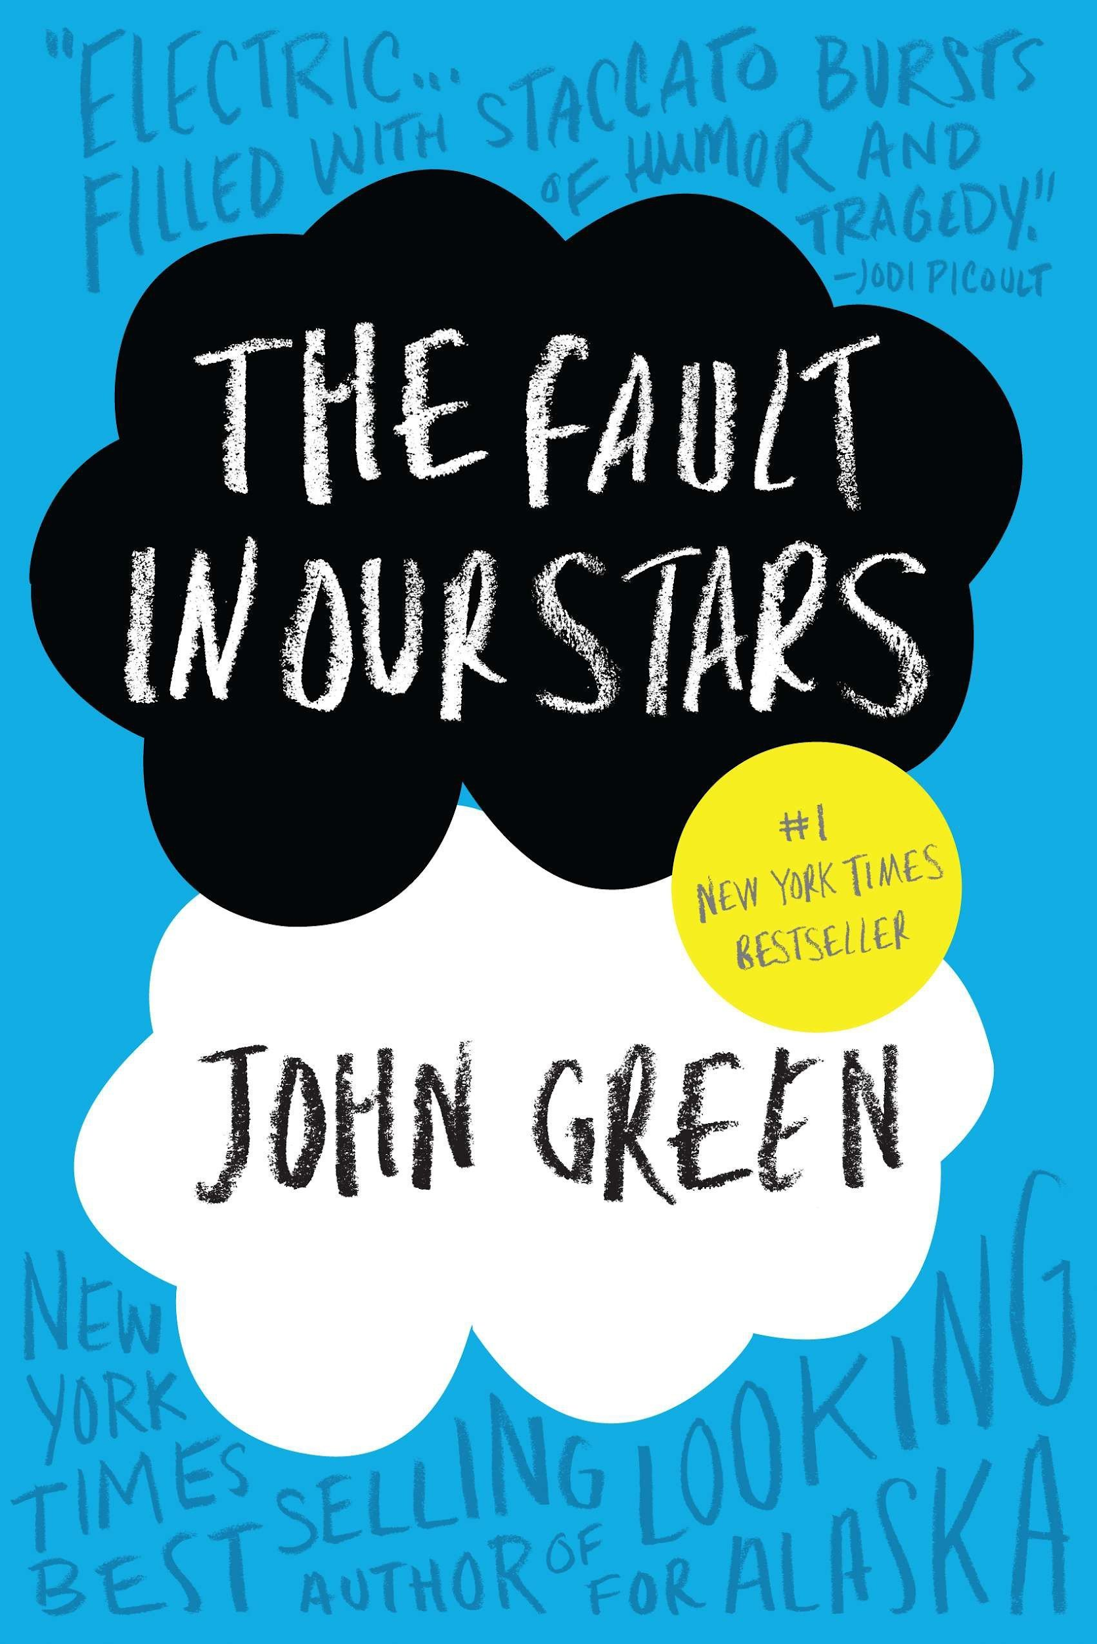

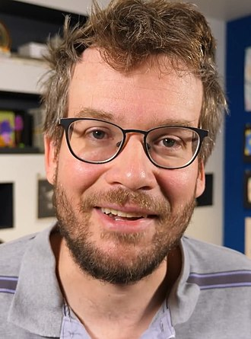  https://www.johngreenbooks.com | John Green  is a contemporary bestselling YA author who spent his childhood constantly moving: from Indiana to Michigan, Alabama, and finally Florida. Over 24 million of his novels have been sold, and he has been published in at least 55 languages. Green has published three bestselling novels, including Looking for Alaska (2005), An Abundance of Katherines (2007), and Paper Towns (2008). Green has been credited with changing the expectations of YA Fiction in the 21st Century, “ushering in a new golden era for contemporary, realistic, literary teen fiction, following more than a decade of dominance by books about young wizards, sparkly vampires, and dystopia” - Wall Street Journal.
Summary

Hazel Lancaster is seventeen years old with lung cancer, unable to live a “normal” teenage life. At support group, she meets the handsome and charming Augustus Waters. Hazel finds herself resisting falling in love for fear of hurting him when it is time for her to die.

Hazel spent years writing unanswered fan mail to the author of An Imperial Affliction, Peter Van Houten, to find out what happens after the protagonist's death. Augustus sacrifices his “Make-A-Wish,” but Van Houten is hateful and drunk. Hazel is disappointed that he has no answers, then discovers Augustus has relapsed.

Augustus’ cancer gets progressively worse until he dies, before Hazel. Van Houten reappears and tries to give Hazel the answers she sought, but she no longer wants to know. The book ends with a eulogy from Augustus, telling Hazel that getting hurt is inevitable, but he was happy with the choices he made.

The Fault in Our Stars Quotes
Chapter 6  “I’m like. Like. I’m like a grenade, Mom. I’m a grenade and at some point I’m going to blow up and I would like to minimize the casualties, okay?” (99)  Here, Hazel argues with her parents that she has no feelings for Augustus Waters. Throughout the novel, Hazel feels guilty for the lives that she is going to harm when she dies, and it prevents her from living while she can. The likeness of Hazel to a “grenade” that is eventually going to inflict pain on all the people she loves is powerful imagery. Have you ever felt guilty for something outside your control? Have you ever felt like a burden?  Chapter 11  “The thing about dead people,” he said, and then stopped himself. “The thing is you sound like a bastard if you don’t romanticise them, but the truth is...complicated I guess [...] cancer kids are not more likely to be awesome or compassionate or persevering or whatever” (173).  In this passage, Augustus rejects cancer cliches. This quote resonates with much of the feelings Hazel struggles with: not wanting to be pitied; However, it captures how complicated this ideology actually is. Even with Hazel’s strong beliefs against her loved ones giving up their lives for her, she finds herself perpetuating this same care onto Augustus as he falls ill and dies. Have you ever fit/not fit into a cliche? Have you ever felt obligated to be someone? | Chapter 25  “You don’t get to choose if you get hurt in this world, old man, but you do have some say in who hurts you. I like my choices. I hope she likes hers.” (313).  In the final chapter, Augustus has written a letter to Van Houten about Hazel. This quote is significant because it allows Hazel to free herself from her guilt about the pain her death will cause for others. The idea that she cannot live because of her impending death is disproved by Augustus, who never restricted himself from love or life simply due to the knowledge of loss. Hazel did not regret loving him even though she ended up losing him. Have you ever lost someone you loved? Have you ever experienced family or friends suffering from illness?

Why Teens Should Read This  Exeter Quality #3: Even out of school, the characters in this novel share similar experiences to many teen readers of finding themselves and of first relationships. Additionally, Hazel is a strong female protagonist.  Exeter Quality #4: The life of a teen with cancer is a unique experience that will broaden the perspectives of many young adults.  Exeter Quality #5: The text difficulty is not patronizing while not overly complex, and introduces many literary, philosophical, and psychological references that would be enjoyable to learn about as a teen reader.  Use This Book in a Classroom  - Therapeutic writing! Write about a time you felt like or unlike a cliche. How can we cope with these feelings after reading The Fault in Our Stars?  - Letter Writing! Write a letter telling Van Houten about someone you know. Describe their qualities, what he should know about them, etc.  - Write creatively about a metaphor or symbol in this novel! (The grenade; water; the cigarette…)  Category from Adolescents in Search for Meaning  Chapter 4: Books About Real Life Experiences  Chapter 5: Books About Facing Death and Loss  Chapter 6: Books About Identity, Discrimination, and Struggles with Decisions | 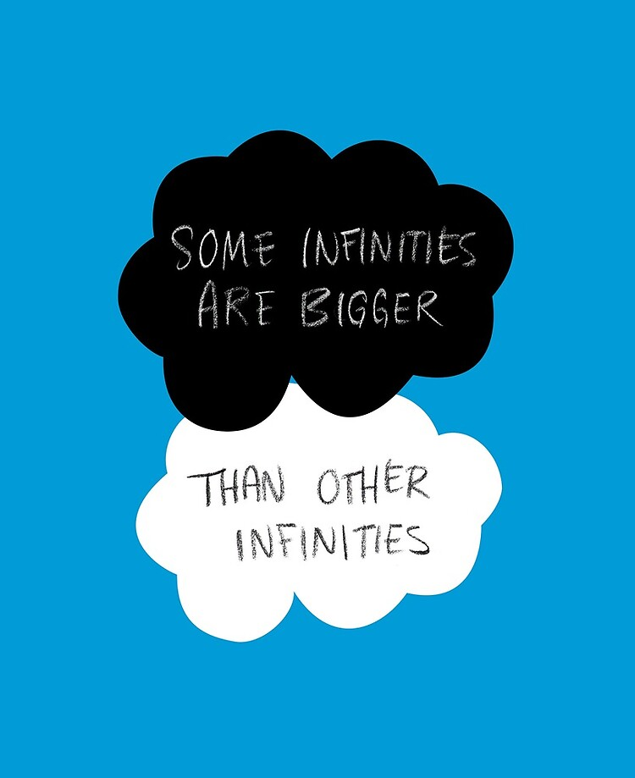(Green 260). Photo from pinterest.com  Text Complexity: Dale-Chall Formula  Raw Score: 3.5921  Adjusted Score: (3.6365 + 3.5921)  Final Score: 7.2  Grade Level: 9-10 (freshman, sophomore)

