Joshua Cruz
Dr. Warner
ENGL 112B
17 May 2021

Unit of Study: Problem Novel About Identity
Rationale
Have you ever felt isolated despite having the entire world’s ear in your pocket? Technology presents us with a double edged sword: it has allowed greater numbers of people to communicate with each other, but it has also altered basic interpersonal relationships between friends and family. These blurred relationships alienate young adults in their most vulnerable time: a time when they’re seeking identity away from academics while also taking the first steps towards adulthood. While phones may be to blame, alienation has always been present since the turn of the 20th century, and as communication advances, young adults should be made aware that they are, won’t, and have not been alone in their predicament.
For this unit of study, I would like to talk about Catcher in the Rye by J.D. Salinger. Specifically, the character journey of Holden and his point of view. The novel largely deals with Holden searching for identity and truth after he is kicked out of school. Told from a first person point of view, it’s easy to dismiss Holden as a whiner, but there is a lot of honesty in his words.
I chose Catcher in the Rye because it’s the first novel that comes to mind when I think about highschool. Our class read it in senior year, and it couldn’t have come at a better time in our lives. Unlike 1984, which was the fear of a possible world, or The Great Gatsby, which was the fear of loss through the eyes of someone we couldn’t relate to, Catcher in the Rye grounds the reader into a timeless setting and relatable protagonist: Holden. We held his hand as he faced the same terrible truths and realities we were afraid of such as growing up or losing our identity.
After highschool, I read the novel again with a different mindset. I found Holden to be annoying and blind to the opportunities given to him; he’s a lot like Daria from the series Daria in the fact that you want to grab them by the head and tell them “it’s only going to get worse from here.” In short, I believed the same things as the adults did in the novel, and I would’ve likely been the subject to an hour-long rant from Holden’s internal monologue.
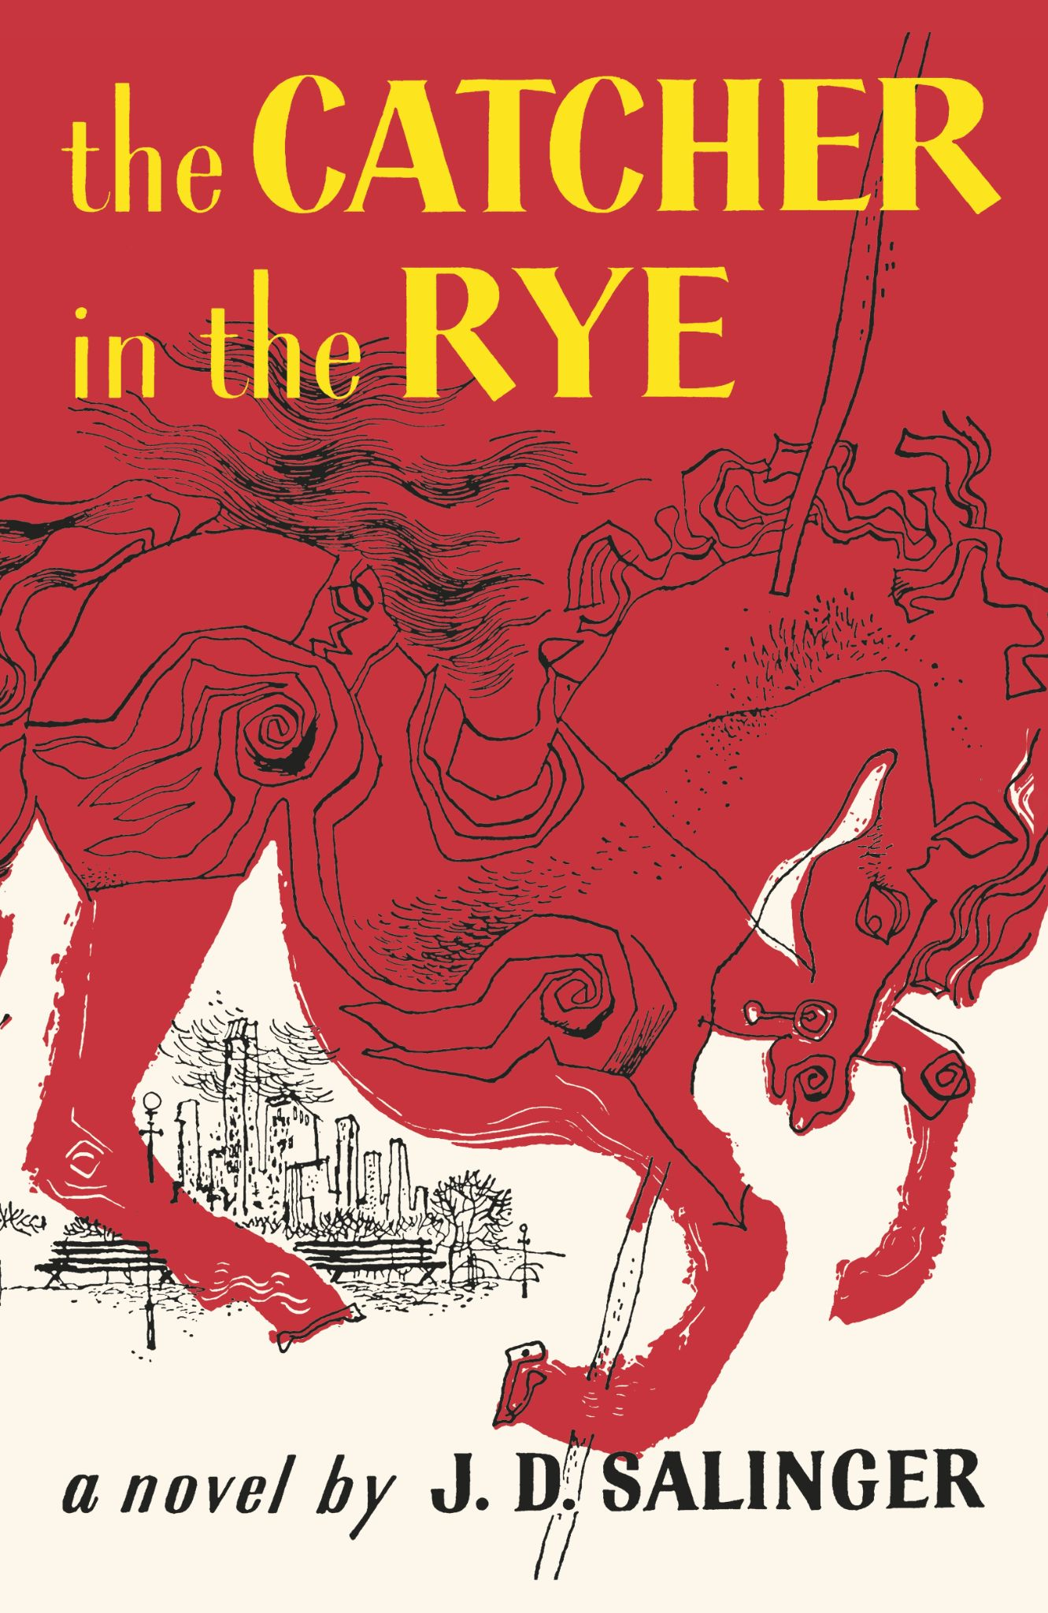
Yet, I recalled enjoying the book as a kid because I related to Holden on three levels: Holden’s failing grades, lukewarm reception to adults, and Holden’s articulation made me like the character. This empathy is why I want to teach my highschool senior class Catcher in the Rye; my hope is that they are able to see that they are not alone in their anxieties about graduation or adult life.

The Canonical Work
Catcher in the Rye, by JD Salinger, is the story of Holden Caulfield, a 16 year old drop out bumming around New York after embarrassment and failure in Pencey Prep School. Published in 1951, the novel is often taught in “many American high schools,” but it has also been banned for “salty language and sexual content” (Lohnes).
The novel itself is written in first person with Holden as the narrator. It’s suggested within the novel that he is in a mental hospital recovering from his time in New York. Readers will find that the novel completes most of the Exeter Qualities, evidence of a good problem novel, and the Honor Book List Characteristics. These are largely accomplished due to Holden’s honest opinion in narration, unique form of narrative grammar, and the main themes in the novel. Like many blooming young adults, Holden is afraid of adulthood because the adults in his life have all turned out to be phonies. Likewise, Holden is trying to hold onto his innocence after the loss of his younger brother and the complete alienation from his peers and family.

The Lesson Plan
Throughout the unit, the class will be given a reading log due at the end of the week. Each reading log will have the student analyze a quote, summarize the work, and/or relate the assigned chapters to anything that has happened in their life. Ultimately, the class should at least have some understanding of Holden’s characterization and motivation.
If there is any confusion surrounding the plot or intention of the novel, then the class will be allowed to watch Crash Course’s two-part video on the novel. Hosted by YA writer, John Green, Crash Course is perfect for visual learners, and Green is able to pack his videos with the necessary information. It’s also a good tool for learning Holden’s character and a little bit more about the author, Salinger (Green). The class will be assigned a small in-class assignment where they must write down five things they’ve learned from each video.
Additionally, students will choose quotes from the novel to share within class. They will then be given group work in the form of chosen quotes that they must analyze in class.
Finally, there is this quote:
“All the kids kept trying to grab for the gold ring, and so was old Phoebe, and I was sort of afraid she’d fall off the goddamn horse, but I didn’t say anything or do anything. The thing with kids is, if they want to grab for the gold ring, you have to let them do it, and not say anything. If they fall off, they fall off, but it’s bad if you say anything to them” (J.D. Salinger, 274).
The quote should be read out loud on the last day of study by one of the students. Each student will have some time to jot down what they believe the quote is about and share it aloud. Additionally, they should be asked a question: does Holden hold onto his innocence? If not, when did he lose it?
Continuing with the reading, there will be Brown Bag assignments throughout the assigned readings. Unlike the Brown Bag in ENGL 112B, which focuses on only items, students must also find a quote within the text that relates to the significance of the object. Volunteers will be chosen to present their Brown Bag items in class, and all Brown Bag items will be turned in alongside the reading log. The idea is to get the students interested in the motifs, symbolism, and other literary devices found throughout the novel.
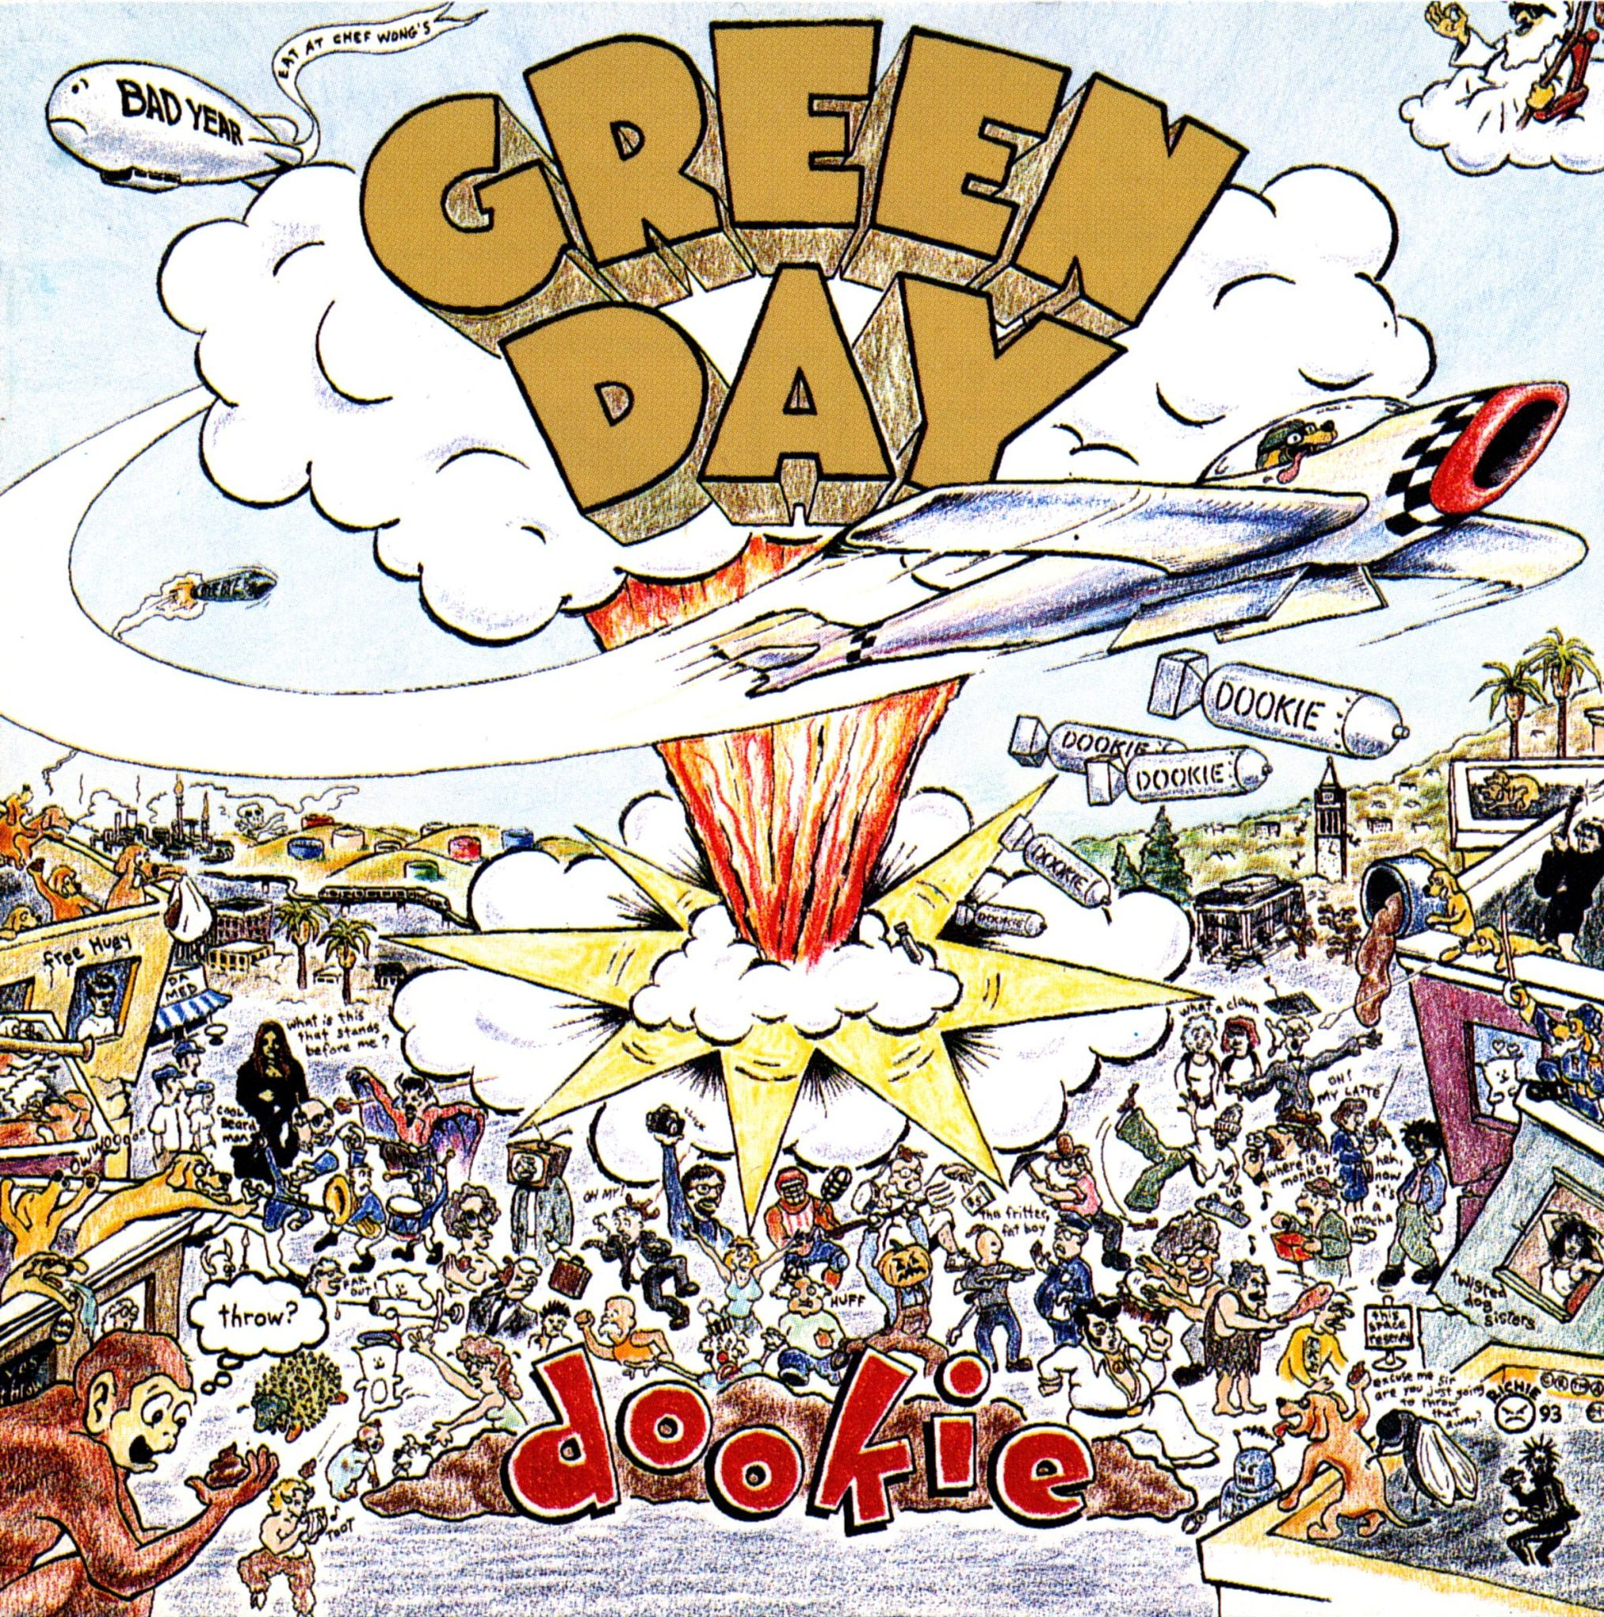
After reading the entirety of the novel, the students will now have the opportunity to analyze lyrics and TV show clips. Students will be given the opportunity to analyze the works to find the deeper meaning as well as compare them to events in Catcher in the Rye. They will also be expected to identify the major themes in order to finish the comparison.
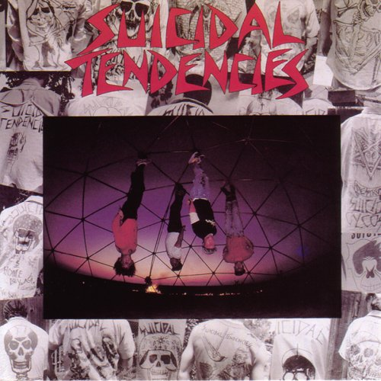
The songs that will be studied are Green Day’s Basket Case and Suicidal Tendencies’ Institutionalized. These punk songs revolve around a misunderstood young adult with similar vibes to Holden Caulfield. It’s the differences between the character’s motivations and authority figures that should be identified. Ask the students these questions: Are these narrators facing the same problem? Can you think of any other song with a narrator like Holden?
In terms of visual medium, students will watch an episode of Mike Judge’s cartoons, Daria and Beavis and Butthead. While not directly relating to Catcher in the Rye, Beavis and Butthead is “storylines centered on crude and often dangerous humor, as well as the duo ridiculing the world around them” (“Retro Junk”).Students will be asked to perform a collaborative creative writing assignment where they will write Holden as if he were two characters, emulating Beavis and Butthead, then volunteers will act out the scene.
They’ll also be asked to compare Beavis and Butthead to Holden Caulfield with two specific questions in mind: Are Beavis and Butthead innocent in the same way Phoebe was, and would Holden consider them phonies?
Daria as a more grounded character should inspire the students to answer this question: does Daria’s situation differ from Holden, and if so, what are the main points of divergence? Additionally, does the series Daria prove that a plot like Catcher in the Rye can be emulated in a visual medium?
Afterwards, students will be introduced to the comparative works.

Comparative Works
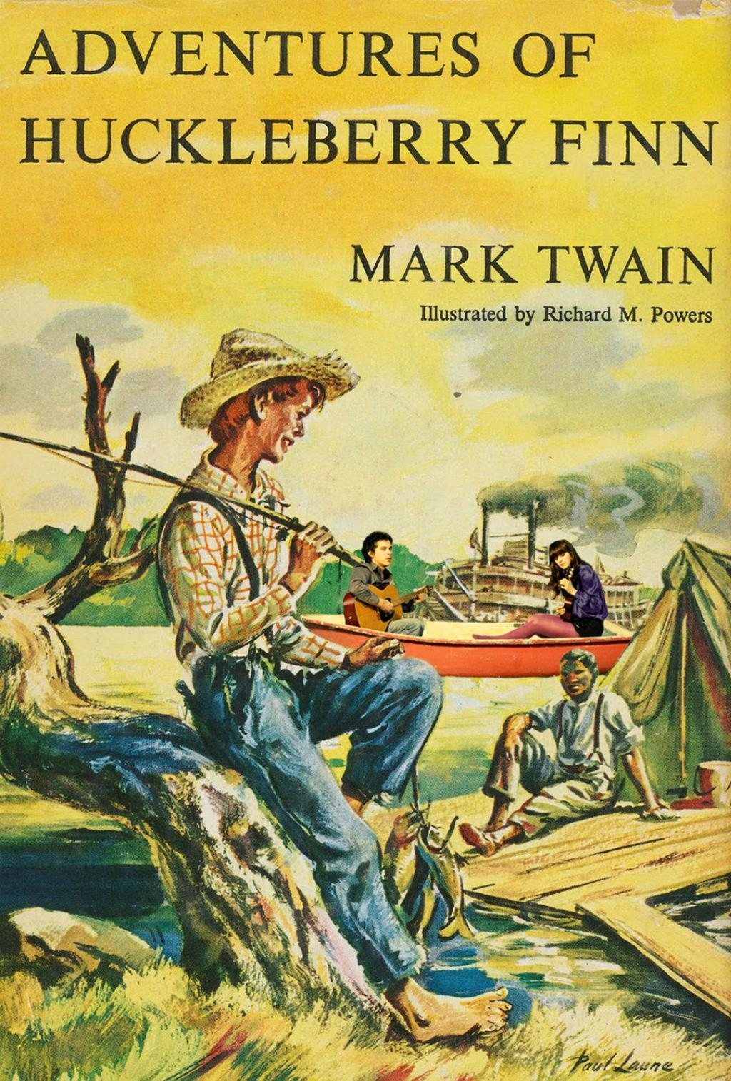
The Adventures of Huckleberry Finn by Mark Twain is a story about a runaway boy named Huckleberry Finn, an escaped slave named Jim, and their journey north. It’s a sequel to Adventures of Tom Sawyer, but it differs due to its more mature content. Likewise, the narrative is similar to Catcher in the Rye due to Huck’s narration and the theme of losing innocence in an increasingly dangerous world. It’s a great match for YA readers, especially since it covers the broader topic of abuse and family issues.
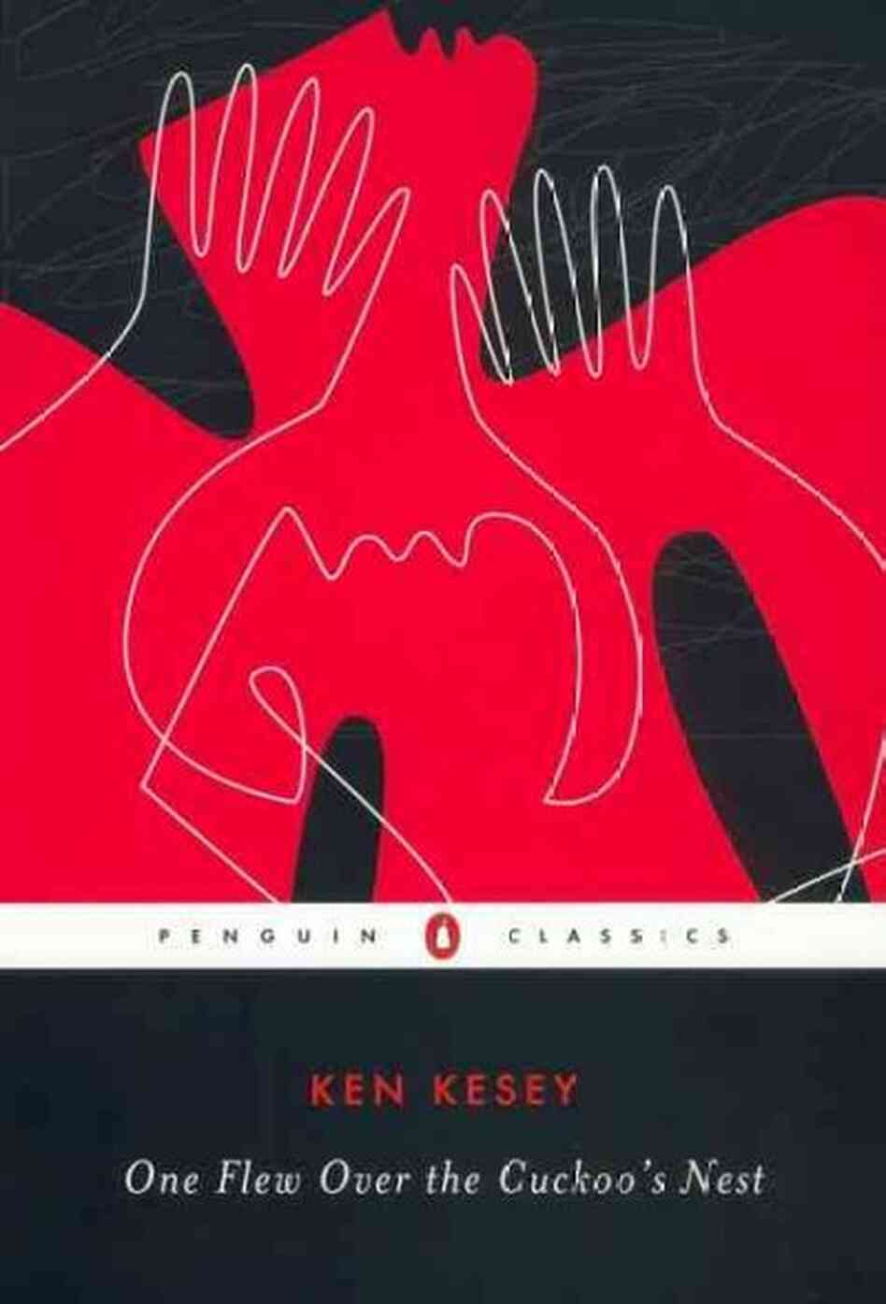
One Flew Over the Cuckoo's Nest by Ken Kesey is a novel set in an Oregon state mental hospital. While it’s narrated by a character named Chief, the story is about McMurphy, a conman who faked his way into the facility. There, he seeks rebellion against the authoritative staff, headed by Nurse Ratched. Chief and McMurphy can compare to Holden in two ways— Chief is discriminated because people believe he is deaf and dumb; this leads him to feel isolated from the people around him. McMurphy compares Holden because he incites the patients to realize their inner humanity, and in this way, he’s like Holden because he’s allowed them to retain their individuality from the darkness of the world.
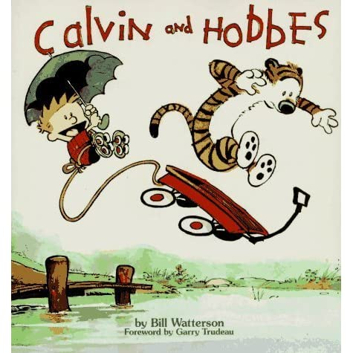
Calvin and Hobbes by Bill Watterson originates as a cult classic newspaper comic. The premise centers around Calvin, an intelligent elementary school kid who is often belittled by adults, and his tiger/only friend, Hobbes. The main source of entertainment, as well as Calvin’s philosophical notions, come from Calvin’s lack of restraint, his relationship to Hobbes, and his refusal to appeal towards authority. Calvin is like Holden: both have poor academic skills, both are subject to the opinions of adults, and both are able to analyze their situation to realize it. The difference between the two is that Calvin is still innocent and isn’t as jaded as Holden.

Concluding the Unit
By the end of the semester, students should have the ability to analyze and compare different works to Catcher in the Rye. Additionally, they should be able to identify the themes of the novel and compare it to their own reality. At the very least, students should understand and empathize with Holden’s fears as well as the major themes of the novel.
The major reason for why Catcher in the Rye should be taught lies in its relatability; this relatability holds especially true for young adults seeking to retain their innocence, and the work can help with anxieties about growing up in an increasingly isolated world. It’s also the reason for assignments to include group work and other sources of media— they show that these lessons are applicable to modern life because of the timeless and relatability of Holden Caulfield.
Finally, the class will end on a multiple choice quiz regarding the literary devices, plot, and themes of the novel. There will be one trick question to show the practical application of critical analysis and a few extra credit points for short answer questions.

Works Cited
Green Day. “Basket Case.” Dookie, Rant Records.
Green, John. “Language, Voice, and Holden Caulfield - The Catcher in the Rye Part 1: CC English Literature #6.” YouTube, Crash Course, 10 Jan. 2013, www.youtube.com/watch?v=R66eQLLOins.
Green, John. “Holden, JD, and the Red Cap - The Catcher in the Rye Part 2: Crash Course English Literature #7.” YouTube, Crash Course, 17 Jan. 2013, www.youtube.com/watch?v=LI1CusL7Ceo.
Kesey, Ken. One Flew over the Cuckoo's Nest: Text and Criticism. Penguin Books, 1996.
Lohnes, Kate, and Kathleen Kuiper. “The Catcher in the Rye.” Encyclopædia Britannica, Encyclopædia Britannica, Inc., 2011, www.britannica.com/topic/The-Catcher-in-the-Rye.
“Beavis and Butthead.” Beavis and Butthead | Retro Junk Article, Retro Junk, www.retrojunk.com/article/show/783/beavis-and-butthead.
Salinger, J. D. The Catcher in the Rye. Back Bay Books, 2010.
Suicidal Tendencies. “Institutionalized.” Suicidal Tendencies, Frontier Records, 1983.
Twain, Mark. Adventures of Huckleberry Finn. Flame Tree Publishing, 2020.
Watterson, Bill. Calvin and Hobbes. Sphere, 2014.

