Sherwin Aguilar
4/3/21

William Shakespeare’s: Tragedy of the Sith’s Revenge
Author Biography:
Ian Doescher is a Portland, Oregon native who happens to also live in Portland with his spouse Jennifer with their two children. Ian Doescher has a B.A. in Music from Yale University. As well as a Master of Divinity from Yale Divinity School. And even a PHD from Union Theological Seminary. His doctoral dissertation was titled “Virtue in the Key of Justice: Reshaping Christian Virtue ethics in light of White Supremacy.”

Mr. Doescher claims that he is only a Star Wars and Star Trek fan, and isn’t very well versed in any other form of science-fiction literature. The idea for William Shakespeare’s Star Wars came to him when he went to the Oregon Shakespeare Festival in Ashland when he finished reading the “Pride and Prejudice and Zombies” novel. He showed the first draft of what he created to Lucasfilm and they ended up responding to him, saying “We like this and it’s fun, but we’d like to see Ian do more with it. Go ahead and have some more fun with it, and go out of bounds of the movie itself.” When realizing he was given permission to go nuts and essentially rewrite the entirety of the original 6 Star Wars movies in his style? He didn’t give it a second thought and made all 6 of the original Star Wars movies from “A New Hope” and finished it off with “Revenge of the Sith”, all written as though it was a play made by Shakespeare himself.

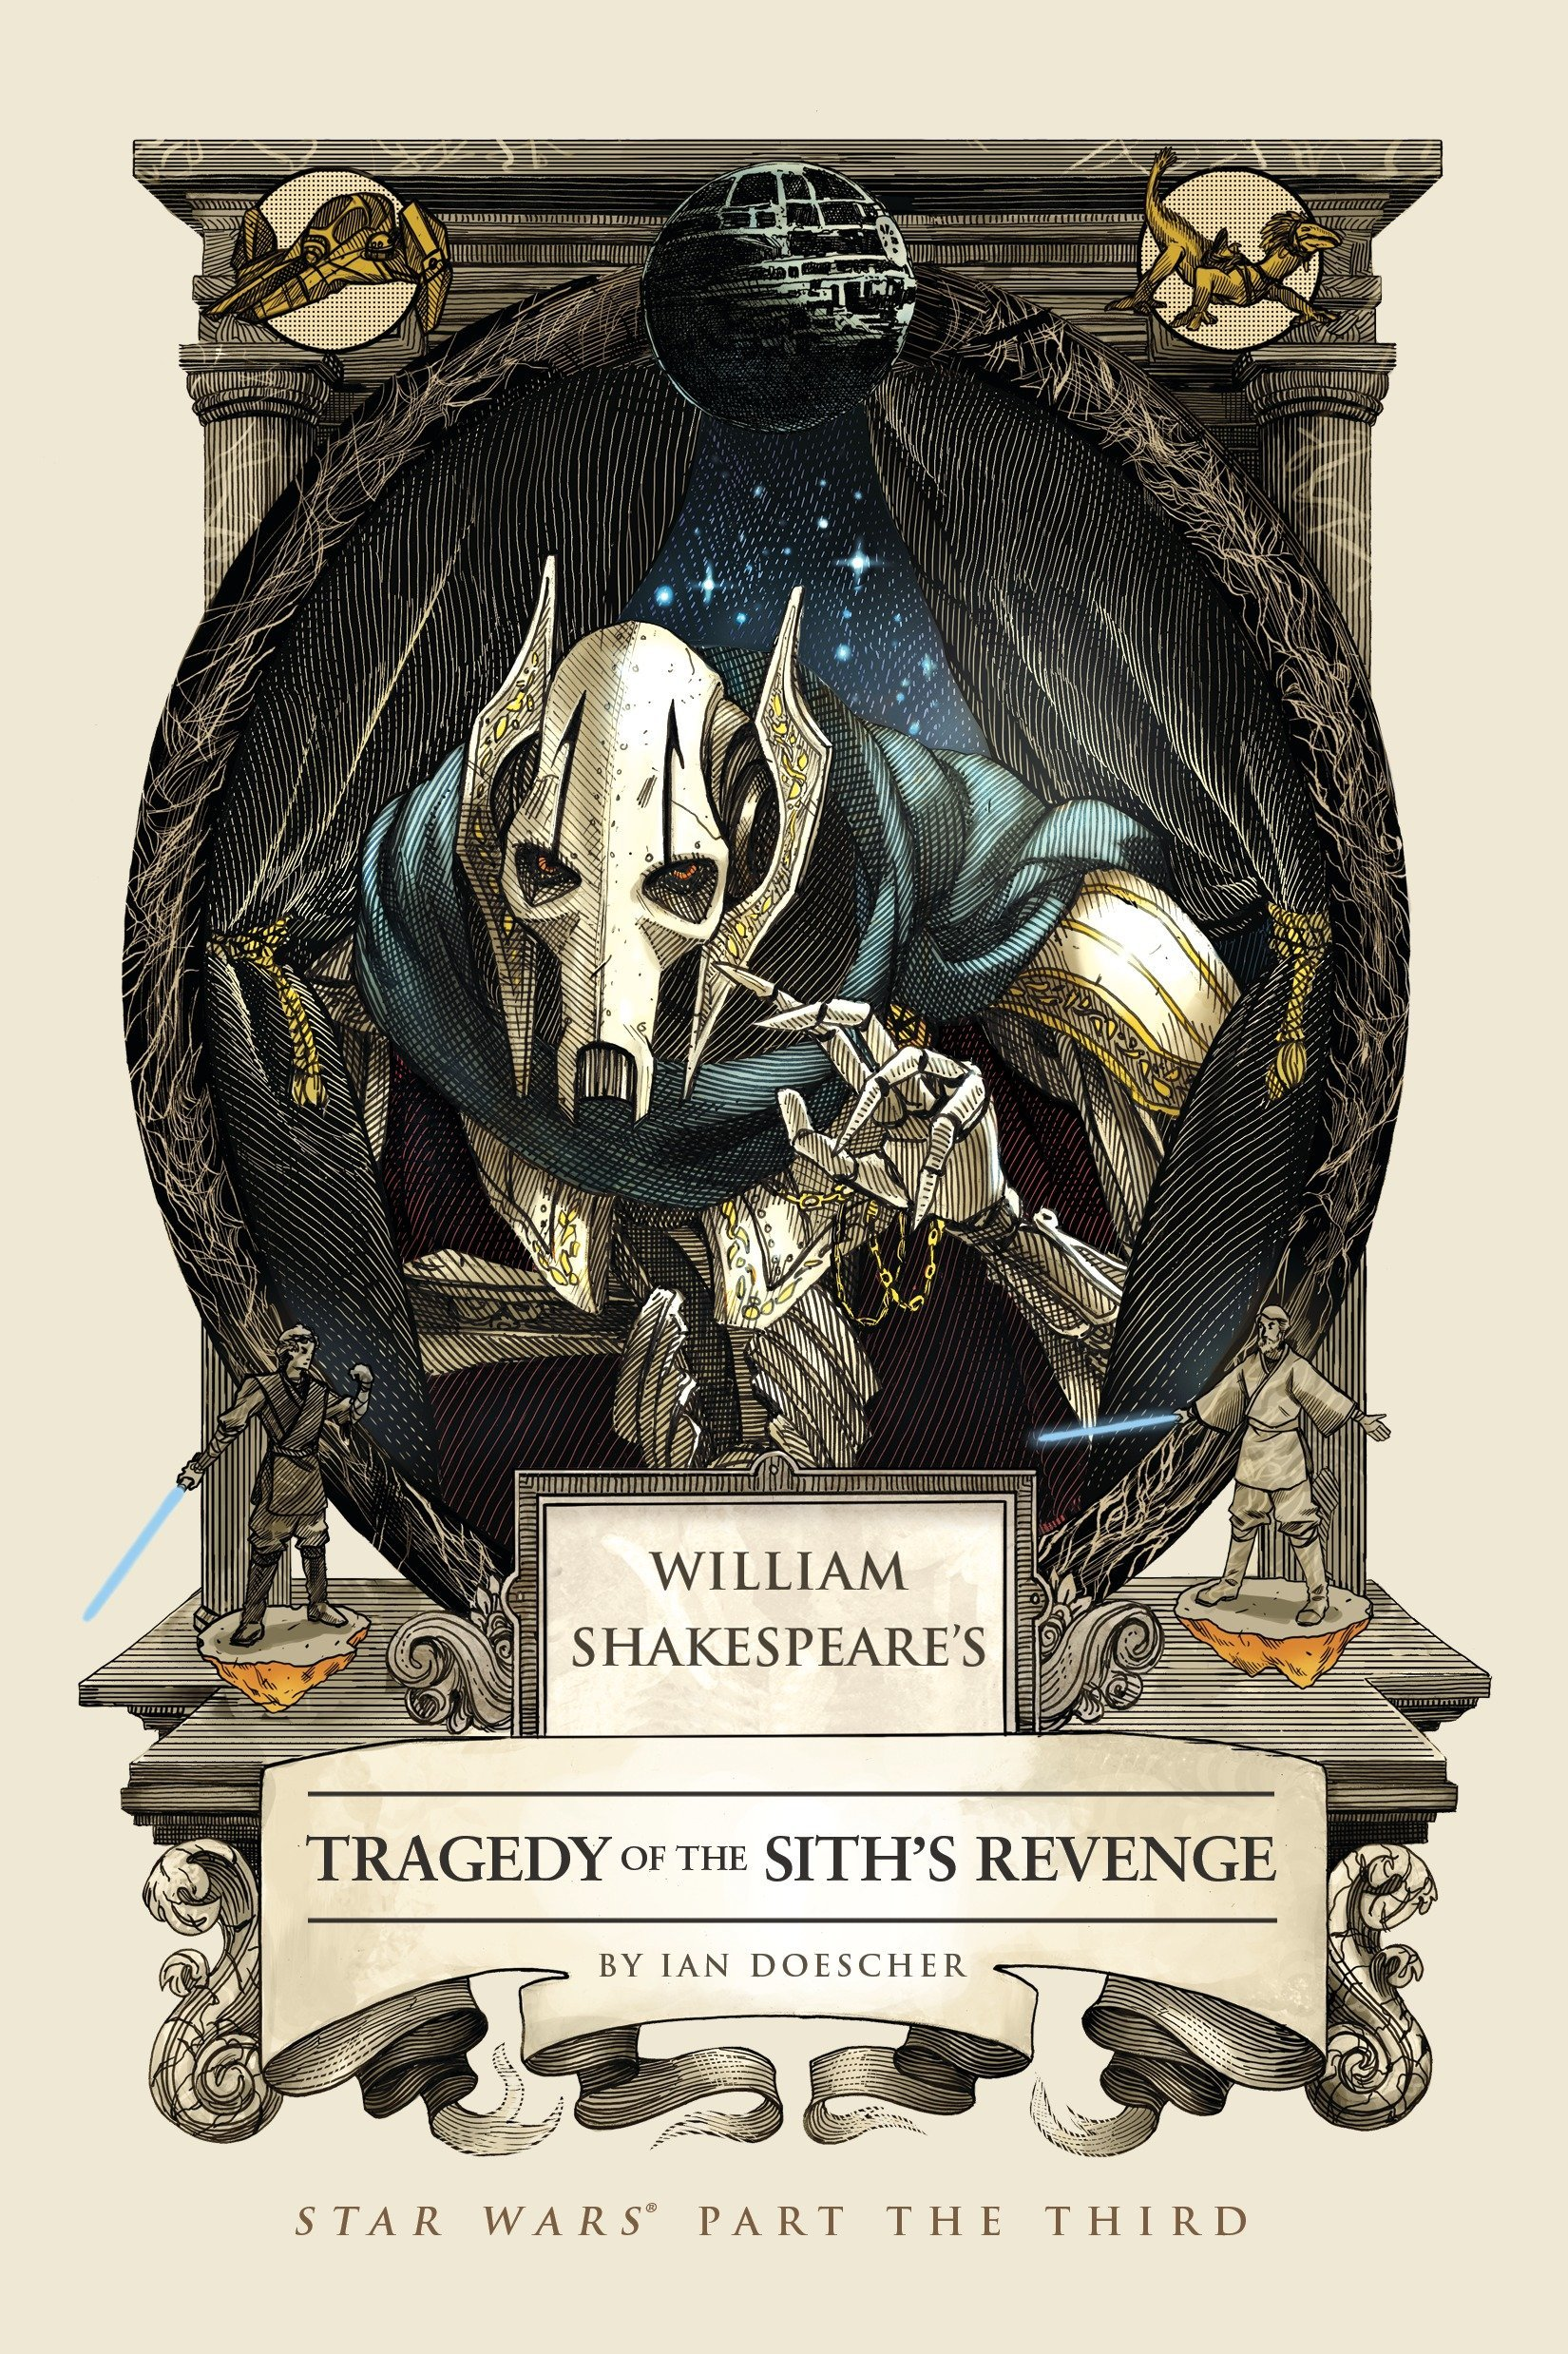
Summary
William Shakespeare’s Tragedy of the Sith’s Revenge is essentially a retelling of the entirety of the movie “Revenge of the Sith” but written in 5 act structure as though it was an actual play from William Shakespeare. Following the story of the characters of Obi-Wan Kenobi, and Anakin Skywalker and his descent into madness for not being able to have the strength nor the power to save the person he loves most, his wife. Who is also pregnant with his 2 children. The Tragedy of the Sith’s Revenge though isn’t simply just a retelling of the movie in an old play style, the modern day equivalent to this would be the Zack Snyder Cut for Justice League. Where we have scenes given new context, scenes rewritten and characters who never spoke before, finally speaking and given dialogue that brings new context to the scenes. The entirety of the Tragedy of the Sith’s Revenge plays about exactly as it did in the original story with none of the more important moments from the story itself being changed. From Anakin killing Count Dooku, Palpatine telling Anakin the story of Darth Plagius, and finally, Anakin’s full transformation into becoming Darth Vader.

Important Quotes and Analysis

- “PALPATINE: Aye, kill him now.
ANAKIN: —I should not do this deed.
PALPATINE: I say the word, and thou must do it, lad! [Anakin beheads Count Dooku.
ANAKIN: What have I done? Was this a Jedi’s act? Did rage or justice mark my movements here?
PALPATINE: Thou didst aright, courageous Anakin: The man was all too dangerous to live.
ANAKIN: Forsooth, yet he was also prisoner— Unarm’d at that. Unhanded, too, by me. Already I regret I acted so, ’Tis not the Jedi way, the way I seek.
PALPATINE: ’Tis but the call of nature in thine heart: He did unarm thee once; thou didst demand A valid recompense for what he ow’d. If reasons such as these give neither balm Nor succor to thy soul, do thou recall: ’Twas not the first time thou hast sought revenge. Remember what thou didst relate to me About thy visit to the sand people, How thou didst slay their settlement entire For to avenge thy mother innocent. Now, let us hence before more droids arrive. (Act 1, Scene 1, Pg. 24)

- Now, this quote, and scene is incredibly significant in understanding something that will shape the story of this play. This is the beginning of when the character, the chosen one, the warrior of light, Anakin Skywalker, takes one of his most extreme steps to turning to the dark side. Here we could see that he is conflicted, he had defeated Count Dooku, he had already shown that he is his superior as to correct his humiliating defeat from their last encounter. But While a simple defeat would have sufficed, Palpatine went from Praising Anakin’s Efforts, to immediately ordering him to killing Count Dooku. This is important as we discover later on, the man behind everything that occurs in the story, Order 66, the fall of the Jedi, and basically the galaxy being taken over by the empire? Was all Palpatine’s doing, and he just needed to push Anakin in the right direction. See, Palpatine is the devil on Anakin’s shoulder, and he wasn’t even considering killing Count Dooku, as that is not the Jedi Way. But after he was ordered to do so, Palpatine simply commends Anakin for his actions, as well as even give him a justified reason as to why he believes he shouldn’t feel guilty over what he had done. This was all for the greater good, and revenge should not be considered a bad thing, Palpatine, with dialogue not in the original scene, even reminds Anakin of how he killed the Sand People for the revenge of his mother.
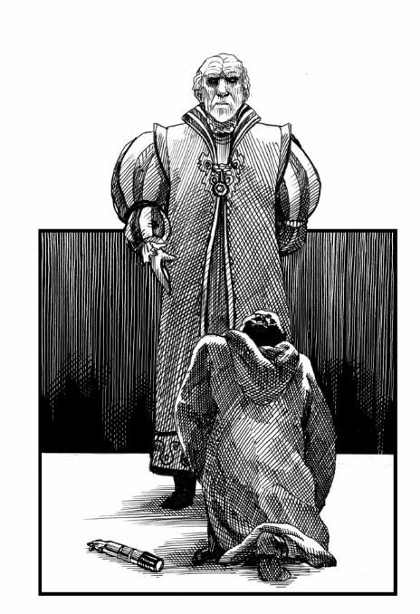
- “ANAKIN: Nay, nay! ’Tis not your place to sentence pass— He must stand trial in the Senate, see?
MACE: Use thou some logic! We must never grant This hard—as temper’d iron—man two chances. Forsooth, he is too dangerous to live!
PALPATINE: I bid thee, beg thee: let me not be slain. I am so weak, defeated by your might.
ANAKIN: ’Tis not the Jedi way! He must not die— I need him, O, I need him more than life. [Mace begins to strike down Palpatine, but Anakin cuts off Mace’s hand with his lightsaber.]
MACE: O, agony! Mine hand dead—and alive I suffer by the hand of Jedi Knight!
PALPATINE: Ha! Power reigns, and thus you meekly die— O, pow’r unlimited, I am your god! [Palpatine/Darth Sidious strikes Mace with lightning, and Mace falls out the window, dead.]
ANAKIN: Alas, what have I done? This noble man, Whom with a crack’d heart I have sent to death, Lov’d me above the measure of a father, Nay, Jedi Master he made me, indeed.
SIDIOUS: ’Tis here, upon this bank and shoal of time, Thou dost begin to know thy destiny And see it well fulfill’d, strong Anakin. Become my true apprentice; thou shalt learn To use the potent dark side of the Force.
ANAKIN: As you command me, thus shall I perform.
SIDIOUS: ’Tis well. (Act 3, Scene 4, Pg.100-101)

- Just when it seemed like there was a chance for the galaxy to be saved, just when it seemed like there could’ve been hope for everyone. Even when it seemed like there was finally going to be a chance for Anakin to be saved, and Palpatine would stand trial, Anakin cut Mace’s hand off. And Palpatine force lightning electrocutes Mace Windu, fully killing him. Anakin has been lost and confused as to what he should, as throughout this tale, we see him torn between two things, his duty as a Jedi, and his new responsibility as a future father for his wife, Padme. He loves Padme more than anything, and has been haunted by nightmares of her death that he could not save her from. Palpatine though has been giving him all sorts of hints, answers, and ideas that there IS indeed a chance at saving his wife, and he cannot even fathom the idea of having anyone take that chance away from, if he were to lose that chance? He’d have nothing left and he’d have to see his wife die, and thus, in a moment of panic, he disarms, literally might I add, one of his most trusted allies and friends. This action shows that Anakin’s state of mind was at the most shattered, and also, the most malleable, it was this exact moment that Palpatine could finally embed his influence and fully indoctrinate him into becoming the puppet he had always wanted Anakin to be, all this time.
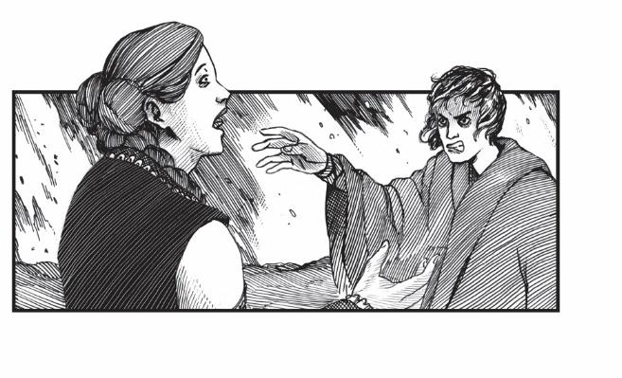
- “ VADER: Yet do thine eyes not see with vision clear? We do not need to run—be not dismay’d. I’ve brought the peace th’Republic so reveres. Above the chancellor my pow’r doth rise. Together, we shall rule the galaxy— Aye, thou and I, my sweet. This thought abides: What we desire, thus shall we make indeed.
PADMÉ: What mine ears hear, my mind cannot believe: Thy words have neither rhyme nor reason, nay. Aye, Obi-Wan has it: thou art reliev’d Of ev’ry sense, transform’d by thoughts insane.
VADER: I’d hear no more of Obi-Wan tonight. The Jedi turn’d from me; do not the same.
PADMÉ: Who is this who doth speak with tongue like knife? I tell thee truly, I know not thy name. Mine heart is broken by thine alteration; This path thou follow’st is not mine to walk.
VADER: ’Tis due to Obi-Wan I am forsaken?
PADMÉ: ’Tis that within thine heart thou hast unlock’d— What thou hast done and further plann’st to do. I prithee stop this now, and come thou back. I love thee still.
Enter OBI-WAN KENOBI.
VADER: —Thou, liar, shalt die soon: Thou didst bring him to kill me—’tis a fact! [Vader begins to choke Padmé using the Force.]
OBI-WAN: Release her, Anakin—indeed, at once!
VADER [aside:] Forsooth, my vengeance should strike where ’tis due. [Vader releases Padmé, who falls aside, unconscious. [To Obi-Wan:] You turn’d my love, mine only love against me!
OBI-WAN: Thine actions sole are cause to that effect. Forswear the chancellor, and be restor’d: The rudder of thy ship may still be turn’d. (Act 5, Scene 2, Pg 143-144)

- And this is it, the most crucial moment, and the part of the story that showed that Anakin has truly reached his lowest point. He has fully succumbed to his rage and is now even willing to attack his own wife. Whatever traces of Anakin that was left, has disappeared, and he has fully embraced the dark side. Padme is trying to talk to him, get him to understand, and try to get him out of the feelings of despair that he is currently experiencing. But to Anakin, or rather, Darth Vader? He feels the path he is on at this current moment, is the right one. The only one, Vader feels like he is finally free of the strict rules, the things that were forbidding him and Padme from being together, from being truly happy. Anakin has been pushed and denied so many things throughout this story, and just when it seemed like he finally has things that he wanted, his wife is telling him what he’s doing is wrong. This broke Vader, because he fought, tooth, and nail. Betrayed everything he knew and massacred children and all for what he believes is true peace. But when Padme was not willing to listen and be on board with what he has done? He accuses Padme of siding with Obi-Wan, believing she brought him there to kill him, and even when he harms her by force choking her, he is still so blinded in the dark side and his rage that he thinks it is all Obi-Wan’s fault, not believing that any of what has occurred, is Vader’s own doing.

How and why to teach with Tragedy of the Sith’s Revenge
The best way to go about using Ian Doescher’s “Tragedy of the Sith’s Revenge” to teach 11-17 year olds, would be to show them just what kind of effect a story can have if given to another writer. The ideas of something that was interesting to others, could be given a whole new perspective if it was taken by someone else. After all, there are so many themes that are inside Star Wars that make it and the machinations of Shakespeare, perfect for each other. Such as the figures who are larger-than-life and known for their great tragedies like Darth Vader and King Lear. The young people seeking to better their lives are pursuing a chance to find their destiny. Much like all of Shakespeare’s lover characters and George Lucas’s Luke Skywalker and Leia. As well as the more complicated pats of Shakespeare and George Lucas being so similar with the complicated and interesting father son relationship. Just like with Hamlet and King Hamlet, as well as Luke and Darth Vader. The best way to look at why teaching this book should be best, it is because if you really think about it, if William Shakespeare were to be writing stories and plays today? It would basically be exactly like the stories and tales of Star Wars. The best way to teach this to middle schoolers and high schoolers would be to try and understand character motivations and look deeper into the subtext of scenes. Try and see if they can figure out the inner machinations and choices behind what a character does and why they would do it in the first place. The best way to test kids and teach them how to understand plays, is to see if they are able to see the themes behind certain scenes, understand mindsets and see if they can give their own interpretation to why the scene played out the way it did, and why the character made that specific choice.

Text Complexity and Age Group
The Dale Challenge Score 2.737, the adjusted score is 3.635 + 2.737) making the final score a 6.4 which is the appropriate age to show to 6-8th graders this. From what Lexile.com has shown, this book is a 610L-800L. Meaning that the best ages and group to show this version to would be 11-17 year olds, Middle Schoolers to Early Highschoolers. The words of William Shakespeare are hard to understand for the most part as there are a lot of nuances and ye old fancy speak with the vocabulary, but it’s still enough in there for someone with enough interest in investigating to understand the deeper meaning and now rewritten version of famous scenes from the movie. The structure of the play follows his style very similarly as well with words and contractions being pushed together in ways that would seem very odd to those who has never seen a play written by William Shakespeare before. The reason why it would be best to teach middle schoolers and high schoolers would be due to how intense in terms of figuring out the structures of how far one can go for their desires and the hopes to keep their loved ones safe. This story gets very intense with how there are multiple moments of death. But it is made a tad silly when certain dramatic moments are met with the dialogue style of William Shakespeare such as the scene with Padme when she confronts Anakin, but that is what makes this entire thing very interesting to see and understand in the first place.

Why people should read this book
- Importance of William Shakespeare's Work in Modern Times
- Shakespeare always had ways to address human issues so articulately in his work, with his genius use of words especially. The works he created are timeless, and we can see that kind of influence it had on modern works with how we see the human issues such as how far one man will go for his love in Revenge of the Sith. The modern day dramas may differ from Shakespeare drama since they rely more on visuals, the underlying themes will always be there, such as the classic scenario of lovers not being allowed to be together Ala Romeo and Juliet with the characters Anakin and Padme

- Bringing new spins to Stories
- Shakespeare is as relevant today as he is back than as his words and ideas always ended up standing the test of time. Readers can resonate with the universal messages of his works. And with the idea of making a well known story like Star Wars and turning it into something like Shakespeare's play, the entirety of it becomes something brand new for people to see. Scenes added like Palpatine bringing up Anakin’s mother could shed more light into a character's ability to manipulate. With this idea of writing, we could see all sorts of ways stories can be recreated and reprinted for a new audience and a new way to appreciate the entire thing.

- Shakespeare's style opens up imagination and radical thinking
- The style created by Shakespeare himself makes it so we can see issues such as the relationships between the people in the stories are brought into light, and with it being used for Star Wars, the different ways we can now see the context between characters in certain scenes. Perhaps even get a different idea of what they were feeling.

- The plays brings universal messages
- The writing style of Shakespeare is incredibly easy to relate to with how they address the human issues such as identity. With that being brought up in the story of “Revenge of the Sith”, the conflict that Anakin has to deal with in terms of trying to understand his own identity and what he wants to be becomes that much more interesting to see and try and understand. The universality of the messages in his language and their relevance makes the writing incredibly important. After all, it means that one can interpret the meaning of the scenes and the dialogue either by looking at their context, or simply understanding the emotions put on display by the characters themselves.

