Aaron Rodgers
November 6, 2018
English 112B
Professor Mary Warner
Adventure: The Compelling Power in Fictional Works
Rationale:
Adventure is one of the driving forces that has helped shape both the world we live on and our understanding of it as well. Without adventure several things that we take for granted would’ve never been a possibility—had Columbus not sought adventure by sailing across the Atlantic he would’ve never discovered America and the world still would’ve been called “flat”; if Benjamin Franklin did not feel adventurous he never would’ve done his experiments with thunderstorms and he would’ve never discovered electricity; or what about if Lewis and Clark didn’t adventure out across the continent, they’d never have discovered the Pacific ocean. Yes, without adventure our world would be a dark place to live in. It’s that same spirit of adventure that several writers draw upon, describing it with such passion and tone, when they are creating their own stories that would one day capture and encourage readers to follow their own sense of adventure.
As far back as I can remember, I have had a passion for adventure literature since I was a child. I always loved the thrills the character faced, the anticipation crawling up my spine as I anxiously read to the next chapter, my mind wondering what sort of adventures the main character(s) would face next. It’s a feeling that people from all cultures could, probably would, relate to. I think my first encounter with an adventure novel was back in the sixth grade. We were assigned by our teacher to pick a book from her cabinet and read it, before going on one of her school computers and fill out a reading quiz or test, the kind that measures a kid’s reading level. While my memory is a bit fussy, I do remember grabbing a hold on a book that, until then, I had only heard about on TV: Moby Dick. It was the biggest book that I had ever read, over a hundred pages, and almost all of it was filled with the eye-opening adventurers of Captain Ahab and his crew as they chased the white whale. After reading the book, my mind was suddenly opened to the infinite adventures that books had to offer. The next adventure novel that I read was another classic tale of adventure, Around the World in Eighty Days. This book was much more detailed than Moby Dick but the whole plot and the adventure sections kept me glued to the pages.
It was because of these books a fire had been lit inside my mind: I wanted to find stories or novels that had even a little bit of adventure in them and start reading them. I grabbed books from my school’s library that I thought was interesting and seemed adventurous and would read them from cover to cover. As I read more and more adventure novels or novels that had elements of adventure in them, I began to envision the types of stories I would like to write and publish: novels that contain fast-paced action, likable and exciting characters, as well as adventures that the readers could almost envision themselves being a part of. This led to me going back and looking at how the authors managed to create these stories, studying their writing styles and how they formed sentences and paragraphs that seem to just jump out and hook a person into the pages.

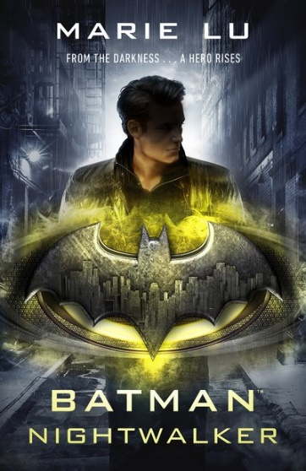
Batman: Nightwalker presents a new and exciting twist the story of how Bruce Wayne started his journey to become the Batman. Bruce, who has just turned eighteen, gets into trouble with the Gotham City police and must now do community service at Arkham Asylum. However, as soon as he starts working at Arkham, a series of events take place and Bruce is suddenly asked by the GCPD to help with an investigation they’ve been working on which involves a domestic terrorist group that calls themselves the Nightwalkers. His assignment: to talk to a new inmate at the asylum and find out what secrets they possess about their organization and their plans. But things get more intense the longer Bruce goes to Arkham. It’s an adventure that any die-hearted Batman fan would enjoy. (Summary written by Aaron; Source: Batman: Nightwalker)
Photo taken from:
https://cdn2.penguin.com.au/covers/400/9780141386836.jpg
Lu, Marie. Batman: Nightwalker. Random House, New York, 2018.
Bruce’s adventures both in and outside of Arkham contain some fast-paced, heart-pounding excitement as he deals with not just trying to help the police solve a mystery but the complex relationships he has with the people in his life. As he tries to figure out who he can trust and how to stop more people from getting hurt, Bruce must also battle with his heart as he tries to help a young woman who manages to capture his attention—in more ways than one. With the clock ticking for the people of Gotham, Bruce must make choices, choose his moves carefully, and prepares himself for the finale, all the while having to protect those who mean so much to him—even when one of them is on the wrong side of the law.

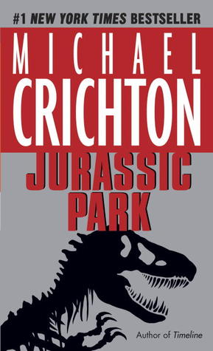
Since their discovery mankind has been fascinated by the fossilized remains of dinosaurs, capturing the imagination of men, women, and children everywhere. In Michael Crichton’s novel, Jurassic Park, thanks to the wonders of modern science and genetic-engineering, these fantastic creatures that once ruled the Earth return to life and are brought to an island off the coast of Costa Rica where people could come and see these magnificent creatures for themselves—provided they pay a fee, of course. However, when things begin to go wrong, and the animals escape their enclosures, the residents and workers on Jurassic Park must work to survive—before they become extinct. (Summary written by Aaron; Source: Jurassic Park)
Photo taken from:
https://nutfreenerd.files.wordpress.com/2015/05/jurassic-park-by-michael-crichton.jpg
Crichton, Michael. Jurassic Park, Alfred A. Knopf, Inc., 20 November 1990.
While almost every kid is fascinated by dinosaur bones and models in a museum, the chance to see several of these ancient beings alive and in the flesh is an adventure like none other. As Michael Crichton’s characters are invited to stay for a few days on Isla Nublar they not only get to experience the dream that has plagued humanity for almost a hundred years but must soon fight to survive as the newly-reborn titans escape their paddocks and begin to create havoc and endanger lives. Even in the first few pages of the book, the entire issue of the novel is revealed when a little girl gets attacked by a small Procompsognathus and must be taken to a clinic so that the wound is properly treated. As everyone races to try and restore order on the island one thing becomes clear: what started out as a simple tour transforms into an unforgettable—if frightening—adventure that none of them will ever forget.
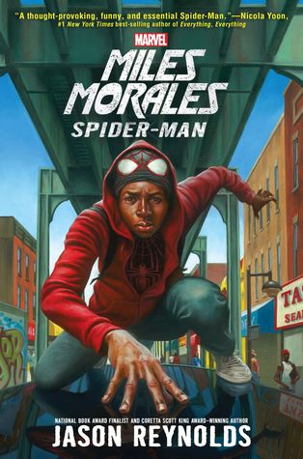
Everyone knows that Peter Parker is the original Spider-Man but there’s more than one Web-Head living in New York. In Miles Morales Spider-Man, along with his life at home and school Miles Morales streaks across the Big Apple as a second Spider-Man, helping the good folks of New York City and protecting them from thugs and super-criminals. Of course, this doesn’t mean he doesn’t have problems. Along with having to deal with homework, bullies, school crushes, and other typical high school issues, Miles’ spider-sense begins to act up, alerting him to threats that are not there, and causes him to get suspended from school. As Miles deals with both his high school life and his superhero life, a threat begins to reveal itself and Miles must weight every decision he makes or else risk putting the people he constantly tries to protect in the line of fire. (Summary written by Aaron; Source: Miles Morales Spider-Man)
Picture taken from:
https://www.goodreads.com/book/show/32793053-miles-morales
Reynolds, Jason. Spider-Man: Miles Morales Spider-Man. 1st ed., Marvel Press, 2017.
Miles Morales’ adventures in the book contain more than just the usual fast-paced action one would expect from a Spider-Man novel. Throughout the book, Miles deals not just his high school life and his superhero one, but he also faces issues such as poverty, racism, and even the struggle to be a good guy. He showcases how every decision he makes affects those all around him and himself, even unintentionally. While there may not be as much action as there should be in a Spider-Man novel this book makes up for it with important topics, memorable characters, and an exciting plot, especially as Miles deals with his superpowers going haywire.
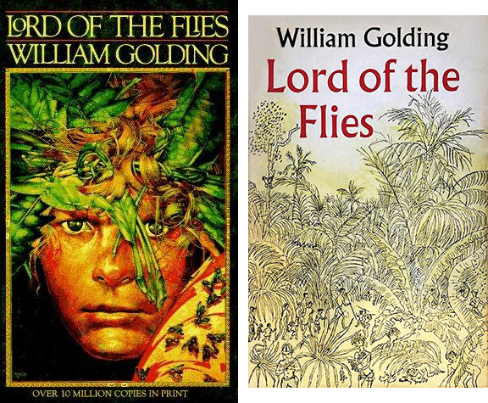
For a child, the prospect of living in a world without adults and their rules, as well as getting to do whatever they want, would be considered a paradise to them. But in the heart-stopping adventures of Golding’s Lord of the Flies, when a group of boys finds themselves stranded on an uncharted island and the adult pilots killed during the crash that vision of paradise quickly transforms into a dark adventure of terror and mayhem. As the possibility of getting rescued grows dim with each passing day and one-by-one the children are killed, whether it be on accident or on purpose, two things slowly flow through their minds: will they ever be rescued and who will survive? (Summary written by Aaron; Source: Lord of the Flies)
Picture taken from:
http://www.60secondrecap.com/wp-content/uploads/2013/05/lord-of-the-flies-1.jpg
Golding, William. Lord of the Flies. Listening Library, 1992.
The Lord of the Flies follows the adventures of young children from different perspectives. As the tension builds between the children, the characters begin to experience madness, greed, and envy that shape their lives for the worst. As their world, and their numbers, dwindle, the boys must act to ensure that they survive or else they to will wind up dead. From the well-structured plots to the hidden themes about society and how it could all fall apart without guidance or order, the adventures told by Lord of the Flies are something that every young adult should consider reading.
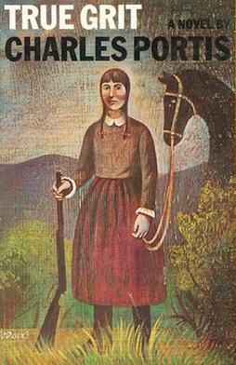
“Mattie Ross is just fourteen years of age when a coward going by the name of Tom Chaney shoots her father down in Fort Smith, Arkansas, and robs him of his life, his horse, and $150 in cash. Mattie leaves home to avenge her father’s blood. With one-eyed Rooster Cogburn, the meanest available U.S. Marshal, by her side, Mattie pursues the homicide into Indian Territory.” (Quote taken from True Grit: A Novel; Source: True Grit: A Novel)
Picture taken from:
https://upload.wikimedia.org/wikipedia/en/a/a9/True_Grit_(Charles_Portis_novel).jpg
Portis, Charles, and Donna Tartt. True Grit: A Novel. Overlook Press, 2007.
True Grit: A Novel is a fine example of an adventure novel that young adult readers would enjoy immensely. The entire novel revolves around young Mattie Ross’s story of when she was a fourteen-year-old girl who had recently lost her father and seeks vengeance on the man who kills him. To do this she travels with a Marshal named Rueben “Rooster” Cogburn and a Texas Ranger named LaBoeuf to find her father’s killer. Throughout the book, both Rooster and LaBoeuf try to lose Mattie but she displays strength and stubbornness in accompanying them to find Tom Chaney. Despite her gender, Mattie displays that she is just as tough as both men and eventually both come to respect Mattie as an equal. The plot of the story is just as impressive as Mattie’s spirit, as the three friends travel across the Wild West, encountering Native Americans and watching as the American West transitions from a lawless land into a piece of civilization. Also, in the story, the characters encounter several issues that are still issues today: crime, drug and alcohol, gender, and justice. These themes and everything else help make True Grit: A Novel worth reading to either yourself or your friends.
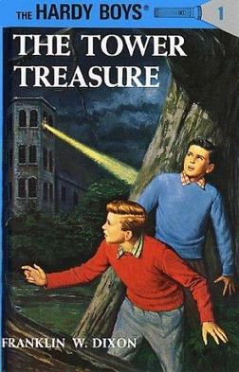
The Tower Treasure, the first book in the original The Hardy Boy Mystery Stories, tells the adventure of Frank and Joe Hardy’s first ever mystery. A series of mysteries start to happen around the populated city of Bayport: the Hardy’s friend, Chet Morton’s, car gets stolen, a high-stakes robbery takes place at the Tower Mansion and the owner is convinced that his employee Henry Robinson is behind the theft, and it is later revealed that Robinson, who was originally in debt, managed to pay off the debt. Did Robinson really steal the money to pay off the debt? What happened to Chet’s car? And where is the stolen loot now? Find out in the amazing adventures of the Hardy Boys. (Summary written by Aaron; Source: The Hardy Boys: The Tower Treasure)
Picture taken from:
https://upload.wikimedia.org/wikipedia/en/0/05/The_Tower_Treasure_(Hardy_Boys_no._1,_revised_edition_-_front_cover).jpg
Dixon, Franklin W. The Hardy Boys: The Tower Treasure. Grosset &amp; Dunlap, 1987.
Frank and Joe’s adventures in The Tower Treasure are both exciting and comical. The book starts with the boys discovering a turned-over car and then learning from their friend Chet that his car was stolen, followed by the mystery of who had stolen the treasure from the Tower Mansion and whether Henry Robinson, who is also a family friend of the Hardys, committed the robbery. The plot has a lot of secrecy and tension that can and would cause shivers to crawl up any reader’s spine, while also well-structured. The boys’ detective skills are also very impressive as they help readers to learn and develop their own skills and observations.
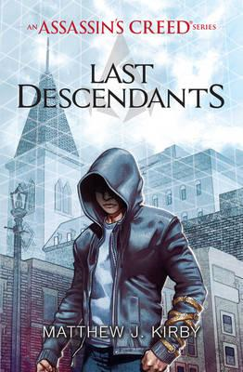
If Owen Meyers had one wish it would be to try an prove his late father’s innocence. Convinced that his father had been wrongly accused of committing a crime, Owen takes part in a program that would give him access to a machine called the Animus and try to relive his father’s memories to prove his innocence. However, instead of finding proof of his father’s innocence, Owen discovers that an ancestor of his encountered a relic that, until that time, had been considered nothing more than a myth—the Trident of Eden. Now with two secret organizations after him, Own joins a small band of teenagers to try to uncover the location of the Trident by searching the memories of their ancestors during the 1868 Draft Riots in New York City before the Assassins or the Templars do. (Summary written by Aaron; Source: Last Descendants: An Assassin's Creed Series)
Picture taken from:
https://d4rri9bdfuube.cloudfront.net/assets/images/book/large/9781/4071/9781407161693.jpg
Kirby, Matthew. Last Descendants: An Assassin's Creed Series. Scholastic, 2016.
Anyone who’s familiar with the Assassin’s Creed franchise knows that there will be some adventure in this novel. With the story mainly taking place in New York City during the 1868 Draft Riots, the readers are exposed to exciting plots filled with secrecy and tension as the Assassins combat against the Templars to claim the Trident, along with meeting famous historical figures such as General Ulysses S. Grant. Along with the story taking place in a past time, the readers are also introduced to Owen and his search for truth regarding his father’s innocence, stubbornly clinging to his belief that his father was innocent of the crime that sent him to prison.
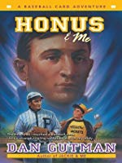
Every baseball fan dream about what it would be like if they meet their baseball idols in the flesh. Well, young Joseph “Stosh” Stoshack gets to experience this first hand in Dan Gutman’s Honus & Me. After touching a rare baseball card, Stosh discovers his ability to travel through time and accidentally pulls Honus Wagner, a famed baseball player from the early 1900s, to his time. Now Stosh must help Honus return to his proper time, but things are never so easy when it involves time travel. (Summary written by Aaron; Source: Honus & Me: A Baseball Card Adventure)
Picture taken from:
http://i.gr-assets.com/images/S/compressed.photo.goodreads.com/books/1349075343i/12436665._UY630_SR1200,630_.jpg
Gutman, Dan. Honus & Me: A Baseball Card Adventure. Harper Trophy, an Imprint of HarperCollins Publishers, 2003.
Stosh’s adventures in the novel are certainly unique. In the beginning of the novel, Stosh struggles with what is the right thing to do when he discovers a rare baseball card that is worth a ton of money and must now deal with whether he should just keep the card and sell it so that his family are no longer struggle with financial trouble or return it to the proper owner. Then, he must deal with trying to get Honus Wagner back home so that he could play for his team. The use of time travel is also very appealing to readers—normally when time travel is involved it mostly has to do with a machine or someone with the ability to create time portals but for Stosh all he must do is hold onto a baseball card and it sends him and whoever is with him to that time or place. Not to mention the amount of details the book describes when Stosh and Wagner return to the past. It’s these types of details that help make a regular book into a great book.
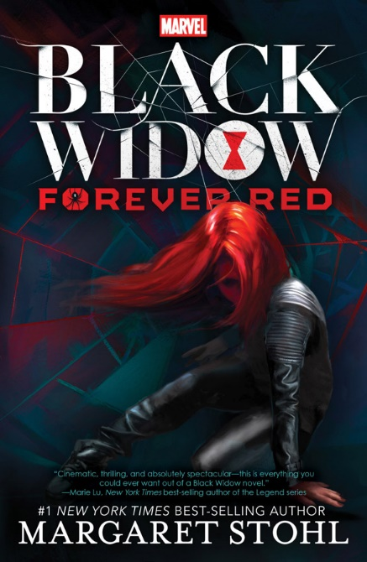
Black Widow: Forever Red introduces a story centered around one of the most recognizable figures from the Marvel universe: Natasha Romanoff alias the Black Widow. Years after Natasha is rescued and recruited by S.H.I.E.L.D. (Strategic Homeland Intervention, Enforcement and Logistics Division) children all over Eastern Europe are reported missing, and at the same time stories of smuggled technology from the Red Room, the training facility where Natasha Romanoff became the Black Widow, begin to appear around the dark web, Black Widow believes her former training instructor may be responsible for these incidents. With the assistance of Ava Orlova, a Russian teenager trying to live as a regular teenager from Brooklyn, the two set out on an epic adventure to track down the deranged individual before he unleashes his plans. However, Ava begins to have dreams about a dark-eyed boy with an hour-glass tattoo and the two discover there is more to the boy than meets the eye. (Summary written by Aaron; Source: Black Widow: Forever Red.)
Picture taken from:
https://www.geekalerts.com/u/Black-Widow-Forever-Red.jpg
Stohl, Margaret. Black Widow: Forever Red. (Black Widow, Vol. 1.). Marvel, 2015.
Right off the bat, there are several things going for this novel that make it a great book for young adult readers. Besides the fact that it is a book that takes place in the Marvel universe, the story revolves around the Black Widow and her very shady past. Along with reading about Natasha’s past we also get to see the book introduce some previously unknown characters, her teacher, Ivan Somodorov, and Ava, also known to fans as the Red Widow. While there are a few grammatical errors in the book it doesn’t take away from the action and suspense as Widow helps Ava track down her old teacher before he could instigate his plans.
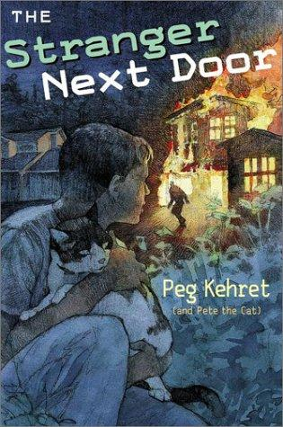
The Stranger Next Door tells the adventures of three characters: Alex, a young boy whose family has just moved into a new housing development and gets bullied by a pair of dirt-bike riders, as they believe he was one of the reasons for destroying their favorite dirt-bike trails; a young boy named Rocky who recently arrived to school but seems to be distant with just about everyone and keeps to himself; and Pete, Alex’s cat who can understand everything that everyone says around them but he can only respond in the usual meows, like other cats. As the story unfolds street signs get cut down and buildings catch on fire. Whose responsible for these events: the bullies, Rocky, or someone more sinister? As both boys and Pete investigate, the two humans’ bond and eventually they discover something much more than just the cause of these incidents. (Summary written by Aaron; Source: The Stranger Next Door)
Picture taken from:
https://img.fantasticfiction.com/images/n11/n59139.jpg
Kehret, Peg. The Stranger Next Door. Puffin Books, 2008.
Kehret’s novel certainly has a lot going for it. Along with being well-written and structured, the main characters—the human ones anyway—showcased several experiences that some of the readers may relate to, like moving to a new place, feeling lonely or isolated, hesitant or refusing to make new friends, among other things. The themes this book has helped the readers grow both emotionally and intellectually as read about the personal issues that both Alex and Rocky go through. The mysteries in the story are very exciting and makes people wonder what’ll happen to the two humans. As the two kids deal with all of this, Pete the cat offers his assistance in solving these mysteries while also helping his owner and Rocky during these trying times. It’s an adventure that a young adult reader with a sense of adventure and family would enjoy.

