Sara Hibbs
Dr. Mary Warner
English 112B
25 November, 2018

Unit of Study: Making Choices
  - Rationale
People are faced with making choices every day. Some of them are so insignificant that we don’t even really bother thinking about it, while others could define our life within seconds. For young adults, sometimes these life defining choices are much more prevalent. Teenagers are having to choose the college they want to go to, the major they believe they want to pursue for the next four years, and even what career they want for the rest of their lives. Teenagers believe that they are all on their own when picking these choices, but to make sure that they have plenty of resources and people they are able to talk to, is something that I believe would be important for students to take from this topic.
The center piece for my Unit of Study would be focused around, The Hate U Give by Angie Thomas. This book dives deep into what it means to be in conflict with yourself, your friends, and the community around you. The book talks about important issues that are happening today, so being able to talk about it in the classroom could help open students’ eyes to the world around them, while also helping students be able to speak about their problems in a safe environment. Students will be able to try and appreciate what others are going through, rather than focusing on themselves and their own problems. Throughout the unit, students will be picking scenes from the book and comparing them to events happening in real life. This will get them to analyze the text, refer back to past experiences, compare and contrast events, and many different literary devices. During the unit, I will provide them with definitions and examples in the text that as a class we would discuss further into what the author might be telling us. After finishing reading The Hate U Give, I will incorporate other YA literature that has similar themes but may be different genres so the students could try out different types of books they may like.
Angie Thomas incorporates many of the Exeter Qualities in The Hate U Give. The book is fast paced and includes “secrecy, surprise, and tension” that are brought out through her narrative (LfTYA9). Thomas goes into depth about what Starr, the protagonist, is going through and how confused she is in what she thinks is the right thing to do. The story, being as fast passed as it is, also starts out with having Starr watch her best friend from childhood die at the hands of a police officer. Another Exeter Quality that is seen throughout the story is “Characters who reflect experiences of teen readers, something that is not found in much of the literary canon, especially when it comes to strong female protagonists.” (LfTYA9) It speaks for itself when talking about a strong female lead. Starr is a teenage girl having to already deal with the troubles that come along with being a teenager, then on top of that she is becoming the face of a civil rights movement. Lastly, one of the Exeter Qualities that is seen throughout the story and can be influential in the students’ lives is “Themes that inform truthfully about the wider world so as to allow readers to engage with difficult and challenging issues relating to immediate interests and global concerns.” (LfTYA9) Having many protests based on civil rights and police brutality against people of color are current events. These are issues that are happening this very moment, so being able to read a book about something extremely similar to the real world can be helpful for the students to possibly understand what is happening a little bit more.
  - Launching the Unit:
I would start the unit out by listening to E-Ne-Me-Ne-Mi-Ne-Moe (The Choice Is Yours To Pull) by The Jackson 5. This song is an upbeat song about making choices and it could be a fun, light introduction into a much more serious topic. Having this song to introduce the subject can help students understand what the unit is going to be about.
Then I would have them get into pairs and have preprinted games of M.A.S.H. M.A.S.H. is a game that was popular in the early 2000’s so most of the student’s wouldn’t know how to play. I would take time to explain how the game works and then have them finish a game or two between partners. This is another relaxed game that the class would play to get them into the theme of choices. I think this is important because it shows them that not every choice they make is life changing, even though it may seem like it at the time.
After the song and the games, I would have them pull out either a piece of paper or journal and answer the questions below. These questions are meant to have them start reflecting on their own decision making. Having them think about what goes through their minds when trying to make an important decision. This task will hopefully get into the much more serious topic of making life altering decisions.
Some of the questions would be:
- How do you normally make decisions?
- Do you normally get other people’s advice before making a decision?
  - If so, who is the number one person you go to for advice and why?
- Write about a time where you had to make a really tough decision. Do you regret making that decision, why or why not? Who helped you through that decision? How long did it take you to the decision you chose?
Lastly, I would introduce Robert Frost’s poem, “The Road Not Taken”. As a class, we would discuss and analyze the poem. We would talk about how their own experience could relate to the one that Frost was talking about in his poem. Being able to relate it back to the students is important.
  - Centerpiece Work
The novel that we would be focusing on is The Hate U Give by Angie Thomas. The homework that I would assign the students would be to read several chapters a night and have them come together as a class and discuss what is happening in the book. During this time I would have students bring in news articles as they relate to the story. This will help the students relate real life experiences to a book that is technically fiction. The events that are happening in the book may not have actually happen but they depict events that are truly happening in everyday life. As a class we would go into discussing some of the themes of the novel. What was the role of the community? Did injustice play a role in these chapters? What were some hard decisions that were made? How did speaking up tie into these last chapters? Throughout reading the book, the students will start a journal reflecting on the readings. Each time they will answer the question, “What would I have done differently? Why or why not?” This activity will help the students with their writing and understanding of the novel. I would read student’s entries, which would be my assessment during the unit to see if they are actually reading the story. Making sure that each entry makes sense and relates back to the chapters assigned.
  - Expanding the Unit
After finishing the book and discussing it as a class, I would show the movie to the students. During the movie, to make sure they were paying attention, I would have them compare and contrast the novel to the film. Seeing how accurate the film was to the novel and which one they preferred. Having the student see what the film either left out or added can help them understand the story a bit more, seeing which part of the story was important to the plot, and possibly which parts weren’t.
After finishing the film and novel, I would get the students into pairs and assign a research project being focused on activist. In the novel, Tupac, the Black Panthers, and Dr. Martin Luther King were just some of the few real-life activists that were mentioned. The students would pair up and pick someone that would be considered an activist and stood up for what they believed in. In the research article, the students would inform the class on who they picked and what their effect on society was. It would be presented as an oral presentation and the student’s would be required to create a visual aid whether it be a PowerPoint or a poster. This project would help them relate Starr to other important characters in history and work on their public speaking.

Additional Readings
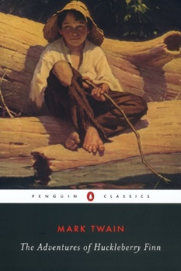
Thirteen Reasons Why could pair well with The Hate U Give because of how Hannah, one of the protagonists in the book, goes about dealing and spreading her story. Hannah takes her life once she moves to a new town and instead of leaving a note for one or two people she leaves voice recordings to each of the people that played a part in her depression and eventually leads her to kill herself. It talks about the decisions that other people ended up making due to the tapes, while you learn more and more about Hannah and how she got to her decision. Thirteen Reasons Why could be triggering to some students so that would need to be addressed.
https://www.goodreads.com/book/show/29844228-thirteen-reasons-why

The Adventures of Huckleberry Finn would be a great addition to the lesson plan because of how Huck Finn goes onto an adventure that involves encountering a family wrapped up on a feud, a runaway slave, two scoundrels pretending to be royalty, and Tom Sawyer’s aunt who mistakes him for Tom. The Adventures of Huckleberry Finn would be able to reach to a wide variety of audiences and could paid very well with The Hate U Give.
https://www.goodreads.com/book/show/2956.The_Adventures_of_Huckleberry_Finn?from_search=true

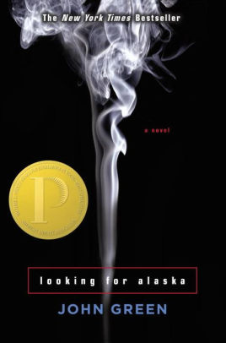
Another great book that would pair well with The Hate U Give is Looking for Alaska. Looking for Alaska is about a boy and a girl who become really close friends during a summer camp. The girl, Alaska, and the boy, Mills, open up to each other in how they view the world and what they are going through. Mills falls in a trance with Alaska until she winds up missing. Mills then gathers a couple of friends and goes on an adventure of a lifetime to find her.

https://www.barnesandnoble.com/w/looking-for-alaska-john-green/1100255278;jsessionid=FD065C268919BE1E956F68E66DAE05DB.prodny_store02-atgap03?ean=9780142402511#/

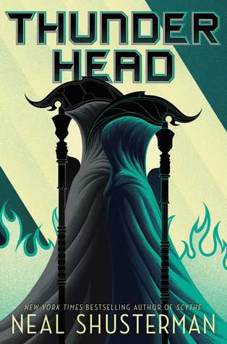
Thunderhead would be another good addition to the unit because it brings in the same concept of making decisions but it’s a different genre. Thunderhead is a Science Fiction story about Rowan who has gone rouge from society. While he is gone, Scythe Lucifer has taken over and is taking down society. Citra is trying to help save the world but can’t do it alone. She decides to risk being “deadish” to communicate with the Thunderhead, but will it help solve problems or simply watch as the once perfect world crumble?

https://www.goodreads.com/book/show/33555224-thunderhead?from_search=true

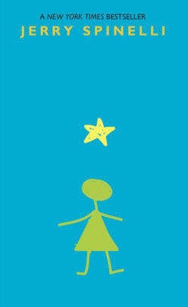
Stargirl is another great book that would pair well with The Hate U Give. It’s also slightly different from the original theme since it’s not as serious as The Hate U Give. Leo, the protagonist in the novel, follows every unsaid rule that is enforced in his high school until Stargirl, who has been homeschooled her entire life and blows the norms to pieces. Leo finds himself falling in love with Stargirl while being reminded of the very important social standards that are deep rooted in his school. The story is about standing up for yourself and not conforming to what everyone else wants you to be.
https://www.barnesandnoble.com/w/stargirl-jerry-spinelli/1100292269;jsessionid=29C280FA12278EA6BF4F1798A529F1F8.prodny_store01-atgap18?ean=9780440416777#/

Works Cited
Asher, Jay. Thirteen Reasons Why. London: Penguin Books Ltd, 2017. Print.
Green, John. Looking for Alaska. New York, New York: Penguin Group, 2005. Print
Shusterman, Neal. Thunderhead. New York: Simon & Schuster Books for Young Readers, 2018. Print.
Spinelli, Jerry. Stargirl. New York: A.A. Knopf, 2000. Print.
Thomas, Angie. The Hate U Give. 2017. Print.
Twain, Mark. Adventures of Huckleberry Finn. New York: Random House, 1996. Print.

