Jennifer Le
English 112B
Dr. Warner
November 29, 2019
Unit of Study
Connecting to the Identity Journey: Coming of Age

Rationale:

The identity journey, also known as the coming of age narrative focuses on the development of an adolescent or youth into adulthood. However, the growth and development are not necessarily defined by age, but rather by tracing one’s journey into maturity through self-reflection, experience, and change. The coming of age theme usually features a young protagonist who undergoes some sort of struggle or problem and overcomes their troubles by process of trials, experiences, or revelations. Through these experiences and revelations, the protagonist realizes self-growth in his or her identity.
The coming of age theme is common in young adult literature, carrying valuable, worldly insights and universal connections that anyone can take away from. The identity journey explains self- discovery and teaches young adults to overcome their own internal and external battles. According to Dr. Warner’s Adolescents in the Search for Meaning: Tapping the Powerful Resource of Story, chapter six presents “Books about Identity, Discrimination, and Struggles with Decisions” which explains the importance of why young adults should read specific books about sexual identity, external body figures, parental pressures, expectations, abandonment, and fitting in (Warner, 188-195). The identity journey literature may allow young adults to connect to the protagonist’s physical or mental struggle. Sexual identity is a prime example Dr. Warner illustrates to be one of the struggles young teens may relate to. Young adults would benefit from reading books about identity and the coming of age because it would help them have a better understanding of themselves and the world around them. “Exeter Qualities” from Alleen Nilson’s Literature for Today’s Young Adults focuses on qualities that would benefit young readers at several levels. Exeter Quality number four, “Characters who go beyond typical experiences so that readers can use the fictional experiences to learn and develop in their own lives” and Exeter Quality number seven “Themes that allow the possibility of emotional and intellectual growth through engagement with personal issues” both connect to the identity journey by allowing young readers to connect with the protagonist and follow their journey of growth and self-reflection in order to understand their own (Nilson, 9).
Studying Archetypes in literature also help define the coming of age with a specific character in a book. For example, understanding the traits of an archetype of a character can help young adult readers understand the character’s point of view on their journey. For example, Alleen Nilson’s Literature for Today’s Young Adults also introduces archetypes such as “The Orphan” is a popular character in most young adult literature (Nilson, 10). Their journey starts off as a lost child, experiencing a setback before their conflict is even introduced in the novel. This reveals the character’s win over the struggles in their journey to be more powerful by overcoming their own external or internal conflicts as the story goes on.
A wonderful example of character development and point of view is presented through Mark Twain’s The Adventures of Huckleberry Finn. Huckleberry “Huck” Finn is the protagonist and narrator of the book. Huck’s resents the mainstream society because he is skeptical of the world around him and the ideas it follows. Huck’s journey and experiences down the river has him questioning everything society has taught him. Huck’s youth into adulthood is influenced by the people and experiences around him. Because Huck is a child at a young age, he intakes his surroundings but ultimately makes up his own rules. Huck represents careful reflection and imperfection as he navigates where he stands in the society presented to him.

The Centerpiece Work:

Mark Twain’s The Adventures of Huckleberry Finn
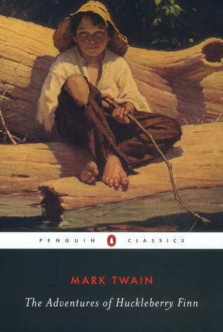
https://www.goodreads.com/book/show/2956.The_Adventures_of_Huckleberry_Finn

The main canonical work of literature for the unit of study is Mark Twain’s The Adventures of Huckleberry Finn. This novel represents Huck’s identity journey as he figures out where he belongs in a society with a set of rules to abide by. Themes of racism, morality, rules, friendship, and family all occur throughout Huck’s coming of age. This novel offers examples of character development, satire and irony, point of view, and a variety of meanings to the text.

Part 1: Launching the Unit
https://depositphotos.com/215942296/stock-photo-group-high-school-students-jumping.html

Before introducing the book in a classroom, I would have students all line up outside in an open area facing me. I would have every student close their eyes and I would read out 5 different statements. If any of the statement applies to any student, he or she would step forward. The five statements I would choose to real aloud are:
- I have at least one time in my life, disagreed with someone or something.
- There is least one thing I wish could be better or improve on in my life.
- I have felt I did not belong or fit in at one point in my life.
- There are things I do not understand in life.
- I have been confused about a topic everyone else around me has understood.
Once I am done reading each statement, and students step forward, I would have everyone open their eyes. I want to encourage students to understand they are not alone in figuring out common teen struggles or troubling ideas. I will introduce the protagonist, Huck, in order to help students identify with Huck’s thoughts and point of view as he navigates through his own journey. I will have students take out a piece of scratch paper and write down one thing they want to accomplish or improve on within the following year. Anonymously, they will fold the papers and put them in a box. I would randomly choose a few to read them aloud. By doing so, I will begin to explain characteristics of identity.
Then, I would begin to introduce the stages of Coming of Age on the board. By explaining the stages of Coming of Age, I will connect it to the definition of one’s identity journey by using some of the anonymous examples in the box. Explaining the stages will help students identify their own steps in order to accomplish their goals or understanding and idea they were unsure or confused about.
Coming of Age: 4 Stages
Realization - growing, changing, emotional, mental preparation.
Removal - separated, change environment, environment.
Challenge - prove if you are ready.
Reintegration - rebirth and coming back into society with new insights and status.
I would pass out a note taking sheet where students can track any quotes, pages, or pieces of texts that may support any of the four stages as they read the novel.
Pre-reading PowerPoint:
Furthermore, my main pre-reading lesson would also consider Huck’s world view of racism. Students cannot understand Huck’s point of view on racism unless they learn about the historical context of the setting. I would give a mini background PowerPoint about slavery in America and the publication of the Jim Crow era. This should be accomplished before meeting the narrator to understand the basics of identity and what makes Huck who he is.

Part 2: Through Activities
Similar to the class I observed, I would teach this book by breaking up the chapters to enhance clarity during the unit. I would revolve the reading on pop quizzes after every section assigned and discuss quotes that talk about each character’s point of view, themes, satire, irony, or character development. Each section would focus on one aspect of character development and stages of development through Huck and Jim. My main focus would be a prewriting assignment followed by a discussion based on the reading assignment.
- Section 1: Chapters 1-8
- This section captures the differences and similarities of Jim’s and Huck’s character and introduces their view on breaking away from their community. Both characters had different reasons for escaping. My main lesson with section one would be for students to analyze the reason behind Huck’s and Jim’s reason for leaving.
- There would be a quick writing assignment, followed by an open discussion on the chapters. My question for section one would be: “In the beginning of the novel, Twain focuses on dialect, using satire and irony to display the ideas of a society’s behaviors. Analyze the break away from Huck and Jim’s “sivilization.” According to Mark Twain, were they right or wrong from doing so? Support your claim with quotes from this section.”
- After 20 minutes of writing, I would come together as a class to discuss everyone’s answers. By hearing everyone’s answers, I would build upon important dialect and language used by Twain to emphasize Huck’s and Jim’s reasoning to leave their society and what that might say about the beginning of their identity journey.
- Section 2: Chapters 9-16
- In this section, Huck is figuring out his decision to help Jim reach freedom. Race and point of view are particularly important in Huck’s morality. The influence of his society has led him to see very little of himself.
- My main lesson would revolve around students listing qualities of Huck’s character. Students would do a prewrite on their list and answer: What conclusion can you make of Huck’s character after chapter 16? Why does Huck think so little of himself?
- During this section, students may also focus on Huck and Jim’s friendship. During the discussion, I would ask questions on the role of power and respect. I would also discuss the importance the role of the river symbolizes and plays in both their identities and characterization by choosing specific quotes and discussing them.
Section 3: Chapters 17-22
- In this section, students will prewrite about Twain’s approach to satire and his description of the society Huck and Jim live in. Language is the main focus in these chapters. I would have students prewrite about how language plays a role in any of these topics in Twain’s description of the society.
- “Give a prime example of Twain’s word choice that emphasizes satire in the novel.”
- Tom Sawyer
- Huck Finn
- The Grangerfords
- Townsfolk in Parkville
- Arkansans
- Boggs
- The murderers on the steamship
- The lynch mob
- The duke and the king
- Jim
- Col. Sherburn
- Pap Finn
- Emmeline Grangerford
- Tom Sawyer’s gang
Section 5: Chapters 29-35
- This section will focus on Huck’s internal and external conflicts.

- His internal conflict: commitment to freeing Jim and aiding him throughout his
journey
- His external conflict: his freeing from his father and Widow Douglas

- Students will have a chance to discuss these ideas.
Section 6: Chapters 36- 43
- This section will portray prewrites about themes connecting to character development.
- Students will choose one element from the list and write about how that affects the
Adventure themes in the novel.
The List:
- The river
- Prayer/ religion
- Nature
- Clothing
- Lying
- Superstition
- Rules
- Violence
- Social Pressure
- The island
After the sections have been discussed throughout the unit, students will be assigned an essay
question.
Part 3: Moving Beyond the Unit
Many young adult novels display character development and the coming of age story.

There are several books I would pair with The Adventures of Huckleberry Finn. These books are:

- We Were Here by Matt De La Pena
We were Here is a great example of identity because Miguel’s character grows as the reader follows along his journal writing and character development. The novel’s coming-of-age theme is juxtaposed with Miguel’s impulsive decision-making and coincidences. Miguel develops an awareness of the impossibility of changing the past and focuses on his future by the end of the novel.
- Life of Pi by Yann Martel
Life of Pi illustrates the protagonist, Pi, who narrates from an older age, looking back at his earlier life as a high school and college student in Toronto. He also looks beyond to his early childhood in Pondicherry. He explains his journey as through his sufferings. Pi later finds solace in religion and zoology.
- The Giver by Lois Lowry
The Giver explains a similar societal rejection in The Adventures of Huckleberry Finn. Jonas, the narrator, lives in a futuristic society where there is no pain, fear, war, prejudice, or hatred. Jonas navigates through his internal and external conflicts just as Huck does in The Adventures of Huckleberry Finn.
- Catcher in the Rye by J.D. Salinger
Catcher in the Rye explains Holden’s journey through a short period of time on how he ends up in a mental institute. Setting and point of view are just as important in Holden’s coming of age and realization throughout his narration.
- To Kill a Mocking Bird by Harper Lee
To Kill a Mocking Bird utilizes three characters and their journey and coming of age. All three characters: Scout Fin, Jem Finch, and Atticus can all be characters of discussion. Class and society can be differentiated between the characters.
- Go Tell It On the Mountain by James Baldwin
Go Tell It On the Mountain is a spiritual novel focusing on John Grime’s journey in Harlem. John’s thoughts are compared to his father’s, and aunt’s. The language and point of view of each character help develop John’s internal struggle to see himself beyond race and racism.
Part 4: Concluding the Unit
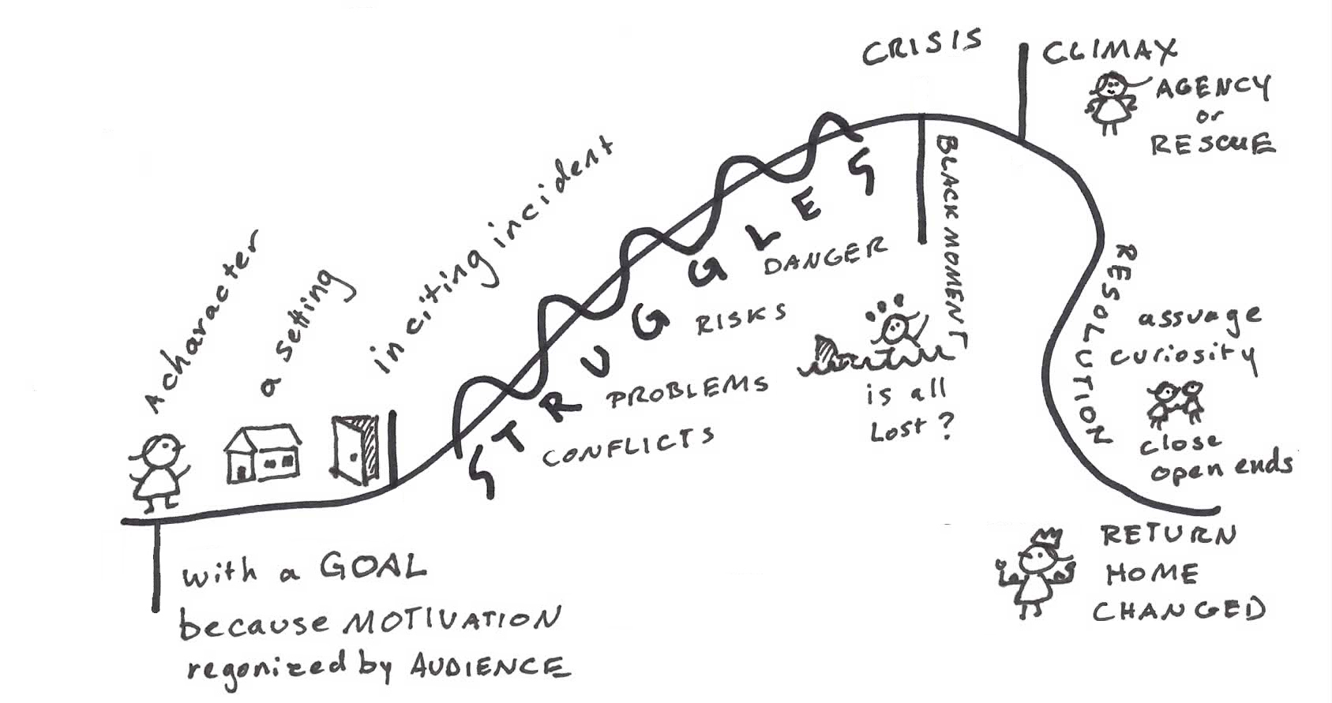
http://eleganthack.com/the-shape-of-story/

I would end the unit on a take home essay assignment focusing on a summary of character development, identity journey, and the coming of age. By the end of the unit, students should have a better understanding of the language, themes, and satire from Mark Twain’s The Adventures of Huckleberry Finn that enhance the identity journey. Some essay questions students would be able to choose revolve around their own identities and comparing them to Huck’s identity journey.
Example of an Essay Prompt: Twain wrote the novel in 1884, when slavery in the U.S. had already been abolished. Describe how Twain develops his themes on slavery and racism through language and point of view of any character.

Works Cited
Baldwin, James. Go Tell It on the Mountain. Everymans Library, 2016.

Lee, Harper. To Kill a Mocking Bird. Guidelines Study Aids, 1989.

Lowry, Lois. Giver. Houghton Mifflin Harcourt, 2020.

Martel, Yann. Life of Pi. Canongate, 2018.

Pace Nilson, Alleen. Literature for Today’s Young Adults. Pearson, 2014.

Pena, Matt de la. We Were Here. Random House Childrens Books, 2009.

Warner, Mary L. Adolescents in the Search for Meaning: Tapping the Powerful Resource of
Story. Scarecrow Press, 2006

Salinger, J. D. CATCHER IN THE RYE. Little, Brown, 2019.

Images:

http://eleganthack.com/the-shape-of-story/

https://depositphotos.com/215942296/stock-photo-group-high-school-students-jumping.html

https://www.goodreads.com/book/show/2956.The_Adventures_of_Huckleberry_Finn

