Jesus Lopez
Dr. Warner
English 112B
30 November 2019
Understanding Fear and how to Avoid its Pitfalls
Rationale:
Fear is a feeling that has gripped everyone at some point, and for good reason, as it is a powerful survival instinct. I wanted to explore the idea of fear and its ability to either bring out the worst parts of humanity or propel people to unimaginable triumphs. Fear is not a learned behavior, however, the way with which it is experienced and dealt with can be. Fear is a topic that should be explored with young adults before they begin navigating the world on their own as it will leave them better equipped to make better decisions.
Growing up I was a very timid child that experienced a lot of fear. My being scared stemmed from constantly changing schools, which left me with no stable support system and subjected me to the taunts of my classmates. The constant ridicule from the other children turned me into a recluse and I often hid myself in the stories of heroes hoping that I could one day emulate that sort of courage. Most of the texts that I was forced to read in school didn’t touch directly onto the subject of fear and thus it became a construct that I wasn’t able to relate to my own struggles.
Reading is a powerful tool that goes underappreciated by many students because the topics that they are forced to read hold no relevance to their everyday lives. Being afraid is something that everyone experiences, but often its importance in shaping students’ lives isn’t discussed. By having students examine not just their own fears, but the fears of characters in literature, it can offer a glimpse into what makes a hero/heroine heroic.
Being afraid isn’t always rationale, and often it doesn’t have to be, but students that can learn to understand their fears and not be subjugated to them, will lead happier lives. Oftentimes fear is rooted in the unknown and one of the biggest issues of fear is our inability to voice it to others. For my Unit of Study, I have chosen the Novel Native Son by Richard Wright as the lead character struggles with fear and ultimately succumbs to it. Bigger Thomas, the protagonist, has his whole life dictated by his fears. The archetype for Bigger isn’t one that is simple to pin down as he could be described as a “Destroyer / Villain” or even an “Orphan,” but it is his ambiguity that makes him a fascinating character to study. Bigger exists in a society that is hard to imagine as it has a dystopian feel, yet he was simply a poor Black man in America during the 1930’s.
Choosing to study fear with students allows them an opportunity for introspection as well as a chance to analyze characters that have their very existence shaped by their fear. Some of the fears that were experienced by Bigger at the turn of the century, are starting to rear their ugly head in contemporary culture. Due to this, I feel it is important to discuss the idea of fear to educate students to explore the unknown with open minds and learn to be empathetic to those that come from different backgrounds. Accomplishing this will hopefully help students to avoid the divisiveness that can be caused through misunderstanding.
Introduction to the Unit
1. Before introducing the novel I would begin with some lines from Kendrick Lamar’s song “FEAR” because he addresses fear at three different ages in his life The reason for the song selection is that it presents the theme in a medium (hip-hop) that is easily accessible for students as well emphasizing fear’s proclivity to be present at all stages of life. Lines from the song include, “I'll prolly die 'cause that's what you do when you're 17 / All worries in a hurry, I wish I controlled things / […] At 27, my biggest fear was losin' it all / Scared to spend money, had me sleepin' from hall to hall / Scared to go back to Section 8 with my mama stressin' / 30 shows a month and I still won't buy me no Lexus.”
A. With the lyrics presented to them I would ask them to write about their thoughts on the lyrics. Ask that they consider some of the fears that they had when they were younger, the fears that they have now, and what are some fears they anticipate having as adults. I would emphasize that they don’t have to be overly personal if they do not wish to but allow them the opportunity to do so if they wish.
B. After allotting about five minutes or so to write I would ask them to gather into groups of four to discuss what they wrote amongst a smaller group of peers (3-5) as it allows them the ability to share in a relatively low stakes environment.
C. This would be given another 8-10 minutes to discuss and then the floor would be open for anyone to share if they like. This would be capped at about 15-20 minutes before moving on to discussing what exactly “fear” is.
2. Discussing what “fear” is. The first evening of homework would include taking some time to consider what they think fear is, what causes it, what are some of the effects of fear.
A. In class after they have finished their assignment at home, I would again open the floor for discussion as the Socratic Method allows students to be involved and have some ownership over the dialogue.

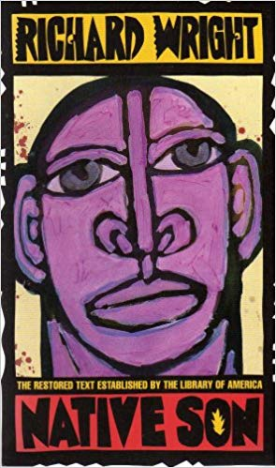
3. Introducing Native Son to the students.
A. Emphasize the importance of the text and give some of the historical background for America during the time of the story.
i. Discuss the history slavery.
ii. Discuss history of Jim Crow laws.
iii. Discuss the systematic oppression towards people of color. Deck is stacked against them.

Working Through the Unit
1. Give a timeline of 15 pages per day for the reading of the book that will allow the class to finish the book within a month. 15 pages per day should take 15-20 minutes daily of reading. To ensure that the reading is being done each student will keep a “Reading Journal” that will serve as their companion to the book. All writing that is done in class will done in these journals and they will be turned in on Fridays so that they can be examined and graded. If there are any personal responses that they don’t wish for me to read, they are able to preface the top of the page with “PERSONAL. DON’T READ.” Writings in these journals are unable to be made up and will represent 20% of their overall grade.
A. After the daily reading’s students will be asked to briefly address what it is that Bigger is doing and feeling in their journals.
i. Why does he do / feel that? How does the world around him affect the way that he thinks and feels? Is he fearful? If so, why? Are the fears real or imagined?
B. Find at least 1 or 2 quotes that support this.
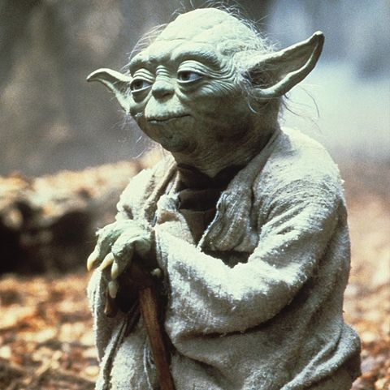
2. There will be daily discussions on the previous night’s readings to gauge the interest of the students as well as their understanding of the text.
A. Show the students the clip from Star Wars where Yoda addresses fear. https://www.youtube.com/watch?v=91_G8iaokk8 . The quote is, “Fear is the path to the dark side. Fear leads to anger. Anger leads to hate. Hate leads to suffering.”
B. Discuss if they believe this to be true. If so, why? Write for 10 minutes before discussing with the class. This will also be in their journal.
C. There will be a daily in-class journal entry discussing the evolution of Bigger’s character arch using at least 1 quote from either teacher or peer about the previous night’s reading.
3. There will be bi-weekly vocabulary tests that will deal with words that have are present in the text as well as words that will serve to strengthen their vocabulary. These vocabulary tests will cumulatively represent 10% of their grade.
4. As we progress through the book the students will be tasked with an art project that will allow them to find/create expressions of fear. This assignment will be due at the conclusion of the book. They can create a picture, take a photo, create a music playlist, movie playlist, find/write poetry, etc. Anything will suffice if it is presented in a thoughtful manner. This will represent 5% of their total grade.
5. Once the book has been finished the students will be tasked with writing an essay that explores the fear that Bigger experiences and whether they are real/imagined and justified/not. The students will examine what are some of the causes for Bigger’s fears. This is one of three main essays that will each represent 10% of their overall grade.
A. For Extra Credit the students will be asked to view the 2019 movie Native Son directed by Rashid Johnson. Assignment is to be one page. Briefly touch on what was appreciated and what could be done better. How does the film compare to the novel?
Extending the Unit
1. After finishing their essay the students will be given an opportunity to choose a text that they wish to read that carries the theme of fear that has been examined in Native Son. Among the choices are:
A. Speak by Laurie Halse Anderson. Melinda Sordino is a freshman in high school that has undergone a sexual assault the previous summer. She lives in fear of telling anyone about what had happened for fear that they wouldn’t believe her. The psychological effects of the fear are examined in the book.
B. We Were Here by Matt de la Peña. Young Miguel has been sent to a group home and harbors a dark secret that he is afraid to speak aloud, for speaking it aloud makes it more real. The fear of judgement and acceptance are present in the text as well. Along with his two companions Mong and Rondell, Miguel escapes his group home and learns to face his fears and accept them.
C. After the First Death by Robert Cormier. This is a story gives the account of a hostage situation through the eyes of three teens. Each character is driven to act from the fear that they harbor as each side sees the other as an “unknown.” Miro is a young terrorist, Kate is a hostage, and Ben, who is on the outside, might be the teen that is most afraid.
D. The Hate U Give by Angie Thomas. The story is about a young girl, Starr, that sees a young Black girl must go to school at predominantly White school while living in a predominantly Black area. Starr is driven by the fear of her friends understanding, how she is perceived in either “world” she inhabits, and societal stereotypes. The book would work in great tandem with Native Son as it offers up a different, and more contemporary, view of the world through the eyes of a person of color.
E. Gemini by Sonya Mukherjee. Two conjoined twins begin to wonder what life would be like if they were able to physically separate from each other. The fear of the unknown lies ahead of them as they are unsure if they will both survive the procedure and what lies ahead if they follow through on it. Looks at the idea of individuality and the fear that drives people to consider the choices that they do.
F. Othello by William Shakespeare. This is a tale that highlights racism and shows the fears that Othello harbors that make him act out irrationally. Othello kills his wife out of fear that his wife had been unfaithful to him. The parallels between Bigger’s world and Othello’s offer a nice compare/contrast.
2. Students will be given roughly two weeks to complete this reading assignment as vocabulary tests will be suspended so that they have more time to focus on their readings. After they have read their book, they are to give a short presentation discussing the fear that is found in the text. This assignment will be count as 5% of their total grade. Among the questions that should be answered by the students (with supporting quotes):
A. What fears did the character have? Why?
B. Do you feel that the character was justified in the way they approached their fear? Why/Why not?
C. Was the character able to overcome their fear? If so, how?
D. What did you learn about fear from this character?
Finishing the Unit
1. Ask students to find some contemporary examples of Bigger’s plight that may still exist in society today. How can we change? Why are people afraid of the unknown? How do we alleviate this fear?
2. There will be a short in-class written response to these questions.

Works Cited
Wright, Richard. Native Son. Harper & Brothers, 1940.
Kendrick Lamar. “FEAR.” Damn. Top Dawg Entertainment, 2017.
Halse Anderson, Laurie. Speak. Farrar Straus Giroux, 1999.
de la Pena, Matt. We Were Here. Ember, 2007.
Cormier, Robert. After the First Death. Pantheon Books, 1979.
Thomas, Angie. The Hate U Give. Balzer + Bray, 2017.
Mukherjee, Sonya. Gemini. Simon & Schuster, 2016.
Shakespeare, William. Othello. 1603.

