Kayla Bolton
Dr.Warner
ENGL 112B
26 November 2019
Graphic Novels

During the early years in a student’s education it is very important for them to be exposed to short stories, books, and plays within Literature to help them with their reading and writing skills. Taking a basic English course and being exposed to different writing prompts and stories allows students to learn how to not only express themselves better, but also learn to feel and sympathize with others. It is also very important for students to become familiar with many different characters and themes so that they are able to understand humor once it is being referenced. With that, the classic novels such as Of Mice and Men by John Steinbeck, or The Great Gatsby by Scott Fitzgerald, for example, should most definitely be taught in a student’s education! To prevent boredom and incorporate intertextuality, however, I am more than happy to teach and provide graphic novels to my classroom as a teacher.
As a young student in middle school, the same books my teachers would provide to the class every year would frustrate me. When a student becomes restless and bored with the same essence of a book, it will hinder them from receiving better grades. The suggestion for me to go out and purchase a graphic novel to read instead made me feel a lot better as it is something different and I am still able to practice my reading skills while growing up. Like the comics, graphic novels provide pictures and words to tell a story. This genre will grab the attention of many students as they are able to immediately see what is happening within the story as they are reading it rather than imagining or guessing. Graphic novels are essentially an easier read for students in their adolescents but has many benefits, nonetheless. Strong readers are able to enjoy graphic novels as well. It is also very beneficial for students with dyslexia too because the pictures and the words are inseparable, and it is much more difficult for them to become lost. Overall, the purpose of exposing my students to a graphic novel is to provide a piece of literature that is not so generic and truly “reel them in” with the intertextuality of a genre they may very much enjoy.
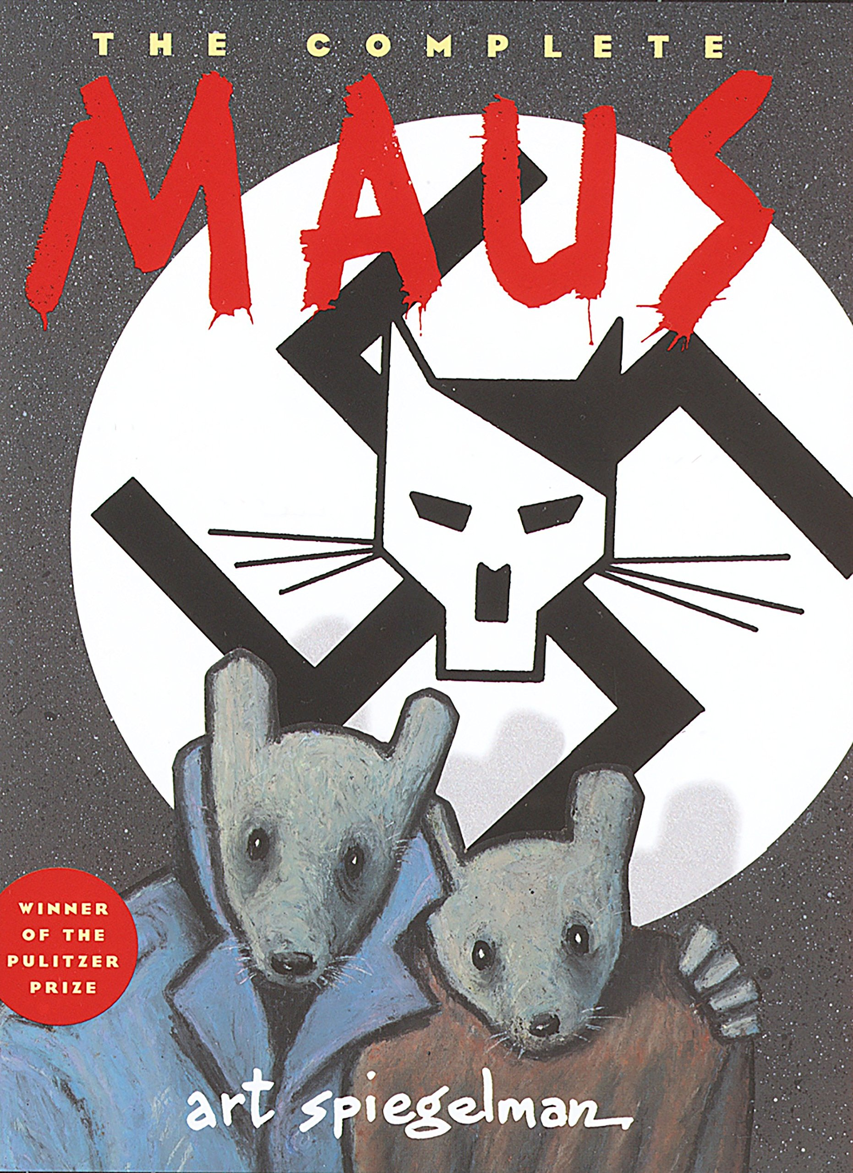
Mrs. Quint, from my field experience, inspires me to start the classroom with the graphic novel of Maus by Art Spiegelman. It is one of the most important graphic novels as it reflects the movement of a new piece of literature. A major event that influences Spiegelman to write and illustrate this novel is the Holocaust. Along with introducing a graphic novel to the class, I would also be introducing the students to a piece of important history during World War II if they have not learned about it already. Not only that, but the students are able to see how people are treated during this time period due to their beliefs of heritage. “Maus” is the German word for mouse, and when the Nazis reign over Germany they refer to the Jewish people as “mice” or “rats.” Giving the students insight on the title and expand their vocabulary from another language will further grab their attention and help them get into the story as it is about mice instead of human beings.
After about every 40 pages of so, Mrs. Quint provides a quiz to the students in order for her to see if they have been paying attention and following along. I notice the class does follow along with the teacher and read the book, however, I notice the students grow very anxious and nervous at the thought of a quiz in front of them. When teaching my class, I am definitely more willing to use a method I picked up from Dr. Warner’s ENGL 112B course, which is to give the students about 20 minutes to simply write. I will give them a prompt on some days for them to follow and on other days I will give them the freedom to write what they want on the particular 40 pages. I would even write with them and after the 20 minutes we will all have a class discussion about what we have written. With this, students are able to practice writing without the stress of taking a quiz. It is like having their own journal. As we all discuss what we have written it will insist the students to developing their communication and public speaking skills.
Of course, students are not going to be able to stick with graphic novels forever as a lot of other important pieces of literature do not fit that genre. My method of providing it first, though, will simply reel them in and prepare them for the next novel that I would like to pair with Maus, which is Night by Elie Wiesel.
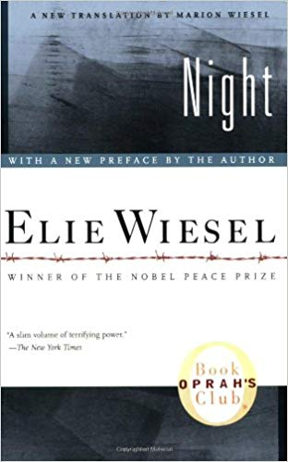

Wiesel writes the novel for young adults about her life during the Holocaust time period. This is where students are able to see first person what Wiesel suffers through. They are given a chance to read a piece of Literature that won a Nobel Prize. When transitioning from Maus to Night, though, I will provide a couple of poems from the Holocaust for the class and I to read and discuss together. Poems are usually short and sweet, yet very powerful and it is something students should be exposed to at an early time of their lives.
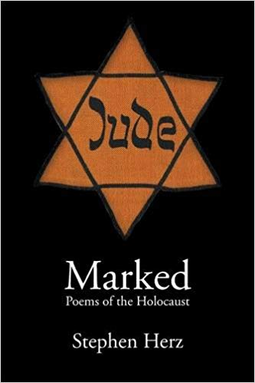
I started to read poetry at the age of 18 when I became a freshman in college, but I wish I became exposed to it earlier as it was sort of difficult for me to understand. After buying this book of poems for myself and the class, I would choose a few that have a deep meaning and discuss it with the class. With this exercise and transition, students are able to feel and understand through poetry and learn about the terminology that goes into it.
Lastly, I would most definitely love to teach my students William Shakespeare’s play, The Merchant of Venice. Students should be exposed to Shakespeare in my English class as he is one of the most powerful, well-known writers from the 1500s. All of the works that I will have provided by then, have all allowed the students to truly feel and sympathize to the characters suffering. By providing Shakespeare’s tragedy as the last part of the course the students are able to see the suffering of Shylock’s character, emotionally instead of physically. He is a complex character that simply gets everything taken away from him due to his religion and also loses his identity. I will be very excited to see how my students feel at the end of the play.
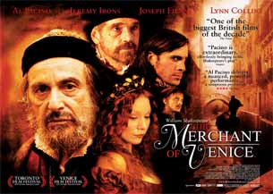
Because I really want to allow students to be exposed to more graphic novels I will tell them that they are to choose a graphic novel to read until the end of the course. As the final they are to write a literary analysis on the book of their choosing and then do a presentation on the book and their overall opinion on the genre of graphic novels! The literary analysis will be for me as the teacher to see how their writing skills have improved and the presentation will be very beneficial to them as they are able to practice their public speaking skills.

Missing Elements (I apologize!)
To first get my young adult students “into” the text, genre for my Unit of Study provide them all with their own post it note stack and ask them to draw their story of what they did over the summer or even their last birthday. This will have them see the difference between explaining verbally what happened and actually drawing it with their creative skills. After that, every student must show and verbally talk about what they did. This is also a great way to see how artistic a person is and how comical it may be to see people’s drawings who are not very artistic.

Through the text I would let each student pick a comic book of their preference. With this they will compare the difference, if there is any, of the comic book and the graphic novel Maus that we will be working on. Essentially, they are both the same thing though there are many differences between the two that they will be able to find.

Beyond the text I expect my students to go out and pick their own graphic novel book similar to what I did in ENGL 112B class where we had a book to read and then later present for the Book Talk presentation. (See above in last paragraph)

Works Cited
Herz, Stephen. Marked: Poems of The Holocaust, NYQ Books, 2014.
Shakespeare, William. The Merchant of Venice, William Shakespeare, 1600.
Spiegelman, Art. Maus, Patheon Books, 1980.
Wiesel, Elie. Night, Bantam Books, 1982.

