Cristian Cortez
Dr Warner
English 112B
10 December 2020
Young Adult Literature Assisting with Mental Health
Rationale: Mental health throughout the years has become a more predominant issue for young adults. With technology and social media dependence increasing in society young adults are the ones who are more influenced by their effects. With the rise of apps such as Tik Tok young adults are creating standards that are impeccably unrealistic. Issues such as LGBTQ+, body standards, friendships, and drugs can be very dominant in the life of a young adult. Although a young adult may not experience all of these issues it is very probable that they have encountered the dilemma through their friends' experience. Young Adult literature that focuses on characters that the reader feels connected to allows the reader to experience the same issues as the character ,as well as learn with them on their journey. Through this specific unit students will be able to comprehend the issues that can damage one’s mental health but also learn how to support themselves and their peers during a troublesome time in their lives.
The unit will include multiple texts that focus on mental health as well learning how to manage a moment of struggle. It must be made aware that the topics that we will be discussing during this unit will be sensitive as rape, drugs, and suicide are apparent. If this becomes an issue with any student I will first approach the student with caution and see if they want to let me know of anything that may be on their mind. Often a student does not want to participate in difficult conversation because they have experienced it. If they feel comfortable enough to share their experience I will be there to listen. If the student does not feel comfortable at the moment I will ensure that they have resources available to them as well as letting them know I am available to speak.
To begin the unit we will be using the canonical text The Catcher in the Rye by J.D Salinger. This a text that I will become familiar with before using it as it is a work that I have not yet read. Holden is the protagonist of the story as he goes through explicit struggles such as the death of his brother leading to his desire of suicide. Within the novel Holden seems to be okay but in reality he is struggling internally. We will specifically look at the text through the various scenes that Holden is in and identify the struggle and how to confront it. For example in the scene in which Holden has a breakdown we will focus on the emotions that he expresses and learning how to process emotions in a healthy manner. The canonical text will be essential in this unit but in conjunction with the supporting work will allow students to proceed with their days knowing they have learned how to properly identify mental health issues and how to process them.
Introduction to the Unit: I will commence the unit by introducing the class to the song 1-800-273-8255 by Logic. The class will walk in and notice that there is a music video playing on the screen. The 7 minute music video displays how a black young adult is struggling with his mental health. In the music video suicide attempt and an LGBTQ+ relationship is apparent. A young African-American boy struggles with accepting himself as he lives alone with his father. I will have the students describe the scenario and what they have felt. I will ask the question in which they will journal about a time in which they have struggled and been able to get back up. It is important for myself to not only have the student reflect on their struggle but also how they managed to recover. Each student will receive the lyrics to the song and asked to analyze it. Afterwards I will ensure that they know the title of the song is a helpline that they can reach out to whenever they are struggling.
Within the text: Each student in the class will be reading a supporting story that they will connect with. Prior to deciding 1 of the 4 novels they will read a brief summary of the story. The 4 novels they will be able to choose from are Looking for Alaska by John Green, Speak by Laurie Halse Anderson, We Were Here by Matt de la Peña, or The Perks of Being a Wallflower by Stephen Chbosky. Each novel focuses on different situations but deals with similar ideas of deteriorating mental health. While reading the novel the student must complete a reading log in which they are expected to complete the following. Write out the name and title of the novel while giving a summary of the story capturing the most crucial events. They must list out main characters of the stories and give a physical description as well as their importance to the story. Setting and time will also be described but it must be mentioned on how it affects the conflict of the story. 3 Themes of the story were described as well 3 essay questions that could be potentially used. Finally they will analyze 3 quotes and their importance to the novel. This log can seem like an overwhelming amount of work but will be given sufficient time to complete.
Although not every single student will be selecting The Perks of Being a Wallflower I will be using it in order to compare and contrast Holden and Charlie. I will break the class into multiple groups of 3-4 students and each group will create a venn diagram to share. Within their venn diagrams I would like to see quotes that build upon the theme in both novels. Each group will present together in front of the class in 5-10 minute presentations. For the students who have decided to read the novel they will have the option of an enrichment assignment to compare and contrast the film to the novel. If available any of the other novels could be used as well.
After watching the film I will assign a poem by e.e cummings, In the Middle of a Room in which the students will analyze for homework. The following day we will participate in a socratic seminar in order to discuss the poem. It is important to change the format of the classroom to build comfort. We will be using the poem, their personal read, and the canonical work to discuss mental health. I will be facilitating the conversation with questions such as: Why did the character feel overwhelmed? What were some warning signs? What would you do if you were a friend/peer to the character? How could you have supported? This question will allow the students to understand the relevance of the works as they too will have experienced struggles. The end of the conversation will focus on preventative measures and what led the characters to struggle.
To end the unit each student will write a research paper that focuses on mental health. Some topics that a student might want to explore are suicide prevention, bullying, substance abuse, and managing broken family relationships. The student will be required to use 2 of the works within the unit to support their argument. The day in which they turn in their assignments will be a self care day in order to reward my students for their hard work. I will bring in snacks, a movie, and arts and crafts so they can have a moment of peace in their difficult day. When class concludes that day I will remind the class of all the resources they have on and off campus as well as reminding them that I have an open door policy. I will be willing to have any conversations they might have.
Beyond the text: After concluding the unit I would encourage my students to continue to read works that they feel connected to. I will suggest novels that continue to focus on mental health.
The Outsiders by S.E Hinton focuses on two gangs that are divided due to socioeconomic status. The themes that are included focus on suicide, death, and poverty. A student would be able to potentially feel connected to the novel as they too may feel exclusively part of a group because of their economic status. Furthermore gang life may be dominant in their lives that affect their mental health.
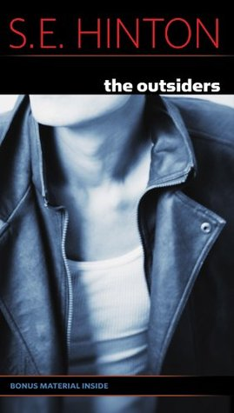
Thirteen Reasons Why by Jay Asher focuses on the life of Hannah Baker and what led her to commit suicide. There is a Netflix T.V show that is an adaptation of the novel. I would suggest this book with caution as it does involve heavy topics such as rape that may be a trigger. Furthermore a student could use the novel in conjunction with the T.V series and notice the similarities and differences.
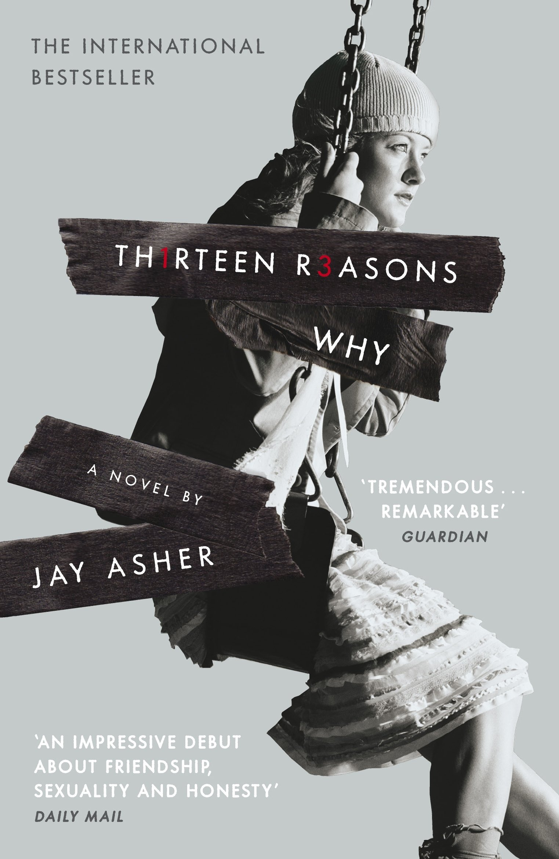
The Absolutely True Diary of a Part-Time Indian by Sherman Alexie focuses on a Junior and his transition from life on the reservation to an all White high school. One of the dominant issues of the novel is lack of wealth as his family cannot afford the new school he attends to but makes it work. Furthermore alcohol abuse leads to deaths that Junior struggles with. A student who may suffer from a parent who struggles with alcohol abuse would be able to turn to this read and not feel alone.
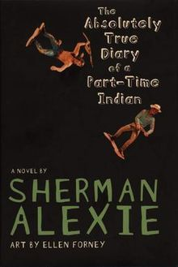
Works Cited
Alexie, Sherman. The Absolutely True Diary of a Part-Time Indian. Cornelsen, 2009.
Anderson, Laurie Halse. Speak. Square Fish/Farrar Straus Giroux, 2019.
Asher, Jay. Thirteen Reasons Why. Klett Sprachen, 2010.
Chbosky, Stephen. The Perks of Being a Wallflower. Thorndike Press, a Part of Gale, Cengage Learning, 2020.
Green, John, and Julie Strauss-Gabel. Looking for Alaska. Penguin Books, 2019.
Hinton, S. E. The Outsiders. Viking, 2019.
Peña Matt de la. We Were Here. Ember, an Imprint of Randon House Children's Books, 2019.
SALINGER, J. D. CATCHER IN THE RYE. LITTLE, BROWN, 2019.

