Jacob Stewart
ENGL 112B
Warner
Human Nature in Science Fiction and YA Literature
Explanation of Topic:
The genre of science fiction— as it is commonly understood now— is relatively new. Mary Shelley’s 1823 novel Frankenstein; or, the Modern Prometheus is now considered the first ever science fiction novel, a title it earns by existing as the first notable example of speculative fiction dealing directly with technological development. The novel is, in many ways, a response to the concept of galvanism and an exploration of the implications of such scientific breakthroughs. Science fiction didn’t immediately take shape; the term “science fiction” only came about in the 1920’s, nearly a century after Frankenstein was published. Since then, the exact definition of “science fiction” has been changed, tweaked, swapped and replaced many times. At its core, though, a science fiction novel is one that examines technology, and humankind’s relationship with it. The genre historically has faced some push-back. Though pure science fiction is grounded in real scientific understanding, it almost always deals in imagined scenarios, possible futures. Because of this, sci-fi works have often been discredited and discounted as being make-believe nonsense with no value, much like how fiction novels were viewed before their own rise in popularity.
It is in this manner that science fiction literature and YA literature are similar. Both genres are seen as childlike, and while it is true that sci-fi is imaginary, and that YA is about children, both genres hold mountainous amounts of value. The profound cynicism of science fiction, as well as its at times rebellious nature have seen many novels banned or withheld from publishing for the message they send. This challenging nature is another reason that sci-fi and YA go hand in hand. YA most often deals with bildungsroman narratives in which young characters find their perceptions and worldview’s challenged and changed. Science fiction, at its heart, is about challenging the perceptions of its characters and its readers.
It is in this age— an age marked by increasing amounts of digitalization, the decay of the natural world, and great political divide— that humankind is most in need of what science fiction has to say. Technology holds more power over people than ever, and that power seems to only be increasing rapidly. The genre is ripe with both canonical and non-canonical works exploring things such as humankind’s relationship with technology, nature, government, and the nature of being human. This is because, even though science fiction is named for it’s focus on technology, it is primarily concerned with humanity. It is self-reflection on a societal level, and that is why it holds so much value. Through a YA perspective, science fiction can tell stories with profoundly insightful implications, leaving readers of all ages with thought-provoking questions. By looking at the way science and spirituality mingle in both newer YA science fiction and less-recent adult science fiction, the value of the genre can be clearly seen.

Annotated Bibliography
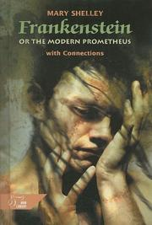
- Frankenstein; or, the Modern Prometheus, by Mary Shelley
Summary: (Have Read)
In Shelley’s novel, a young Victor Frankenstein births— through galvanism and other scientific means— a live, sentient Creature. Horrified by his creation, he abandons it; left alone, it learns to speak and gains an understanding of its own emotions by observing other humans. It returns, asking Victor to make it a mate. Victor declines, and the vengeful Creature becomes a source of misery and death in Victor’s life.
Relevance:
Exeter Qualities: 1, 2, 4, 7
Crowned the first science fiction novel, this story represents the very core of the genre. Shelley was exposed to the then-new concept of galvanism, and the implications of such technology formed the basis of her novel. The novel explores whether or not man is responsible enough to have such technology, which can create life from death. The story is told on a very small scale, which allows it to feel extremely personal. This allows its more spiritual themes to shine. The story marries its scientific commentaries with its philosophical commentaries very smoothly, which is why I felt it would be a perfect centerpiece novel for this annotated bibliography.
- Do Androids Dream of Electric Sheep, by Philip K. Dick
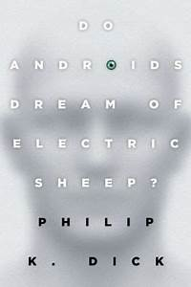
Summary: (Have Read)
Published in the 1960’s, this novel takes place in a gloomily imagined 2021. The story follows Rick Deckard, a bounty hunter who makes a living working alongside the police to kill, or “retire,” androids. As he hunts down a group of deadly androids called the Nexus-6, he finds his perception of the world challenged; in a world where being “human” is marked by whether or not one has empathy, Decker finds himself uncertain who or what deserves to live.
Relevance:
Exeter Qualities: 1, 2, 4, 5, 7
While this book is not a YA novel, Deckard goes on a journey that, in many ways, is similar to the journey of a YA protagonist. He grows as a human being throughout the story, and his previously narrow worldview is opened by the moral dilemmas he is faced with. This story’s commentary covers a wide range— nature, sentience, empathy, religion, and what it means to be human. Much like Frankenstein, the book poses a great many questions regarding the nature of humanity. The Voigt-Kampff test that is used to test whether or not someone is an android is assumed to be infallible, but the story demonstrates that the line may be harder to distinguish than a simple measure of empathy, which is shown by the surprisingly unempathetic actions of some humans, and the empathy shown by androids.
- Scythe, by Neal Shusterman
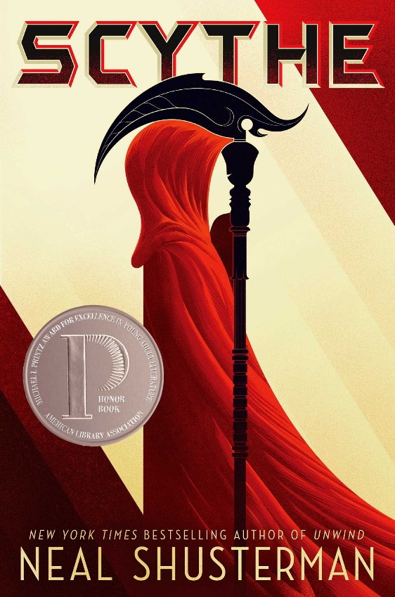
Summary: (Have Read)
Set in a world where human beings live perfect, eternal lives under the care of an AI called the Thunderhead, the dealing of death is the business of individuals called scythes. Citra Terranova and Rowan Damisch are two teens that find themselves apprenticed to a scythe, and both of them must navigate the Scythedom— the last vestige of human greed and power-hunger— as they decide what kind of scythes they want to be.
Relevance:
Exeter Qualities: 1, 2, 3, 4, 5, 6, 7, 8
This novel perfectly marries the YA and science fiction genres. The characters are late high school age, a very transformational and developmental period of the human lifespan, even when that lifespan is endless. The story uses these characters to inform the reader of the world in which they live. Scythe explores the nature of government, as well as human corruptibility in positions of power. It also offers profound insights into the nature of religion and humankind’s relationship to technology. In this world, Shusterman pitches the idea that mankind cannot be trusted with its own ruling, and that perhaps humanity would fare better if we weren’t in our own hands. The death-centric themes of the novel bring up questions regarding the necessity of suffering and what gives life meaning.
- Chaos Walking: The Knife of Never Letting Go, Patrick Ness
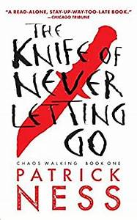
Summary: (Have Read)
Humanity, forced to leave Earth, has colonized New World, and earthlike planet. Todd Hewitt, a boy on this planet, has to live in a world where all women have died, and he is the last boy. On this planet, everyone’s thoughts are audible and visible in a cloud around their head called Noise. Todd is ready to be a man, but his world is flipped upside down when he finds the last thing he would have ever expected: a girl. He finds himself at the center of a conflict he must grow up to face.
Relevance:
Exeter Qualities: 1, 2, 3, 4, 5, 7
While this story isn’t grounded in too much real science and falls more into the general category of speculative fiction, it has many extremely raw and powerful statements to make about the nature of mankind. On this planet, everyone can hear everyone else’s thoughts; there are no secrets, nothing is taboo, nothing is filtered. Todd starts the story with an extremely small and narrow idea of the world; all he wants is to be a man. When he meets Viola, the first girl he’s ever seen in his life, she leads him into a whole mess of secrets, and a violent history that he has to reconcile. The story talks about government, human corruptibility, psychology, and more than anything else, the way hardships make us grow.
- Divergent, by Veronica Roth
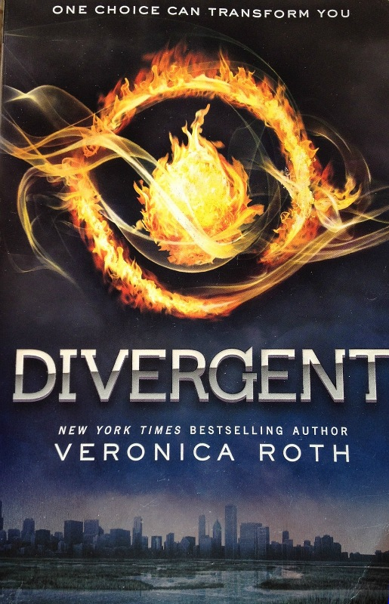
Summary: (Have Read)
Set in a dystopian version of Chicago, humanity lives in factions based on their core values. Tris, a girl born into the selfless faction of Abnegation, finds herself at the age of 16 forced to choose whether to stay in her faction or leave it for another. She has to make the important choice of what she values most, what kind of person she wishes to be. However, as she will soon learn, no human being can be categorized by a single trait. Not everyone can follow.
Relevance:
Exeter Qualities: 2, 3, 4, 7
Possessing the core YA theme of self-discovery and growth, this story takes that idea and sets it into an imaginative and thought-provoking speculative world. The story explores the differences between people and their values, as well as asserting that people can’t rightly be classified by a single characteristic. Much like many other science fiction stories, this novel asserts the negative aspects that can occur under a certain kind of authoritarian rule, as well as explores the danger in division, something very relevant to today.

- Perfect Ruin, by Lauren DeStefano
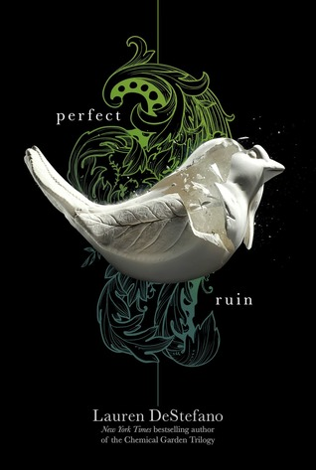
Summary: (Have Read)
This story follows teen characters living on a floating city in a utopian society. They can have any job, they’re matched with their soul mates, and everyone is given livable housing. The only rule: don’t go near the edge. When the city has its first murder in nearly a century, main character Morgan Stockhour finds herself wondering about the ground below their city, and why the edge is forbidden at all. She can’t stop herself from investigating, following in the footsteps of her brother, who was a “jumper.”
Relevance:
Exeter Qualities: 2, 3, 4, 7
Another more speculative story, though still with enough grounding in the idea that it is through technology this situation is possible, this novel keeps with YA themes of growing up and questioning the world around you in a setting that provides profound insights into the nature of censorship and totalitarianism. The story has a lot to say about restrictive government, one that uses utopia as a means to control its population. Through this, the novel asks questions regarding whether or not happiness is the ultimate goal of human life, or whether agency is more important.
- Brave New World, by Aldous Huxley
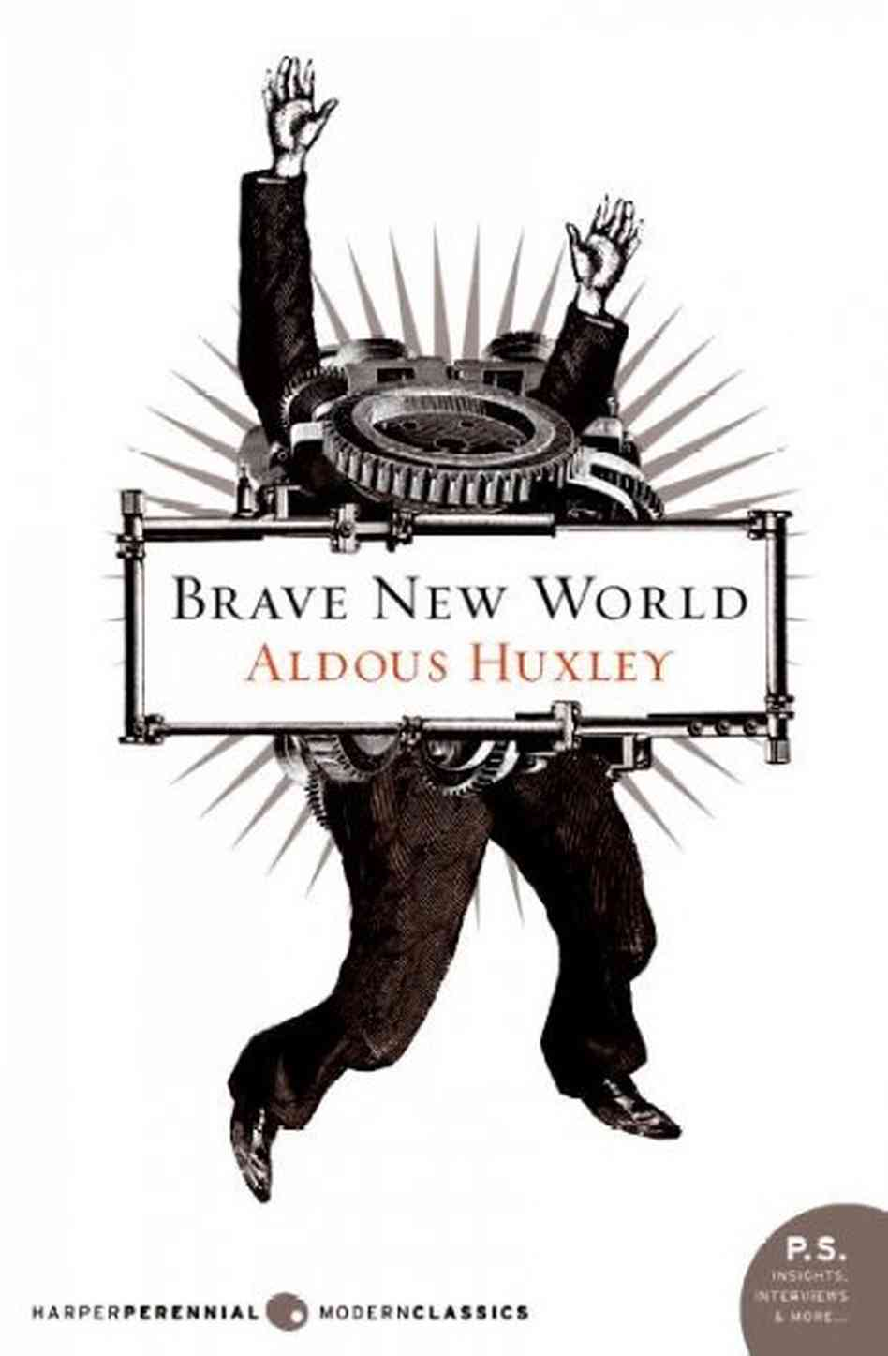
Summary: (Have Read)
Heavily influenced by Orwell’s 1984, Huxley imagines a world where life is pain and stress-free, but meaningless and hazy. When the characters living in this utopia, such as Bernard and Lenina, are exposed to John the “savage,” a man who spent his life on a reservation separate from the rest of the World State, they find their understanding of their existence challenged by Shakespearean ideas of suffering and purpose, which go beyond shallow pleasure.
Relevance:
Exeter Qualities: 1, 2, 4, 6, 7
Though this novel is not a YA novel, it holds many themes that are extremely relevant to youth in today’s world. The story is heavily focused on the use of technology to create a euphoric haze, lulling the population into complacency and obedience. This is extremely relevant to the way the internet and smart phones are being used to influence the way people collectively think, through the rapid spreading of information paired with the chemical pleasure that comes from using a smart phone. This story, through its heavily scientific speculative setting, examines the nature of human suffering and whether or not a blissful existence is truly the most desirable, or if the shallowness of physical pleasure is merely a distraction. This story stands as a testament to the ability of science fiction to challenge the direction of technology and society.
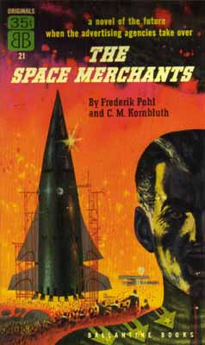
- The Space Merchants, by Frederik Pohl and C.M. Kornbluth
Summary: (Have Not Read)
In a future where capitalism and consumerism are hailed as the highest ideals, this science fiction titan follows Mitchell Courtenay, an associate of one of the two major advertising industries vying for control of the Venus colony’s economic market. Mitchell finds himself forced to help a radical resistance group with which he does not agree, since he is a well-conditioned pawn of the advertising agencies in power. He plans on betraying this group, but he is first exposed to how “the other half” lives.
Relevance:
Exeter Qualities: 2, 4, 6, 7
Written in the 1950’s, this novel is by no means a YA novel, but it cannot be ignored in a conversation about science fiction. This story focuses less on the individual-level of storytelling and instead focus more on the societal allegory. Hailed as “prophetic,” this story exposes the harmful nature at the center of capitalism and consumerism, revealing them to be built upon suffering and exploit. This novel embodies science fiction’s ability to warn of the future, much like Brave New World.
- Feed, by M.T. Anderson
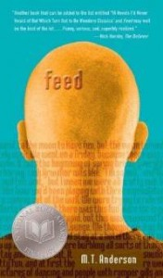
Summary: (Have Not Read)
Another “prophetic” book, Feed takes place in a world where people have implants that connect them to the Feed, which is essentially the internet. Falling under the cyberpunk subgenre, the story keeps with the themes of implanted technology, as well as the way corporations harvest information through this technology. When the main character, a wealthy teenager named Titus, meets a girl names Violet, who makes him question everything he thought he knew.
Relevance:
Exeter Qualities: 2, 3, 4, 6, 7
Cyberpunk as a subgenre of science fiction is specifically concerned with the fusion of humankind with technology, and as such the majority of cyberpunk stories include some aspect of “implantation.” This story, which focuses heavily on the way people’s information and data are harvested through their activity on the Feed, or the internet, is extremely relevant to the modern world where the same thing is currently happening. Though people aren’t implanted with devices, they carry their devices with them. This story explores the nature of this harvesting and the relationship between human beings and their “implants,” or, their smart phones.
- The Giver, by Lois Lowry
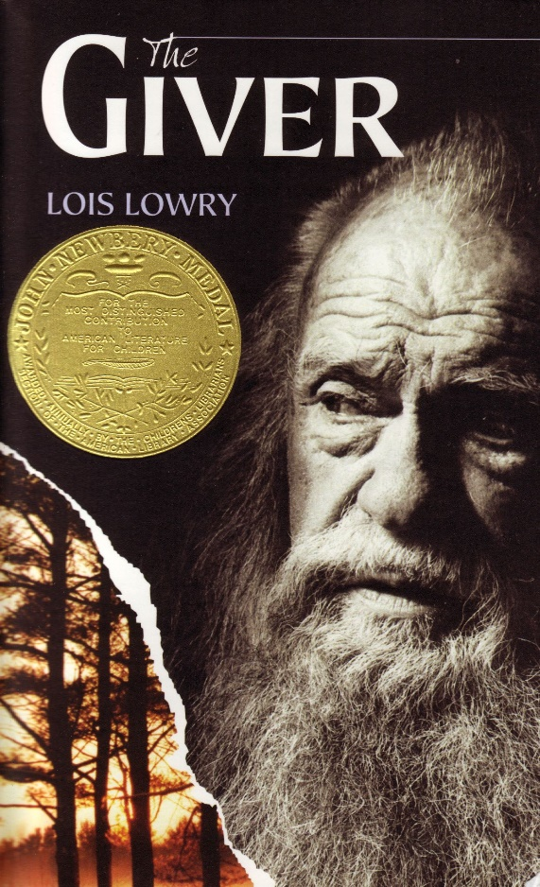
Summary: (Have Read)
Another story set in a seemingly utopian society, The Giver follows Jonas, a young boy living in this painless and prejudice-free future. Everyone is polite, everyone is given a job they’re fulfilled by and a spouse they will get along with. When Jonas is chosen to be the Receiver of Memory, the Giver transmits to him all the memories of pleasure, pain, color, excitement, terror, etc., which lead him to see the world differently, especially once he learns what a world full of these emotions would look like.
Relevance:
Exeter Qualities: 2, 3, 4, 7
This is another story that is more speculative than scientific, but it keeps with the overall themes of science fiction. On a general level, science fiction literature explores what human existence would be like in a world where technology is taken to extremes; The Giver does just this, focusing purely on human psychology and the effects of an emotionless society, as well as how a human would react to emotions if they had never experienced them before. While there are more faithfully scientific novels on this list, I believe the genre can stretch to incorporate less grounded stories such as this one.
Works Cited
Anderson, M. T. Feed. Candlewick Press, 2012.
DeStefano, Lauren. Perfect Ruin. Harper Voyager, 2013.
Dick, Philip K., and Tony Parker. Do Androids Dream of Electric Sheep? Boom! Studios, 2011.
Huxley, Aldous. Brave New World. Chelsea House, 2019.
Lowry, Lois. The Giver. Seedlings, 2016.
Ness, Patrick. Chaos Walking: The Knife of Never Letting Go. Walker Books and Subsidiaries, 2018.
Pohl, Frederik, and C. M. Kornbluth. The Space Merchants. Thomas Dunne Books, 2011.
Roth, Veronica. Divergent. HarperCollins, 2014.
Shelley, Mary Wollstonecraft, et al. Frankenstein. Oxford University Press, 2008.
Shusterman, Neal. Scythe. Simon & Schuster BFYR, an Imprint of Simon & Schuster Children's Publishing Division, 2016.

