Lupita Castañeda
Dr. Warner
ENGL 112B
22 November 2020
Unit of Study:
Developing an Understanding of Intersectionality through Literature

Rationale:
The year 2020 was very difficult for many Americans due to unemployment, sickness, death, and many more problems stemming from the COVID-19 pandemic. At the same time, the death of George Floyd in Minneapolis sparked outrage as police brutality continues to be a prevalent issue in the United States. After his death there were several Black Lives Matter protests not only in the United States, but all around the world. As the BLM movement became prevalent around the world it is evident that racism is something that has been collectively experienced by people of color, and specifically Black people, for hundreds of centuries. As many people stayed at home during the pandemic there was a surge of information and knowledge being shared on the internet to help others understand these massive systemic issues. As people of color around the world shared their negative experiences it made me realize how intersectionality is so complex, yet at the core of intersectionality there is the basic understanding that there are distinctions in each human that affects the quality of life within themselves as an individual and their communities as a whole. It is important to make a note of these distinctions collectively under the umbrella of intersectionality to understand the complexity of different issues around the globe.
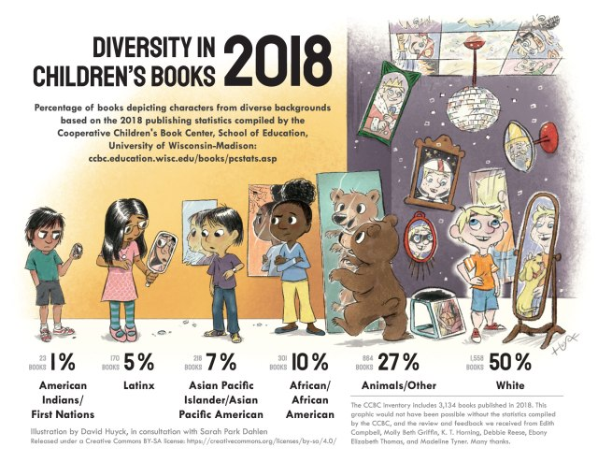
Image taken from Dr. Dahlen’s Infographic: https://readingspark.wordpress.com/2019/06/19/picture-this-diversity-in-childrens-books-2018-infographic/
Many students often feel that their experience is not represented within the classroom, which has clearly been discussed within the pandemic as certain students struggle without internet access all while their entire education is now internet-based. Within Dr. Dahlen’s infographic, it is evident that the erasure of specific identities that are not considered to be a part of the “majority” are underrepresented in children’s literature. Although this infographic focuses on children’s literature it can easily be applied to K-12 schooling as the lack of representation continues even in the twenty first century. If there is a lack of representation in books this can easily transfer to a lack of representation of content in the classroom as there is little content to begin with. When there is a larger percentage of representation of animals over humans in literature a change must happen. Because each minority is underrepresented at different percentages it is vital that intersectionality be taught in order to help all students understand the varying experiences of people through literature that depicts an array of cultures, ethnicities, races, nationalities, the list goes on!
The centerpiece of this Intersectionality Unit will be the canonical text, The House on Mango Street by Sandra Cisneros. I was introduced to this text while I was in my Junior year at San José State University and it changed my life forever! This is the true joy that students will find in this unit, the joy that is found when reading about yourself, your community, and your story within the classroom setting in a text. Although A House on Mango Street revolves around Esperanza, a Chicana, it is crucial to recognize the various ways in which this text explores several themes discussing intersectionality. This will allow every student to see themselves in the story, even if they do not identify as Chicanx. One main theme discussed in the text is racism, which is something that has been faced by students of color ever since Native Americans were sent to “assimilation schools” in which their culture and identity were stripped from them.
Intersectional themes in A House on Mango Street:
- Financial problems
- Bilingualism
- Privilege
- Housing
- Puberty
- Harassment (verbal/sexual)
- Gentrification
- Immigration
- Income
- Relationships/Friendships
- Cultural prevalence/erasure
  - These are considered “intersectional themes” because they are collectively experienced within people despite differences in race, class, gender, etc. For instance, a Japanese student and a Portuguese student could relate to the theme of bilingualism found within A House on Mango Street even though both the students and Esperanza are of a different race. They still share a collective experience of the difficulties surrounding bilingualism, even if the languages spoken at home are different. Through the intersectional theme of bilingualism any student speaking a different language at home can relate to Esperanza despite not identifying as Chicanx. The beauty of these themes is that every student will find a way to relate to the novel making their experience more powerful.
It is evident that intersectionality will give all students the platform they deserve to showcase what makes them and their culture, family, religion, race, or ethnicity unique. By reading The House on Mango Street students will be able to identify which themes of intersectionality are at play within Esperanza’s life all while understanding how they can see themselves in the book as well. This text will serve both as a mirror and window for students to see themselves reflected on the pages and to get an insight on the lives of the students that make up our classroom in the pages. As a teacher of color, it a great honor to show my students works create by authors of color that reflect authentic experiences.

Introduction “into” the Text:
When I first learned about intersectionality it was difficult yet fascinating to see how many different aspects were a part of one specific word. The best way to begin the introduction to intersectionality would be of course by listening to the words Kimberlé Crenshaw who coined the word in 1989. We will watch this short YouTube clip https://www.youtube.com/watch?v=w6dnj2IyYjE together before coming back for our intersectionality activity. This video is great because it defines the word, explains how Crenshaw coined the word, and gives examples of the word in play in people’s lives.
Intersectionality Activity:
As the students come back together, I will have students stand in four preselected groups, one at each corner of the classroom. On the walls there will be a large poster paper with different “fill in the blank” questions surrounding intersectionality. There will be a total of four questions.
- One important aspect of my culture is _________.
- I feel that I am unique because _________.
- My favorite language to speak at home is _________.
- My favorite cultural holiday is _________.
Each group will start with one of the questions, the question they start off with will be their group number. Each group must write down their group number with four different answers under that number, one for each member of the group. They do not need to put their names next to their answers. After two minutes each group will move counter clockwise to the next poster with the next question and repeat the process until each group has answered all four questions.
After the complete cycle has finished each group will sit in chairs gathered together, so there will be four different desk clusters. I will have the groups select which student will explain their answers for each question, every group member will speak because there are four questions and four group members.
Following this activity, I would give a short lecture to the different aspects of intersectionality. I would ask students to take notes as that will be important for our next activity. I will specify which words to look out for that will appear in our next assignment before beginning my lecture. I would have a PowerPoint presentation to help guide the students along to the key points of my short lecture. After the short lecture I would follow up with a simple yet informative Intersectionality chart activity. My short lecture will cover the definitions of the six words listed on the chart and how they relate back to intersectionality. I will give each students the chart and give them fifteen minutes to fill it out to the best of their abilities. The chart will be used to help the students recognize how intersectionality is at play in their daily lives. By understanding this concept through their own individual experiences, it will enable them to then further see different aspects of intersectionality in other students. The student will draw themselves in the middle and fill out the chart. The circles will be overlapping, demonstrating how intersectionality is at work when more than one identity is at work within an individual, for example race and culture. Below is an example of a chart that I created for this activity.

Intersectionality Chart
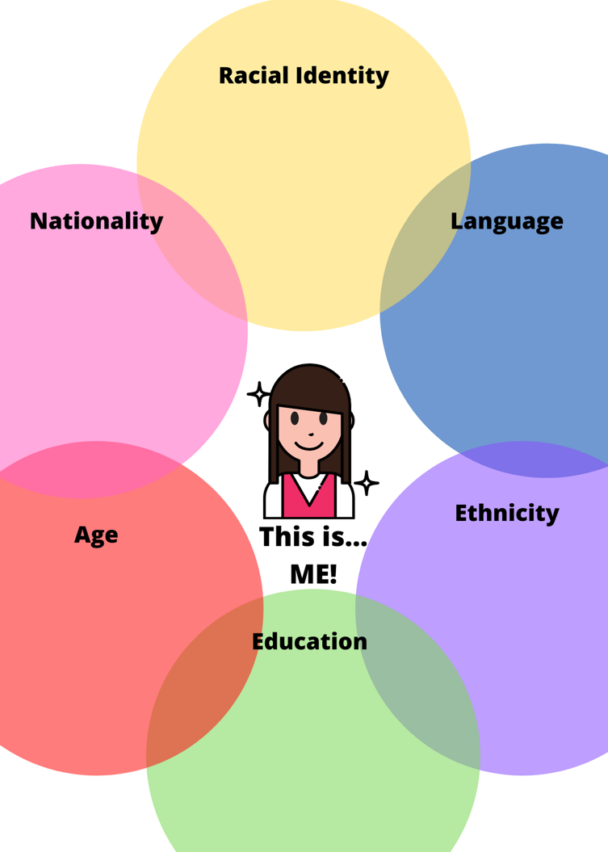

Reading “through” the Text:
The House on Mango Street is a quick and fun read with loads of information about intersectionality. Within the class we will read ten pages together and assign twenty pages for homework and the book can be completed in four class sessions. I will be following the block schedule of the two teachers that I observed, Sarah Johnston and Laura Weaver. They have about two or three classes a week with the students depending on which block (A/B) started on Monday.
The first step in our class discussion will be a “Bell Ringer,” taken from my observation hours with Sarah Johnston. The Bell Ringer consists of three questions related to the text, but at a much larger scale in order to help student begin to think about problems and themes that will arise in our ten-page in-class reading. I will give the students ten minutes to answer the questions in their writing journal. This journal will be collected at the end of the week for participation points, it will not be graded on grammar or spelling errors, simply on completion. After ten minutes there will be an opportunity for one or two students per question to verbally share their responses with the class. Here is an example of what a Bell Ringer may look like, according to the first ten pages we will read in class.
Bell Ringer Day 1:
- Have you ever noticed another classmate struggling with something that came easy to you? (Question based on page #5 when Esperanza talks about the struggles of her physical home)
- What smells, memories, or feelings remind you of home? Does home have to be a physical place, or can it be something larger like a country? Why or why not? (Question based off of page #7 when Esperanza states that hair texture and the smell of bread reminds her of home)
- What is the story behind your name? Who named you, were you named after someone else? How does your name make you feel? (Question based off of page #11 where Esperanza talks about the issues surrounding her name)
After we have finished half of the book, I will assign the “My Name” assignment following Esperanza’s journey with her name, specifically within the vignette “My Name” on pages ten and eleven. On these page specifically, Esperanza has a fascinating journey with her name. She explains the differences of her name in its English translation and Spanish translation. She explains how she was named after her grandmother, which gives her little hope as she was forced into a marriage. Esperanza even comes to create a new name for herself.
The students will be asked to write a poem that explores their name in depth. They will develop self-awareness as they describe emotional, social, cultural, and racial aspects of their name in the poem. The poem must be at least sixteen lines long, divided into stanzas composed of at least four lines. Each stanza of four lines will have a different goal, students must cover all four goals. The goals include 1) The cultural aspects/significance of your name. 2) How your name came to be and what is signifies. 3) Personal opinions about your name. 4) Would you keep your name or change it, why or why not? I will give students some sentence starters as well as my own poem written for this assignment. My poem will depict several different styles found in poetry in order to help students see that poetry can come in all shapes and sizes and still be considered poetry. I am going to do a free verse poem so that students understand that poetry can still be poetry without rhymes. This will allow them to focus on the content instead of worrying about the selection of words that rhyme.
Some “Starter” Ideas for My Name Poem
My name is _________.
It means _________ (can use more than one language)
It makes me happy because _________.
It reminds me of _________.
I was named by _________.
This relates to my culture because _________.
My friends and family call me _________.
My Name Poem: Lupita
My name is Lupita.
In Mexico, this name is given as a nickname to anyone named Guadalupe.
Guadalupe is my middle name.
It is an honor to be named after La Virgen de Guadalupe, she is very important in my culture.
Because I am named after her, my name gives me special attention every December 12th.
El 12 de Diciembre.
This day is special because it is the day that La Virgen appeared to Juan Diego.
We sing Las Mañanitas to her at five in the morning at church.
On this day I receive gifts from family members because it is my Saint’s Day.

I was named after La Virgen because my mom was told she would never bear children.
I was her miracle baby and she gave thanks to La Virgen because she was able to bear children.
I almost died at birth because I could not breathe, yet La Virgen still protected me.
My name is significant because I was considered a miracle.

My real name is Maria Guadalupe
But everyone calls me Lupita
So. My name is Lupita
I love my name because it rolls of the tongue softly
I love my name because it reminds me of how I have been fighting to live since birth
I love my name because it reminds me that I was a miracle against all odds
I love my name because it reminds me of Mexico
I love my name because it is me

I would keep my name because it is who I am
Because it resembles the strength and resilience of my culture
Because it reminds me of my ancestors
Because it reminds me that there is a Saint always watching over me

After the second half of the novel is completed, we will have our final project. Our final project will be a literary analysis paper in which the students will select a reoccurring character within The House on Mango Street and describe the ways in which Sandra Cisneros employs intersectionality within the characters. It is important that the character is reoccurring in more than two vignettes because some characters are mentioned once and then never brought up again. We will begin to examine characters before starting the literary analysis paper.
Students will use the same chart that was used in the Intersectionality chart, but this time they will put a character in the middle and they will change what each bubble states, it does not have to be preselected. This will allow the students to see if the character they selected has enough content to work with for a paper as they will need to fill in six different characteristics that make the character unique.
The work for the thesis will mirror the simple five paragraph essay. The students will pick their top three characteristics out of the six characteristics in the Intersectionality chart to employ in this essay. These three characteristics will be the basis of each of the three body paragraphs. After writing the thesis I will explain that this is a working thesis and it can be changed at any point of the writing process. Then, I will proceed to have the students write one body paragraph in class and two body paragraphs for homework. The next time they come to class they will have their thesis and body paragraphs completed.
The next step will be to randomly assign students to an in-class peer review. Once this peer review is completed the students will be asked to make changes at home. Once these changes are made, we will have a “meeting day” where students will work on the introduction and the conclusion paragraphs while I meet with each student one on one to talk about their thesis and body paragraphs. This will feel like a “low states” day as they have already completed the main work of the paper and we will be able to go through their ideas so far. When looking at the student’s paper I will make sure to address any concerns and guide them in the right direction if necessary. If the student needs extra assistance, I will let them know when and how to contact me for further help on the assignment. We will do a total of two drafts and two peer reviews before turning in the assignment. Each draft and peer review will be worth some points as to give the students an incentive to work on their drafts and help their peers. The third draft will be turned in as the final draft, but there will be an opportunity to revise later if necessary. The process of peer reviewing with several drafts will give the students critical experience that will be used in college level education.

Moving “beyond” the Text:
Students can explore several other novels that follow characters that can all be analyzed through their characteristics within intersectionality. Each novel explores different topics within intersectionality.
American Born Chinese by Gene Yang is a graphic comic strip novel that follows the life of Jin Wang. His parents are immigrants from China, they met when they were both in graduate school in San Francisco. This novel explores themes surrounding the experience of first-generation Americans including assimilation, self-hatred, cultural ignorance, bullying, stereotypes, immigration, income, housing, and myths. The novel follows Jin through the experiences of first hating himself because he was considered “different” according to his White peers, to finally understanding that his differences are what make him unique. He tried to assimilate by pretending he didn’t speak Chinese, perming his hair, and ignoring the only other Chinese student. He struggles a lot with wanting to become a typical White guy in order to impress his White crush. As he progresses through self-awareness the novel presents the Monkey Deity who also goes through the same changes as well. For instance, the Monkey Deity is first proud of his accomplishments, then he tries to assimilate into the dominate culture as he is ridiculed for being barefoot. He does his best to forget his culture through assimilation until he also becomes aware that his culture is important even if others try to make him believe it is not.
Speak by Laurie Anderson depicts themes surrounding gender, sexuality, sexual harassment, bullying, shame, jealousy, friendships, relationships, and body image. This novel follows Melinda’s experience as a typical teenage girl who has the added weight of sexual assault trauma. The weight is intensified and causes more stress as her classmate’s question Melinda’s actions as she called the police. Her only friend is Heather, because she’s the new girl, but Heather isn’t a true friend as her main goal is to become popular. Melinda finds some relief in the art class through her creativity, but outside of that no one wants to be seen around her. As she becomes villainized it’s difficult for her to see her rapist being loved and praised by other girls. However, once Melinda exposes her rapist it brings an end to the shame as other girls feel empowered to do the same.
The Rose That Grew from Concrete by Tupac Shakur is a collection of free verse poems written by 2Pac. His poems cover a span of themes including romance, relationships, death, trauma, social justice, civil rights, income, poverty, cultural identity, failure, and religion. His poems all incorporate more than one aspect of intersectionality as Shakur’s cultural identity and racial identity is something that he powerfully projected in these poems. Throughout this collection it is evident that Shakur spent a lot of time processing events happening around him, such as the war on drugs or the climate surrounding low-income project housing. He also studied social justice topics and displayed them in several poems as he discusses poverty and hope. There are several poems discussing relationships between family, friends, lovers, and girlfriends. All in all, the poems discuss an array of topics infused with powerful personal ideas.
The Whale Rider by Witi Ihimaera follows the life of Kahu who is set to become the next leader of her Maori tribe but is blocked by her grandfather Koko Apirana who does not want her to have that power. This novel discusses themes surrounding gender, feminism, marriage, relationships, power, leadership, cultural identity, customs, and age. Her grandfather continues to push Kahu out of everything because he is secretly searching for a boy to take her position, despite her being the next leader in the lineage. He simply does not want to allow her this power and strength because he believes she is incapable of being a leader because she is a girl. This hurts Kahu, but her grandmother Nanny Flowers is a strong female figure that continues to push Kahu towards her destiny. Nanny Flowers is a strong representation of a woman as she goes against the male leaders and continuously speaks her mind despite what others may say. Nanny Flowers knows that Kahu will have to face this gender struggle; therefore, she follows the after-birth custom and takes Kahu’s umbilical cord and plants it in the floor. Because of this powerful custom Kahu is always binded to the native land no matter where she goes or what she does. In the end Koko realizes that he is wrong in looking for someone to take over Kahu’s place because Kahu shows everyone that she was the Whale Rider they were waiting for.
Whale Talk by Chris Crutcher follows T. J.’s experience at a small high school in which the jocks believe they are elite. This novel explores various themes including racism, sexual harassment, abuse, trauma, adoption, disability, success, and therapy. As T. J. grows in the novel, he comes to understand that he receives most of his personal strength when helping others with major problems in their lives, especially people who cannot help themselves. Through this revelation T. J. helps people around him change their lives for the better, although he is sometimes risking his own health and wellbeing. Because T. J. is one of the only people of color in his small town, he recognizes that people often exert their racism onto him, but he does not let that get him down. He continues being his best self regardless of everything that goes on around him and his life.

Conclusion/Importance of the Unit:
The Intersectionality Unit of study is highly significant because it can be easily applied to various classes, events, people, and world topics. For instance, when discussing a topic in history class in order to understand that topic fully, different aspects of intersectionality must be addressed. Does gender, income, or race come into play and how do these different factors effect different people during that time period. It is necessary to understand intersectionality in order to understand the differences of individuals and how those differences function in society. These differences may hinder some people from succeeding while upholding others. A great example would be how bilingualism within a young immigrant or first-generation student is often looked down upon within the K-12 school system. In the same token, bilingualism offers a variety of opportunities outside of the K-12 system for the child, although it may take some time for them to understand its value and importance due to the factors of assimilation within the school system as a whole. Many factors come into play within individuals, so it is important that students can interconnect specific characteristics of intersectionality and use them beyond the classroom.

Works Cited
Anderson, Laurie. Speak. Farrar, Straus, and Giroux, 1999.
Cisneros, Sandra. The House on Mango Street. Arte Público Press, 1984.
Crenshaw, Kimberlé. “What is Intersectionality?” YouTube, uploaded by the National Association of Independent Schools (NAIS), 22 June 2018, https://www.youtube.com/watch?v=ViDtnfQ9FHc
Crutcher, Chris. Whale Talk. HarperCollins, 2001.
Dahlen, Sarah. “Picture This: Diversity in Children’s Books 2018 Infographic.” Sarahpark.com, Cooperative Children’s Book Center, School of Education, University of Wisconsin-Madison, https://readingspark.wordpress.com/2019/06/19/picture-this-diversity-in-childrens-books-2018-infographic/. Accessed 22 November 2020.
Ihimaera, Witi. The Whale Rider. Harcourt, 2003.
Shakur, Tupac. The Rose That Grew from Concrete. Pocket Books, 1999.
Yang, Gene. American Born Chinese. First Second Books, 2006.

