Shannen Rose B. De Ocampo
ENGL 112B Young Adult Literature
Dr. Warner
07 December 2020
Unit of Study: Humor in Literature
RATIONALE
In a world of memes and television sitcoms, we are all constantly exposed to humor. Whether it is Charlie Chaplin falling down or Rudy Giuliani, farting on national television, humor is everywhere.
Growing up, I had always listened to my dad cracking jokes with his brothers and friends. He made sure he was always the center of attention. Without humor, he really wasn’t the most engaging guy you can talk to. My dad and I had a very strong relationship, and our number one way of communicating was through humor. Until this day, comedy is my favorite genre of books, films, and television shows. In the workplace, I try to make new employees laugh so they can feel comfortable. In family gatherings, my relatives never fail to make me laugh and vice versa.
I love watching new and old skits of Saturday Night Live and Netflix comedy specials from Jo Koy, John Mulaney, and Dave Chapelle. When I was trying to cultivate my rationale for this unit of study, I came across Dave Chapelle’s SNL monologue, in which he talks about the 2020 Presidential Election, the impact of COVID-19, and racial inequality. He quotes, “I can’t even tell something true unless it has a punchline behind it.” This made me realize the purpose of humor: to open conversations about aspects of the human experience.
Being the centerpiece of my unit of study, Sherman Alexie’s The Lone Ranger and Tonto Fistfight in Heaven is a mass of intertwined short stories that narrate the lifestyles of Native Americans in the twentieth century. In these short stories, Alexie uses dark humor to emphasize social issues in Native American culture in macro-U.S. society. Alexie’s humor shows readers that the characters in his short stories are fully capable of understanding problems within themselves and their people. Alexie uses the characters’ innocence and casual experiences to show the normality of oppression, violence, failure, and stereotypes.
Through humor, young adult texts exhibit Exeter qualities:
6. Themes that inform truthfully about the wider world so as to allow readers to engage
difficult and challenging issues relating to immediate interests and global concerns.
7. Themes that allow the possibility of emotional and intellectual growth through engagement with personal issues.
Literature for Today’s Young Adults, “Chapter 1: Young Adults and Their Reading”
Humor in young adult literature allows young adult readers to engage in complex themes through a light-hearted lens. Different types of humor such as self-deprecation, observational, or even dark humor all play significant roles in talking about the greater issues that are underlay in the punchlines. From time to time, people will laugh or joke about something that is serious. Students who are taught about humor in literature also learn how to make light out of hard situations. Humor alleviates tension and leads people to open conversations. Students will be able to learn how to lighten the mood whilst enlightening those around them.
LAUNCHING THE UNIT
To begin the unit, I will be having students do a “Quick Write.” For 10 minutes, the students will be writing to answer the following prompt:
“What is a film, book, or television show that uses humor in its storyline? Write two to three sentences to describe what it’s about. Then, write about a scene when humor is used.”
This introduces the concept of humor and what is humorous amongst their classmates. After ten minutes, students will share their answers. It is important to note that some students will have different levels and types of humor from their peers. Therefore, it is a good idea to remind students to keep it appropriate.
After this light activity, I will have students read Guy de Maupassant’s short story, “An Uncomfortable Bed.” Written in 1909, this short story follows a man who believes he is the subject of his friends’ practical joke. For five minutes, I will allow the students to share their thoughts about the story amongst their table groups, which were assigned to them at the beginning of this class. Once the five minutes end, I will give a handout to each table. Each group will have 15 minutes to complete the handout:
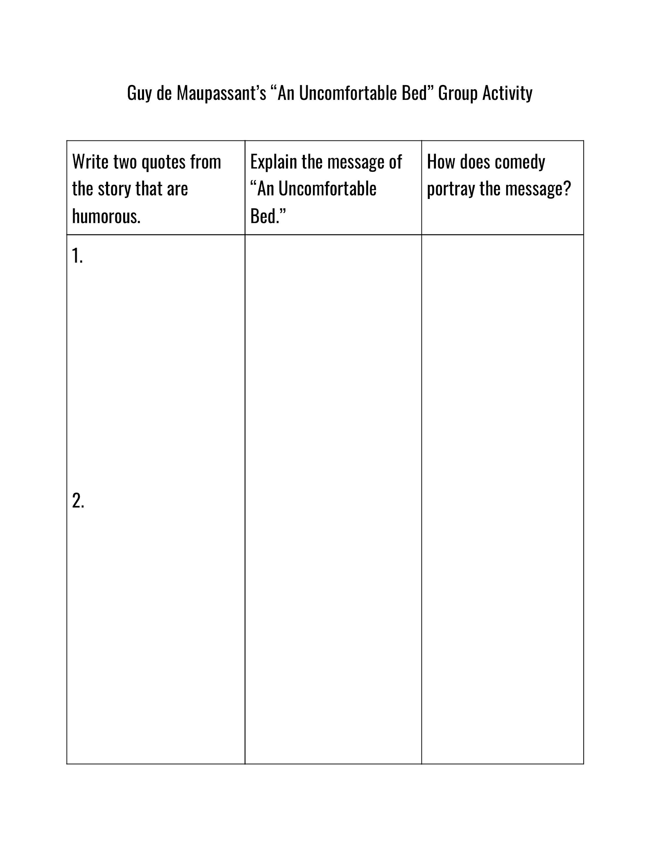
To further the introduction of the unit, I will play Saturday Night Live’s skit on Youtube titled, “Welcome Video.” Using satire, the skit is a spoof of the U.S. Customs and Border Protection’s welcome video, commenting on President Donald Trump’s 2017 travel ban. The writers of SNL are major critics of Trump, and his discriminating travel ban was one of his many doings that SNL was bound to attack with humor.
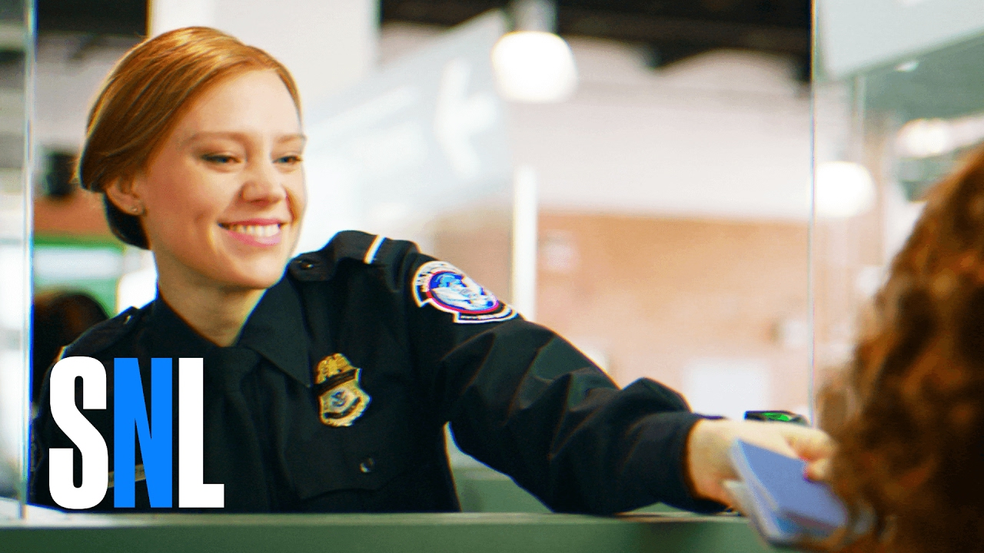
Saturday Night Live, “Welcome Video”
After the video finishes, a set of three questions will be displayed on the whiteboard. Each student will answer one of the questions orally:
- Is this skit funny? Why or why not?
- Why do you think the writers of this skit wrote this?
- How does the skit critique prejudice?
Although they are very different from each other in regards to style and time of publication, Guy de Maupassant’s “An Uncomfortable Bed” and Saturday Night Live’s “Welcome Video” are two great representations of how humor is used. Having these two different pieces of art shows how humor can take any form and use it to relay a message.

BEFORE THE READING: “INTO” THE TEXT
I believe it is important to learn about the author before reading the canonical text. Not only does it provide context to the story, it also provides the author’s credibility and beliefs that ultimately influenced the writing of their work. For the students’ first homework assignment, I’ll assign them to read World Literature Today’s “Humor Is My Green Card: A Conversation with Sherman Alexie.” Conducted by Joshua B. Nelson, this interview focuses on Alexie’s culture and heritage, how they influence his writing, and why he incorporates humor to speak his truth. After reading the transcript of the interview, students will answer the questions on the handout I would have provided.
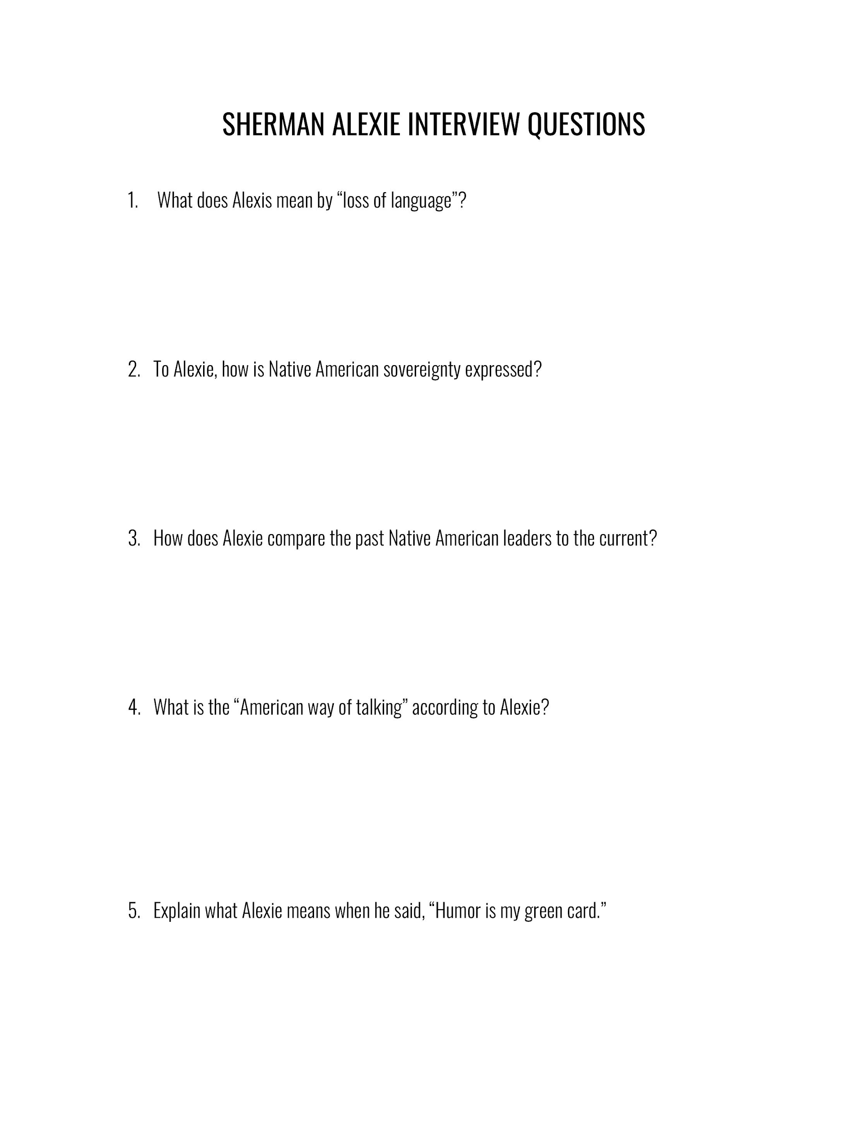

DURING THE READING
As the teacher, I would want to make sure that all students are fully engaging with the reading. In Alexie’s The Lone Ranger and Tonto Fistfight in Heaven, there are 24 short stories that are all connected. The students will be assigned to read one short story per day. For at least 12 short stories of their choosing, students will be assigned to write in their daily reading journal one quote along with its context and significance to the story. This will also be very useful for their analytical essay.

AFTER THE READING
Once the reading is completed, students will share one of the quotes they have written down in their daily reading journal with their table groupmates. After that, I will open a discussion in which students will connect Alexie’s The Lone Ranger and Tonto Fistfight in Heaven to themes of oppression, violence, and stereotypes in the lens of humor. This will allow students to hear other students’ interpretations and observations of the text.

ANALYTICAL ESSAY
In order to capture the students’ understanding of the connection between the canonical novel, The Lone Ranger and Tonto Fistfight in Heaven, and the unit of study, humor, I will assign an analytical essay. The prompt is:
Compare and contrast two of the twenty-four short stories in Sherman Alexie’s The Lone Ranger and Tonto Fistfight in Heaven. How is humor shown in both stories? At the end of your essay, explain why or why not humor is a great way to convey a point/message.
EXTENDING THE UNIT + FINAL PROJECT
For the final project, students will get to explore humor in any of the young adult novels listed.
- Whale Talk, Chris Crutcher
Whale Talk follows The Tao Jones, or T.J., a senior in high school leading a swimming team full of outcasts and defending the less fortunate with his physical aptitude and witty comebacks in a fictional small town in Washington. Being the main protagonist of the story, T.J. learns about empathy and humanity from other characters of the book.
- It’s Kind of a Funny Story, Ned Vizzini
It’s Kind of a Funny Story introduces Craig Gilner in New York City. Craig finally gets in the school of his dreams, however, the academic pressure takes a toll on him. After attempting to commit suicide, he ends up in a psychiatric hospital and befriends the unlikeliest characters. Craig learns how to live with his mental illness while creating strong bonds with his peers.
- Of Mice and Men, John Steinbeck
Of Mice and Men is the story about the friendship of George and Lennie. This pair’s adventures explore California during the Great Depression era. Desperately looking for jobs, George and Lennie also develop their relationship. Their natural friendship is challenged by external forces.
- A Series of Unfortunate Events, Daniel Handler and Brett Helquist
A Series of Unfortunate Events, told by thirteen books, follows the Baudelaire children: Violey, Klaus, and Sunny. After the tragic, yet mysterious, event of their parents’ deaths, the Baudelaire children are forced into the care of their “closest relative” Count Olaf. Neglected and abused, the children are followed by a series of tragic events as they try to figure out the secret lives of their parents and escape the hands of their guardian.
- American Born Chinese, Gene Luen Yang
American Born Chinese is a graphic novel that displays a paradigm of Asian American culture. Jin Wang tries to embrace his ethnicity and nationality, but also assimilate into Western culture. The story encourages young Asian Americans to accept their dual identities through the intertwined characters of the Monkey King, Jin Wang, and Danny.
Similar to their TLRATFIH analytical essay, this essay will observe humor in one of the listed novels. The prompt is:
Please select one of the five novels listed to analyze for your 3-4 paged final essay OR 10-15 Googleslides presentation. You will be answering the following questions:
- What is(are) the theme(s)/message(s) of the story?
- How does humor convey the theme(s)/message(s)?
- How do(es) the theme(s)/message(s) relate to our world today? Provide an article to support your answer.
You are required to have three quotes from the novel. It must be in MLA format, and you must cite your novel and article. You are also required to have a Works Cited page.
(If you chose the presentation, you will be presenting orally to the class for 10-12 minutes)
This project will be assigned two months prior to the due date, allowing students to read their selected novels and to come up with any questions they may have. We will also have three designated writing days that will be two weeks before the due date for this assignment. Doing this project, students will see how humor portrays a variety of themes in order to create conversations about the past, present, and future experiences of ordinary people.

Works Cited
Alexie, Sherman. The Lone Ranger and Tonto Fistfight in Heaven. Atlantic Monthly Press, 1993.
Crutcher, Chris. Whale Talk. HarperCollins, 2001.
“Chapter 1: Young Adults and Their Reading.” Literature for Today's Young Adults, by Alleen Pace Nilsen et al., Pearson, 2014.
“Dave Chappelle Stand-Up Monologue - SNL.” Saturday Night Live, performance by Dave Chappelle, season 46, episode 6, NBC, 2020.
Handler, Daniel and Brett Helquist. A Series of Unfortunate Events. HarperCollins, 2000.
Maupassant, Guy de. An Uncomfortable Bed, 1909.
Nelson, Joshua B. “ “Humor Is My Green Card: A Conversation with Sherman Alexie.” World Literature Today, 2010.
Steinbeck, John. Of Mice and Men. Spark Publishing, 2014.
Vizzini, Ned. It’s Kind of a Funny Story. Hyperion Books, 2006.
“Welcome Video.” Saturday Night Live, season 42, episode 13, NBC, 2017.
Yang, Gene Luen. American Born Chinese. First Second Books, 2006.

