Patrick Cardenas
ENGL112B
Dr. Warner
27 November 2023
Rationale
One of the biggest difficulties of teaching English is that not all kids may feel the want to read classical and conventional works that the English curriculum forces upon them. We have revered authors and playwrights like Shakespeare and F. Scott Fitzgerald who are required to be taught in the school setting. This leaves barely enough room for English classrooms to flourish and expand with different types of literature that could grab the attention of a teenage student who may not have much of an interest in reading. The focus on classical works in the educational setting is to its detriment. Many things could be gained from using genres such as young adult to expose kids to different aspects of English that they may not get in the standard works that they read. Young adult literature is taboo to talk about in class, but this should not be the case. What young adult literature can do as a genre is expose youth to themes and motifs in a way that is more personal and touching to them. While classical texts are important they should be taught alongside a piece of work that is also geared towards the audience that is reading it.
The central topic that I would like to work with for my annotated bibliography is coming of age. I also want to explore how trauma can affect an adolescent's journey to come of age. I mainly focused on chapters 4-6 of Adolescents in the Search For Meaning: Tapping the Powerful Resource of Story in order to formulate the topic for my annotated bibliography. These chapters are centered around books about real-life experiences, books about facing death and loss, and books about identity, discrimination, and struggles with decisions. Many kids in high school are dealing with problems like those discussed in the chapters above and I want to work with literature that they can feel personally attached to and connect with. When a teenager is exposed to a character they can not only relate to but may be going through relatable things, it can broaden their perspectives and lead to better of themselves and those around them. We have seen many examples of this when looking at different authors’ experiences with how their works deeply affected those who read them, such as Laurie Halse Anderson and Chris Crutcher. I think these epiphanies in students are more likely to emerge with a focus on young adult literature in the classroom.
Annotated Bibliography: Coming of Age with Trauma
- Me and Earl and the Dying Girl by Jesse Andrews
—I have read this book and watched the film—
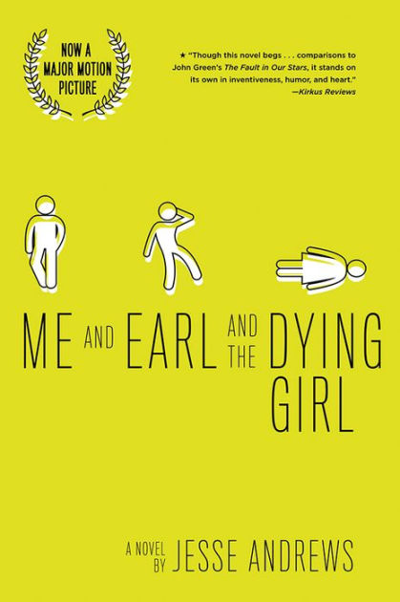
Andrews, Jesse. Me and Earl and the Dying Girl. Amulet Books, 2012.
The novel follows the story of world-renowned (not really) high school loser, Greg S. Gaines. While trying to navigate his way through high school very awkwardly, he is confronted with the news that one of his old friends, Rachel, has been diagnosed with acute myelogenous leukemia. It is because of Rachel’s bleak and sudden diagnosis that Greg’s mother forces him to befriend her and keep her happy in the time she has left to live.
What makes Me and Earl and the Dying Girl impactful as a story is that it takes the typical coming-of-age story, but adds cancer to it. It is admittedly more sophisticated than just that, but the beauty of the novel and its story is in its simplicity. Greg is not a hotshot casanova who wins at life and gets whatever he wants. He is an awkward loner with barely any friends who is now expected to be the emotional saving grace for a girl who is suffering from a terrible disease and may end up dead before the year’s conclusion. Greg’s effectiveness as a protagonist comes from his laid-back and realistic portrayal as an average teenager. He acts how a teenager would in the situation, he does not know how he should feel about confronting things that only adults typically go through, and throughout the narrative, we see how his character is deconstructed as he learns to address Rachel’s condition and in turn, learn more about himself. This book heavily features concepts from chapters 4-6 in Adolescents in the Search For Meaning: Tapping the Powerful Resource of Story seeing as it revolves around Greg’s struggles with real-life experiences, death and loss, and struggles with decisions. Rachel’s life is constantly teetering between life and death, and Greg constantly uses humor as a coping mechanism to avoid dealing with the trauma of watching his friend die. Many students would be able to relate to Greg due to the way that he is written to address the situation like any inexperienced teenager would.
- The Outsiders by S. E. Hinton
—I have read this book and have watched the film—
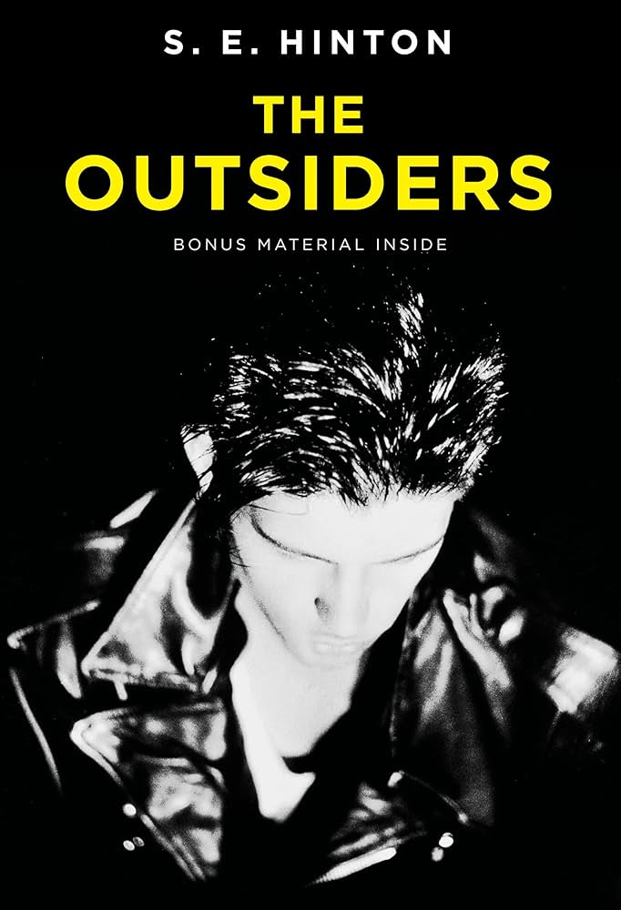
Hinton, S. E. The Outsiders. Viking, an Imprint of Penguin Random House, 2021.
The Outsiders follows the protagonist Ponyboy Curtis. Ponyboy is a greaser, one of the gangs in town that is considered lower class. The greasers are in constant conflict with a rival gang, The Socs, who are more upper-middle-class. We follow Ponyboy, his brothers, and his gang as they try to survive in a constantly hostile and ever-changing environment.
The Outsiders is a much-acclaimed and revered piece of young adult fiction. The struggles that Ponyboy faces as he tries to find his place not just in life, but also in his gang serve to escalate his coming of age. There is a constant threat of attack or discrimination from the Socs, and Ponyboy can not always rely on the greasers, as they are not always going to be there for him. The chapter in Adolescents in the Search For Meaning: Tapping the Powerful Resource of Story that this book addressed is chapter 6 as it deals with identity, discrimination, and struggles with decisions. Seeing as the greasers are interlocked in an intense conflict with a rival gang, Ponyboy is also a target of the Socs. One of the Exeter qualities that the novel exemplifies well is having characters who go beyond typical experiences so that readers can use the fictional experiences to learn and develop in their own lives. While gang warfare is likely not to be an issue for many typical youth in classrooms, the themes of family, courage and survival that are prominently featured are things that many kids can relate to.
- Native Son by Richard Wright
—I have read this book—
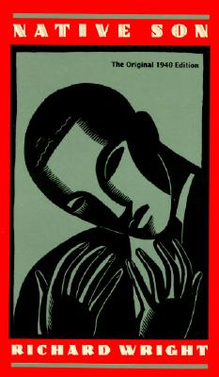
Wright, Richard. Native Son. Pan Books, 1990.
Native Son is a protest novel that follows Bigger Thomas, an African American living in Chicago. Bigger is granted an opportunity to work for a wealthy white family, the Daltons. In the process of working for them, Bigger accidentally murders the family’s daughter and has to find a way to survive in an environment filled with racist individuals who want nothing more than to see him fail.
This novel is important to think about because it offers students valuable insight into the life of someone who belongs to a race that constantly suffers from discrimination. Bigger is not the most flawless and upstanding protagonist, but it is his circumstances that have shaped him to become the person that he is. This novel asks readers to think critically about how single stories can influence our perceptions of others. Like The Outsiders a big focus in this novel is how Bigger deals with identity, discrimination, and struggles with decisions. It is Bigger’s desperation for a better life that leads him to work for the Daltons and when he accidentally messes it up, it turns his whole world upside down. All of the prejudices that Bigger is fighting against have been accidentally reinforced because Bigger has turned into a murderer in the eyes of the public. One of the most prominent Exeter qualities exemplified in this novel is that it has themes that inform truthfully about the wider world so as to allow readers to engage with difficult and challenging issues relating to immediate interests and global concerns. Racism is a very sensitive subject but it is one that the world deals with daily. The novel does not shy away from showing readers the harsh reality that is living as someone from a marginalized group.
- Speak by Laurie Halse Anderson
—I have read this book and have watched the film—
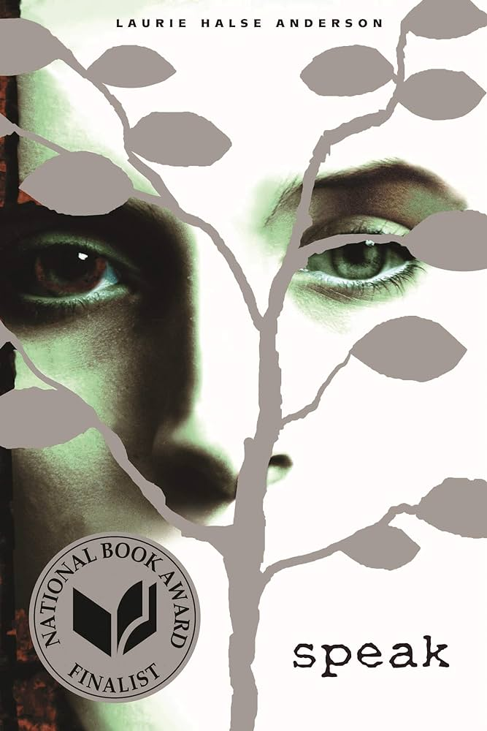
Anderson, Laurie Halse. Speak. Penguin Group, 2006.
Speak follows the protagonist, Melinda Sordino, and her journey to navigate high school after a highly traumatic event. Melinda has become somewhat standoffish as a result of being raped at a party. No one truly knows what Melinda has gone through, and when Melinda calls the cops after the rape, everyone sees her as a buzzkill, because they do not have the full story. It is because of this that Melinda has trouble making any real friends and must find a way to confront her trauma and rekindle the relationships that she has lost.
Speak is a very impactful read, and in some ways, it is reminiscent of Me and Earl and the Dying Girl. These two books would pair very well with each other as they both deal with high school-aged people dealing with traumatic and life-altering events. Melinda and Greg have very different responses to how they address trauma, and while their trauma is not exactly the same in nature, their different responses to it are worth noting. Melinda becomes very reclusive and hostile to those around her, as she feels as though she can not speak to anyone about what happened at the party. Speak is a very important story for many people to hear because it addresses a sensitive topic realistically and respectfully. Laurie Halse Anderson’s anecdotes about how readers of her story have reached out to her and have confided in her about their experiences is something that really speaks to the effectiveness of her storytelling in this novel. This book especially exemplifies the Exeter qualities in that it features themes that allow the possibility of emotional and intellectual growth through engagement with personal issues. The story revolves around Melinda and her journey to confront the trauma that she has endured in order to understand it and come to terms with it. We see Melinda’s growth throughout the story and over time, we see how her outlook towards her trauma has changed. Young adult literature offers readers insights into situations that could deeply affect them on a personal level whereas other genres may fail to inspire the same type of engagement.

- Darkroom: a Memoir in Black and White by Lila Quintero Weaver
—I have read this book—
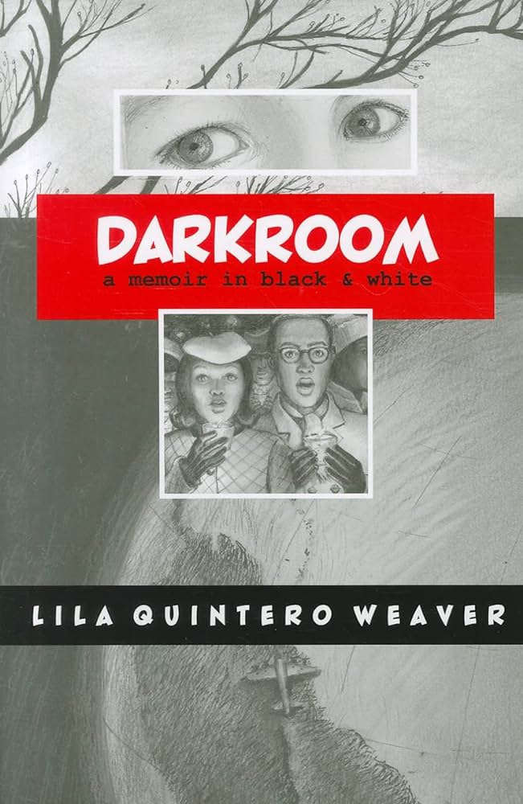
Weaver, Lila Quintero. Darkroom: A Memoir in Black and White. University of Alabama Press, 2012
Darkroom: a Memoir in Black and White is an autobiographical graphic novel that details the life of the author, Lila Quintero Weaver. Weaver recounts her life and experiences during the civil rights movement of the 1950s to 1960s. Racism was abound and Weaver, being born in Argentina and immigrating to America with her family at a young age, struggled to find her place amongst the intense racial turmoil between blacks and whites.
Darkroom: a Memoir in Black and White is an important work for students to analyze because it offers so many different perspectives on race relations in the U.S. Seeing as Weaver is an immigrant from Argentina, she has a unique take on race relations because she is not white or black. This narrative tackles very real questions of identity, as this is not a fictional account, these are all things that Weaver thinks about or goes through. Her story about her upbringing can raise many questions about just how much race really matters in society. Her family is much more neutral in their stance when it comes to blacks and whites. A more memorable scene from the narrative is that in which Weaver’s father brings African Americans to sing at a white church. The white people are immediately appalled by Weaver’s father's thinking to bring African Americans to a white church. There are many moments like this in the narrative in which Weaver questions where she belongs in this world of black and white. The title, the illustrations, and the story work to reflect this concept. Incorporating different types of young adult literature can help students to analyze a text differently. With this novel, students will have to analyze the text not just with words, but also with images. The things that Weaver experiences are far from uncommon and this is one of its biggest strengths. The characteristics of young adult novels are strong here, as this story is as real as it gets and it especially features characters who reflect the experiences of teen readers, something that is not found in much of the literary canon, especially when it comes to strong female protagonists.
- Writing My Wrongs: Life, Death, and Redemption in an American Prison by Shaka Senghor
—I have not read this book—
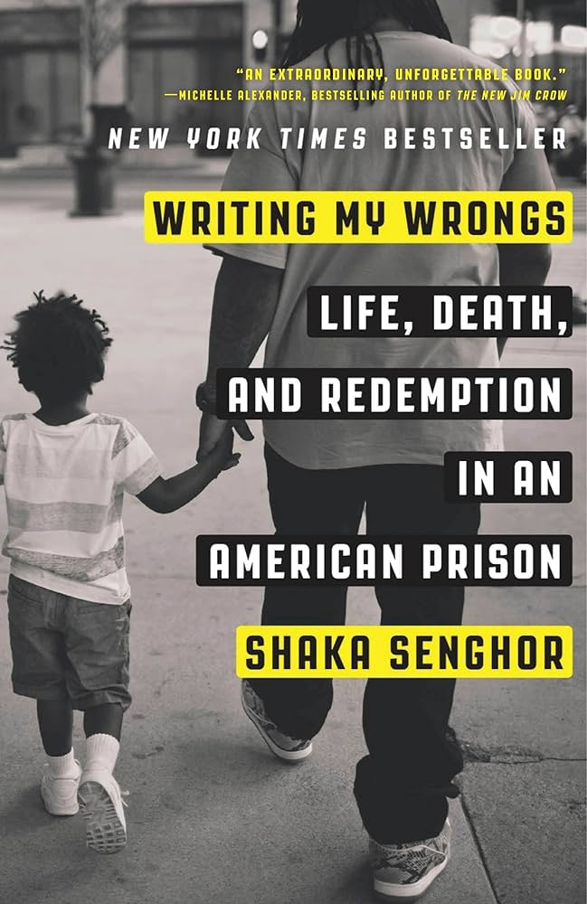
Senghor, Shaka. Writing My Wrongs: Life, Death, and Redemption in an American Prison. Convergent Books, 2017.
Writing My Wrongs: Life, Death, and Redemption in an American Prison is a memoir written by convicted murderer and university lecturer Shaka Senghor. The memoir follows Senghor’s life from his early teens to his 20-year-long prison sentence. Senghor sheds light on his life of criminality, his time in prison, his overwhelming remorse, and the aftermath in which he proceeds to live a fulfilling and happy life.
Summary from:
“Writing My Wrongs Summary.” SuperSummary, www.supersummary.com/writing-my-wrongs/summary/. Accessed 27 Nov. 2023.
This text would be important to discuss in a classroom because Senghor’s story of growth and perseverance in times of strife is something that is very important for a young adult to hear. Senghor’s life is not one of luxury and relaxation, he had to struggle immensely and spend a long time in prison to realize that his life could be improved and that it's never too late to turn your life around. This memoir is especially poignant in how it relates to coming of age in association with trauma. There are many out there who would have given up and accepted that they are nothing more than just a criminal to be judged by society and the judicial system. This story is one of triumph, and hope. Chapter 4 of Adolescents in the Search For Meaning: Tapping the Powerful Resource of Story especially applies to this novel as it deals with the author’s real-life experiences with prison and how he overcomes the cards that he is dealt in life. Prison life is not something that many students would be familiar with so reading this memoir could offer students insights into what the rehabilitation process is like for prisoners. This novel also encapsulates many Exeter qualities, the most prominent one being “Themes that inform truthfully about the wider world so as to allow readers to engage with difficult and challenging issues relating to immediate interests and global concerns”. This narrative recontextualizes to a reader what being in prison means, and how it can be a guiding light for someone who may be accustomed to the less appetizing side of life.
- The Fault in Our Stars by John Green
—I have not read this book but I have watched the film—
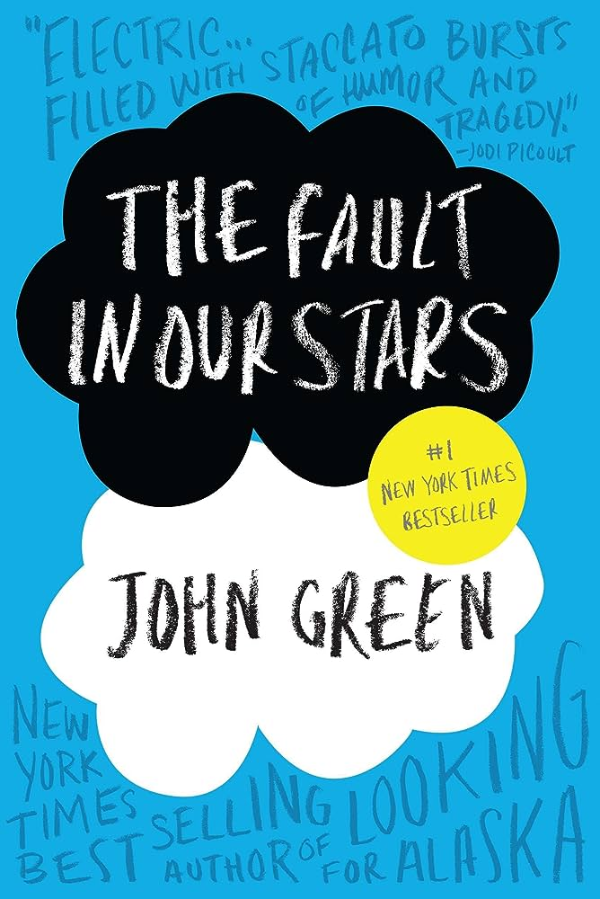
Green, John. The Fault in Our Stars. Penguin Random House Australia, 2022.
The Fault in Our Stars is a young adult novel that follows Hazel Grace Lancaster, a teenage girl who is diagnosed with cancer. Rachel goes to a cancer support group at her Mom’s request. and at this group, she meets Augustus Waters. The novel follows the relationship between the two as they find comfort, love, and support in each other.
Summary from:
Sparknotes, SparkNotes, www.sparknotes.com/lit/the-fault-in-our-stars/summary/. Accessed 27 Nov. 2023.

The Fault in Our Stars is a beloved teen romance novel that in a similar vein to Me and Earl and the Dying Girl, involves teens who are dealing with a horrible and unforgiving disease that is slowly killing them every day that they are still alive. While Me and Earl and the Dying Girl took a more comical and satirical approach to its subject matter, (while still being overall an emotional coming-of-age tale) The Fault in Our Stars takes a more humanitarian approach and gives its take on the tragic love story between two people who are dealing with their worlds ending. This narrative’s inclusion in the annotated bibliography is in an effort to find works that include differing perspectives on how love operates alongside death. Love is very much a big part of coming of age, and this novel seeks to dissect love to its bare essentials, seeing as the two main characters in question do not have the luxury of time. The Exeter quality that is being applied here is “Themes that allow the possibility of emotional and intellectual growth through engagement with personal issues”. Cancer is something that millions of people deal with, and so exposure to the harsh reality that it can even come for kids, lovers, the elderly, and adults, all the same, is eye-opening for any kids who may not have experience with such issues. This book also addresses chapter 5 of Adolescents in the Search For Meaning: Tapping the Powerful Resource of Story in that it revolves around facing death and loss.
- It by Steven King
—I have not read this book but I have watched the films—

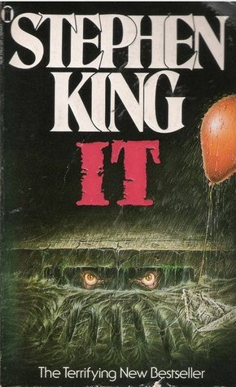
King, Stephen. It. Sperling & Kupfer, 2022.
It follows a group of 11 unpopular kids and eventually adults in the town of Derry, Maine. The leader of this group is Bill Denbrough, and they discover a sinister evil that they simply refer to as “it”. This monster is revealed to be Pennywise, a shape-shifting monstrous clown, who comes to haunt the town every 27 years. The kids gang up together in order to battle the evil and destroy it once and for all.
Summary from:
“It.” Encyclopædia Britannica, Encyclopædia Britannica, inc., 20 Oct. 2023, www.britannica.com/topic/It-by-King.
It is a coming-of-age horror story that is infamous and written by critically acclaimed writer, Stephen King. This story has exploded in popularity in the past few years seeing as its film adaptations have not failed to haunt the minds of those who have watched them. The book is being included in the annotated bibliography, because of its uniqueness amongst the rest of the content featured on this list. The fantastical and horrifying tone of the novel allows readers to look at young adult literature in a different context. Instead of looking at YA lit from a perspective of romance, or comedy, we look at it through the lens of horror. The Exeter quality that most apply to this text is “Characters who go beyond typical experiences so that readers can use the fictional experiences to learn and develop in their own lives”. The main set of characters being kids who confront a larger-than-life evil can be more relatable to a teenage student. Two chapters of Adolescents in the Search For Meaning: Tapping the Powerful Resource of Story that we haven’t addressed yet are chapters 7 and 8. They are “Books about Courage and Survival” and “Books on Allegory, Fantasy, Myth, and Parable”. The story of It tackles these topics where the others in this list may not apply as much. The villainous persona of Pennywise could interpreted in many different ways in relation to the kids and could be analyzed in many interesting contexts.
- The Hate U Give by Angie Thomas
—I have not read this book—
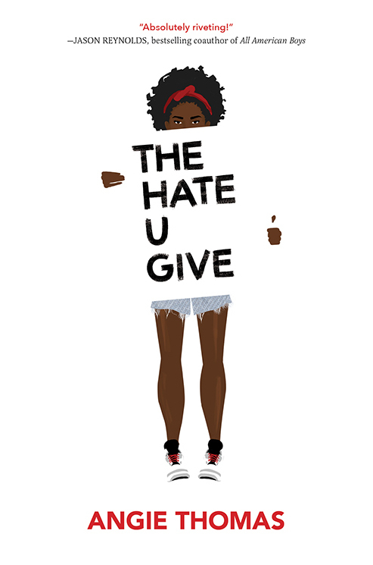
Thomas, Angie. The Hate U Give. Balzer + Bray, an Imprint of HarperCollins Publishers, 2022.
The Hate U Give follows Starr Carter, as she moves from the poor neighborhood that she lives in to a richer neighborhood. There she attends a fancy suburban prep school. This jarring transition between environments is made even more rough as she witnesses the fatal shooting of her childhood best friend Khalil at the hands of a police officer. Khalil was unarmed and was wrongfully killed. After his death, rumors are going around that he was a drug dealer and a gangbanger. Starr endeavors to find out what really happened the night of her friend's death.
Summary from:
Angie Thomas, angiethomas.com/the-hate-u-give/#:~:text=Summary,hands%20of%20a%20police%20officer. Accessed 27 Nov. 2023.
The Hate U Give is especially poignant in today's political climate, seeing as it deals with the concepts of racism and police brutality. This book when paired alongside Writing My Wrongs: Life, Death, and Redemption in an American Prison can be used to show the detrimental impact of racism and the effect it has on so many people. Despite the fact that marginalized communities suffer so much unjust pain, they only seek to better themselves in any way that they are allowed. Senghor and Thomas’s writings do a lot to allow students to read about these issues from the perspective of those who have been adversely affected by death, racism, and unjust treatment. In much the same vein, the way that some may relate to the writings of Laurie Halse Anderson and Chris Crutcher and their respective stories, many could, unfortunately, relate to the writings of Senghor and Thomas. Chapters 5 and 6 are especially touched on in this book since Starr has to face death and discrimination around every corner. Young Adult literature allows students to be able to read about serious and real-world issues in a way that they can relate to, seeing as this literature is meant to be read and analyzed by young adults. There are multiple Exeter qualities that this story could apply to because while it is a fictional story, it is a story that is all too real and encourages readers to engage with its many themes and messages of anti-racism.
- The Boy in the Striped Pajamas by John Boyne
—I have not read this book—
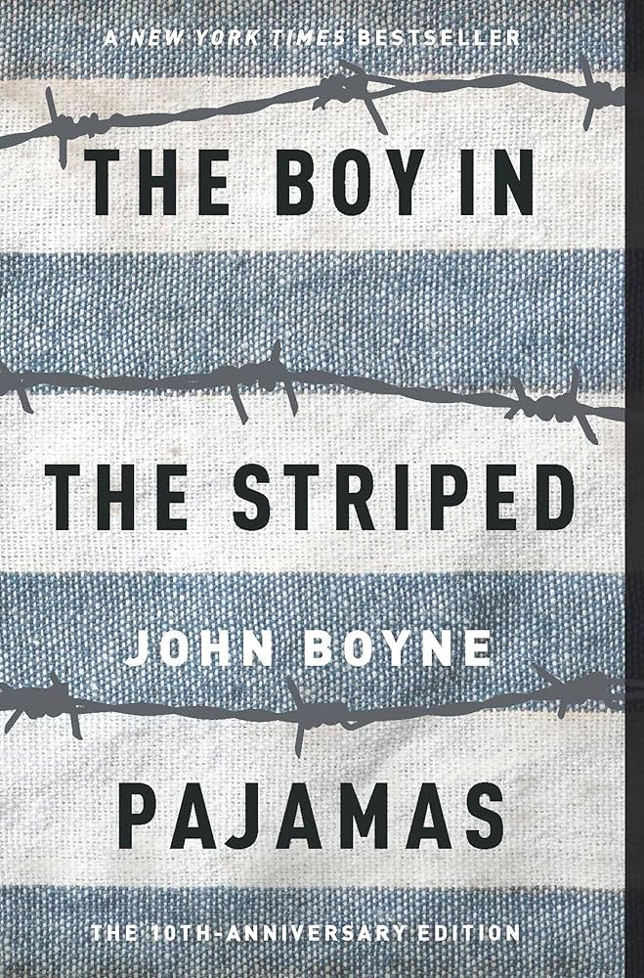
Boyne, John. The Boy in the Striped Pajamas. Thorndike Press, a Part of Gale, a Cengage Company, 2022.
The Boy in the Striped Pajamas follows the characters of Bruno and Shmuel. Bruno is a nine-year-old boy, who stumbles upon an isolated boy on the other side of a fence in a concentration camp named Shmuel. Bruno’s father is a commandant in the German army, however, the two boys are oblivious to the horrors going on around them and a friendship quickly develops between them.
Summary from:
Boyne, John. “The Boy in the Striped Pajamas Summary of Key Ideas and Review: John Boyne.” Blinkist, www.blinkist.com/en/books/the-boy-in-the-striped-pajamas-en. Accessed 27 Nov. 2023.
This tale of innocence in a period of time that was full of despair is very impactful as a story. The novel and its subsequent film adaptation are much-revered pieces of storytelling. This story prominently features children as its main protagonists and their responses to the situation that they are in are notably different from the adults and teenage protagonists that have been displayed in the other novels in this list. While there are child protagonists in Stephen King’s It the horror is much more overt, while this historical-oriented horror is more subdued in its execution compared to a shape-shifting killer clown. What this allows the story to do is play on the innocence of the two boys, as Bruno does not know much about what is going on and the role that his father plays in his friend’s suffering. A child’s perspective on the holocaust is a perspective not typically seen in a lot of media surrounding the horribly violent and traumatic event. Seeing history unfold through the eyes of a young boy challenges the students to think about the holocaust in a way that they may have never thought about before. This book exemplifies many Exeter qualities, but the strength of this book is in its premise. Using the undying love and friendship that two boys from two very different worlds have for each other is a powerful way to view how awful an atrocity the Shoah really was.

Works Cited
Anderson, Laurie Halse. Speak. Penguin Group, 2006.
Angie Thomas, angiethomas.com/the-hate-u-give/#:~:text=Summary,hands%20of%20a%20police%20officer. Accessed 27 Nov. 2023.
Boyne, John. “The Boy in the Striped Pajamas Summary of Key Ideas and Review: John Boyne.” Blinkist, www.blinkist.com/en/books/the-boy-in-the-striped-pajamas-en. Accessed 27 Nov. 2023.
Boyne, John. The Boy in the Striped Pajamas. Thorndike Press, a Part of Gale, a Cengage Company, 2022.
Green, John. The Fault in Our Stars. Penguin Random House Australia, 2022.
Hinton, S. E. The Outsiders. Viking, an Imprint of Penguin Random House, 2021.
“It.” Encyclopædia Britannica, Encyclopædia Britannica, inc., 20 Oct. 2023, www.britannica.com/topic/It-by-King.
King, Stephen. It. Sperling & Kupfer, 2022.
Senghor, Shaka. Writing My Wrongs: Life, Death, and Redemption in an American Prison. Convergent Books, 2017.
Sparknotes, SparkNotes, www.sparknotes.com/lit/the-fault-in-our-stars/summary/. Accessed 27 Nov. 2023.
Thomas, Angie. The Hate U Give. Balzer + Bray, an Imprint of HarperCollins Publishers, 2022.
Weaver, Lila Quintero. Darkroom: A Memoir in Black and White. University of Alabama Press, 2012.
Wright, Richard. Native Son. Pan Books, 1990.
“Writing My Wrongs Summary.” SuperSummary, www.supersummary.com/writing-my-wrongs/summary/. Accessed 27 Nov. 2023.

