Zuleica Coronel
ENGL 112B
Warner
December 04, 2023

Visual Literacy: Graphic Novels

I. Rationale

Graphic novels have often fallen under the pretense that they are simple-minded and inferior to written literature; however, despite these common beliefs graphic novels have proven to enhance learning through its visual representation. Similar to written works, graphic novels explore complex subjects through formal visual elements. While unconventional, they deserve to be treated in the same manner in which we examine written literature because they offer literary analysis like other written works. People, who disregard graphic novels as “recreational reading” that young adults should grow out of, fail to recognize the important role this subgenre plays in offering commentary on issues affecting adolescents.
The centerpiece I chose for my Unit of Study is Maus I: A Survivor's Tale: My Father Bleeds History by Art Spiegelman. Maus is a true story – told in cartoon form, about Spiegelman's parents, who were Polish Jews and survivors of the Holocaust. In the graphic novel the main protagonist, Artie, follows his parents' journey (Vladek and Anja) in Poland during the 1930s Nazi invasion. One reason why I chose this text is because it not only educates young adults about the harsh realities of the Holocaust but also because it teaches them to think beyond their own circumstances and think critically about the past and their own roles and responsibilities today. Another reason why I chose Maus is because I want students to see that while it does center on the Holocaust it also explores other themes such as family issues that students can relate to.
II. Introducing the Unit

At the beginning of the unit, students will be given a brief history lesson about the Holocaust. Students will watch a short documentary in which some survivors share their personal experiences. Before reading the text, students will be given a vocabulary list that they can refer to throughout the unit. The list will include literary definitions such as theme, metaphor, symbolism, etc., as well as graphic novel terminology such as panel, bleed, voice balloon, etc. This list will be used in correspondence with any in-class activities and/or discussions so that students can familiarize themselves with the terminology as well as incorporate it into their writing.
III. Working Through the Text

Given that this may be some students first time reading a graphic novel, we will read Maus in the classroom. Each chapter will be read aloud. After each reading, we will have an in-class discussion.
Discussion Questions
Day Two: How does Spiegelman create visual metaphors and similes? How is visual figurative language different from literary?

Day Three: Do you feel more or less sympathy for the characters because they are mice, pigs,
and cats? Does the use of animals affect and/or influence how you view the
Holocaust or the character’s stories?

Day Four: How is Vladek, Anja, and Artie’s relationship? How has the war affected their relationship?
- Students will have a mini-lesson of what transgenerational trauma is and how it can affect families.

After each discussion, students will pick a panel or a sequence of panels from each chapter and write down what they learned from the words and what they learned from the images. In addition, students will be asked if these words and/or images either provide the same information or reveal different information.
Written Assignment:
Example
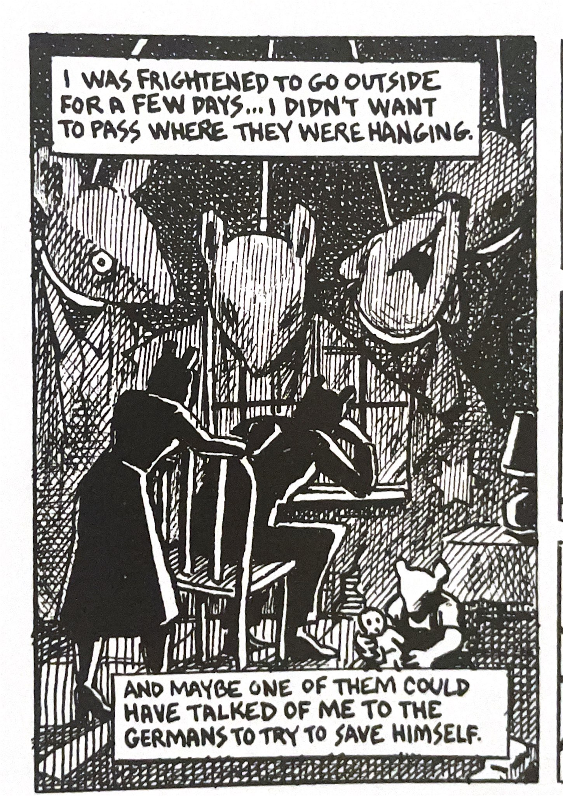
1. What did you learn from just the words?
- Vladek is “frightened” and has feelings of guilt. He is
aware that they could have told on him to save themselves,
but they did not.
2. What did you learn from just the image(s)?
- The innocent deaths still haunt him and linger in his
memory. Their images act like a shadow that follows him.
- Anja is trying to be a supportive wife, while also
experiencing the affects of the Holocaust.
3. Do the words or image(s) provide the same information
or reveal different information?
- The image reveals Vladek and Anja’s life before Artie.
Their firstborn son, Richieu is seen at the bottom right
corner of the panel.

(Maus, 84)

IV. Beyond the Novel
Once students are finished reading Maus and are able to demonstrate that they can apply visual literacy skills, student will then read selected parts of My Favorite Thing Is Monsters Vol.1, by Emil Ferris. My Favorite Thing Is Monsters is a fictional graphic novel set in 1960s Chicago. It is about a ten-year-old named Karen Reyes, who tries to investigate the mysterious death of her upstairs neighbor, Anka, who was a Holocaust survivor. While trying to investigate Anka’s death, Karen explores many aspects of her identity.
For this graphic novel, students will not only identify common themes but will also analyze elements of a graphic novel such as color use, speech balloons, splash, etc., which is similar to what we did with Maus. In-class we will discuss verbal and visual elements the illustrator uses to create meaning. Student will also compare and contrast the verbal and visual differences and similarities between both works as well as themes. The main goal is to build visual literacy.

V. End of Unit

At the end of the unit students will make their own graphic novel (comic) that explores a theme or idea that they have taken away from reading Maus or My Favorite Thing Is Monsters. The comic can be either fictional or non-fictional, as long as it engages at least one central theme or idea that they have learned throughout the unit. Students will demonstrate their understanding by utilizing formal elements of a graphic novel. While students will not be graded on their artistic ability, they will be graded on craft and how well they use elements of a graphic novel. In addition, students will also have to turn in a reflective paper explaining what their central theme is and what formal elements they used to create meaning.
Comic Instructions and Reflection Paper
- Must be at least 2-3 pages in length.
- Reflect on one central theme or idea from our readings that you found most meaningful or important (this is open to your interpretation).
- Demonstrate an understanding of written and/or visual elements of graphic novels to convey your ideas.
- Must have a one-page reflection that engages with your own work. You will explain how you used the elements of graphic novels to communicate your message to your audience as well as any other information that you feel is important for the reader to understand your comic.

Works Cited
Ferris, Emil. My Favorite Thing Is Monsters: Volume 1. Fantagraphics Books, 2017.
Spiegelman, Art. 1992. Maus I: A Survivor's Tale : My Father Bleeds History. New York,
Pantheon Books.

