Laura Stefanko
ENGL 112B
Prof. Warner
6 December 2021
Demystifying Romanticism and Wuthering Heights
Like most other people in the English department, my desire to pursue an English teaching degree stems from my love for literature and my desire to teach others. It would be correct to assume that I had a positive high school English experience and chose this path because I was inspired by the literature I read in school. However, this is not every student’s experience with high school English, and it’s unlikely that every student is going to share the passion for literature that all of us in 112B have. My favorite canonical text, Wuthering Heights by Emily Brontë, is a novel most either adore or despise. Despite negative reviews, I believe in the value of teaching Wuthering Heights as a foundational text in the Romantic/Gothic genre. Brontë’s novel exemplifies the themes of nature, the individual, the sublime, male and female roles, and isolation/melancholy present in Romantic literature.
Wuthering Heights also explores themes of gender, race, and social class that continue to prevail nearly 175 years after its publication. Catherine and Cathy’s female roles, Heathcliff’s obscure race, and Heathcliff’s ascent in social class can be analyzed from both a historical and contemporary lens. These insights can be used to discuss the detriments of gender, race, and class expectations and how these factors work against the characters in the novel as well as in real life.
In my Unit of Study, I hope to design a curriculum that makes Romantic literature approachable and understandable for young adult students of varying interest levels–whether they enjoy, despise, or are indifferent towards English literature. In order to facilitate this task, I will provide into, through, and beyond activities that will aid students as they read Wuthering Heights and learn about Romanticism. In addition to this, I will provide a YA book pair that could complement a reading of the novel and provide a different, more contemporary approach to Romantic literature. To introduce the unit, I will have students read Edgar Allan Poe’s short story The Fall of The House of Usher. After this, I will have students read Wuthering Heights by Emily Brontë in class accompanied by a graphic novel counterpart by the same name by Sean Michael Wilson. Separate reading outside of class would be Black Spring by Alison Croggon. Black Spring is a contemporary retelling of Wuthering Heights that stays true to the original novel’s Romantic/Gothic genre. After the reading and reading activities, I will go beyond the canonical text and suggest YA novels that supplement Brontë’s novel, specifically House of Salt and Sorrows by Erin A. Craig, After the First Death by Robert Cormier, and We Were Here by Matt de la Peña.

Into the text:
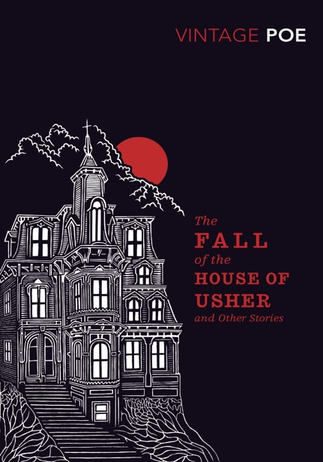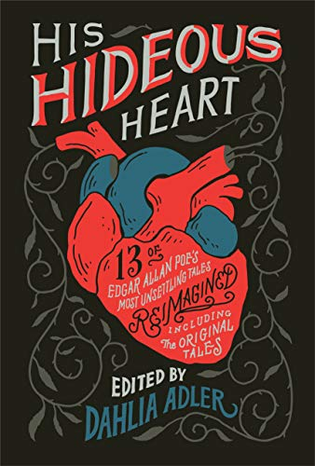

“The Fall of the House of Usher”
To begin the unit on Romanticism, I will do an in-class reading of Edgar Allan Poe’s “The Fall of the House of Usher”. This short story is dark, suspenseful, and contains typical Gothic and Romantic elements students will be able to identify in Wuthering Heights. Using Poe’s story as a jumping-off point, students will be introduced to Romanticism and how the genre is further divided into subgenres like American Romanticism, British Romanticism, and Gothic. Although British Romanticism inspired American Romanticism, Poe’s story comes chronologically before Brontë’s and is, in general, easier to digest and less dense. Before beginning Poe’s story, a short presentation on the background, founders, characteristics, and examples of Romantic literature will be given. In the second half of the class period, we will begin an in-class reading of “The Fall of the House of Usher”. Aiming to read half of the story in class, students will be instructed to finish the rest of the story for homework.
After the reading, students will discuss their opinions on the story as well as how this text fits into the genre of Romanticism. Special attention will be given to the setting of the story and its supernatural elements as these themes correspond directly to Wuthering Heights. Questions to facilitate discussion will include:
- How does Poe convey a dark and ominous tone through the setting and mood of the story? Cite specific examples.
- What role do supernatural forces play in the story? How do these elements affect the characters and environment?
Students will also be instructed to create a chart of the characters in the story, Roderick, Madeline, the narrator, and the mansion itself. They will discuss how these characters are described, developed, and finally debate whether the house is a character of itself or plays a role in the story.
Concluding this introduction, students will read “The Fall of the Bank of Usher”, a retelling by YA author Fran Wilde contained in the book His Hideous Heart edited by Dahlia Adler. This story will be made accessible to students online and they will be assigned the reading for homework. These two stories will be discussed together, and students will determine if the themes in Poe’s original story are present in the retelling. To deepen students’ understanding of Romanticism, they will decide the retelling is accurate to the genre of Romantic Fiction and discuss why or why not.

Through the text:
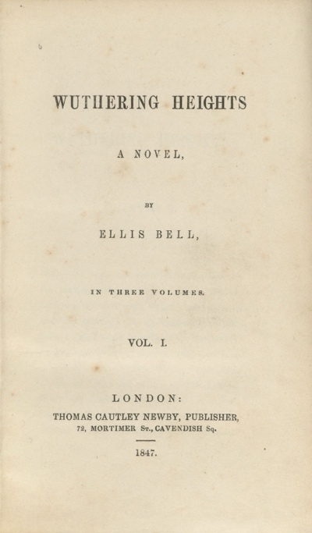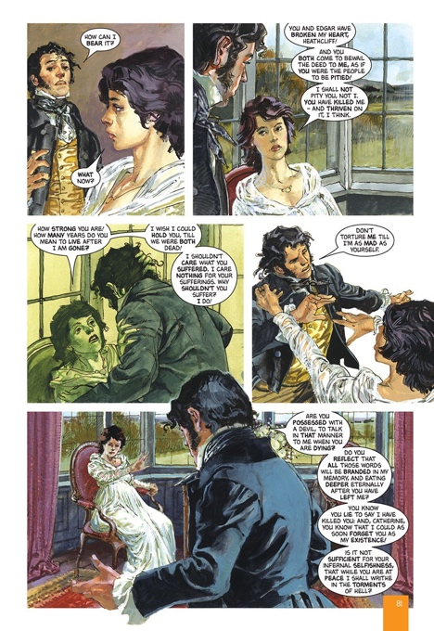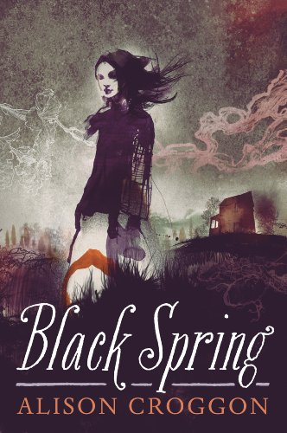

Starting Wuthering Heights
Before we begin reading Wuthering Heights, I will make students listen to, watch, and analyze Kate Bush’s song “Wuthering Heights”. Emphasis on how I will make students do this because I anticipate they will dislike Kate Bush’s high voice and find her dance moves a little… strange (although I adore Kate Bush and will defend her to the grave!). Below is a sample of the lyrics.
“Out on the wily, windy moors
We'd roll and fall in green
You had a temper like my jealousy
Too hot, too greedy
How could you leave me
When I needed to possess you?
I hated you, I loved you, too

Bad dreams in the night
They told me I was going to lose the fight
Leave behind my wuthering, wuthering
Wuthering Heights

Heathcliff, it's me, I'm Cathy
I've come home, I'm so cold
Let me in your window
Heathcliff, it's me, I'm Cathy
I've come home, I'm so cold
Let me in your window”
Bush’s song will be used to introduce the setting of the novel on the Yorkshire Moors, the tumultuous relationship between Heathcliff and Catherine, and the supernatural elements at play throughout the book.
Finally, we will begin reading Wuthering Heights in class. Because of the novel’s complex themes, narration, and slow pace, all reading of the original text will be completed in class. During the reading, students will be able to view the graphic novel adaptation Wuthering Heights the Graphic Novel: Original Text by Michael Wilson projected on the screen and follow along. Reading will be carried out by myself and the students. Before the reading, students will sign up for what day of the week they would like to read aloud. Students will be expected to read once a week. I anticipate the reading and activities to take four to five weeks to complete.

Reading Activities
- Journal and Final Exam: Students will be expected to keep a journal throughout the reading of Wuthering Heights. Each day, students will be given 10 minutes to write a summary of what occurred in the section we covered in class. In addition, they will write any thoughts they have on the reading and write one question they hope to know the answer to by the end of the novel. When reading is concluded, students will try to answer their questions and turn in a document with the questions and answers. I will select questions from these journals to include on a final exam. Journals will be graded for completion and students will be encouraged to keep detailed notes so they can use the journals during the test.
- Family Tree: To facilitate a greater understanding of the family structures and connections in the novel, students will create a family tree and fill it out as they gain more insight into the relationships between characters. Family trees will be constructed in the journal and submitted with the Q&As.
- Additional Reading of Black Spring: Black Spring by Alison Croggon is a YA retelling of Brontë’s Wuthering Heights. Croggon’s novel contains Romantic/Gothic elements similar to Wuthering Heights. It is supernatural, mysterious, and romantic, and students will enjoy the language of this contemporary Gothic novel as a break from the often confusing and cryptic language in Brontë’s. Reading of Black Spring should be completed as homework since students will not be expected to do out-of-class work on Wuthering Heights. After both novels are finished, students will be given a final assignment incorporating both works.

Beyond the text:
Final assignment(s) for Wuthering Heights
In addition to the final exam, students will have the option to choose between multiple assignments to conclude the unit. I think it’s important that students have authority over what they choose to write or create. This will allow students to pick a topic they feel most comfortable with or inspired by and, hopefully, this will allow them to produce their best work.
- Final Essay: Write a final essay incorporating Emily Brontë’s Wuthering Heights and Alison Croggon’s Black Spring. Choose from the prompts below or create your own (with authorization from myself)
  - Compare and contrast the two texts. Consider the unifying genre of Romantic/Gothic literature and comment on how both texts contain the previously discussed hallmarks of Romanticism.
  - Book Review! Write an argumentative essay about which text you prefer. Discuss how literary elements such as plot, narration, setting, character development, etc. influence your decision.
  - You may write about Wuthering Heights or Black Spring separately if you wish. Topics you may discuss include:
    - The role of social class and how it affects characters and the novel as a whole.
    - The role of the environment in the novel. How does the environment influence the plot and characters of the novel?
If you choose to write an essay on just Wuthering Heights or Black Spring, it is required you write a 500-word book review of the other text.
- Audioscape:
  - This final assignment requires two parts. First, students must create a (minimum) 10 song playlist for each novel (20 songs in total, a maximum of 3 songs may be the same for both texts). For each song, you must write a rationale explaining why you chose this song and quotations from the novels that inspired your choice.
- Graphic Novel
Students have two options for this assignment.
- Create a minimum 5-page graphic novel for both texts. These graphic novels should be a general summary of key events in both stories. On each picture include a short description of the visual. Write a rationale for both graphic novels explaining why you chose these key events.
- Create a minimum 10-page graphic novel that incorporates both stories. Using characters and/or events from both novels, write and visualize your own unique story.
i. On each picture, include a short description of the visual. Write a rationale explaining the authorial decisions you made when reimagining the stories.
Additional YA Resources:
After the unit on Romanticism, I will provide students with this list of further readings that tie into the Romantic/Gothic themes presented in “The Fall of the House of Usher,” Wuthering Heights, and Black Spring.
- House of Salt and Sorrows by Erin A. Craig
  - Craig’s novel is a YA adaptation and retelling of “The Twelve Dancing Princesses” by the Brothers Grimm. Craig’s novel contains Romantic/Gothic elements similar to Wuthering Heights. It is supernatural, mysterious, horrific, and romantic, and students will enjoy the language of this contemporary Gothic novel as a break from the often confusing and cryptic language in Brontë’s.
- After the First Death by Robert Cormier
  - Cormier’s YA novel is dark and revolves around themes of death and issues of race and class. Like Romantic/Gothic novels it is suspenseful and psychological, and it offers insight into the character’s thinking and decision-making process. The story is told from multiple perspectives and, like Wuthering Heights, doesn’t necessarily end on a happy note.
- We Were Here by Matt de la Peña
  - De la Peña’s YA novel is suspenseful in its own rite. Although there is an obvious conflict that propels the plot forward, the details of how the conflict began are not revealed until the end of the novel. Told from a first-person perspective different from many Romantic/Gothic novels, the main character also deals with themes of death and race. Like House of Salt and Sorrows, de la Peña’s main character embarks on an adventure and the mystery unravels for the reader to witness.

Works Cited
Brontë, Emily. Wuthering Heights. Pearson Education, 2008.
Bush, Kate. “Kate Bush - Wuthering Heights - YouTube.” Youtube, 2011, https://www.youtube.com/watch?v=Fk-4lXLM34g.
Bush, Kate. “Wuthering Heights.” Kate Bush - Wuthering Heights Lyrics , STANDS4, 2021, https://www.lyrics.com/lyric/22700/Kate+Bush/Wuthering+Heights.
Cormier, Robert. After the First Death. Penguin Books, 2016.
Craig, Erin A. House of Salt and Sorrows. Random House Children's Books, 2019.
Croggon, Alison. Black Spring. Candlewick Press, 2013.
De la Peña, Matt. We Were Here. Ember, an Imprint of Randon House Children's Books, 2019.
Poe, Edgar Allan. “The Fall of the House of Usher .” His Hideous Heart: Thirteen of Edgar Allan Poe's Most Unsettling Tales Reimagined, edited by Dahlia Adler, Flatiron Books, New York, 2021, pp. 397–423.
Wilde, Fran. “The Fall of The Bank of Usher.” His Hideous Heart: Thirteen of Edgar Allan Poe's Most Unsettling Tales Reimagined, edited by Dahlia Adler, Flatiron Books, New York, 2021, pp. 193–230.
Wilson Seán Michael, and Brontë Emily. Wuthering Heights: The Graphic Novel (Original Text). National Geographic Learning, 2013.

