Shelby Escott
English 112B
Professor Warner
25 November 2017
Annotated Bibliography:
Rebel Girls
Anderson, Laurie H. Ashes. New York: Atheneum Children’s Books, 2017.
In the final installation of Anderson’s Seeds of America trilogy, Isabel continues her fight for freedom from her position between armies as she searches for her sister Ruth and tries to keep her friend Curzon by her side and away from the war in Ashes. When the war threatens to tear her small family apart, Isabel must decide if her freedom is worth losing everything she fought so hard to restore, or if choosing a side will truly be the end of her dream of freedom. Along with the Exeter Qualities two and five, exciting plots and diverse use of language, Ashes exemplifies Quality six as well, embodying wider themes that deal with global issues. These themes and issues include racism and sexism as well as issues that cannot be so easily articulated, such as the choice between political parties and whether war is truly a necessary evil. Isabel’s role as a marginalized woman fighting for freedom can be easily related to real life heroines of today who fight for the same rights as Anderson’s fictional representation of internal strength in the face of ongoing war.
Anderson, Laurie H. Chains. New York: Atheneum Children's Books, 2016.
Caught in the midst of the American Revolution, Isabel struggles to keep herself and her sister together as they adjust to life in war torn New York City. Through trials, tragedy, and trauma, Isabel finds friendship and loyalty as she fights for her freedom in this first book of the Seeds of America trilogy. By telling the well-known story of the American Revolution through the eyes of a hidden past, Anderson provides insights into the minds of the slaves of the revolution. While this novel embodies every Exeter Quality to some degree, it represents two specifically, including numbers two and five. Quality two describes a fast paced novel that is driven by secrecy and surprise, elements which are prominent in Chains. Furthermore, the language of the book encapsulates the regional individuality of the time, as described by Quality number five, which can be used traced to the individualistic language and cultures of today’s America. Telling the untold tales of the othered peoples of America and how they helped form current society by fighting for the freedom and rights of future generations, Anderson connects the past to the present in order to change the future.
Avi. The True Confessions of Charlotte Doyle. New York: Scholastic Inc, 2015.
On the crossing from Liverpool England to Providence Rhode Island, the character of Charlotte Doyle goes through immense change from naïve and obedient to daring and loyal as she shifts from high class passenger to common sailor on the ship Seahawk, documenting the entire process in her journal which comes to be known as The True Confessions of Charlotte Doyle. Throughout her journey, Charlotte repeatedly rejects the chance to return to her place of propriety and social normalcy, choosing to side with the persecuted and downtrodden until the exposure to the truth of classism changes her character permanently. Of the Exeter Qualities, number seven is most prominently embodied in this novel, describing emotional and intellectual growth instigated by an individual character’s journey. Charlotte’s external change is only surface level and acts as a representation of her far more significant internal change from privileged and naïve to possessing both inner and outer strength as well as fiercely loyal. Another prominent Quality is number four, wherein a character’s experience goes beyond any typical experience, but which can be translated into reality and applied to the lives of the affected readers. Avi’s novel embodies the rebel spirit needed to enact societal change, translating the decision to defy propriety to embracing the often gritty means to achieve that change.

Donnelly, Jennifer. These Shallow Graves. London: Hot Key Books, 2016.
Josephine Montford is in her final year of finishing school and expected to marry early and live well, yet she longs to be a journalist and follow in the footsteps of her inspiration Nellie Bly, one of the few woman journalists of the time. When her father dies in a shroud of mysterious circumstances, Jo follows her journalistic instincts and seeks the true cause of her father’s death, defying the life path set for her in order to find and expose the truth behind what she believes to be murder. Featuring a prominent name in Women’s journalism, Nellie Bly, These Shallow Graves provides real life inspiration for rebel women as well as fictional examples of a more accessible age range. The third Exeter Quality plays an important role in this novel for many young readers, both male and female, who are expected to follow certain paths set for them in life, but who want something else for themselves. Donnelly’s novel promotes agency and self-made decisions while serving to entertain as well as inform.

Klass, Sheila S. Soldier's Secret: The Story of Deborah Sampson. New York: Henry Holt, 2009.
Having been given away by her family and indentured for years, Deborah Sampson makes the conscious decision to take fate into her own hands for once. Escaping from an unwanted suiter and dressing as a man, Deborah joins the continental army in the fight for independence, gaining her own freedom and equality in the process by rejecting her feminine role in society in order to become a soldier. While Deborah Sampson was a real life rebel who chose to make her own destiny, this account by Klass is a fictionalized version with fictional characters and events. Even so, Klass draws from Deborah’s true life accounts and tells a tale of daring heroism in the face of social injustice and bloody war, gaining the novel the fourth Exeter Quality of beyond typical experiences. Deborah’s story encourages the embracing of femininity as well as fighting for gender equality, themes that are and will be prevalent in today’s reality.

Meyer, L A. Curse of the Blue Tattoo: Being an Account of the Misadventures of Jacky Faber, Midshipman and Fine Lady. Boston: Houghton Mifflin Harcourt, 2010.
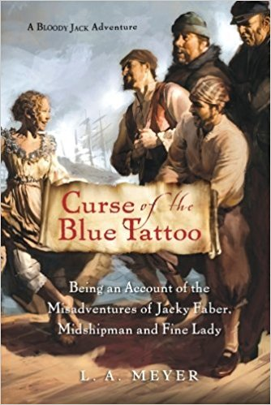
In this second instalment of the Bloody Jack series, Jacky Faber must adapt to a life she never envisioned for herself, transitioning from the role of a pirate fighting navy boy to a fine lady in training in the Lawson Peabody School for Girls in Boston. While Jacky learns the ins and outs of high society manners, she cannot deny the life of misbehavior and independence and must carefully navigate the highly pious law of puritan Boston lest she shame herself and her newfound American family. This book, along with the rest of the series, exhibits all Exeter Qualities, but most of all numbers two, three, and six. The character of Jacky Faber is deeply flawed and incredibly loveable for it, creating an instant connection to the readers despite her fictional existence in a distant past. Jacky’s penchant for getting herself into trouble and rebelling against whatever goes against her personal code of conduct makes her time spent in a Boston finishing school an action packed adventure. Lastly, the themes of the novel range from Women’s rights and the end of slavery to more surface level but equally applicable ones such as peer pressure and fitting in.

Meyer, L A. Mississippi Jack: Being an Account of the Further Waterborne Adventures of Jacky Faber, Midshipman, Fine Lady, and the Lily of the West. Boston: Houghton Mifflin Harcourt, 2011.
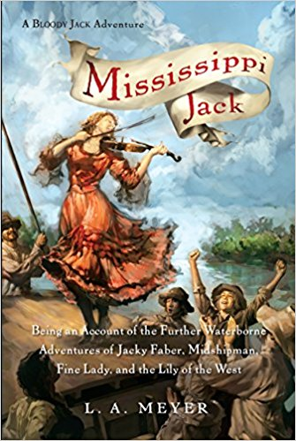
Continuing her tour of America, Jacky flees British forces by venturing into the western wilds of America to travel down the Mississippi and return to the sea, her chosen home. Along the way, perils of all sorts hound her heels, as well as her beloved Jaimy who is hot on her trail, as she sings and dances her way along the Big Muddy. Once more, this epic series embodies each and every Exeter Quality, primarily numbers two and three, diverse and exciting plots as well as character relatability to a teen audience. Throughout her journey through the Americas, Jacky encounters a variety of real and fictional historical figures, with elusions to major historical events on the fringes of the novel. Besides informing teen readers of these events, Meyer describes the history from a young woman’s point of view, basing her knowledge and thought processes on what is experienced and witnessed by the female mind of the time. Because the series is written by a man, the amount of research done for accuracy sake in writing in a young female voice is evident, serving to appeal to both male and female audiences.

Rinaldi, Ann. Girl in Blue. New York: Scholastic, 2004.
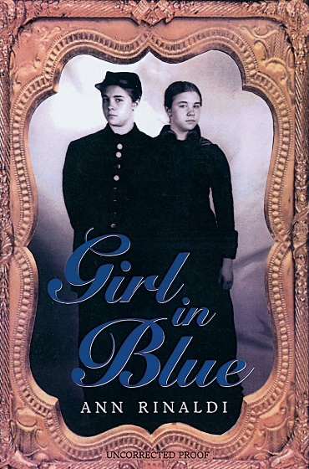
Inspired by a book about a female pirate captain, Sarah Louisa Wheelock chooses to live a life of independence by refusing to be the quiet wife of a much older man and joining the Union Greys disguised as a man to fight in the Civil War. She lives the life of a soldier, a doctor, and later when her identity is discovered, a spy against the south, transforming herself from an object fit only for marriage to an American war hero. While the trope of women disguising themselves as men to participate in masculine society is well known, Sarah’s ability to code switch between the roles of male and female as well as between social classes creates in her a complex character that goes beyond the typical expectation for protagonists. For this reason, the Exeter Quality associated with this novel is the fourth, which describes characters whose experiences go above and beyond that which is typical. Her multiple personas and ability to change her character so fluently represents the ability of the readers’ to enact change by choosing the unexpected over the safe.

Spotswood, Jessica. Tyranny of Petticoats. New York: Candlewick Press, 2016.
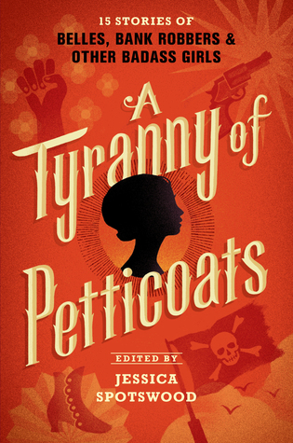
Fifteen teen authors write fifteen stories, detailing the accounts of fifteen American heroines from across the country, all rebelling against the strictures of societal norms in order to live their lives the way they want to. These stories range from pirates to pilots, classic western vibes to sociopolitical movements witnessed by an outside eye, and all told from the point of view of women of the time. With so many accounts written by a variety of authors, Tyranny of Petticoats represents women’s American history as perceived by numerous individuals and so provides differing insights depending on the author’s chosen focus. In this way, each story is representative of a specific theme or subject, covering American history of women, through a fictional lens, from the points of view of differing backgrounds and knowledge. Because this anthology is a collective effort, the message of solidarity in order to enact change is even stronger than in any single author’s novel, encouraging education and collaboration in its readers.

Winters, Cat. In the Shadow of Blackbirds: A Novel. New York: Scholastic, 2014.
Set during the final stages of the First World War, In the Shadow of Blackbirds chronicles the supernatural experiences of Mary Shelley Black, a sixteen year old girl who, with her aunt, struggles to survive the bouts of Spanish influenza that rage through 1918 San Diego. When her beloved supposedly dies in battle, Mary Shelley begins to see his spirit, which leads her to actively seek the true cause of his death in order to allow his spirit to finally rest. Because this story takes place in more recent history, the themes are even more prevalent in the modern world, such as PTSD and the military draft. Because of this, the Exeter Quality that is most exemplified in this novel is number six, the relation to wider issues on a global scale. The convergence of science and the supernatural creates a tone of darkness that existed in this time wherein madness was yet to be comprehended and so could not be scientifically explained, despite the heroine’s attempts to do so. Although such uncertainties are no longer such an issue, ailments of the mind are still prominent in the lives of readers both young and old, and the knowledge of these ailments’ history can provide insight for future treatments.

