Kylie Hinson
ENGL 112B
Dr. Warner
4/30/18

Annotated Bibliography: History Portrayed in Graphic Novels
For teenagers, history class can be a snooze-fest. From reciting Abraham Lincoln’s famous speech, to learning the significance of who that one person was who yelled, “The British are coming! The British are coming!” this course requirement can be a difficult subject to teach that typically enters through one ear and out the other. It becomes a memorization game of “who, what, when, where, how” and oftentimes that information is only retained for a short while, typically within the timeframe of the exam. How come a subject that is taught year after year throughout elementary school, and continuing throughout high school, can’t be remembered when reaching adulthood? Our history books only state facts. They lack the ability to make empathetic connections, which is the key to making these important events in history memorable.
Historical fiction and non-fiction in graphic novels makes reading history both entertaining and engaging. The mixture of art and narrative creates a perfect harmony that challenges cognitive thinking. Real-life figures in history can even represent different archetypes, and an alluring story can be built from them. I’ve always enjoyed reading graphic novels, and after reading Boxers and Saints by Gene Luen Yang for my book talk, I really liked how he tied the narrative to an event in Chinese history and linked the characters to actual historical figures. You get a 2-for-1 deal of learning history, plus reading a pretty cool story. This following collection possesses many Exeter qualities that make them essential in learning history through graphic novels.

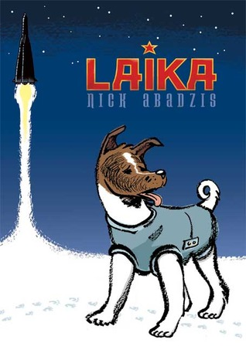 | Abadzis, Nick, and Hilary Sycamore. Laika.  Square Fish, 2014.  Laika is a graphic novel that gives a fictionalized account of the life and death of the eponymous dog, the first living creature launched in orbital spaceflight. Based on a true story, the graphic novel tells the story of Laika from multiple points of view: from that of the ambitious Sergey Korolyov, Chief Engineer responsible for the launching and construction of Sputnik 2; to that of Yelena Dubrovsky, official trainer of the space-bound dogs; to that of Oleg Gazenko, scientist; and finally from the viewpoint of Laika herself, who had lived as a stray on the streets of Moscow. (Wikipedia) I chose this book because it covers Exeter quality number six by challenging the reader to engage with larger issues, such as our treatment of animals and the morality of animal experimentation. It also demonstrates Exeter quality number one, giving the different perspectives of the engineer, scientist, trainer, and dog.
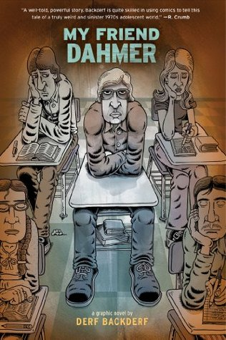 | Backderf, Derf. My Friend Dahmer. Abrams  Appleseed, 2017.  In 1991, Jeffrey Dahmer — the most notorious serial killer since Jack the Ripper — seared himself into the American consciousness. To the public, Dahmer was a monster who committed unthinkable atrocities. To Derf Backderf, “Jeff” was a much more complex figure: a high school friend with whom he had shared classrooms, hallways, and car rides. In My Friend Dahmer, a haunting and original graphic novel, writer-artist Backderf creates a surprisingly sympathetic portrait of a disturbed young man struggling against the morbid urges emanating from the deep recesses of his psyche — a shy kid, a teenage alcoholic, and a goofball who never quite fit in with his classmates. With profound insight, what emerges is a Jeffrey Dahmer that few ever really knew, and one readers will never forget. (goodreads.com) This story follows Exeter qualities 3 and 7. The exploration of how this notorious serial killer was as a teenager can help us understand what led him to commit such heinous crimes.
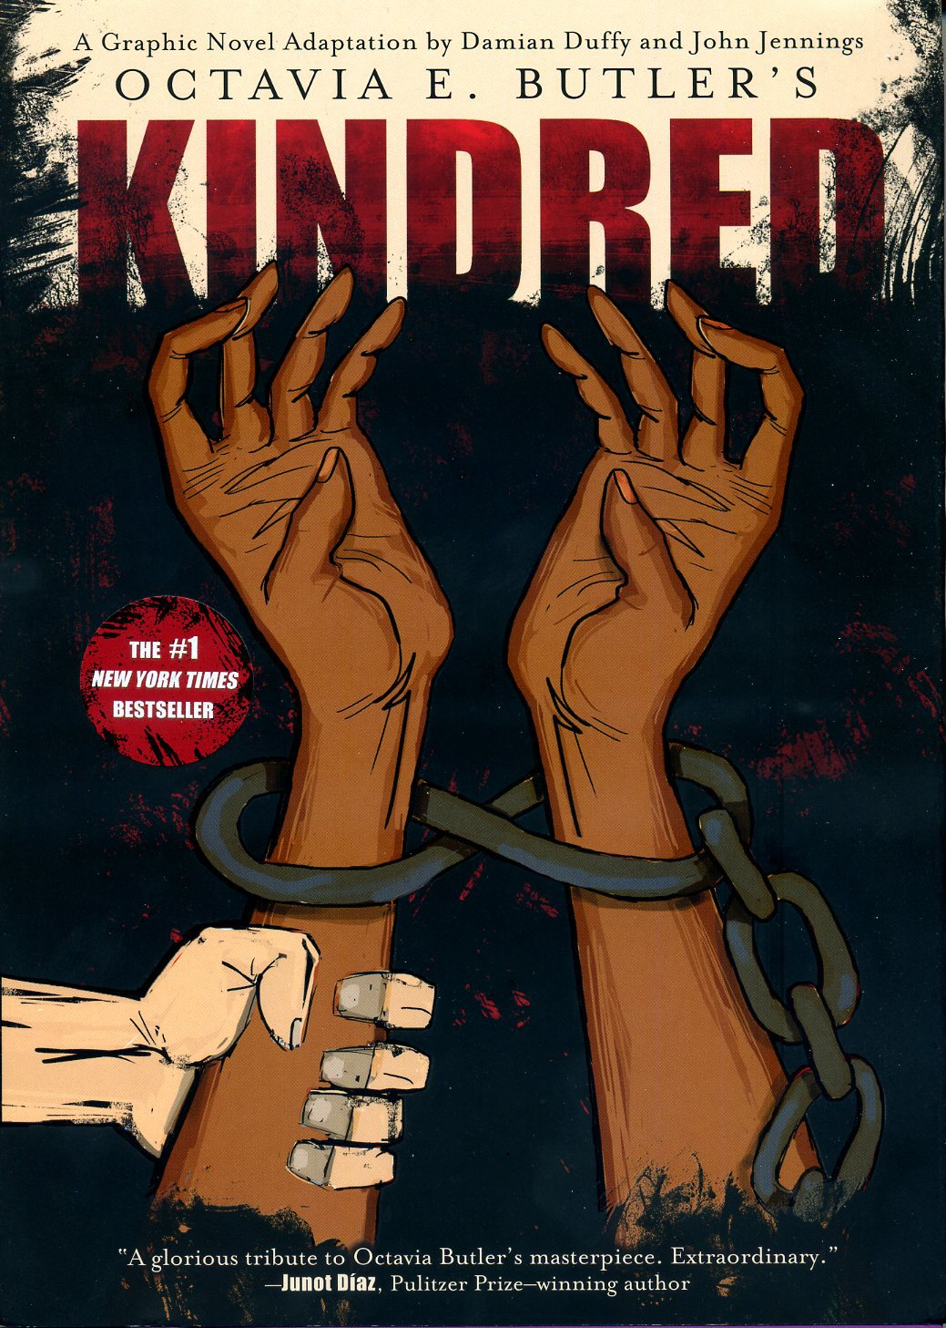 | Duffy, Damian, et al. Kindred: A Graphic Novel  Adaptaion. Abrams. Comicarts, 2017.  Adapted by celebrated academics and comics artists Damian Duffy and John Jennings, this graphic novel powerfully renders Octavia Butler’s mysterious and moving story, which spans racial and gender divides in the antebellum South through the 20th century. Butler’s most celebrated, critically acclaimed work tells the story of Dana, a young black woman who is suddenly and inexplicably transported from her home in 1970s California to the pre–Civil War South. As she time-travels between worlds, one in which she is a free woman and one where she is part of her own complicated familial history on a southern plantation, she becomes frighteningly entangled in the lives of Rufus, a conflicted white slaveholder and one of Dana’s own ancestors, and the many people who are enslaved by him. (goodreads.com) This story covers Exeter qualities one and six, demonstrating the shifts between time periods and explores the horrors of slavery and how it impacted America.
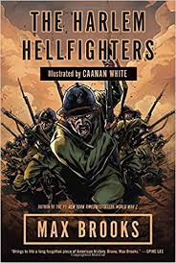 | Lewis, J. Patrick, and Gary Kelley. Harlem  Hellfighters. Creative Editions, 2014.  In 1919, the 369th infantry regiment marched home triumphantly from World War I. They had spent more time in combat than any other American unit, never losing a foot of ground to the enemy, or a man to capture, and winning countless decorations. Though they returned as heroes, this African American unit faced tremendous discrimination, even from their own government. The Harlem Hellfighters, as the Germans called them, fought courageously on--and off--the battlefield to make Europe, and America, safe for democracy. (goodreads.com) These brave men fought and sacrificed their lives for a country that won’t accept them as an equal. The discrimination they face explores the six Exeter quality because seeing through a lens of a race whose country forsakes them will create a more empathetic and understanding response.
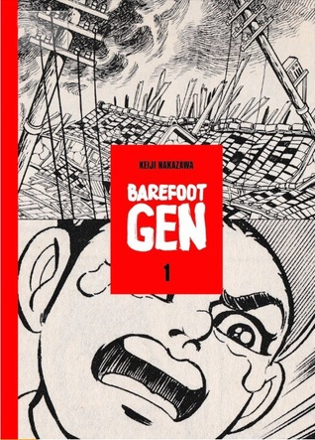 | Nakazawa, Keiji. Barefoot Gen. Last Gasp of  San Francisco, 2016.  This harrowing story of Hiroshima was one of the original Japanese manga series. New and unabridged, this is an all-new translation of the author's first-person experiences of Hiroshima and its aftermath, is a reminder of the suffering war brings to innocent people. Its emotions and experiences speak to children and adults everywhere. Volume one of this ten-part series details the events leading up to and immediately following the atomic bombing of Hiroshima. (goodreads.com) This narrative clearly demonstrates Exeter quality four because the author shares his story of the before and after effects of his home being desecrated with an atomic bomb. This is not a typical experience an average teen would go through.
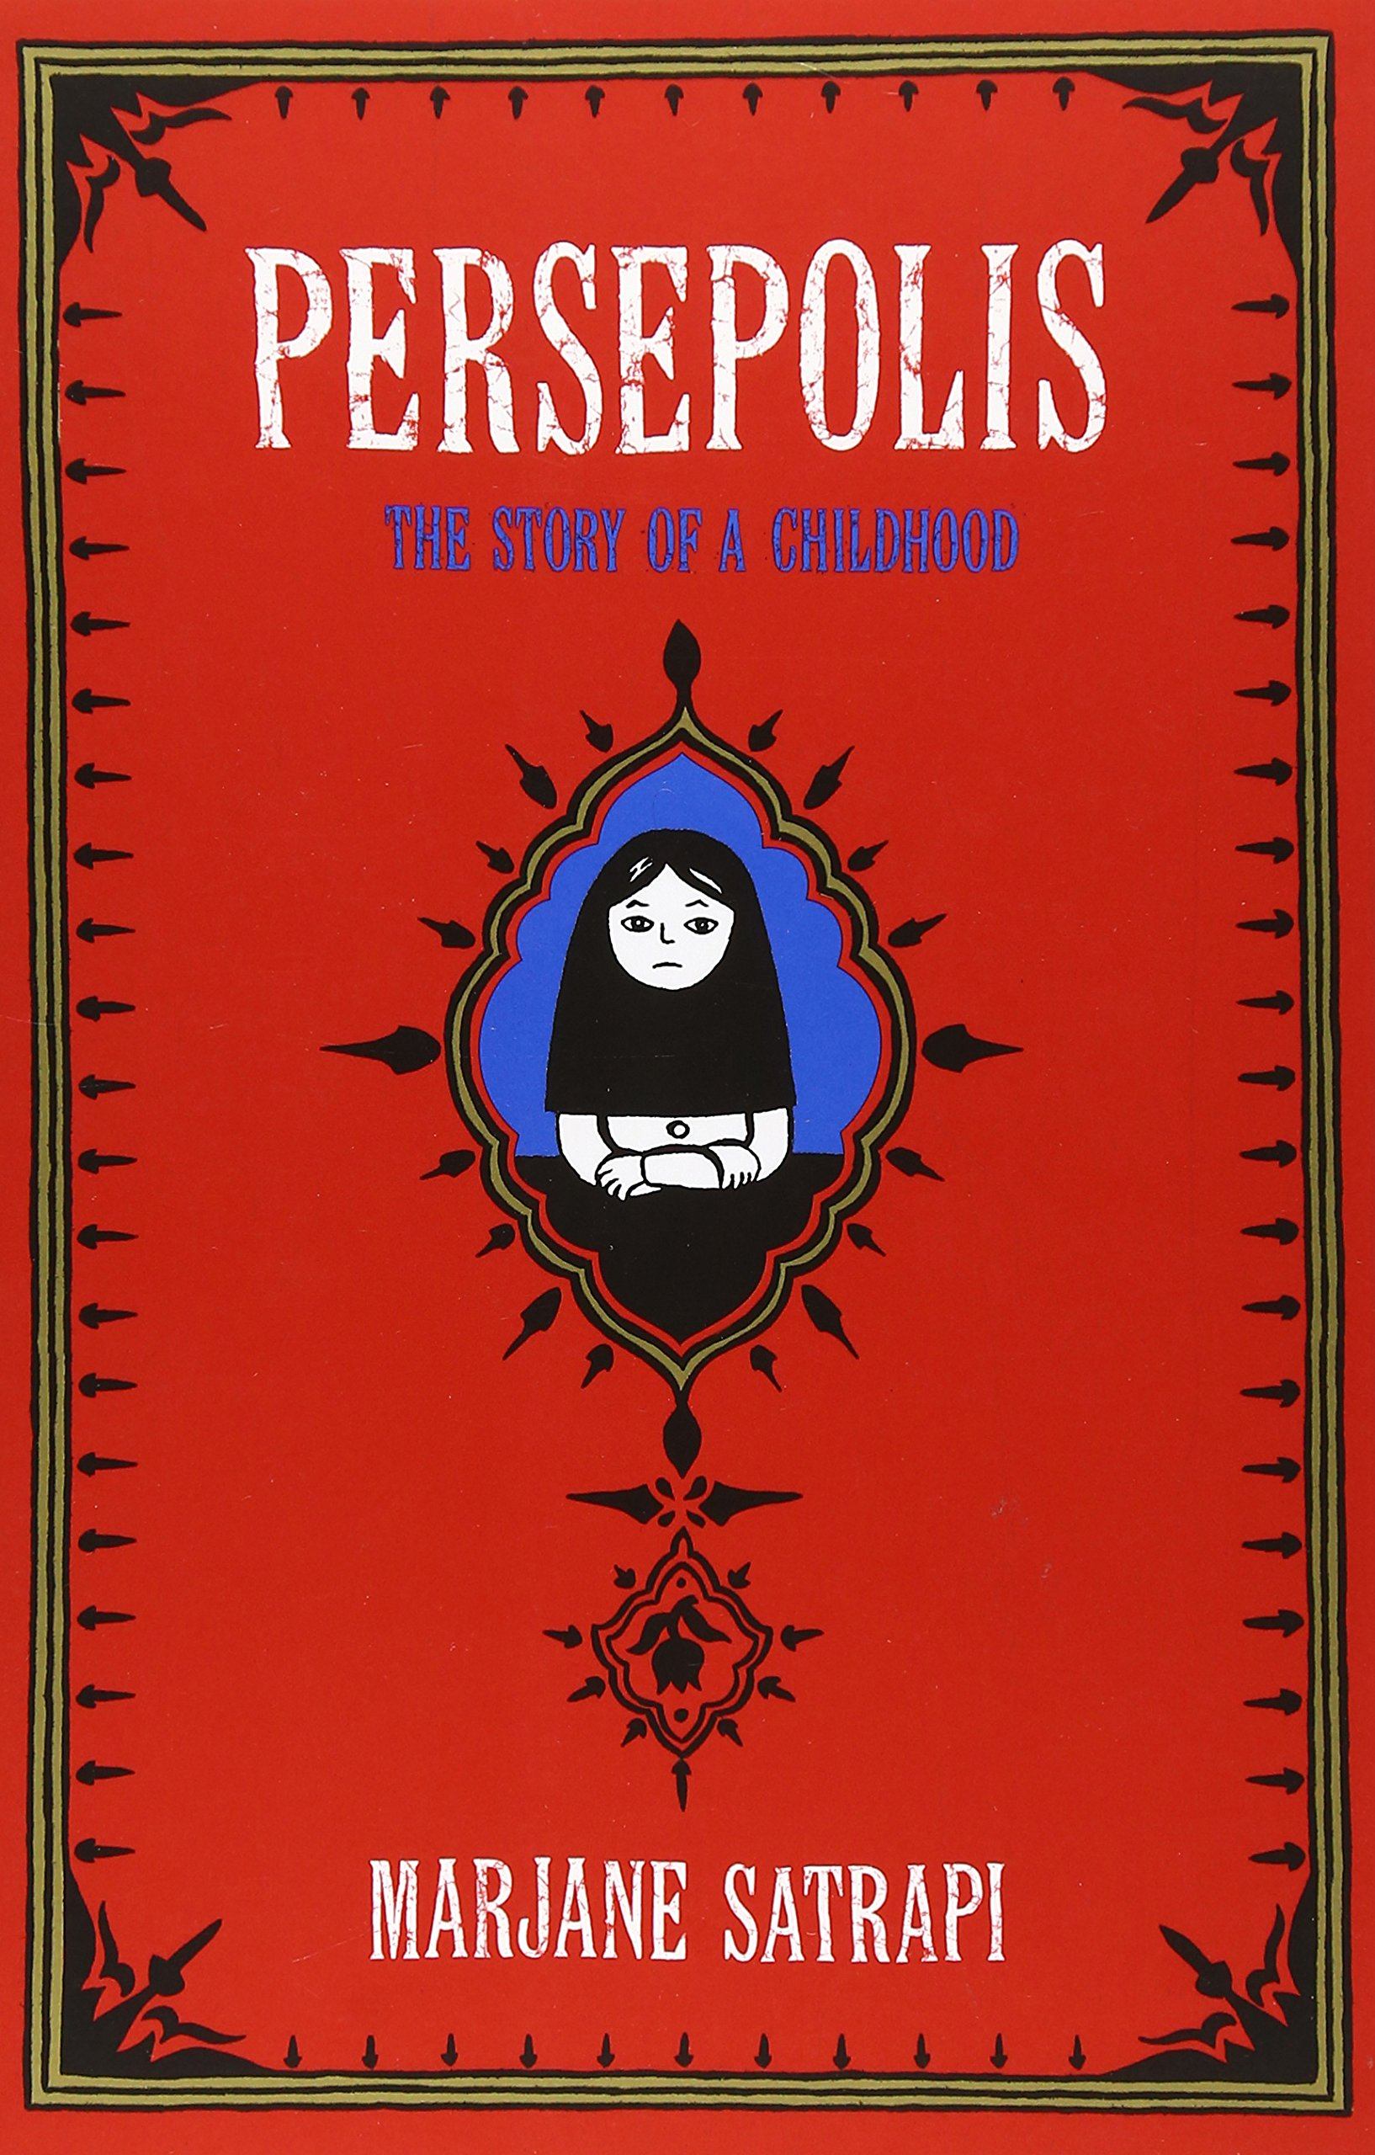 | Satrapi, Marjane. Persepolis. Pantheon Books,  2003.  Persepolis paints an unforgettable portrait of daily life in Iran and of the bewildering contradictions between home life and public life. Marjane’s child’s-eye view of dethroned emperors, state-sanctioned whippings, and heroes of the revolution allows us to learn as she does the history of this fascinating country and of her own extraordinary family. Intensely personal, profoundly political, and wholly original, Persepolis is at once a story of growing up and a reminder of the human cost of war and political repression. It shows how we carry on, with laughter and tears, in the face of absurdity. And, finally, it introduces us to an irresistible little girl with whom we cannot help but fall in love. (goodreads.com) This exhibits Exeter qualities six, and seven because it informs the reader of the wider world, and the ability to grow intellectually from personal experiences.
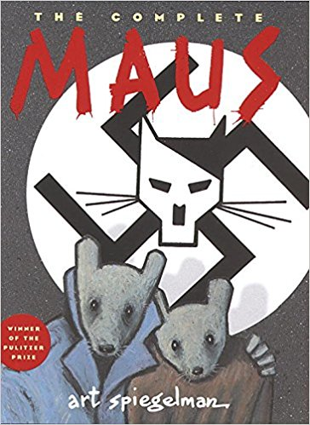 | Spiegelman, Art. Maus: A Survivors Tale. Pantheon,  2011.  This follows the story of Vladek Spiegelman and his wife, living and surviving in Hitler's Europe. By addressing the horror of the Holocaust through cartoons, the author captures the everyday reality of fear and is able to explore the guilt, relief and extraordinary sensation of survival - and how the children of survivors are in their own way affected by the trials of their parents. A contemporary classic of immeasurable significance. (goodreads.com) This portrays Exeter quality six because the protagonist experiences one of the most devastating tragedies in world history.
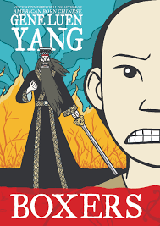 | Yang, Gene. Boxers. Delcourt, 2015.  In Boxers, Little Bao negatively experiences a Christian missionary disrespecting his village’s faith and display violence towards his father. This causes him to grow a profound hatred toward these “foreign devils” and vows to eliminate all foreign devils to reclaim China. Bao learns Kung Fu, and trains his fellow villagers to create his army called, “The Righteous and Harmonious Fist.” Throughout the narrative, this spiritual entity guides Bao through his journey and reminds him of his goals to restore China, no matter how immoral his actions may be. (by Kylie) This demonstrates Exeter qualities one through seven. In this two-part series, the narrative is seen through two different perspectives of Bao and Vibiana and their experience through the Boxer rebellion. It explores the disconnect between two opposing religions and the effects of colonization.
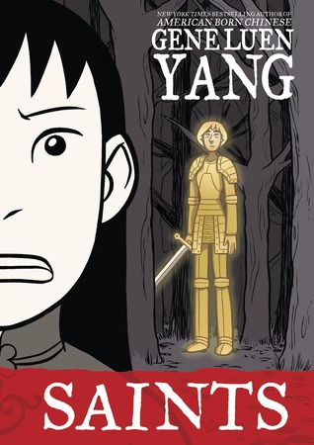 | Yang, Gene. Saints. Delcourt, 2015.  Saints follows the story of four-girl, who acquires that name for being the fourth child and is the unlucky number of death in Chinese culture. Due to that superstition, she experiences abuse and neglect from her family. In her search for identity and belonging, she discovers the Christian faith and converts willingly with the help of her spirit guide, Joan of Arc. She is baptized and chooses her new Christian name as Vibiana (after St. Vibiana, known as the virgin martyr of nobodies), and becomes a caretaker at an orphanage in a colonial encampment. (by Kylie) This explores Exeter qualities one through seven, similarly to the previous novel I mentioned. Yang uses humor throughout the novel and creates an engaging plot that urges the need to see how both stories converge. Vibiana is on a path to discover her identity and her issues with acceptance and guilt are qualities that most teens can relate to.

