Marie Raymond
Engl. 112B
5/8/2018
Unit of Study

Young Adult Literature for Minorities and Immigrants That Include Immigrant Foster Children

Unit of Study Rationale:
Students who come to the United States during their high school years are at a disadvantage academically. They must contend with being immersed in learning to understand and speak English. They then must learn to read and write in English. This is of course second to learning and becoming a part of the culture. The ideal way to help immigrating teens to assimilate is through stories. Adolescents can embark on a journey with the protagonists in the stories. It is through stories they can learn academic skills as well as cultural and life skills through the protagonists in the stories. As the protagonists share their decision-making process as well as the benefits reaped from good decision and consequences suffered from bad decisions. Through stories there are experiences that can be learned by reading. Stories with experiences about feeling like an outsider, or a minority, or even survival skills. These skills are a crucial addition in the classroom. An excellent story that provides all of these is The Absolutely True Diary of a Part-Time Indian by Sherman Alexie. This is a story about Arnold (Junior) Spirit. He lives on the Spokane Indian Reservation. In the beginning of the book Junior provides his experiences of being a dirt-poor, underfed American-Indian living on an Indian reservation that is filled with dysfunctional adults and alcoholics. This speaks to non-native high school students whose parents have dragged them here to the United States hoping for a better life with no money, just the American dream. The immigrant high school student can identify with Junior in many ways. They can also learn how to make difficult decisions through Junior, and how to make a plan about their future.
Junior makes the tough decision to transfer from the high school on the reservation to a high school off of the reservation, Reardan High School, a very white, American high school. At Reardan High School he is a minority and doesn’t feel like he fits in anywhere because he is not only the only Indian at Reardon, but he is also the only dirt-poor student. When Junior makes it through his first year at Reardan he realizes transferring to a high school off of the reservation is a wise choice. He realizes he will have a better life than he could have ever imagine if he stays at the high school on the reservation. Through Junior’s experiences and decision, good and bad, offers lessons in being a minority, suffering, and making wise decisions; albeit difficult decisions, but also very rewarding. This is truly a valuable read for adolescents who live as Junior lives, which is between two worlds of their home and culture and school and fitting in.
This is a great book about being a minority. Through Junior’s journey young adult minorities and immigrants’ struggles are brought to life. This is also true for young adult immigrants who come as refugee foster children.
The Absolutely True Diary of a Part-Time Indian is easy to read while offering a bit of a challenge in vocabulary and length, and the pictures offer a nice visual to help the students bring what they are reading and learning together in their minds. Students will read about Junior’s experiences as a minority and underdog. Students will learn that they are not alone and can be a part of Junior’s decision-making process and reasoning, for which will be discussed in length in class. Also, students can become aware and empowered by their decisions and choices by utilizing Junior’s reasonings.

Launching the unit:
Exploratory questions
1. Discuss what a minority is, and what it means to be a minority. Discuss American-Indians as a minority.
2. Discussion questions
A. Do you live in a community with others like yourself? If so, do you feel protected and safe
B. Do you feel isolated?
- Do you see yourself fitting in with a particular group at school? Do you want to fit in to a particular group at school?
- Do you see others of a different race better than you?
- Are you afraid of any particular race or group of people?
- Do you make decisions for yourself about school, friends, and your community?
3. What do you know about the Native Americans race? And, how is it the same and different from other races in the United States?
4. Post student responses to #3 around the room.
- Have students discuss the responses in small groups of 3 or 4.
- Have the small groups pick 1 response to fight for or against.
- Have each team state their argument while the rest of the class asks questions and agree or disagree to the responses. Ensure students understand why they are for or against responses.
5. Have each student write a paragraph on the response they can identify with the most.

A good poem to share prior to reading is “Freedom Candy” by E. Ethelbert Miller. This poem is about diversity and racism in schools.
So what kind of name is Omar?
I ask this new boy at school.
You named after a candy bar or what?
You know you too light to be milk chocolate

Omar looks at me and laughs.
Since that first smile he’s my best friend,
maybe my best friend ever.

Folks call us the inseparables
like one of those old singing groups
my daddy is always talking about.

Omar is a muslim name Omar tells me.
I think it sill sounds like a candy bar,
like O’Henry, Baby Ruth, Mars or Almond Joy.

Maybe his momma should have named him
Snickers because of the way he laughs.
Omar’s name sounds like candy
and the way he acts is sweet to me.

Every teacher except Mrs. Greenfield think so.
Ms. Greenfield she don’t like Muslims
and the resto of us she calls natural born sinners
because of the way we talk and behave.
Omar says we should tell Mrs. Greenfield
about herself since it’s Black History Month.
So Omar stands up and says to Mrs. Greenfield:

How come you don’t lead us somewhere?
Why you not like Harriet Tubman?
Why no field trips?
Why no trips to the museum or zoo?
Why we never go nowhere, why?

Mrs. Greenfield, she don’t say nothing.
She just look at Omar as if he is the last Muslim
on earth and is about to die.

I think of how Omar says Muslims pray
five times a day and how cats have nine lives and
just maybe Omar might make it to 3 o’clock
or maybe he won’t.

Suddenly Mrs. Greenfield has one of those
fainting spells just like old Moses Tubman.
She has to sit down behind her desk so
she tells me to go get her some water.

I feel free as I race down the hall
wondering how Omar can be sweet sometimes
and get on everyone’s nerves the next.

My daddy once told me M&Ms
melt in your mouth and your hands
especially if you colored.

Wait until I tell Omar.
(The 100 Best African American Poems, p167. Compiled by Nikki Giovanni. Sourcebooks, Inc. Poet. 2010)

Using this particular poem addresses minorities in school in a fun, lighthearted way that is easy to read and understand for high school students.

Before reading The Absolutely True Diary of a Part-Time India divide the book into section to be read by the students each day or week. Go over assigned vocabulary for students to translation and define and make sentences for each section of assigned reading.

Begin reading The Absolutely True Diary of a Part-Time Indian. Inform students to bring five quotes from the book next class. Have students keep an in-class journal of the book and their chosen quotes answering questions about events, how they think/feel about what’s going on, and the significance of their quote.
Once the book is finished give students 10-page handout that includes Junior’s decision-making process to complete. This will guide them through the process step-by-step of writing an essay about the book.

Have students create and share slides of pictures with some words and/or quotes based on their essay. This helps bring the book into a full circle as they share what they have written.

Concluding and Reflecting:
Reflecting on the book students will create and perform a play of a chosen scene in the book, or a combination of scenes that makes the best representation of the book and its theme (encourage incorporation of a scene of one of Junior’s decisions). This performance will be recorded and saved to share with family, friends, and students and staff at school.

Other books and further reading on minorities and immigrants and immigrant foster children are as listed below. The follow are excellent further readings to help minorities and immigrants and immigrant foster children assimilate. This list is of course idealistic and should be the goal for the year; however, realistic will be two, maybe three books for the year for these students. These books provide protagonists who embark on journeys in identity and growth facing bigger-than-life problems. They are entertaining and can hold the attention of the students. These books are empowering and provide a safe journey for young adult minorities and immigrants and immigrant foster children to embark though the protagonists. The First Crossing compiled by David Gallo is particularly interesting, for it provides many short stories about young adults who have immigrated to the United States and their experiences and struggles.

First Crossing: Stories About Teen Immigrants edited by Donald R Gallo
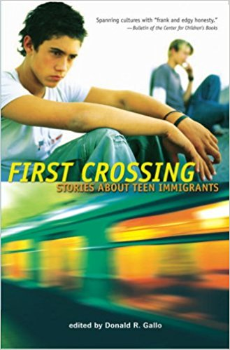
(https://www.amazon.com/First-Crossing-Stories-About-Immigrants/dp/0763632910/ref=sr_1_4?s=books&ie=UTF8&qid=1525655099&sr=1-4&keywords=young+adult+books+about+immigration)
The First Crossing by Donald R Gallo is a recommending pairing with The Absolute True Diary of a Part-Time Indian. It is a compilation of stories by eleven different authors about young adults who have immigrated to the United States for a myriad of reasons. This is a great book to read entirely or in parts. It has young adult stories who have immigrated to the United States. These stories vary widely from around the world. The teen characters have immigrated to the United States for many reasons. This book can reach a wide variety of readers, especially those who don’t have the attention span or ability to read a full-length novel. I have not read. This book tells the story of children, teenagers, who have immigrated to the United States for various reason and their experiences and struggles transitioning.
The Border: They Never Wanted to Run by Steve Schafer
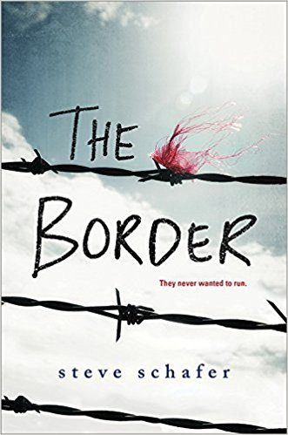
(https://www.amazon.com/Border-Steve-Schafer/dp/1492646830/ref=sr_1_1?ie=UTF8&qid=1525654044&sr=8-1&keywords=the+border+book)
The border by Steven Schafer is a recommending pairing with The Absolute True Diary of a Part-Time Indian. It is a book about four teens separated from their families and flee from Mexico to the United States via Arizona. This is about their journey into the United States crossing the border. I discovered this book on YA Wednesdays and discovered it works perfectly with this unit of study. They are separated from their family and are running for their lives. This is a journey of Pato, Arbo, Marcos, and Gladys whose lives have forever lost the lives they once had in Mexico. They must make decisions and sacrifices as they run for safety and a life in the United States as Mexican immigrants.
American Born Chinese by Gene Luen Yang
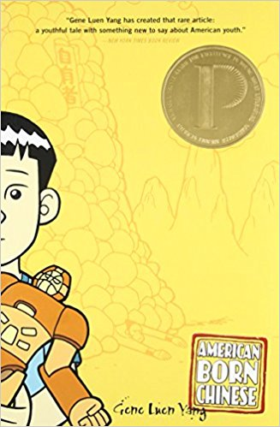
(https://www.amazon.com/American-Born-Chinese-Gene-Luen/dp/0312384483/ref=as_li_ss_tl?ie=UTF8&linkCode=sl1&tag=rickmedne-20&linkId=a0de8ab1eaeebec0e2643c776c004a0c)
American Born Chinese is a recommended pairing with The Absolute True Diary of a Part-Time Indian. It is a graphic novel by Gene Luen Yang. It is about a Chinese boy who struggles with his Chinese identity living in the United States. Jin Wang is the only Chinese-American student at his school. Danny is his American identity who is an all-American at school, in sports, and with girls. This book follows Jin through his journey with his struggle with his identity and traditional Chinese parents. It turns out that through mystical Chinese powers Jin is both Danny and himself. As Danny he struggles with his embarrassing cousin from China. As Jin he struggles with his Chinese culture and identity.
We Were Here by Matt de la Pena
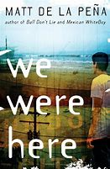
(https://www.amazon.com/We-Were-Here-Matt-Peña/dp/0385736703/ref=sr_1_2?ie=UTF8&qid=1525651818&sr=8-2&keywords=we+were+here)
We Were Here by Matt de la Pena is a recommended pairing with The Absolute True Diary of a Part-Time Indian. It is an excellent book that relates to unit of study. It is a powerful story about three boys in a group home that come together as a team. The main character Miguel is sent to juvenile hall for killing his brother. The judge decides he will benefit from being in a group home with similar boys in his situation, and where there is an intense attempt to rehabilitate the boys. The rehabilitation includes therapy, group counseling, and education. While at the group home Miguel meet Mong and is reunited with Rondell, with whom he was in juvenile hall with. They all run away together. On their journey Miguel discovers himself meaning in life after killing his brother. He is required by the judge to keep a daily journey. In his journey he details the events while on the run to Mexico. On the way down the coast of California he develops a trust and bond with Mong and Rondell. He realizes he must complete his sentence in the group home and participate in the therapy and counseling sessions to learn to live life.

Whale Talk by Chris Crutcher
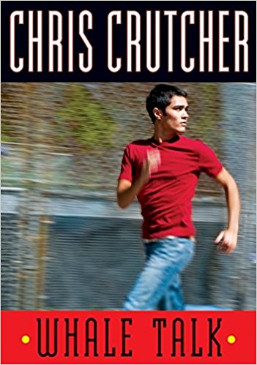
(https://www.amazon.com/Whale-Talk-Chris-Crutcher/dp/0061771317/ref=sr_1_1?ie=UTF8&qid=1525667726&sr=8-1&keywords=whale+talk)
Whale Talk by Chris Crutcher is a recommended pairing with The Absolute True Diary of a Part-Time Indian. Whale Talk is about a boy, The Tao Jones (TJ), who is adopted. He is in high school and struggles with abandonment issues. When he was a baby he was severely neglected by his mother. The one good thing she did for him was give up to his adopted parents. His adopted parents are perfect for him. His adopted mom is an attorney for abused and neglected children, and his adopted dad does community services helping children who are abused and neglected. Between his adopted parents and his therapist, Georgia, he is provided with the support and encouragement through their experiences to become a functional adult.
Books highlighted on YAWednesdays’ website regarding young adults coming to America are:
https://yawednesdays.com/2017/11/24/coming-to-america-a-reading-list/
The Lines we Cross by Randa Abdel-Fattah. It is about an Afghani refugee.
The Go-Between by Veronica Chambers. It a light-hearted take on Mexican immigration.
Refugee by Alan Gratz. It contains three refugee stories three different time periods.
The Radius of US by Marie Marquardt. It is a story of immigration and racism and PTSD.

Works Cited
Crutcher, Chris. Whale Talk. Greenwillow Books. 2001
https://www.amazon.com/Whale-Talk-Chris-Crutcher/dp/0061771317/ref=sr_1_1?ie=UTF8&qid=1525667726&sr=8-1&keywords=whale+talk

De la Pena, Matt. We Were Here. Random House Inc. 2009
https://www.amazon.com/We-Were-Here-Matt-Peña/dp/0385736703/ref=sr_1_2?ie=UTF8&qid=1525651818&sr=8-2&keywords=we+were+here

Gallo, Donald R. First Crossing: Stories About Teen Immigrants. 2007
https://www.amazon.com/First-Crossing-Stories-About-Immigrants/dp/0763632910/ref=sr_1_4?s=books&ie=UTF8&qid=1525655099&sr=1-4&keywords=young+adult+books+about+immigration
and
https://prezi.com/dhfqvfn238hz/the-first-crossing-stories-about-teen-immigrants-by-david-gallo-book-review-project/

Yang, Gene L. American Born Chinese. First Second. 2006
https://www.amazon.com/American-Born-Chinese-Gene-Luen/dp/0312384483/ref=as_li_ss_tl?ie=UTF8&linkCode=sl1&tag=rickmedne-20&linkId=a0de8ab1eaeebec0e2643c776c004a0c
Schafer, Steve. The Border. Sourcebooks Fire Genre. 2017
https://www.amazon.com/Border-Steve-Schafer/dp/1492646830/ref=sr_1_1?ie=UTF8&qid=1525654044&sr=8-1&keywords=the+border+book

Miller, E. Ethelbert. “Freedom Candy” The 100 Best African American Poems, p167. Compiled by Nikki Giovanni. Sourcebooks, Inc. Poet. 2010

Website and books referenced:
Adolescents in the Search for Meaning: Tapping the Powerful Resource of Story by Mary L Warner. 2006

YA Wednesdays. Coming to America Reading List.
https://yawednesdays.com/2017/11/24/coming-to-america-a-reading-list/

Amazon
https://www.amazon.com/b/?node=283155&tag=mh0b-20&hvadid=78271504125042&hvqmt=e&hvbmt=be&hvdev=c&ref=pd_sl_1670j3im06_e

