Natalie Logsdon
Warner
Engl 112B
8 May 2018
Annotated Bibliography
For my annotated bibliography, I decided to focus on an aspect that every young adult is required to have, yet may be difficult to maintain: courage. Young adults are going through the transitional stage in life where they are beginning to make important decisions on their own. The choice of friends, college, and identity occur during this crucial stage of life. Courage allows young adults to confidently go through the path of life they decide to take. Not only are there important long term decisions to be made, but also many influences along the way. At this age most young adults are being introduced to alcohol, drugs, and the opposite sex. Having courage during this time period enables students to stand up for what they believe in, even if they are standing alone. As I read the news, I am so encouraged by the wave of young adults who are fighting for justice. Just recently many high school advocates stood up and said gun violence needs to come to an end. Weeks ago, James Shaw Jr. dismantled a gunman in a Waffle House, saving many lives. Although Shaw is out of range for what is considered to be a young adult, he is part of the Millennial generation that is taking courage and fighting back.

Anderson, L. Speak. United Kingdom: Puffin, 2001. Print.
Melinda Sordino is a freshman in high school carrying the weight of a secret from the summer before. At a party celebrating the end of summer, Melinda calls the police after a life altering incident, which sequentially ends both the party and friendships. She now faces the struggle of adapting to high school while being ostracized by her friends. In an attempt to acknowledge the inner battle she is fighting, she expresses her voice through artwork created in Mr. Freeman’s class. Melinda is able to face her problems and recreate her identity.
Anderson exemplifies what it means to be courageous in her novel, Speak. Standing up for what is right takes courage; standing up for what is right even when one is standing alone takes fearlessness. Throughout the novel, Anderson’s authenticity regarding the hardships that come with courage remain consistent. She exhibits that courage can be found in everyone, even a young, timid high school girl. This novel illustrates that internal strength is found among every individual. Exeter quality number seven is perfectly presented in this novel because the reader follows Melinda while she carries the secret of her personal issue, which presents the possibility for personal and emotional growth. This is a novel I have read and think will be useful for students.
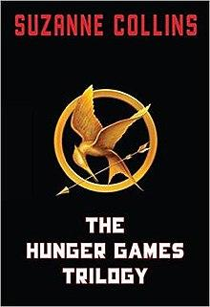

Collins, S. The Hunger Games. New York: Scholastic Corporation, 2008. Print.
Katniss Everdeen stands in shock as her sister’s name is read out of a fish bowl containing the names of all boys and girls aged twelve to eighteen. Her younger sister, Primrose, has been selected for the annual Hunger Games; an event where two individuals are selected from twelve of the districts surrounding the Capitol and battle to the death. In a frantic outcry, Katniss volunteers to take Prim’s place and must now do all she can to survive.
Katniss showed many levels of courage throughout the novel. Initially, she puts on a brave face when volunteering herself to take her sister’s position. Then, throughout the Hunger Games she courageously defeats other victors. Although Katniss finds herself in a situation most young adults don’t, she shows courage and selflessness when she stands up for her sister. The novel is fast paced and includes secrecy, surprise, and tension; therefore, fulfilling exeter quality number two. This is a novel I have read and think many students will find the fast pace and intense storyline interesting.
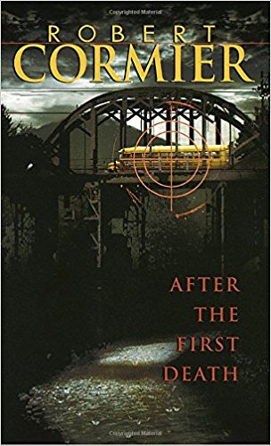
Cormier, R. After the First Death. New York: Pantheon Books, 1979. Print.
Kate is a high school student driving a bus full of young children to summer camp. Her morning route takes a turn for the worst when four terrorists hijack the bus on a bridge hoisted hundreds of feet in the air. The terrorists threaten to kill the children if any attempt of an attack is made on them. The purpose of the hijacking is to demand the release of prisoners, payment of ten million dollars, and the dismantling of “Inner Delta”.
This book exemplifies exeter quality number one because the story is mostly told from the point of view of Kate, Miro, and Ben, switching back and forth from past and present. After the First Death also presents exeter quality number four, “Characters who go beyond typical experiences so that readers can use the fictional experiences to learn and develop in their own lives”. I have read this novel and believe that the use of symbolism will attract students.
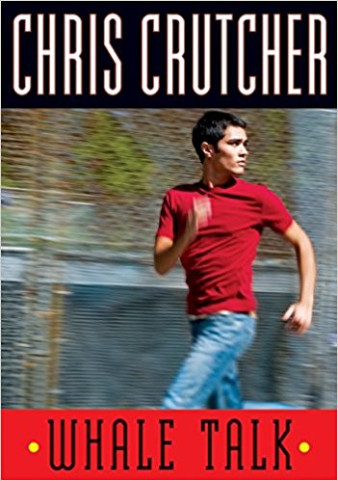

Crutcher, C. Whale Talk. New York: Harper Collins, 2001. Print.
The Tao Jones, also known as TJ, is a half Black, half Japanese teenager who resides in a predominately White town in Washington state. TJ attends Cutter High School,who pride themselves in their athletic abilities and achievements. He decides to put together a swim team containing underdogs in order to irritate the school’s elite athletic program.
This novel presents exeter quality number seven, “Themes that allow the possibility of emotional and intellectual growth through engagement with personal issues”. Whale Talk goes deeper than simply being a sports book by revealing the trials many of the teammates have gone through. The reader goes on the emotional journey as people on the team discuss their personal story. This novel shows young adults that each individual has a story to be heard, as well as shows the reader that they have a story to tell. I have read this novel and think students will relate to TJ’s sarcastic humor, while being moved by the overall story.
De la Peña, M. We Were Here. New York: Delacorte Press, 2009. Print.
Miguel is a teenager who finds himself in trouble with the law and now residing in a group home. At his sentencing, the judge required that he keep a journal in which Miguel must write for an entire year. He and two other group home members, Mong and Rondell, leave in the middle of the night and head for Mexico to start fresh. Steps away from the Mexican border, Miguel is unable to finish the journey he started and decides to return to the group home and serve his time.
This novel exemplifies exeter quality number four because the storyline is about a situation that goes beyond typical experiences. Most young adults will hopefully not have to reside in a group home and serve time. We Were Here allows the reader to go on Miguel’s journey with him and learn from his experiences and apply those lessons to their lives. Readers learn that they have a voice and purpose. This is a novel that I have read and believe it will be useful in the Bay Area because it discusses many places that are well known to those who reside there.
McCormick, P. Sold. Hyperion, 2006. Print.
Lakshmi is a thirteen-year-old girl living in the country of Nepal. Her family is incredibly poor, but she is able to find joy in simple pleasures. Monsoons come and wash away all that remains of her family’s crops, putting them further into a financial burden. Lakshmi’s stepfather introduces her to a stranger who informs the young girl that she will be the maid for a wealthy woman. Lakshmi makes the long journey to the “Happiness House” and soon learns that she has been sold into prostitution where she remains trapped until her family’s debts are paid for.
Exeter quality number seven is present in this novel as the reader follows Lakshmi on her emotional journey. Sold showcases how trials are turned into triumphs and the power of perseverance. Although alone and frightened, Lakshmi hears her mother’s faint words in her head, “Simply to endure is to triumph”. Only then does she form friendships with the other girls in order to get through this nightmare, and eventually gain the courage to make a life altering decision. I read this book and was moved by Lakshmi’s courage and perseverance, and believe students will be as well.

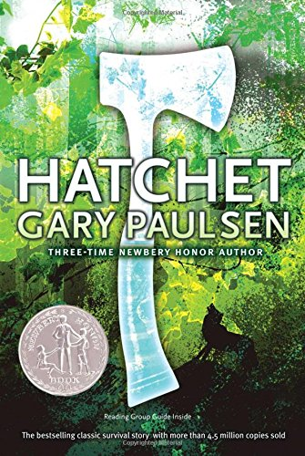
Paulsen, G. Hatchet. Simon & Schuster, 1987. Print.
Brain is traveling to Canada to visit his father when the pilot suffers a heart attack, forcing Brian to crash land in the wilderness. The only belongings he obtains are his clothing and a hatchet given to him as a present from his mother. Now exhausted, afraid, and alone, Brian must put aside his anger over his parents’ divorce and knowledge of his mother’s secret, and focus on survival.
“Hatchet by Gary Paulsen | Scholastic.” Scholastic Publishes Literacy Resources and Children's
Books for Kids of All Ages,www.scholastic.com/teachers/books/hatchet-by-gary-paulsen/.
Gary Paulsen’s thrilling novel exemplifies exeter quality number two. The storyline consists of secrecy, surprise, and tension as Brian fights for survival. Young adults will be able to identify the undeniable courage that Brian exudes, as well as the power of positive thinking. Instead of drowning in self pity, Brian is motivated by his English teacher’s words that replay in his mind: “You are all you have.” Although I have not read this book, it reminds me of the Hunger Games, but rather being man vs man, it is man vs nature.
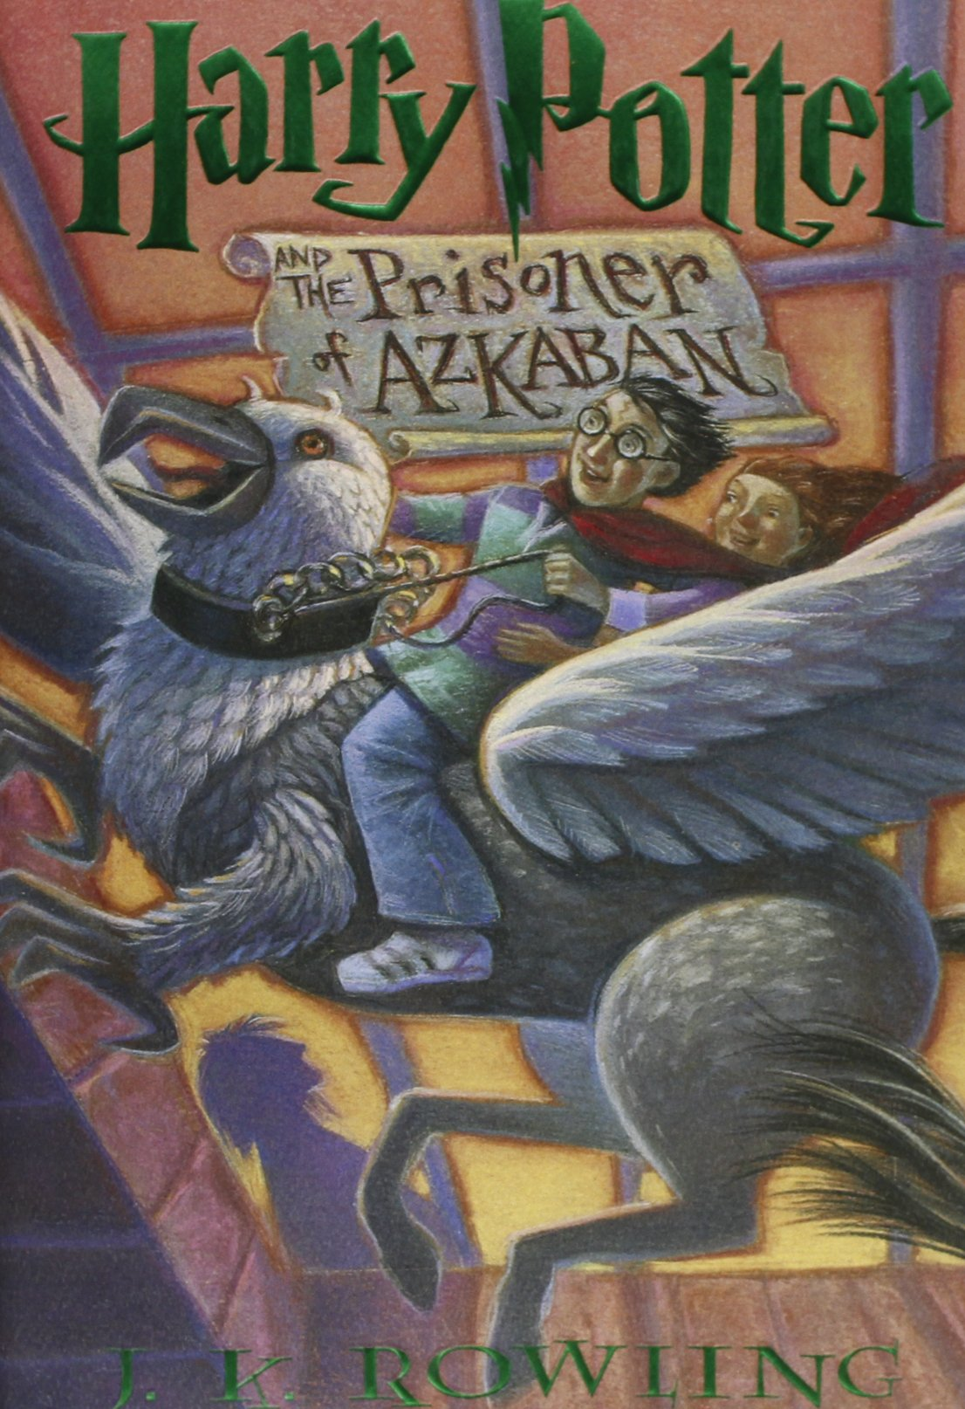
Rowling, J.K. Harry Potter and the Prisoner of Azkaban. New York: Arthur A. Levine Books,
1999. Print.
Harry enters his third year at Hogwarts with best friends Ron and Hermione by his side. His excitement quickly dwindles as he learns that Sirius Black, an escaped prisoner from Azkaban, is trying to find Harry and finish what Lord Voldemort began. Although Harry puts on a brave face, fear overrides him as he digests the potential reality of his future.
The novel exemplifies exeter quality number two due to the face paced storyline that contains a lot of secrecy, surprise, and tension. Harry is able to undergo a stressful period thanks to his close friends. This novel teaches young adults the importance of friendship and having a positive support system. Although there will be hard times with friends, the power of friendship is always stronger than any trial. After reading this novel myself, I was reminded that having good friends is a foundation for getting through difficult situations.
Sachar, L. Holes. New York: Farrar, Straus and Giroux, 1998. Print.
Stanley Yelnats is an unlucky teenager who is falsely accused of theft and sent to Camp Green Lake, a juvenile corrections facility in the desert of Texas. Stanley, along with all the other convicts, must dig a hole everyday to “teach character”; when in reality, the Warden of the camp is searching for something. As the story progresses, the reader learns the truth behind Stanley’s bad luck, his relationship with a fellow camper, and the object the Warden is looking for.
Exeter quality number one is presented in this novel because the storyline switches back and forth between nineteenth century and present day. The plot introduces new information that eventually pieces the puzzle together. Along the journey of discovery, Stanley gains enough courage to stand up for himself and his new friend, Hector. The novel teaches the lessons of consequence and the importance of friendship. I read this book multiple times growing up because I was so interested in how the past and the present coincide. 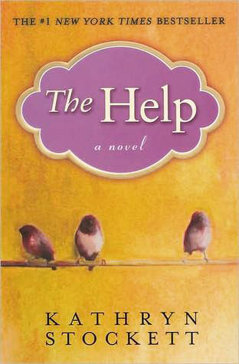
Stockett, K. The Help. United Kingdom: Penguin Books, 2009. Print
In Jackson, Mississippi during the 60’s, many households have an African American woman who work to keep the house running smoothly. These women get the chance to share their personal stories and experiences working for white families with the assistance of Skeeter. Eugenia “Skeeter” Phelan has recently graduated from the University of Mississippi and aspires to become a writer. She lands a job writing a column about cleaning, but soon finds a story that is more intriguing.
This novel exemplifies exeter quality number three because it is a story told from the voice of a woman. Skeeter is the strong female protagonist who is the extension of many other African American woman who share their experiences. Skeeter shows courage by writing a book that is very much so risky at the time. She also allows many women’s voices to be heard for the first time. When I read this book I felt every sort of emotion as I drew nearer to the characters and anticipated Skeeter’s collection of stories.

