Tsogtbaatar Otgonbaatar
Professor Warner
English 112-b
May 6th, 2018
Praise the Lord and pass the ammunition
America is the most important nation in the world and have been since the end of the Second World War. There is no greater economy, no greater military and no greater cultural influences than America. However, these traits do little to truly show and reflect the American experience. Young adults and teenagers are growing up in a society with unprecedented levels of information exposure. News that would take a day to report and a week to settle in are now relegated in the face of sensational media. Amongst these changing circumstances and perspectives, novels provide a quality source of understanding and becoming aware of the reality of the American experience.

Historical fiction in American history has played an exceptional role in shaping the American people as a whole.Take the story of Davy Crockett and his legendary life with the heroic last stand at the Alamo. Countless boys and girls all across America read his semi-biographical tales, embellished to a tolerable extent by whichever publisher had put out the book. On the other hand, historical fiction has been used in American society to address the shortcomings. Richard Wright and his stories on the racial plight of blacks in America gave audiences a shocking and realistic depiction of another life, exhibiting the sixth Exeter quality. What these two different works both demonstrates is the diverse ability for American literature to reflect its society from nearly any angle. Our society began as a mixed and diverse one, a trait our literature expresses, even if our laws and politicians fail to do so. These historical novels are for young adult consumption, while giving a deeper look into the people and situations which create America.

For Pilgrim Feet: a collection of stories dedicated to the outsiders of America
Lord, Bette Bao., and Marc Simont. In the Year of the Boar and Jackie Robinson. HarperCollins Publishers, 2003.
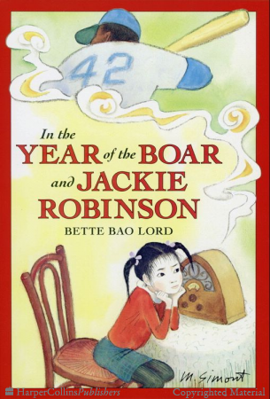
The story of an immigrant Chinese girl and her family to the diverse and vibrant Brooklyn region of America, this book displays the power of baseball in helping outsiders achieve their American identity. Shirley Temple Wong is a young girl, who comes to live with her family in America, where the conflict and harmony between Chinese culture and America culture are shown. Through Shirley's interactions with her schoolmates, she follows the struggle of Jackie Robinson and the Brooklyn Dodgers until they win a championship. Jackie Robinson role as a outsider breaking barriers reflects Shirley's story, while allowing baseball to serve as a platform for friendship, growing up and assimilation. I chose this book based on the Exeter qualities of 3, 4, 6 and 7. This story contains a strong female minority protagonist, who experiences relatable growth and development while enduring atypical experiences.

Cisneros, Sandra. The House on Mango Street. Vintage Books, a Division of Random House Inc., 1991.
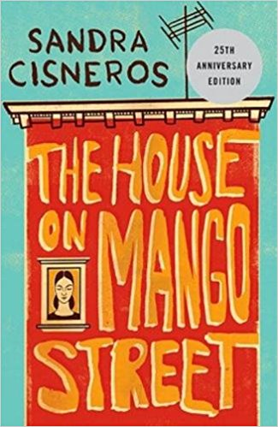
The semi autobiographical series of stories from a Chicana perspective, this tale of childhood, trauma and eventual escape reflects the reality of impoverished minority neighborhoods. The struggle of Esperanza as she grows up with her family and her friends in an uncertain environment is offset by the tenderness of familial love and the enduring nature of hope. Esperanza suffers from her lack of choice and the uncomfortable people she grows up with, leading her to leave at the end with the desire to help people she left. I chose this book because it is a strong examples of Exeter quality three, reflecting many parts of a Chicana experience and giving this less heard group an accessible voice.

Wright, Richard. Native Son. Harper & Bros., 1940.
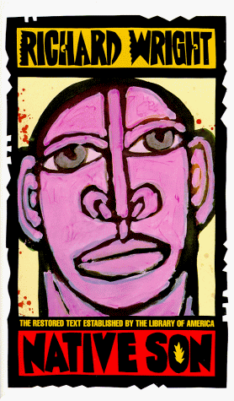
A gritty story featuring elements of poverty, systemic inevitability and the experience of being black, Native Son stands as the portrait of a broken cycle. Bigger Thomas, a man who feels mentally caged in is compelled by bad judgement to commit a crime and cover it up. Despite being caught, an oddly sentimental defense comes from the victim's boyfriend's lawyer, a man who argues that Bigger is trapped within a system that slowly leads him to reject the desire for a meaningful life. Native Son is critical in understanding the conditions that poverty and racism have on a person and the swift retribution which follows any violent or negative response to the oppressive tension. It displays Exeter qualities 2 and 6, highlighting a thrilling chase through Chicago and showing a world in which black people aren't just treated differently, but also live differently.

For Glorious Tale: a collection of stories showing the impressive achievements of Americans

Cooper, James Fenimore. The Last of the Mohicans: a Narrative of 1757. New American Library, 1980.
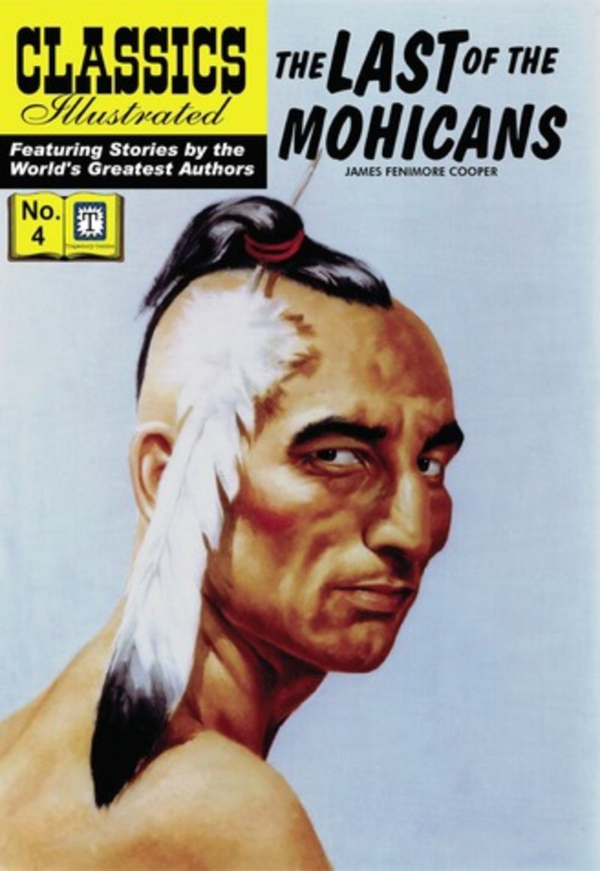
The story of the thrilling rescue of Lieutenant's daughters and the travel of a diverse group of Americans, the book is a reflection of the racial and cultural nature of early American society. The book's white protagonist is based off of the legendary frontiersmen from the nation's early history, interacting with the stoic and Noble native Americans. Although these depictions we're later critiqued for introducing stereotypes and romanticizing potentially bad people, the book displays strong Exeter qualities. Quality 2 and 5, which involve exciting plots and imaginative dialogue are expressed very strongly, providing a wonderful reading experience. This book shows what it meant to be American in the earliest days

Hemingway, Ernest. A Farewell to Arms. Scribner Classics, 1997.
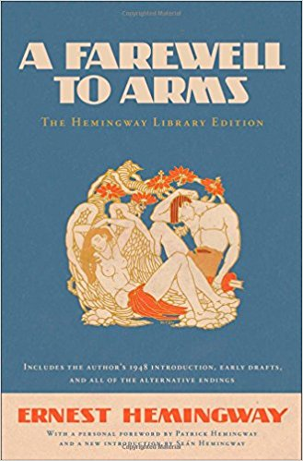
The story of an American ambulance driver in World War one. This moving tale takes many emotional moments sprung from the ravages of war and love and gives us the portrait of the overseas American, fighting and falling in love. This still occurs to this day, with the conduct of various Middle Eastern conflicts, while before that the Vietnam war brought thousands of war brides. Farewell to Arms is only a single moment within that larger narrative, occupying a space which can be understood many decades later. It's got strong Exeter qualities of 2 and 5 but historical background and emotional struggle provide good examples of qualities 6 and 7.

Powers. Yellow Birds. Distribooks Inc, 2014.
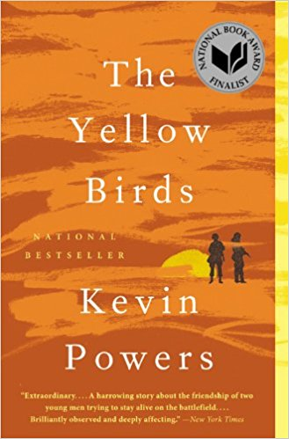
A portrait of the experience of an Iraq war veteran and the uncomfortable feeling of a loss of control against the formidable machine of war. The book sees the protagonist, Bartle and his friends struggle to not become casualties, especially the 1000th one, while facing distance from the public back home. The book is crucial in understanding a veterans perspective of the public reaction and the grim realities that sink in when war becomes something incomprehensible, even to the fighters. It has powerful Exeter 2 elements, showing off tense military scenes while also providing good quality 6 elements, as these experiences are ongoing, with the soldiers still deployed in Afghanistan

For the Patriot Dream: For America
LAmour, Louis. Last of the Breed. Bantam Books, 1986.

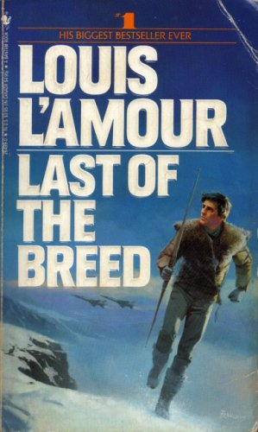
The story of a native American who survives being shot down in hostile Soviet territory, despite being tempted to betray his country due to the mistreatment of native Americans. Makatozi, who is half cherokee and half Sixou, uses his uniquely American skills in order survive a long trek through Siberia and eventually attempts an escape back to Alaska. The book is a tribute to the best aspects of Native American culture, showing off the pride and self restraint while displaying the incredible survival skills. The native American traits for ruggedness and nobility under duress have become a part of America and Makatozis story shows elements of Exeter quality 2, serving as an extremely fun read.

Koestler, Arthur, and Daphne Hardy. Darkness at Noon. The Macmillan Company, 1941.

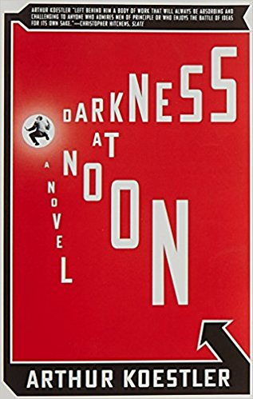
An insight to the fatal nature of totalitarian governments, this is a book written to display the cold, calculated paranoia of the Society regime. Arrested and imprisoned by the Bolsheviks, Rubashov is shown the grim reality of the regime in which he fought to bring about. Other inmates are shown including anti communists and other communists like him, showing that there is no difference based on what they believe but rather on their actual imprisonment. This book is crucial in establishing the horrors of a socialist regime and understanding America’s special role in upholding freedom. Without the sort of balance and restraint seen in America through our constitution, the totalitarian and arbitrary government falls victim to its own paranoia and elites use indoctrinated rank and file men to commit atrocities. This book contains Exeter quality 2 and 6, being a good read while exposing the danger of Communism

Wolfe, Tom. I Am Charlotte Simmons. Harper Perennial, 2011.

The story of a naive freshman who comes from a poverty stricken background and is overwhelmed by the sex obsessed and intellectually vain culture of college. Charlotte Simmons enters college focused on being seen as intellectual, but after being taken advantage of and regaining her control, she learns that material wealth and physical pleasure are not as important as being respected as an equal and worthy individual. The themes of sex and social status affecting grades, emotions and personalities can be reflected throughout our own college experience. While not as exaggerated at SJSU than in the book (which seeks to embody ivy leauge schools) there is still a concern for the value of academics over pleasure and material. It shows strong Exeter quality 3, with Charlotte Simmon discovering the self respect she had for herself all along.

Kelton, Elmer. The Time It Never Rained. Forge, 2008.

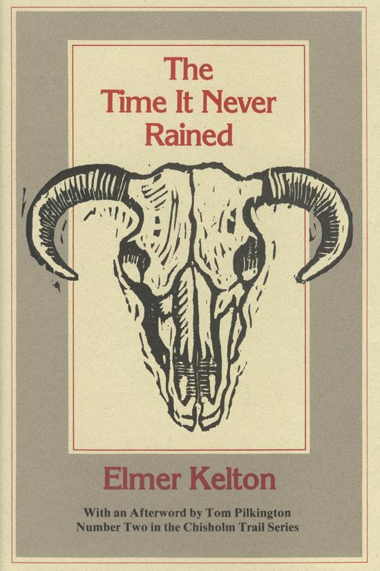
The story of a ranch hand who suffers tremendous drought but refuses government aid in order to remain independent. Throughout the story however, the conflict over inheritance and decision making in the house begin to manifest as a result of Charlie's indepence. His son won't take the ranch and his wife quarrel constantly, yet when the rains come back, Charlie is left as the only ranch hand who did not become another cog in the government. This story of enduring struggle and personal freedom is the basis of the American character. This country does not promise anything for free, but it does give people an opportunity to maintain their dignity and respect despite all odds. The freedom of choice is critical in understanding what Americans do and how we respond to struggle.

