- Jackeline Ruiz
- English 112B
- Dr. Warner
- 9 May 2019
- Finding Your Voice
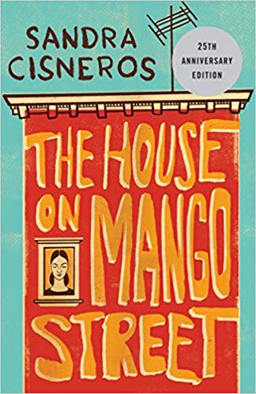
- I was born and raised in the City of Champs: Inglewood. The public schools in Inglewood are low funded, and lack resources that students need in order to succeed. Because these schools also do not enforce their teachers to teach, students are deprived of knowledge that could help them attain higher education. Evidently, high schools located in Inglewood have a low percentage of students attending college after graduation. I was supposed to attend Inglewood High School, but in hopes of increasing my chances of attending college, my mom enrolled me into a charter high school.
- Animo Inglewood Charter High School truly prepared me for college, and I am grateful for the time and effort my teachers put into providing us with the best education. Compared to my middle school, my high school teachers prepared engaging lesson plans, assigned homework, and expected class participation. It was not until 9th grade that I read my first book after my English teacher assigned the book The House on Mango Street.
- As a young adult, I was mostly intrigued by the way Sandra Cisneros applies poetic devices into her book. Each chapter is a different poem written in prose, and she uses alliteration, metaphors, similes, and other figurative language to write beautiful imagery. Each chapter tells a different story, and I also like how essentially the book could be read in any order because the chapters do not connect until the end. All these creative factors encouraged me as a young adult to not only discover books similar to The House on Mango Street, but to write my own stories.
- By reading The House on Mango Street, I was able to identify my voice as a Latina. Sandra Cisneros writes about the racism and misogyny present in the Latino culture, and these are are issues that too affect my community. I connected so much with Esperanza, and she inspired me to write about my own experiences as a Latina. Just how I found a sense of cultural identity after reading The House on Mango Street, I hope my students also gain an understanding of their culture. Even if the book is not about their culture, the story can help students be more accepting “of people from different cultures,” (Adolescents in the Search For Meaning: Tapping the Powerful Resource of Story, Chapter 4: Books about Real-Life Experiences).
- The Bay area is home to a wide variety of cultures and races. The best way to learn to be accepting of these different cultures is by reading about them through literature. I want my students to have the opportunity to read about their cultures in order to feel like they have a voice in literature. The House on Mango Street cannot just teach students about cultural identity, it can also educate students on discrimination, abusive relationships, decision-making, and feminism. All these topics are important factors of YA literature, and thus why I will teach The House on Mango Street.
- Introducing the Center Piece:
(youtube: https://www.youtube.com/watch?v=OY2b9YI0i0I)

- Because The House on Mango Street centralizes on Latinx culture, I would like to teach this book during a unit of cultural identity. Esperanza, the protaginst, struggles with understanding how to deal with her cultural expectations as a woman. In order to get my students engaged in this unit, I would begin class by showing them the Disney short film “Bao.” “Bao,” depicts the story of an Asian mother who has a dream that one of her dumplings turned into a baby. She raises the dumpling as her son, and we see how she struggles to connect with his American culture. The mom tries to understand her son, however bumps head with him, as she feels disrespected because he does not abide by her cultural expectations.

The film not only introduces the concept of culture-clash, but it also depicts Asian culture and its integration into American communities. Disney’s representation of the Asian culture is seen through the illustration of Asian lanterns hanging below the streets, outdoor grocery stores selling Asian produce, and dumplings being prepared for dinner. These are some of the aspects of the short film I would ask my students to keep in mind in order to get them to think about their culture and neighborhood. After watching the film, I would ask the students to write in their journals a short response to the film.

The guiding questions I would provide are: What foods would you normally eat at home for dinner? What role do your parents’ play, as in is there a stay-at-home parent or are both providers? What language is spoken at your house, and why? What language do you see in your community (buildings/signs/stores/etc)? What people do you see in your community? What does culture mean to you? Almost all teenagers enjoy watching movies, and showing students “Bao” is a great way to get students visually engaged with the text. This will not only allow students to prepare for the unit, but it will give them the agency to start thinking about their own cultural representation.

Resources During the Unit

When I was a high school student, I enjoyed poetry but I always felt intimidated by its complexity. Poetry reads elegantly, and every word has a purpose. Understanding how poetic devices help create a hidden message was somewhat difficult for me, however, when I read The House on Mango Street I remember finally realizing the power of figurative language. Many students can relate to the way I felt about poetry, and introducing this book can help alleviate the stress that may come with poetry.

The resources I plan on using during my integrated “cultural identity in poetry” unit are mostly writings by authors of color. What I plan on doing with The House on Mango Street is grouping all the chapters by themes; I will group all chapters about neighborhood together, family-dynamics together, women expectations together, racism together, and etc. I really like how this book does not need to be read in traditional order, and I want to highlight that creative aspect of the novel. The reason I want to do this is to help me present another canonical resource I plan on using during the cultural identity in poetry unit.

milk and honey by Rupi Kaur

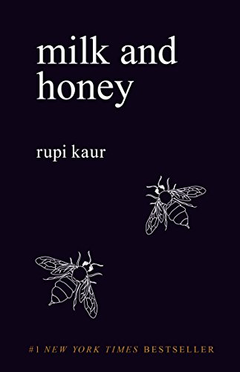
milk and honey is a collection of poems by Rupi Kaur. Rupi Kaur was born in India, and moved to Canada where she resides. Rupi Kaur writes about her struggles as an Indian woman, and brings awareness to the issues present in her native culture. The book is broken up into four sections titled: the hurting, the loving, the breaking, and the healing. Rupi Kaur writes in free verse poetry, and I think this would be an interesting way to teach free-verse style. Not only can I introduce a style of poetry by utilizing milk and honey, but also introduce another text that focuses on cultural identity. Rupi Kaur writes about heartbreak, family-dynamics, femininity, love, and cultural expectation, which are all themes found in The House on Mango Street.

Students can begin connecting the ways in which different cultures have similar conflicts, all while analyzing different forms of poetry. The activity I plan on doing is going around and reading our favorite poem from one of the four sections. After discussion, I will break the class up into groups of 4 and assign each student one of the following topics: the hurting, the loving, the breaking, and the healing. In order to keep the assignment consistent with the unit, I will ask my students to write their interpretation of what they think it means to be hurting, loving, breaking, or healing in their culture. Pictures are also a form of writing and expression. Rupi Kaur includes images that relate to what the poem is about; therefore I will give my students the option of either writing a short poem or draw a picture.

Some guiding questions I will provide my students with are: What hurts you about your culture (expectations, ideals, history)? What do you love about your culture? What do you wish to change, or break, about your culture? Do you think you could change any of these ideas, in order to heal your culture?

Freeway 280 by Lorna Dee Cervantes

Freeway 280 is a poem that somewhat follows the “I Am” style. Like Cisneros, Lorna Dee Cervantes describes her culture and community by utilizing poetic devices such as figurative language, syntax, and imagery. Cervantes uses metaphors and similes to describe how her old home used to look. Freeway 280 would be a great resource to use for this unit because not only is the theme of cultural identity present, but the poem can be used to teach poetic devices like metaphors and similes. A great way to connect The House on Mango Street and Freeway 280 is by analyzing the chapter “Those Who Don’t.” In the chapter “Those Who Don’t,” Esperanza speaks about how people who are not from her neighborhood perceive it as dangerous.

Because both Freeway 280 and “Those Who Don’t” are about community and culture, I plan on having my students write a poem in “I Am From” style in order to creatively engage them in the unit. The “I Am Poem” is another style of poetry I think students will have fun with because of how simple the format is. The “I Am Poem” allows a student to be creative while writing about personal details. Since freeway 280 is actually in San Jose, this is an exciting way to connect the unit with our own community. Freeway 280 can also aid students to think about how their culture is represented in San Jose.

For guiding questions, I would use the five senses in order to teach them how to effectively write descriptive language. Some include: Who do you see in your neighborhood? How does it smell? How do you feel walking alone at night in your neighborhood? What are your neighbors like? What do you think when you see somewhat unfamiliar in your neighborhood? Are you friends with your neighbors? How do you feel when you go to a foreign neighborhood?

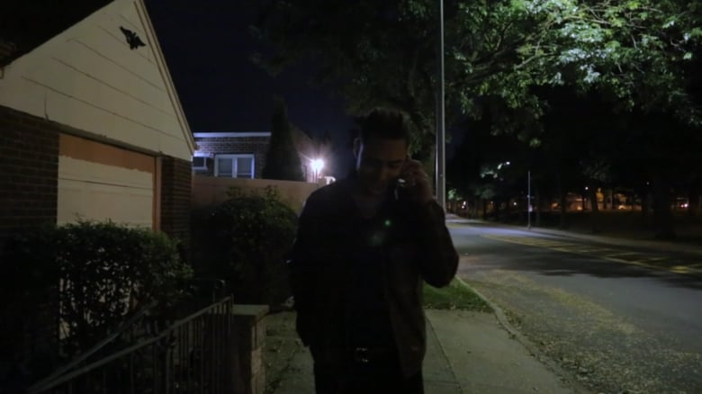
“Get Out” directed by Jordan Peele

A way to visualize the chapter “Those Who Don’t” is by showing the class the introduction to the film “Get Out.” The intro scene to the film is about a black man who is walking alone at night in a white-dominant suburban community. As the scene continues, a white car suspiciously pulls over next to him, and the viewer can see how the African American actor is scared for his life. This introduction can be connected to what Esperanza writes about at the end of “Those Who Don’t”; she writes about how she feels scared whenever she is in a foreign community. “Get Out” is a popular film among adolescents, thus a useful resource to use while teaching The House on Mango Street.

The Rose that Grew From Concrete by Tupac Shakur

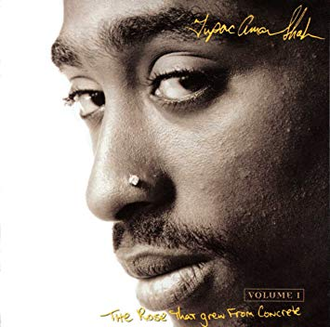
Tupac Shakur is a popular rapper, and famous for his poetry. His book The Rose that Grew From Concrete is a great resource for “cultural identity in poetry” because of the theme he writes about. Tupac writes about his neighborhood, love, racism, femininity in colored women, and about family, which are the topics that Cisneros writes about in The House on Mango Street. These topics are not only important for the overall unit, but also for youth readers. Tupac Shakur utilizes many poetic devices, from figurative language to iambic pentameter. I think using this book to teach iambic pentameter is a unique way because of who Tupac Shakur is.

Being a rapper, students may not expect to think they can learn from Tupac Shakur. However, Tupac Shakur uses iambic pentameter in his poetry, which is a poetic device normally found in formal poetry. The Rose that Grew From Concrete is a ‘cool’ way, as the youth would say, to teach iambic pentameter and formal poetry because the students will be analyzing rap. Instead of introducing iambic pentameter through Shakespeare, Tupac’s poetry can alleviate the pressure that comes with learning formal poetry; it is a useful way to have students participate in an activity that they normally find tedious, while staying consistent to the unit.

The poem The Rose that Grew From Concrete is the perfect example to use to teach iambic pentameter. The activity I will have them do is write a formal poem in response to one of Tupac’s poem. Some guiding questions I will ask are: Has the world changed since the poem? Is your community/culture the same? How dooes your culture/community differ from Tupac’s?

Beyond the Unit

After the “cultural identity in poetry” unit is done, I want to encourage my students to now read literature and books that discuss this theme. I will push my students to read ethnic literature, and compare how each book represents their culture. Some of the books I would recommend my students to read after the unit are:

The Bluest Eye by Toni Morrison

I read The Bluest Eye in my AP Literature high school class. I really enjoyed this book because I read about cultural issues that affect black women. This book relates to the unit of “cultural identity in poetry” because Morrison also writes in prose like Cisneros. The story gives the perspective of teenage girls, and their experience with colorism. The books speaks on the themes of misogyny, racism, family-dynams, and friendships, which is why students can find this book interesting. There are some crude scenes, and thus the book has been banned from many high schools. However, it can work as recommendation if students enjoy reading The House on Mango Street.

Disappeared by Francisco Stork

I read Disappeared for my book talk this semester. This book follows a similar style as The Bluest Eye in the way that each chapter is titled based on the speaker of the chapter. The story is about a brother and sister who are in a critical problem with druglords in Mexico. Because Disappeared has themes of friendship, cultural expectations, and family problems, this book would be a great recommendation because it informs students about cultures outside of the US; it can help them start thinking about outside culture representation.

American Born Chinese by Gene Luen Yang

American Born Chinese I actually a comic book stylebook. As a teacher, it is important to provide different forms of writing. By providing different forms of writing, I can encourage my students to read in whatever form interests them. I have not read American Born Chinese, but I do think it relates to the unit of cultural identity. The story gives the perspective different boys, and even a monkey! Each character struggles to accept their culture because of American standards, and views on foreign cultures. This book is a great recommendation for after the unit because of how creatively it depicts the themes of friendship, culture, and family.

Ultimately, I want my students to have a better understanding of poetry and cultural identity after this unit. After understanding poetry, I hope I inspire them to read about their culture in fiction. I think cultural representation in writing is important for minorities, especially as a youth reader. Just how I found my voice in Esperanza, I hope my students do too.

