A Study in Charlotte
A Book Talk by Alen He
About Brittany (Bri) Cavallaro
Brittany Cavallaro was born in 1986 in Springfield, Illinois. She lived there until she went to attend Interlochen Arts Academy to study creative writing. She spent her twenties teaching literature, creative writing, and composition to undergraduates at the University of Wisconsin and gifted high school students through Northwestern University’s CTD program. Now, she lives in the Bay Area with her husband and their “very small, very loud” cat.
http://www.brittanycavallaro.com/

Book Summary
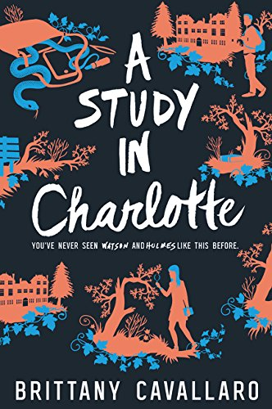
A Study in Charlotte is the first book in the trilogy about the two crime-solving teen descendants of Sherlock Holmes and John Watson: Charlotte Holmes and Jamie Watson. The novel follows the perspective of Jamie Watson, a boy who has moved away from his home in London to attend Sherringford, a privileged prep school based in Connecticut. All Jamie wants to do is live a normal life, but once he meets Charlotte Holmes, the option of living that normal life goes right out the window.

After acknowledging the existence of one another, the duo is almost instantly put at the top of the suspects list for a crime that occurred involving someone they both have history with. Jamie is now forced to work with Charlotte in order to prove their innocence, while trying his best to balance his school and social life and figure out how he truly feels about Charlotte – after all, the only people they can trust is each other.

Quotes
“‘You had to have learned something,’” I said, choosing to ignore that last part. In my short experience with her, Holmes had treated her body like an inconvenience, at best, and at the worst of times like an appendage she was actively trying to destroy” (84).
Charlotte Holmes has just returned from surveying male students under the disguise of “Hailey,” one of her many personas. Jamie proceeds to ask her how everything went, and she spews out replies without any substance as if she is irritated because she failed to find any evidence to prove them innocent. Charlotte mentions how she is starving, but she claims to have eaten the day before. So, this is where Jamie reflects on his perspective of how Charlotte is always so caught up in her own work that she forgets or refuses to eat and sleep. I believe a lot of young adults can find what Jamie says about Charlotte to be relatable.

“She shook my hand off with a snap. ‘Don’t you ever touch me without my explicit permission.” [. . .] But she was afraid. Of me” (116-117).
After finding their first piece of evidence, the duo decides to attend their homecoming dance. Charlotte claims she wants to go to question students of the school, but Jamie is not entirely convinced of that. Later in the night, Jamie finds Charlotte outside looking at the evidence they have, and he begins to question Charlotte’s intentions and innocence. There are a lot of things Charlotte does not tell Jamie whether it is about the case they are involved in or her personal life. This is the first “real” fight between the duo and this is the first time where their vulnerabilities are illustrated. They both see each other’s monstrous and fearful sides for the first time, so I think this is important for readers to realize in case they run into the same situation with their peers.
“At that moment, I was in the awful position of thinking something that I desperately didn’t want to believe. [. . .] I didn’t feel any better. Not even when the door swung open to let in my haggard, who took one look at my face and said, ‘Right, we’re going home’” (131-132).
Jamie overhears Charlotte being interrogated, and he believes that everything he is hearing is staged. However, he cannot tell if what Charlotte is saying is true or mere fabrications of lies. He begins to seriously consider Charlotte to be guilty of something; he also questions his loyalty to her and their relationship. Their night has been a mess just like Jamie’s thoughts are at the moment. I think this quote is important because it exemplifies the trust or mistrust that the crime-solving duo have or lack in each other. They have to either be honest with one another, or they crash and burn from their own insecurities.

For Teaching
This book is a great piece of literature for use in the classroom because it is easy to read and it makes use of prevalent archetypes and themes that are found in both older and more contemporary texts. The book can also be used to explore and analyze the dynamics of the different characters (adult and teen) while studying and defining the relationships between the characters. This book is most appropriate for young adults between the ages of 13 and 18 because all of the problems, situations, and experiences that Jamie and Charlotte go confront reflect similar ones that young adults go through. A Study in Charlotte fits into the categories of books about “Identity,” “Real-life Experiences,” “Struggles with Decisions,” “Courage,” “Survival,” and “Discrimination.”

Text Complexity
Lexile Measure: HL750L, ATOS Level: 12.0, New Dale-Chall Readability: 6.5
The novel is easy enough for middle school students and high school students to read and understand, and it also offers enough complexity and depth for older teens to relate to as well because the novel includes mature situations experienced by and through the perspective of teens.

