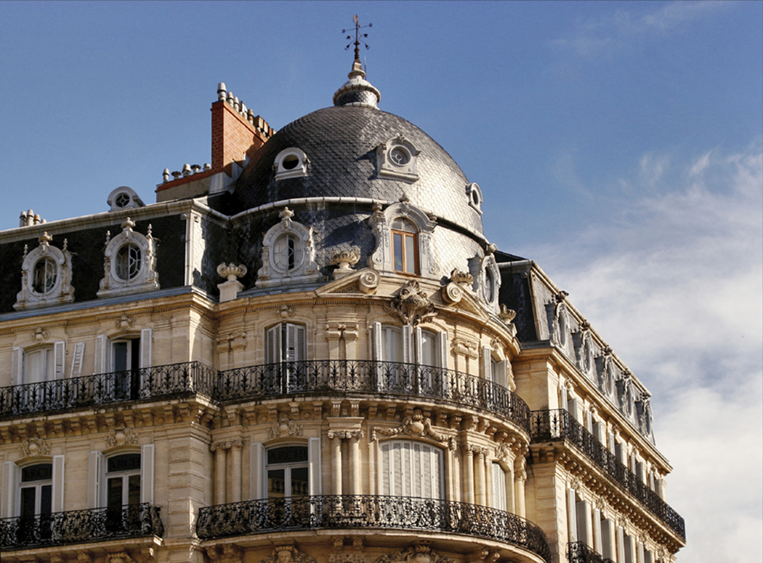
San Jose State University
Department of Hospitality, Recreation and Tourism Mgt
HRTM 102 Fundamentals of Hotel and Lodging Operations
Section 1
Fall, 2011

COURSE INFORMATION
Instructor: Dr. Kate Sullivan, Professor Call me Dr. Kate

Course Title: | Fundamentals of Hotel and Lodging Operations
Course Code: | HRTM 102
Section: | 1
Class Hours & Location: | T and Th 9-10:15 am
Classroom: | Clark Hall 302
Office Hours: | W 9:30 am-12:00 or by appointment
Office Location: | MH 515 HRTM main office SPX 45
Office Phone: | (408) 924-3201
E-mail: | kate.sullivan@sjsu.edu (preferred communication method)
Department Fax: | (408) 924-2011

COURSE DESCRIPTION

Principles of organization, management and decision models applied to the tasks and challenges of hotel operations. Involves techniques of problem solving (including planning, organizing, staffing, directing and controlling operations) in areas of front office operations, housekeeping, food/beverage, sales, maintenance, accounting and human resources.

Required Textbook

Hotel Operations Management by Hayes and Ninemeier, 3rd edition, 2012, Pearson Prentice Hall publishers
Textbook (required) ordered at Spartan Bookstore or Roberts Bookstore or online

Disney Institute. (2001). Be Our Guest: Perfecting the art of customer service. New York, NY: Disney Edition.

Students need to create an account at www.hotelbusiness.com to receive industry news.
Check out the American Hotel and Lodging Association; Hospitality Sales and Marketing Association; and The California Hotel and Lodging Association. Become a student member!

Student Learning Objectives for the Course:

Upon completion of this course, students should be able to:

describe the history and trends of the lodging industry;
identify the major hotel markets;
comprehend the structure of the hotel and lodging industry;
describe the managerial functions of hotel managers;
explain functions of each department in a hotel; focus on reservations
examine the sales and marketing activities within a hotel;
make revenue management decisions;
evaluate operational results.

COURSE REQUIREMENTS

a). Participation and Punctuality
Participation in this course is expected. It accounts for 10% of your grade. To receive maximum benefit from this course, you are expected to attend all classes, come prepared, and actively participate in the discussion. Late arrival and early departure in class are marks of disrespect, unprofessional, and interrupt class. Please be on time. Evaluation of participation will be based on participation in class discussions and exercises, homework, assignments, Internet exercises. You are also expected to attend field trips, dress appropriately if not dress up a little! You never know who you will meet as part of a networking opportunity!

b). Survey of Major Hotel Markets (group)

The purpose of this assignment is to identify the major hotel markets in the US. Each group is responsible for surveying one major hotel market, which include: Anaheim, Los Angeles, San Francisco, San Diego, Las Vegas, Honolulu, Boston, San Jose, Philadelphia, New York, Chicago, Miami, Orlando, and New Orleans. For each market, survey the following information:
1. From the Economic Census of 2002 or the most current available, www.census.gov, using county level data, find out total number of accommodation establishments (NAICS = 721, 7211, 72111, 72112, 72119), total sales, annual payroll, paid employees, and average salary.
2. From www.salary.com, find pay ranges for the front office manager and another type of hotel or lodging employee.
3. Locate the largest hotel in your study area. Find the rates of a room with two double beds for two adults and two children, daily from specific dates given by Dr. Kate and from the following four websites:

a. The hotel’s own website
b. www.travelocity.com
c. www.cheaptickets.com
d. www.hotels.com
e. find your own online source
f. find a creative online source

c.) Issues in the Hotel Industry (individual presentation)

You will have 3 minutes to present a tightly put together presentation about a current issue or trend in the lodging industry. How do you find an issue? READ! You need to go to the library and check out some of the hotel research journals (list to be given out in class) and look online for current events that either are affecting the lodging industry or may do so in the near future. Power point may be used if you are ready to go with your own laptop, but other props that are quick to display your issue may be appropriate. No handouts but links to URL’s are acceptable. You should practice with someone else before you present. You will be graded on clarity, content and creativity. If your voice is too quiet, you lose points. You must turn in a one or two page paper about your opinion of your trend/issue at the end of your presentation with the website information downloaded and attached to your comment paper. No late papers accepted. When you sign up for a date to present and you are absent, you lose a letter grade for this assignment unless a prearranged 2nd date has been ok’ed by Dr. Kate.

d.) Homework and In class exercises- If you miss a class and do not turn in homework, or miss an in class exercise which is collected and graded, you cannot make it up. Do not ask the instructor if there was homework or “did I miss anything?” if you are absent. I consider that an insult to my teaching. Find out the name and phone number of someone in the class and call them should you have to miss. Sometimes homework is assigned randomly.

e.) The Future Hotel project. You will be asked in a group to build a model of a futuristic hotel or portion of a hotel and identify 3 new ideas for “greening” the hotel and 3 futuristic ideas. You will label the model and write one group paper about your project. Your paper will use direct sources from industry professionals and their ideas. The whole group will present the project to the class and to a group of judges who are professionals from the hotel industry and environmental industry. More details to be given in class.

f.) Mid-term Examination
The format of the mid-term examination may be true/false, multiple choice, short answer, and/or mini-essay. The instructor will not administer a make-up examination unless there is an acceptable excuse. A doctor’s excuse must accompany any illness excuse. No make ups given once the mid terms are returned to the class.

g.) Final Examination
The final examination will be a comprehensive exam with more weight on the materials covered after the mid-term exam. No rearrangement of exam time due to travel, unless a family emergency.

GRADING INFORMATION
Assignment | Due | Weight | Points earned
a. Participation |  | 10
b. Survey of major hotel market/presentation and group paper | Week of 09/27/11 | 10/10
c. Issue in the Hotel Industry individual presentation and paper | ongoing | 10/5
d. Homework | ongoing | 10
e. Future Lodging Project and Presentation | Week of 12/06/11 | 15
f. Mid-term examination | 10/20/2011 | 15
g. Final examination | Wed. Dec 14, 7:15 am | 15
Total |  | 100

Grading Percentage Breakdown Final Grade
Total Points  96% and above | A+
94%-95% | A
93% - 90% | A-
89% - 87% | B+
86% - 84% | B
83% - 80% | B-
79% - 77% | C+
76% - 74% | C
73% - 70% | C-
69% - 67% | D+
66% - 64% | D
63% - 60% | D-
below 60% | F

UNIVERSITY, COLLEGE, and DEPARTMENT POLICY INFORMATION

Dr. Sullivan’s Teaching Philosophy
I want to help you learn and learn with you while we have fun along the way! I want to be a facilitator to you as you are introduced to the book, information, hotels and each other! I want you to be more hospitable to yourself, those you will encounter in business or leisure, and those whom you don’t understand. In this class, I believe that sometimes you can lead the group! I expect your best. I expect you to read the books, take notes, go back over your notes after each class. Arrive early to class, pay attention, ask questions, work with others. I expect you to turn your cell phones off before class, don’t come in late or leave early unless absolutely necessary. I teach not only through lecture and discussion but with example. I use the readings and the field trips and guest speakers as additional help. I love to teach, have received some special awards for it, and want you to leave the class feeling special, ready to go and more aware of how to make this a more courteous and kind world!
Email Philosophy
Papers cannot be emailed. Hard copies are due in class on the date identified in this syllabus. If you have questions regarding the class, you can email me. Just be sure to put in the subject/address that you are in the 102 class because I’ll prioritize it as important to be read asap.

University Policies
Students should know that the University’s Academic Integrity Policy is available at http://sa.sjsu.edu/judicial_affairs/faculty_and_staff/academic_integrity/index.html. Your own commitment to learning, as evidenced by your enrollment at San Jose State University and the University’s integrity policy, require you to be honest in all your academic course work. Faculty members are required to report all infractions to the office of Student Conduct and Ethical Development. The Student Conduct and Ethical Development website is available at http://www.sa.sjsu.edu/judicial_affairs/index.html.
Instances of academic dishonesty will not be tolerated. Cheating on exams or plagiarism (presenting the work of another as your own, or the use of another person’s ideas without giving proper credit) will result in a failing grade and sanctions by the University. For this class, all assignments are to be completed by the individual student unless otherwise specified. If you would like to include in your assignment any material you have submitted, or plan to submit for another class, please note that SJSU’s Academic Policy F06-1 requires approval of instructors.

Campus Policy in Compliance with the American Disabilities Act
If you need course adaptations or accommodations because of a disability, or if you need to make special arrangements in case the building must be evacuated, please make an appointment with me as soon as possible, or see me during office hours. Presidential Directive 97-03 requires that students with disabilities requesting accommodations must register with the Disability Resource Center (DRC) at http://www.drc.sjsu.edu/ to establish a record of their disability.

Student Technology Resources
Computer labs for student use are available in the Academic Success Center located on the 1st floor of Clark Hall and on the 2nd floor of the Student Union. Additional computer labs may be available in your department/college. Computers are also available in the Martin Luther King Library.
A wide variety of audio-visual equipment is available for student checkout from Media Services located in IRC 112. These items include digital and VHS camcorders, VHS and Beta video players, 16 mm, slide, overhead, DVD, CD, and audiotape players, sound systems, wireless microphones, projection screens and monitors.

Learning Assistance Resource Center
The Learning Assistance Resource Center (LARC) is located in Room 600 in the Student Services Center. It is designed to assist students in the development of their full academic potential and to motivate them to become self-directed learners. The center provides support services, such as skills assessment, individual or group tutorials, subject advising, learning assistance, summer academic preparation and basic skills development. The LARC website is located at http:/www.sjsu.edu/larc/.

SJSU Writing Center
The SJSU Writing Center is located in Room 126 in Clark Hall. It is staffed by professional instructors and upper-division or graduate-level writing specialists from each of the seven SJSU colleges. Our writing specialists have met a rigorous GPA requirement, and they are well trained to assist all students at all levels within all disciplines to become better writers. The Writing Center website is located at http://wwsjsu.edu/writingcenter/about/staff/.

Schedule:

Table 1: Course Schedule.

. | Date. | Topics | Chapter(s) to read.
1. | Week of August 31, 2011 | Intro and Welcome to the Lodging Industry
2. | Week of Sept 6, 2011. | Structure of the Lodging and Hotel Industry | 1-2.
3. | Week of  09/13/2011. | Guest Services; Reservations | 3.
4. | Week of  09/20/2011. | Managing the Lodging operation | 4.
5. | Week of 09/27/2011. | City Presentations | Paper One due
6. | Week of 10/04/2011. | Field Trips
7. | Week of 10/11/11 | Staffing the Lodging Operation | 5.
8. | Week of 10/18/2011. | Front Office Management  Review for midterm | 6.
9. | 10/20/11. | Mid-term Examination.
10. | Week of 10/25/11 | Sales and Marketing | 7.
11. | Week of 11/1/11 | Housekeeping | 8.
12. | Week of  11/8/11 | Maintenance; Safety and Security | 9. & 13.
13. | Week of 11/15/11 | Food and Beverage | 10.
14. | Week of 11/22/11 | No classes Thanksgiving
15. | Week of 11/29/11 | Accounting and Finance | 12.
16. | 12/6/11 12/08/11 | Futuristic Hotel Presentations  Review for Final Examination.
 | Final Exam | Monday, Dec. 13, 2010 7:15 am

