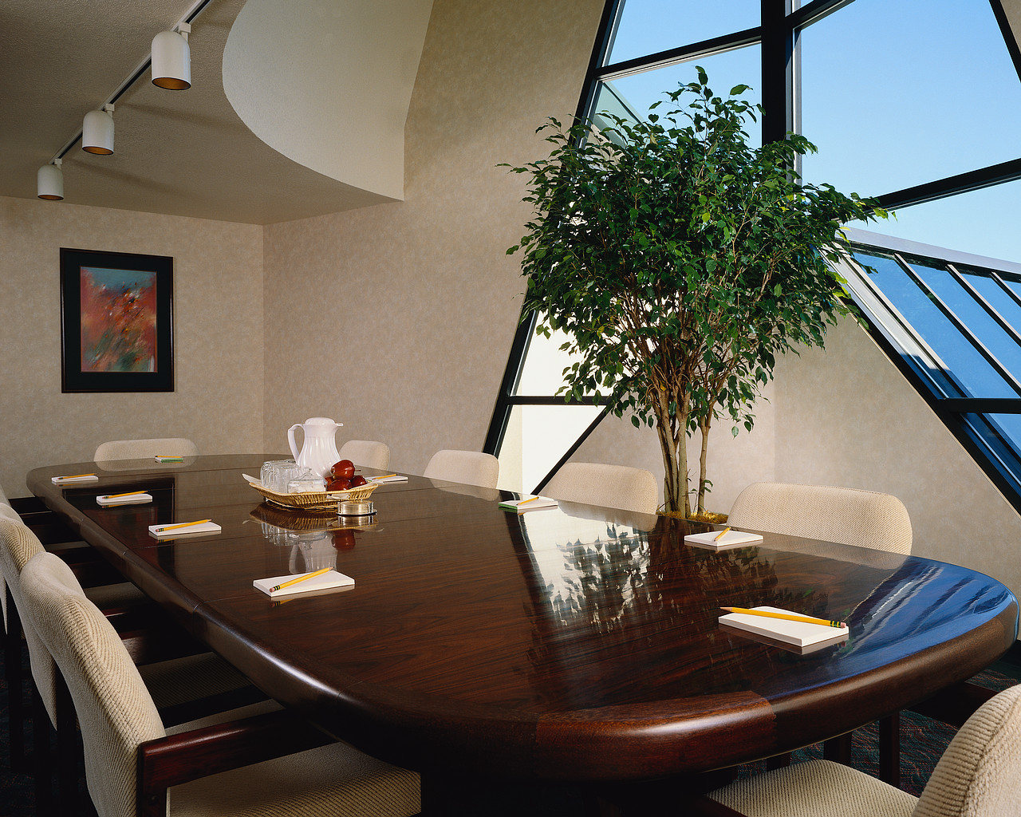

San José State University
Dept. of Hospitality, Recreation and Tourism Mgt.

Meeting, Convention and Event Mgt. Fall 2011

1:30-2:45 T and Th
Instructor: | Dr. Kate Sullivan, Professor  Call me Dr. Kate
Office Location: | 515 Macquarrie Hall
Telephone: | 408-924-3201
Email: | Kate.Sullivan@sjsu.edu (preferred communication method)
Office Hours: | W 9:30 to noon or by appt.
Class Days/Time: | T TH 1:30-2:45 pm
Classroom: | SH 345 (temporary)
COURSE DESCRIPTION
Goals and Objectives

1.0 The student will become acquainted with the size and scope of the meetings and convention market.
1.1 The student will become familiar with a variety of meeting types:
corporate meeting
association meetings
trade shows and exhibits
conventions, conferences and special events
1.2 The student will understand the key elements of the meetings market such as:
convention and visitors bureau
hotel industry
transportation industry
convention centers
exposition management industry
food and beverage

2.0 The student will identify the value and economic impact of the meetings market on the over-all economy of the United States.

3.0 The student will understand the key financial and managerial elements of the conference and convention market including:
exhibit space
insurance requirements
meeting housing
program planning
negotiations and contracts
site selection
leases, confirmation letters
space use and set-up design
registration
billing and post convention review

4.0 The student will understand the environment of a "meeting in progress" in terms of client needs including:
speaker needs recreational planning
lighting/heating/cooling special event planning
head table meeting space assessment

REQUIRED Text
Meetings, Expositions, Events, and Conventions, 2012, 3rd edition
Fenich, George G. Isbn -10 0-13-234057-7

Recommended additionalText
Abbey, James R. and Astroff, Milton T. 2010. Convention Sales and Services, Waterbury Press, Cranbury, NJ 8th Edition Isbn 978-0-9620710-6-5

Bibliography:

Professional Meeting Management (2011) Education Foundation of the Professional Convention Management Association, 4th Edition.
The Meetings Market, 2008, Market Probe International, Inc. for Meetings and Conventions.
Convention Liaison Manual, (2010) Convention Liaison Council.

Periodicals:

Meetings and Conventions-monthly
Meeting News-monthly
Association Meetings bi-monthly
International Association of Convention and Visitors Bureau Newsletters, bi-monthly

Classroom Protocol

If you are sick, coughing or otherwise contagious, stay home! Bring tissues and use hand sanitizers.

Coming in late is distracting to all of us; eating in class is, too. Please do your best to show excellence in your behavior. When a fellow student is presenting something, all screens down and away! Shut your phones off during class; I would prefer no texting or reading text messages while I am speaking. These rules are common courtesy especially for an HRTM major! Read my expectations for participation under course requirements.
If there is an earthquake, know to duck and cover. Do not take my lead as I am from the East coast and am still not calm during them! Go to your MYSJSU account and sign up for ALERT SJSU immediately! That is the SJSU police’s way to contact you should something bizarre happen on campus and evacuations are occurring. While you are in your account, be sure your email address is accurate because I will be sending out occasional messages to you via the roster.
There are times when I may be late or ill and I will give you notice via email as best as I can so as not to inconvenience you in anyway. Also, I have some hearing loss so bear with me! If you are sitting in the back of the room and say something I cannot hear, I may ask those in the front to relay what you said so that I can hear it. Sometimes I misinterpret what you said because I can’t hear certain intonations, so please don’t be offended.

Dropping and Adding
Students are responsible for understanding the policies and procedures about add/drop, grade forgiveness, etc. Refer to the current semester’s Catalog Policies section at http://info.sjsu.edu/static/catalog/policies.html. Add/drop deadlines can be found on the current academic calendar web page located at http://www.sjsu.edu/academic_programs/calendars/academic_calendar/. The Late Drop Policy is available at http://www.sjsu.edu/aars/policies/latedrops/policy/. Students should be aware of the current deadlines and penalties for dropping classes.

Information about the latest changes and news is available at the Advising Hub at http://www.sjsu.edu/advising/.

Assignments and Grading Policy
Course Requirements Points

A. Class Participation 10
B. Trends presentation 15
C. Midterm and Final 15 and 15
D. Field Trips 10
E. Homework 15
F. Meeting 20
Total points 100

Explanation of the above requirements:

Class Participation

Attendance is expected and roll will be taken. You must come to class prepared, speak up, have something to say. It means reading before class and arriving at class with something to say, whether it is a question, comment or a topic. Quieter students need to speak up and more talkative students need to help the professor draw out the quiet ones. Asking questions of your peers is appropriate and encouraged. For example, “ Why do you feel that way?” “That’s interesting, can you say more?” Open communication means respecting the opinions of others, especially ones you disagree with. We come from a variety of backgrounds with a variety of opinions, thus, making a rich background for discussion. You must be willing to listen. You will be assessed for this 10% through your participation in each class discussion, in class assignments, activities and interaction with fellow students and the professor.

Conference and convention trends/issues presentation

In a well organized manner, you will tell the class about a trend or relevant and current issue in the conference and convention industry. You may not stand up and be a commercial for a product. Floodlight, don’t spotlight an issue or trend! Your voice will be able to be heard in the back of the room or you will not pass this assignment! You may use powerpoint, handouts or props to strengthen your 3 minute presentation. You will also explain why this trend is important to the meetings industry and hospitality in general. On the day of your presentation, you will turn in a 1-2 page write-up about your reactions to what you presented. A copy of the information source you used will be attached to this paper. 12 point font please!

Midterm and Final Examinations

A midterm examination and a comprehensive final examination are given to assess your ability to absorb the information covered in the class. Examinations will include true and false, multiple choice, short definitions, matching, and mini-essays. If you would like to see a copy of other exams I have given, ask me and I will bring one to class. Don’t let your reading stack up until the last week before the final. It will show. Study continuously.

Field Trips

You will be asked to meet at a specific location at a specific time, hopefully, class time but not always. We may have to do a Friday or Saturday tour. All tours will give you a behind-the-scenes look at the site. You are required to attend 2 out of 3 field trips. Car pooling is suggested. A follow up evaluation of what you observed will be required. On my priority list are the following: San Jose, Santa Clara and San Francisco Moscone Convention Centers.

- Homework

You will be given homework assignments which must be turned in on time the following week after issued. Use 12 point font. If you are absent at the class in which the homework is due, it will not be accepted in the next class. No late papers on homework. You must turn in 4 of 5 assigned homework papers.

F Live or virtual meeting production. Details to be announced in class

Final total percentage range and letter grade:

96 – 100 A+
93 – 95 A
90 – 92 A-
86 – 89 B+
83 – 85 B
80 – 82 B-
76 – 79 C+
73 – 75 C
70 – 72 C-
66 – 69 D+
63 – 65 D
60 – 62 D-
59 and below F

Dr. Sullivan’s Teaching Philosophy

I want to help you learn and learn with you while we have fun along the way! I want to be a facilitator to you as you are introduced to the book, information, SJSU and each other! I want you to be more hospitable to yourself, those you will encounter in business or leisure, and those whom you don’t understand. In this class, I believe that sometimes you can lead the group! I expect your best. I expect you to read the books, take notes, go back over your notes after each class. Arrive early to class, pay attention, ask questions, work with others. I expect you to turn your cell phones off before class, don’t come in late or leave early unless absolutely necessary. I teach not only through lecture and discussion but with example. I use the readings and the field trips and guest speakers as additional help. I love to teach, have received some special awards for it, and want you to leave the class feeling special, ready to go and more aware of how to make this a more courteous and kind world!

Email Philosophy

Papers cannot be emailed. Hard copies are due in class on the date identified in this syllabus. If you have questions regarding the class, you can email me. Just be sure to put in the subject/address that you are in the 140 class because I’ll prioritize it as important to be read asap.

University Policies
Students should know that the University’s Academic Integrity Policy is available at http://sa.sjsu.edu/judicial_affairs/faculty_and_staff/academic_integrity/index.html. Your own commitment to learning, as evidenced by your enrollment at San Jose State University and the University’s integrity policy, require you to be honest in all your academic course work. Faculty members are required to report all infractions to the office of Student Conduct and Ethical Development. The Student Conduct and Ethical Development website is available at http://www.sa.sjsu.edu/judicial_affairs/index.html.
Instances of academic dishonesty will not be tolerated. Cheating on exams or plagiarism (presenting the work of another as your own, or the use of another person’s ideas without giving proper credit) will result in a failing grade and sanctions by the University. For this class, all assignments are to be completed by the individual student unless otherwise specified. If you would like to include in your assignment any material you have submitted, or plan to submit for another class, please note that SJSU’s Academic Policy F06-1 requires approval of instructors.

Campus Policy in Compliance with the American Disabilities Act
If you need course adaptations or accommodations because of a disability, or if you need to make special arrangements in case the building must be evacuated, please make an appointment with me as soon as possible, or see me during office hours. Presidential Directive 97-03 requires that students with disabilities requesting accommodations must register with the Disability Resource Center (DRC) at http://www.drc.sjsu.edu/ to establish a record of their disability.

Student Technology Resources
Computer labs for student use are available in the Academic Success Center located on the 1st floor of Clark Hall and on the 2nd floor of the Student Union. Additional computer labs may be available in your department/college. Computers are also available in the Martin Luther King Library.
A wide variety of audio-visual equipment is available for student checkout from Media Services located in IRC 112. These items include digital and VHS camcorders, VHS and Beta video players, 16 mm, slide, overhead, DVD, CD, and audiotape players, sound systems, wireless microphones, projection screens and monitors.

Learning Assistance Resource Center
The Learning Assistance Resource Center (LARC) is located in Room 600 in the Student Services Center. It is designed to assist students in the development of their full academic potential and to motivate them to become self-directed learners. The center provides support services, such as skills assessment, individual or group tutorials, subject advising, learning assistance, summer academic preparation and basic skills development. The LARC website is located at http:/www.sjsu.edu/larc/.

SJSU Writing Center
The SJSU Writing Center is located in Room 126 in Clark Hall. It is staffed by professional instructors and upper-division or graduate-level writing specialists from each of the seven SJSU colleges. Our writing specialists have met a rigorous GPA requirement, and they are well trained to assist all students at all levels within all disciplines to become better writers. The Writing Center website is located at http://www.sjsu.edu/writingcenter/about/staff/.

Peer Mentor Center
The Peer Mentor Center is located on the 1st floor of Clark Hall in the Academic Success Center. The Peer Mentor Center is staffed with Peer Mentors who excel in helping students manage university life, tackling problems that range from academic challenges to interpersonal struggles. On the road to graduation, Peer Mentors are navigators, offering “roadside assistance” to peers who feel a bit lost or simply need help mapping out the locations of campus resources. Peer Mentor services are free and available on a drop –in basis, no reservation required. The Peer Mentor Center website is located at http://www.sjsu.edu/muse/peermentor
Schedule: Subject to change without notice
Table 1: Course Schedule. Subject to

. |  | Date. | Topics | Chapter(s) to read.
1. |  | 08/27/11 | Intro and Welcome to MEEC
2. |  | Week of 08/31/11. | What is a Meeting? Who holds meetings ? Where are meeting venues? | 1-2. 4.
3. |  | Week of  09/06/11 | Destination Marketing Organizations (DMOS)  Destination Management Companies (DMCS)  Service Contractors | 3. and 7.  6.
4. |  | Week of  09/13/11 | Exhibitions and Trade shows  Special Events Mgt. | 5.  8.
5. |  | Week of 09/20/11 | Field Trips
6. |  | Week of 09/27/11 | Planning and Producing Meetings and Conventions  Negotiatons, contracts, session scheduling, housing | 9.
7. |  | Week of 10/04/11 | Food and Beverage | 10.
8. |  | Week of 10/11/11 | 10/11Review for Midterm  10/13 Midterm
9. |  | Week of 10/18 | Legal Issues | 11.
10. |  | Week of 10/25 | Technology and the Meeting Professional | 12.
11. |  | Week of  11/1/11 | Green Meetings and Social Responsibility | 13.
12. |  | Week of 11/8/11 | Field Trips Planning of our own meeting
13. |  | Week of 11/15/11 | International Meetings | 14.
14. |  | Week of 11/22/11 | Happy Thanksgiving! No classes!
15. |  | Week of 11/29/11  Week of 12/6 | Putting it all Together  Review for final | 15.
 |  | Final Exam | Wed. December 14, 2011 12:15-14:30

