MESA Engineering Program—SJSU
Remedial Core GE Fall 2017 Catalog Industrial & Systems Engineering (120 units)

ENGL 1AS (3)
ENGL 1B (3) +
Core GE & WST
ENGR 100W (3)
(GE Area Z + R)
ISE 151 (3)

ENGL 1AF (3)
English
ENGL 1A (3)

CHEM 1A

(5)
ISE 131 (3)

1
Math 3A (4)
Mathematics
Math 30 (3)
Math 19 + 19W (6)
or
Math 30P/PL
(5)
+ workshop (1)
Math 6A (3)

MATE 25 (3)
PHYS 50 (4)
ISE 135(3) 
5
ISE 120 (3) 

6
ISE 195A (3)

PHYS 51 (4)
ISE 115 (3)

ENGR 8 (1)

GE Check List:
General Education Engineering
Basic Skills (9 units)
□ A1: (3)
□ A2: (3)
- A3: * Pending Degree *(3)
Humanities (9 units)
□ C1: (3)
☑ C2: ENGL 1B 3)
□ C3: (3)
Social Science (9 units)
3
Math 32 (3)
2
Math 123 (3)
ISE 105 (3)
Math 31 (4)

ISE 102 (3)
4
ISE 130 (3)

CMPE 30 
ENGR 10 (3)
(GE Area E)
CMPE 30↗

6
ISE 167 (3)
ISE 170 (3)
ISE 140 (3)

7
ISE 195B (3)

KEY:
ISE 155 (3)
□ D1: (3)
□ D2: (3)
□ D3: (3)
Human Dev. (9 units)
☑E: * Engineering 10 *(3)
Social Science (9 units)
□ US1: (3)
□ US2: (3)
□ US3: (3)
Pre‐requisite Co‐requisite

CMPE 30 (3) 

ME 20 (2)

Critical Path Additional Requirements:

ISE 135↗
ISE 194 (1)
CMPE 131 (3)
ISE 142 (3)
ISE 120

ENGR 10 Pre‐Requisite English 1A Readiness Required Math 19 Readiness Required Generals Education
Technical Elective Courses: (6 units)
SJSU Studies: (9 units) ☑ R&Z: ENGR 100W (3) □ S: (3) □ V: (3)

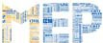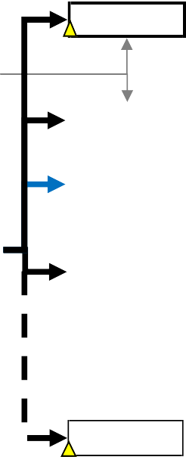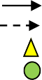Disclaimer: This chart is only a reference and not an oﬃcial document from the college/department. Always consult your with major advisor
Revised: Summer 2017/Prepared by: MESA Engineering program—SJSU (2014)

