Integrating Standards Education
into the Business School Curriculum
Case Studies

Part 2 of 2
Final Report – submitted 6/30/2014
Award 60NANB12D285
NIST Measurement Science and Engineering (MSE) Research Grant Programs
Standard Services Group (SSG) Grant Program

Stephen K. Kwan, Ph.D.
Lucas Professor of Service Science
Corresponding author: stephen.kwan@sjsu.edu

Nitin Aggarwal, Ph.D.
Associate Professor,
Management Information Systems

Lucas College and Graduate School of Business
San José State University
One Washington Square
San José, CA 95192

2014

List of Case Studies

Case 1 – Is it real or is it SDN?
Stephen K. Kwan and Nitin Aggarwal
Case 2 – Charge it!
Stephen K. Kwan and Nitin Aggarwal
Case 3 – Wireless Payment – Wallet Share
Stephen K. Kwan and Nitin Aggarwal
Case 4 – Incompatibility in Mobile Chargers – Need Based or Strategic?
Stephen K. Kwan and Nitin Aggarwal
Case 5 – Apple vs. Samsung – The War of the Titans
Stephen K. Kwan and Nitin Aggarwal
Case 6 – E-Books – Not all are created equal! (invited contribution)
Patricia Franks, Associate Professor, School of Information, SJSU
Case 1: Is it real or is it SDN?

Stephen K. Kwan and Nitin Aggarwal
Cisco Systems, Inc. had been the bellwether for the telecommunication network industry since it was founded in 1984 and went public in 1990. It had been a dominant player in the industry providing the infrastructure for the nascent Internet in its early days and had grown into a business with $46B in revenue in 2012. It had gone through many iterations of ups and downs in the sometimes-turbulent industry and had survived. It recently rebranded its name to Cisco to shed some of its reputation as just a “box” company to a “solution” company. Today Cisco has in its product lines network routers, switches, wireless infrastructure, software, services, and enterprise consulting.
The later part of 1990’s and early part of 2000’s can be characterized as the era of the Internet bubble when wealth was created based on unreasonable exuberant expectations of ecommerce engendered by the advent of the Internet. There was great demand for building out the telecommunication network in the United States. Unfortunately the promises of quick money based on unrealistic business plans and expectations did not materialize and the dot-com bubble burst in March 2000. This led to the collapse of many newly started dot-com companies and the demand for network expansion ceased. As a result, the telecommunication industry experienced fallout that affected both large and small companies.
During the next few years, Cisco Systems was back in form as it forayed into the consumer market by acquiring companies with technology that connect high-speed networks to home networks. It also entered the market for delivering high volume digital contents such as teleconferencing and streaming media.
During this period the telecommunication industry was undergoing a lot of technological changes and cost cutting in infrastructure procurement became the mantra of many enterprises and government agencies. One of the major technological advances that received industry-wide adoption was virtualization.
Virtualization refers to the creation of one or more guest virtual machines on a host machine that is provisioned to operate like a real machine with its operating system and stack components. This is done with a combination of hardware and software capabilities in order to maximize the host machine’s resources as well as minimize the proliferation of physical servers with concomitant space, power and environmental requirements. Virtualization has been used with mainframe computer systems for quite a while but it has become more popular recently with new advances in virtualization software and cloud computing implementation of Software as a Service (SaaS), Platform as a Service (Paas), and Infrastructure as a Service (IaaS).
Along with the virtualization trend the industry was also consolidating its technology along the lines of i) increasing speed by reducing latency, and ii) increase flexibility by doing more with software. These led to telecommunication products that combine server with router into a single machine to reduce the physical distance between circuitry that perform different tasks. The attempts to do more with software to increase flexibility led to the development of what is called Software Defined Network (SDN).
The advent of SDN is a natural extension of virtualization of servers and other computing hardware. The functions of a hardware device that defines and controls a network can be instantiated as a virtual machine running in the same environment as other computing functions. The SDN can be defined and controlled from the virtual machine as if it were a hardware device (which functions are defined by software anyway). This is also made possible by existing technology where network control devices are aware of and have access to all network end-points. The SDN is in essence a virtual overlay on top of existing infrastructure that is laid out by hardware devices and connecting cables.
As with the introduction of most new technology no universal technical standard had been established. The existing standards such as TCP/IP and HTTP have been in place and adopted in the telecommunication industry for quite a while. These account for the successful proliferation of network technology, which inter-operate throughout the world and have made the Internet ubiquitous. There are, however, different standards proposed and implemented by vendors of SDN who are seeing this as a growth market. Companies such as VMware, HP and IBM are all involved in this new market. Many of these companies favor a standard called OpenFlow which allow companies to program generic routers and switches to create their own networks.
Even though the industry understands that standards are needed to achieve interoperability there is still fierce competition among the players in setting standards.
At the 2012 fiscal fourth quarter earnings report conference call, John Chambers, CEO of Cisco was asked about how Cisco competes with other SDN vendors. He indicated that
“…We think the future is going to be hardware and software combined. Secondly, we saw virtualization coming. We went into it early in 2009, which is exactly when we entered the data center. We see …, OpenFlow type activity being a few years out. We are looking at partnerships we can work on.”
During the call other Cisco executives also mentioned Cisco’s Open Network Environment (ONE) architecture, a program under which Cisco opens part of its network gear operating systems to its partners as part of its efforts to counter the threat of SDN.
On April 8th, 2013, the Linux Foundation announced in a press release the creation of a new collaborative project called OpenDayLight.org. Its goal was to create a “New open source framework to drive innovation and acceleration of technologies, allows customers, partners and community to shape SDN”. The organization’s membership reads like a who-is-who of the industry that includes Big Switch Networks, Brocade, Cisco, Citrix, Ericsson, IBM, Juniper Networks, Microsoft, NEC, Red Hat, and VMware. The conceptual framework is shown in Figure 1.
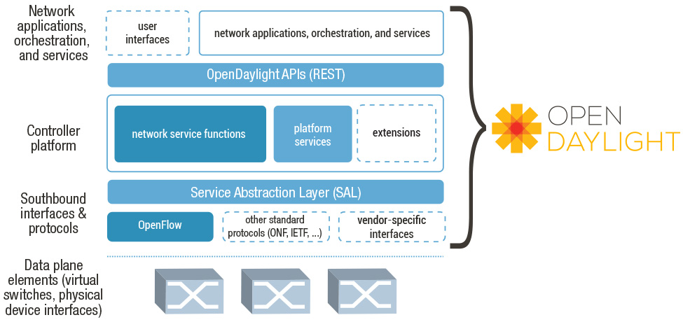
Figure 1: OpenDayLights’s Conceptual Framework of SDN
When asked why his company joined the OpenDayLight.org, an engineering director who participated actively said that “Keep your friends close, but your enemies [competitors] closer.”

Preparation of Case Study
Students should familiarize themselves with the concept of virtualization, some of the vendor offerings in the market, and real-life examples of SaaS, PaaS, and IaaS (even some they have contacts with on a daily basis).

Case Study Questions
- Use the Porter competitive forces model to analyze the current telecommunication equipment market with respect to Cisco.com.
[Instructor Note: SDN is often viewed as a disruptive technology, how does it affect the dynamics of the players in the industry?]
- Compare and contrast the ONE, OpenFlow and OpenDayLight approaches to the design and development of SDN solutions.
[Instructor Note: these are competing approaches and the industry is searching for standard(s). What roles do the non-profit organizations play in this environment?]
- The OpenDayLight.org is a collaborative project in the Apache Foundation, which has a strong framework for open source software development. Why do all these big companies participate in such “open” projects? Define and explain “openness” in this context. What are the pros and cons of open source frameworks for software development and open standards for technology interoperability?
[Instructor Note: Students should have an understanding of “openness” in this context because of some common and persistent misunderstanding which created “fear, uncertainty and doubt” in the enterprise world. This is a good place to bring in discussion of business models of open technology, open API’s as well as SDN.]
- The students should provide an update of the industry as it relates to the case scenario.
[Instructor Note: The industry is changing fast and it is important to urge the students to learn about the environment and the impact of the technology both from the supply and demand side.]

______________________________________________________________________________
This case study was prepared as a basis for discussion rather than to illustrate either effective or ineffective handling of a business scenario and/or leadership/role behavior. This case study project was undertaken with the support of a research grant from NIST Measurement Science and Engineering, Standards Services Group, and the Lucas College of Business at San José State University. This case study is distributed under the Creative Commons Attribution-NonCommerical-ShareAlike (CC BY-NC-SA) license.
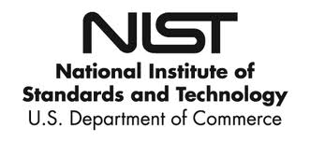
Case 2: Charge it!

Stephen K. Kwan and Nitin Aggarwal

Historical Perspective
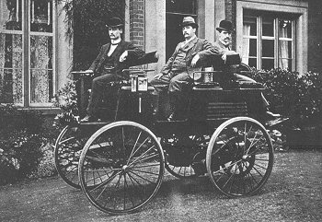
Figure 1: First Electric Car
If you find electric cars fascinating and wonder why we didn’t think of them before, you are in for a big surprise. Electric cars are almost as old as the traditional gasoline powered cars that you see on road today. An automobile works on a simple principal. An engine converts energy into mechanical motion which moves the car forward or in reverse. While the basic principal remains the same, the source of energy can be different. A gasoline car uses an internal combustion engine to burn gasoline which generates the motion. An electric car uses energy stored in the batteries to generate motion.
In late 19th century when electric cars were first introduced, they had some of the same advantages and disadvantages that electric cars have today. They were quieter, cleaner, and easier to drive but lacked charging infrastructure, took a lot of time to charge, and had a very limited driving range. Unfortunately, the disadvantages far outweighed the benefits, and we saw an increase in the popularity of gasoline engines. Since the early success of the gasoline engines, there have been very few opportunities for electric engines to comeback. Every time, there is an energy crisis, or an oil shock, electric engines make a comeback. However, the interest is short lived and lost as soon as the oil prices stabilize.

The Present
However, things seem to be different now. There is a renewed interest in electric cars and it seems like this time it may succeed. For one, this time, major multinational players like Toyota, Honda, Ford, General Motors, amongst others, are invested and committed to producing Electric Vehicles (EV). Second, manufacturers are developing and introducing, less risky and more acceptable, hybrid solutions that are successful in alleviating customers biggest concerns of range anxiety. Plug-ins and EVs already constitute 3.3% of overall automobile sales. The federal government has also committed to replacing some of its ageing fleet with hybrid electric vehicles. Finally, there are substantial government incentives for both manufacturers, to build electric cars and infrastructure, and for customers, to buy electric cars and to go green.
For example, President Obama wants one million electric cars on American roads by 2015. To support his goal and incentivize EV manufacturing, the U.S. government is providing billions in funding, to car manufacturers, for building all-electric vehicle factories across the United States. The government is also providing billions in funding to factories engaged in manufacturing EV batteries, motors, and other components. Likewise, to prop up consumer interest and demand, the Federal and State Governments are providing tax rebates for consumers to buy electric cars incentives like $7,500 federal tax incentive and $2,500 California tax rebate, both stackable with each other. All in all, it is said, that by 2019 the US government would have invested $7.5 billion to support and promote use of manufacturing and use of electric cars.
Fisher Karma | 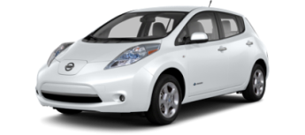  Nissan Leaf | 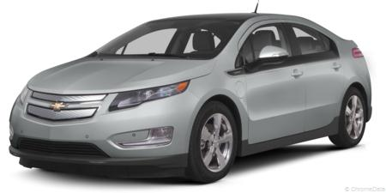  Chevy Volt | 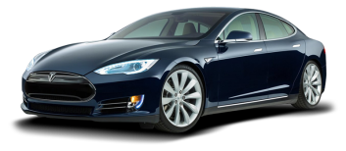  Tesla Model S
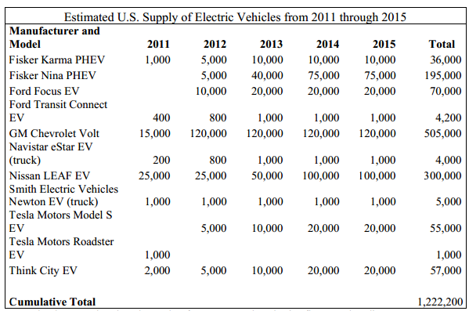
Table 1: Source: Department of Energy: February 2011 Status report on one million electric vehicles2
Besides commitments from the government and the manufacturers, it seems like, this time; even consumers are actively committed to the electric bandwagon. The consumers’ interest is motivated by the contemporary design of electric cars and their superior performance as compared to gasoline engines. As a matter of fact, consumers consider the electric cars design and technology far more superior to their gasoline counterparts. This is evident from the consumers’ willingness to pay premium for electric cars compared to their equivalent gasoline counterparts. Today’s electric cars are almost as powerful as their gasoline counterparts and boost of similar pickup speeds and driving ranges. For example, Tesla Model S can go from 0-60 miles in 5.9 seconds, and drive more than 250 miles, on a single recharge, which is comparable to other midsize luxury sedans.

The Issue
Figure 2: Tesla Charging Stations (2014)
Figure 3: Gas Stations (Each dot is multiple stations)
One of the biggest bottlenecks affecting adoption of electric vehicles is the range anxiety. Range anxiety refers to the fear that the electric car will run out of charge before reaching its destination, thereby stranding the passenger in the middle of nowhere. The problem is the lack of electric charging infrastructure. For one, electric charging stations are few and far between. They are not even a measurable fraction of gas stations across the world. Second, whatever infrastructure that does exist is fragmented by use of proprietary charging connectors that exclude competing cars to use their network. For example, Tesla’s proprietary charging connector restricts charging stations access to Tesla cars only. In other words, unlike
Gasoline cars that can be refueled at any gas station, electric cars have to dock with their own kind to recharge. This lack of interoperability limits the charging options for the consumers.
The range that the car can be driven is usually depended on two things: the battery capacity and the battery charging infrastructure. If there are few charging stations, you need a higher capacity battery because mean time between charging will be high. However, if there are many charging stations near you, you can probably settle for a smaller battery because mean time between charging can be low. This matters because battery is an expensive component of the cars overall cost. Adding 60 miles to Tesla’s range –85kWh battery instead of 60kWh battery - adds $10,000 to Tesla’s Model S’s sticker price. Today there are a variety of cars available with varied battery sizes. Hybrids, like Toyota Prius, recharge primarily on engine braking and have a limited battery capacity. You can drive them only for a couple of miles before the gasoline engine kicks in. This in contrast with electric only vehicles, like Tesla Model S, that has big batteries and can go up to 250 miles or more on a single charge. Nonetheless, batteries have a physical capacity limitation and the success of electric cars will ultimately depend on the availability of charging infrastructure – in home and on road.
Charging infrastructure includes slow level 1 AC charging using home power outlets, fast level 2 charging using modified home/commercial chargers, and commercial DC based superchargers. While every car manufacturer provides a standard level 1 charger that you can plug into any power outlet, the process is slow and time consuming. For example, Prius plug in, with a range of about 11 miles, takes about 3 hours to charge, and Tesla Model S, with a range of 300 miles, takes about 3 days to charge, using a 120-Volt AC power outlet. In other words, a 3,000 mile cross country trip, will take about 25 days’ just to recharge. To reduce the charging time, bigger batteries need bigger chargers. Companies provide higher voltage, higher amperage, level 2 chargers that can charge the car in much lesser time. These chargers can be installed at home or can be found at public charging stations. Then there are DC based superchargers that can recharge your car in less than an hour. Unfortunately, most of these chargers are not compatible with each other. That is, if you own a Nissan Leaf and a Tesla Model S, you will have to get separate chargers for them and if, while driving, your charge runs out, you cannot recharge at a competing station. Worst, if you buy a new car, even from the same manufacturer, chances are that the chargers may not be compatible.
Charging Type | Specifications | Standards | Details
Level 1 Charging | 120v AC / up to 16amp /1.92kW/ Single Phase | - J1772 | Standard in all cars, Uses Home charging –standard outlets,  Charges up to 5 miles / hour
Level 2 charging | 240V AC / up to 80 amp / up to 19.2kW (6.6 kW most common)/Single Phase | - J1772  - Magne Charge (J1773)  - AVCON  - Mennekes IDE 62196 VDE-AR-E 2623-2-2 | Specialized connectors incompatible with other cars, Uses modified home or public charging infrastructure, charges up to 70 miles / hour
DC fast charging | 300-600V DC/ up to 200 amps/120kW/ Three phase | - Mennekes IDE 62196 VDE-AR-E 2623-2-2  - CHAdeMO  - Tesla Super chargers  - J1772 Combo Coupler | Specialized connectors incompatible with other cars, uses specialized public charging stations, charges up to 340 miles / hour
Table 2: Charging levels
Car charging infrastructure is critical to the success of electric car. However, it is also expensive to set up. Home setup costs a minimum of $2,000 for each charger and a single super charging spot can cost an upwards of $100,000.00. It will be extremely difficult for a single company to set up a network wide enough to compete with the traditional gas stations. As a result many car companies have agreed upon technology standards that allow them to use a compatible 240V charging port. This essentially cuts the charging time in half. The standards usually specify the physical, electrical, communication, and performance protocols for electric cars and charging stations. The problem is there are just too many standards. Two most popular globally accepted standards for electric car charging are CHAdeMO, a Japanese standard developed by the Tokyo Electric Power Company, Nissan, Mitsubishi, Toyota, and Fuji Heavy Industries, delivers up to 62.5 kW of high-voltage direct current for quick charging. The second standard, J1772, was developed by the Society of Automotive Engineers and is preferred by American manufacturers. The J1772 standard is written to accommodate up to 240V 80 Amp charging.
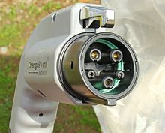 | 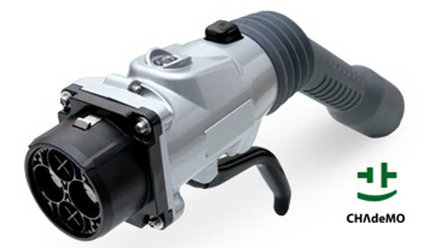 | 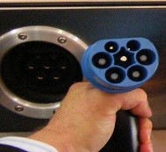 | 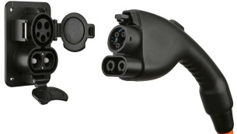 | 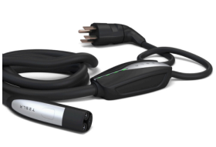
J1772-2009 plug | Chademo plug | Mennekes plug | J1772 combo plug | Tesla Plug
Figure 4: Car charging plugs
There is a third proprietary charging technology promoted by Tesla motors that is incompatible with all other manufacturers. While Tesla supports J1772 standard by providing additional adapters, they have their own proprietary technology, proprietary plugs, and proprietary stations, incompatible with all other car manufacturers. Considering that Tesla is a relatively new player in the industry, this doesn’t make sense. It will be so much easier, and less risky, for them to adopt one of the established standards and piggyback on their infrastructure. However, Tesla is adamant on developing its own network. Their reluctance to adopt may in part be explained by their need for ultrafast charging, due to their bigger capacity batteries and maintaining their image of innovative company breaking the norms. As a result Tesla has introduced super chargers that can provide 250 amp 400V 90 kW charging capacity. Existing standards, even though comprehensive, have not been tested at such high performance levels. At the same time, Tesla provides J1772 adapters to charge at public charging stations delivering AC at 240V 30 A. So while maintaining compatibility with public charging stations, Tesla has been trying to gain competitive advantage by creating early network effects. More supercharging stations will lead to more sales which will help setup more exclusive charging stations.
Tesla, recently, opened up their patents for anyone to use in good faith. This further indicates that Tesla’s official position is to continue developing its own technology and even try to make it an industry standard. How does this help Tesla? Tesla already provides compatible chargers allowing its users to use the vast J1772 and CHAdeMo charging infrastructure. By allowing other companies to use their patents for free, they are hoping that other parties will pitch in to build support infrastructure, which will benefit Tesla more than any other manufacturer. It will also help them gain recognition, sell their high capacity batteries and chargers, and attract investment. Whether others will bite is an open question, after all, if Tesla wanted a standardized charger, they could have always adopted modified J1772 combo standard.

The Future and Conclusion
Whether the current momentum will continue or soon disappear depends upon how well companies can eliminate range anxiety, which in turn depends on charging infrastructure. Companies can cooperate, and standardize on the charging infrastructure, just like gas stations that can service any make and model of the car or they can compete and develop independent and exclusive charging networks. Standardization would involve agreeing on charging standards both in terms of hardware and electric specifications. Companies can then compete on car design and features. Standards on the other hand will have to be broad enough to encompass varying needs of car manufacturers. For example, superfast charging may not be required for cars like Toyota Prius plug-in but may be essential for the success of Tesla Model S. A standard should be able service both these needs.
If companies decide to compete on charging infrastructure they can go two different routes. They can either join one of the established networks like CHAdeMo or J1772, or they can do it on their own. The advantages of joining a network are that the risk is shared with other manufacturers, it gives time for company to focus on designing and manufacturing cars instead of worrying about setting up an infrastructure, and it enhances the network effects i.e. it increases the value of the entire network. The advantages of doing it alone are, if you can pull it off, you get to keep all the spoils, which may be substantial. One who controls the standard, controls the profits.
When ATMs were first introduced, every bank tried to create their own proprietary network of ATMs across the country. The bank with largest ATM network would attract more customers because of their omnipresence. This would also be the source of their competitive advantage. However, proprietary networks are expensive to maintain and no longer a source of competitive advantage. As a result, banks decided to cooperate and agree on financial transaction standards. Car manufacturers are in the similar territory when it comes to creating their own networks to gain competitive advantage. Will they eventually cooperate depends on how long they can sustain their competitive advantage from using proprietary technology.
Case Study Questions
- Why did electric cars fail? Why did they never stand a chance vis-à-vis their gasoline counterpart? Have we overcome the difficulties and do the electric cars now have a fair shot at competing with gasoline cars?
- Should the electric car manufacturers cooperate to create a network of electric car charging stations and support infrastructure or should individual manufacturer develop their own network? What are the pros and cons of each approach? Why would you recommend one over the other?
- How can electric car manufacturers alleviate consumers anxiety related to purchase of electric cars? Do individual car manufacturers have the resources and capabilities to build their own infrastructure? If not, what approach will you recommend?
- Use Porters five forces model to analyze the electric car industry.
- Do we really need a universal car charging standardized solution? How can electric charger incompatibility be a source of competitive advantage for electric car manufacturer? What are the pitfalls in following such strategy? Is it a recommended approach?
- Identify two ethical/moral issues that may arise from incompatibility of electric car chargers? How should manufacturers address this issue?
- What competitive strategy would you recommend electric car manufacturers to compete with each other?
- Why has Tesla decided to share their patents with all car manufacturers?

______________________________________________________________________________
This case study was prepared as a basis for discussion rather than to illustrate either effective or ineffective handling of a business scenario and/or leadership/role behavior. This case study project was undertaken with the support of a research grant from NIST Measurement Science and Engineering, Standards Services Group, and the Lucas College of Business at San José State University. This case study is distributed under the Creative Commons Attribution-NonCommerical-ShareAlike (CC BY-NC-SA) license.
Case 3: Wireless Payment – Wallet Share

Stephen K. Kwan and Nitin Aggarwal

George would do anything to get rid of his wallet. It is heavy and creates an ugly bulge in his pocket. George has been to Japan where he saw locals using phones to seamlessly pay for everything including tolls, fares, groceries, and other expenses. So when Google announced their new Nexus 4 phone with the ability to touch and pay, George got really excited.
George was one of the first people to get a mobile payment enabled Google Nexus phone and promised himself that he would never pick up his wallet again. What’s more, Google even showcased a new vending machine, in San Francisco, where George purchased a Coke using his new Nexus phone. George was on top of the world and very excited. He actively started looking for the universal mobile payment symbol at retailers so that he could plan his wallet-free shopping.
Unfortunately even after owning his phone for a whole year, George is still carrying his wallet.
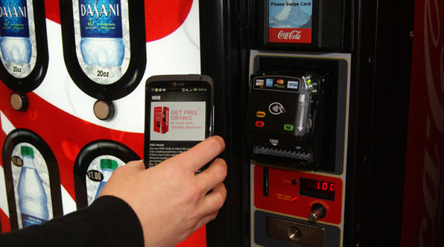
Mobile payments are a subset of a larger electronic payments ecosystem, where payments are initiated using a mobile device. The history of mobile payments dates back to 1997, when Coke introduced the first touchless vending machines based on Simple Messaging Service (SMS) payments. Initially the system was used for simple tasks like downloading ring tones and buying movie tickets; payments were billed directly to the customer’s mobile account. The big push came from Asian countries like Japan and the Philippines, where commercial mobile commerce platforms were launched, and in Europe where mobile payments for parking, train tickets, and flight bookings were taking form. In 2002, the European Telecom Standards Institute issued the first guidelines, “Mobile Commerce (M-Comm); Requirements for Payment Methods for Mobile Commerce ”. However, these requirements were minimal and basically laid down only the essential features needed to support a mobile payment platform.
Japan took an early lead in mobile platform adoption. With a highly tech savvy population and Internet access via mobile surpassing access via personal computer, combined with early standardization on NTT DoCoMo’s iMode platform, mobile payments experienced rapid penetration and access. Moreover, Japan’s mobile wallet service was developed in partnership with wireless service providers and handset vendors. Mobile wallet features include cashless payment, online shopping, ticketing, check-in, banking, digital keys, loyalty cards, and identity cards. Similar progress has been seen in countries such as South Korea, the Philippines, India, and China where mobile payment markets are usually characterized by a duopoly. The winning formula in each of these successes has been a mix of partnerships, cooperation between multiple entities, and standardization of the payment platform. One of the biggest beneficiaries of mobile payment platforms has been countries in Africa where there is limited access to traditional banking services.
Unfortunately, mobile payment adoption in the United States has not shared the same level of success as seen in Asia and Europe. According to the CTIA -the wireless association, in 2012, the wireless penetration rate, from devices like phone, hotspot, and tablets, in the United States stood at 102%, with 35% of households connecting purely over wireless networks. Yet only 12% of Americans have used mobile as a form of payment and that has been mostly for paying bills, transferring money, or peer-to-peer payments.
The current size of the United States mobile payment market is $12.8 billion annually, which is predicted by the Forrester group to grow to $90 billion by 2017. On the other hand, according to Gartner, the worldwide mobile payment market is expected to increase from $171 billion in 2012 to $646 billion in 2017, or possibly even a trillion dollars according to some estimates. In other words, the U.S. share of the global payment market is only 14% and expected to remain the same over the next 5 years. This is far less than the U.S. share of the world GDP, which is about 22%.

 | United States | Rest of the World | U.S. Share
Mobile Payments (2012) | $12.8 billion | $90 billion | 14%
Mobile Payments (2017) | $171 billion | $646 billion | 14%
GDP | $15 trillion | $83 trillion | 18.07%
Ecommerce | $231 billion | $1000 billion | 23%
Mobile payment as a percentage of ecommerce | 5.5% | 9.0% | -
Table 1: Mobile Payment Market
While desktops are still the dominant mode of Internet access, mobile devices are projected to surpass desktop Internet traffic by 2014. With customers preferring to use mobile devices to do their daily chores, the mobile payment market is poised to become even more lucrative. There are many stakeholders vying for a share of the mobile payment pie, but the lack of cooperation and standardization reflects a general economic principal as stated by Dranove and Gandal:
“A monopoly in the bush is often worth more than an oligopoly in hand”.
In other words, instead of developing the mobile payment market and competing for a share of the pie through standardization and cooperation, the market players have decided to compete for the pie. Table 2 below shows the different mobile standards and technologies available to consumers.

Funding Source | Platform | Examples | Technology | Applications
Bank Account, Cash, Check, Prepaid reloadable cards, Money order  MasterCard, Visa, Discover, American Express or any other Credit Card  Phone bill, cable bill, or any other direct billing | Hardware-based solutions | Near Field Communication | Extension of RFID, distances restricted to less than 4 inches. Security enabled | Google Wallet,  ISIS, Merchant Customer Exchange (MCX)
 |  | Radio Frequency Identification | Radio transmitters and receivers | PayPass  SpeedPass
 |  | Low Energy Bluetooth Payment System | Bluetooth technology | Speculated to be used in Apple iPhone devices (iWallet)
 |  | Near Sound Data Transfer (NSDT) | Audio Signal based payment | Tagpay
 |  | Trusted Execution Environment | Secure area residing in main processor of a smart phone where sensitive data is stored | In development
 | Software-based solutions  (Mobile Payment Platforms or Mobile Web Payments) | Closed Loop Mobile Payments | Proprietary wallet using barcodes, 2d or 3d bar codes, QR code (akin to gift cards in the physical world) | Starbucks payment app
 |  | Cloud-based mobile payment platform | Payment information is stored in the cloud and apps access the information to allow payments to be made using bar codes, QR codes, or the likes | Paypal, Serve, Venmo
 |  | SMS Text based payment  In-App Billing | Simple messaging service and In-App purchasing | Donations, payments, Ringtones, In-App purchases
Table 2: Mobile Payment EcoSystem
The potential for super normal profits, high fragmentation, and the absence of worldwide standards in the mobile payment industry is attracting more players to the market; making the market even more fragmented and confusing for retailers as well as customers. Recently, Target and Walmart have joined with two dozen other retailers to develop their own mobile payment system to compete with Google. The retailers feel that a system developed by them would foster loyalty and increase their revenues. The retailer’s motivation might be very different, albeit orthogonal, to the motivations of mobile service providers and handset manufacturers. While service providers might be interested in the exchange fee generated each time a transaction is processed, retailers might be trying to minimize the exchange fee by owning their own payment network.
With such a range of choices comes customer confusion like that experienced by George. His favorite retailers do not subscribe to his service provider’s payment system. Moreover, George is forced to use Sprint’s network because AT&T, T-Mobile, and Verizon do not support Google’s Wallet. If George wants to switch cellular providers so he can talk for free with his friends and family, he will have to start all over again with the competing ISIS services, supported by Verizon, T-Mobile, and AT&T. But then again, he may not be able to pay at Target or Wal-Mart and may still have to carry his wallet anyways.

Photo Credits:
- CostanzaWallet by Kyle MacDonald Licensed under creative commons Attribution 2.0 available at http://www.flickr.com/photos/kylemacdonald/62025338/in/set-1339638/
- Coke Vending Machine: Source http://www.coca-colacompany.com/stories/tapping-into-taste-pay-with-your-phone-at-the-vending-machine

Case Study Questions
- What is the fundamental reason George couldn’t ditch his wallet?
- Verify that the facts, assumptions, and data presented in the case study are still valid and applicable?
- Using Porter’s Competitive Forces Model, evaluate the mobile payment industry.
- Using SWOT analysis, evaluate the different payment methods.
- Using BCG matrix with predictive market share and predictive growth rate, evaluate the feasibility of these mobile technologies.
- Draw the transaction flow from a consumer purchase to the supplier of goods/services. Who gets a cut of the transaction (i.e., transaction fee) and how much is it?
- Mobile payments do not always mean contactless payment. Newer methods like NFC are credited with incorporating the best of both the worlds. Compare and contrast the different standards of mobile and contactless payments and highlight the superiority of one over the other.
- Why has adoption been slow in the United States?
- Why is the Mobile Payment market so fragmented and why are there no clear standards? Can there ever be a single standard?
- What are the US credit card companies and banks doing to prepare for potentially explosive growth in the mobile payment market? What standards are they backing or developing?
- Can one of these mobile standard become the de-facto industry standard? Why or why not? Provide an example from the technology industry.

_____________________________________________________________________________________________
This case study was prepared as a basis for discussion rather than to illustrate either effective or ineffective handling of a business scenario and/or leadership/role behavior. This case study project was undertaken with the support of a research grant from NIST Measurement Science and Engineering, Standards Services Group, and the Lucas College of Business at San José State University. This case study is distributed under the Creative Commons Attribution-NonCommerical-ShareAlike (CC BY-NC-SA) license.

Case 4: Incompatibility in Mobile Chargers – Need Based or Strategic?

Stephen K. Kwan and Nitin Aggarwal

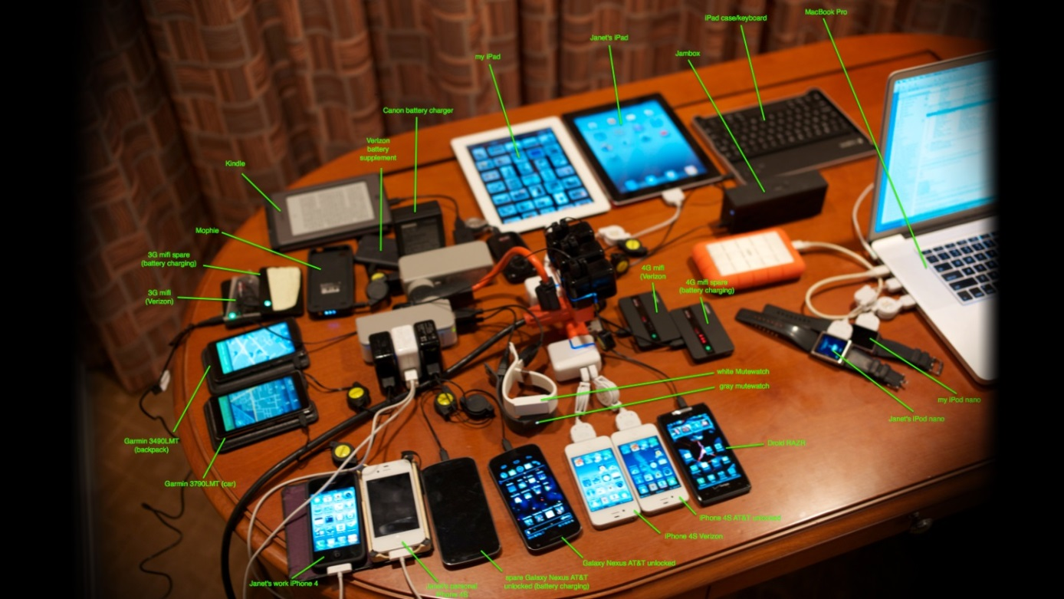
Figure 1: Steve Wozniak, Apple’s co-founders, backpack. Image Source: Gizmodo.com
“Phone chargers to be standardized in 2011”, read Jim on a fine Sunday afternoon in January 2011. The news got him excited. He had been waiting for this for so long that he couldn’t even remember. Jim researched more to confirm and came across several other articles boldly claiming the same; “Universal Phone Chargers Coming in 2011: Samsung, Apple, Nokia, RIM Commit To MicroUSB Standard,” “Apple, others agree to universal cell phone charger standard in Europe.” Jim rejoiced and felt a sigh of relief.
Jim is a Silicon Valley tech professional who, like many others, carries multiple electronic devices. Along with personal devices like a smart phone, a tablet, and an e-reader, Jim also carries a laptop, a portable hard drive, a personal hotspot, and a small camera. This is typical of many average Americans, who according to a recent survey by Sophos, carry on an average three electronic devices, including smart phones, tablets, mp3 players, and e-readers. This might not sound a lot, but considering that personal carry on space is extremely limited and inconvenient, especially for the travelers, people like Jim pay careful attention to selecting how many and what devices to carry, usually based on size, weight, and functionality. For example, Jim ditched his iPod for the built in MP3 player in his smart phone and is now getting ready to dump his portable hard-drive in favor of cloud storage.
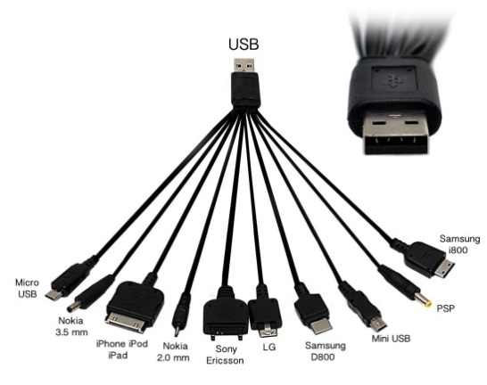
Figure 2: Jim's universal charger purchased at - http://www.amazon.com/Xcessor-Universal-Charger-BlackBerry-Ericsson/dp/B006L9XHHW
Personal carry on space is not just limited but also extremely saturated. There are already devices specialized to handle everything from trading stocks to hiring a cab to measuring how many steps we take in a day. It is a market with high barriers to entry. It is not only difficult to introduce new products in this domain, but also difficult to change people’s habits and make them switch. Imagine how difficult it is to convince someone to move their entire music collection to a different platform. Manufacturers are mindful of these limitations and compete fiercely to bring innovative products to the market – products that are smaller, lighter, and more convenient to use. Unfortunately, one thing that gets overlooked, both by consumers and by the manufacturers, is that each device needs its own charger. Manufacturers oblige by providing a charger, usually, compatible only with the specific device that was sold. That would be just fine if the consumer was carrying only one device, but unfortunately for people like Jim, who carry multiple devices; consumers are forced to carry as many chargers as there are devices. Not just that, every time a Jim buys a new phone, he is paying for a new charger as well. This is a problem not just for him, but also for the environment. Annually, 51,000 metric tons of electronic waste from chargers ends up in landfills just in Europe with worldwide figures crossing few hundred thousand metric tons.
Jim gets frustrated dealing with all these chargers. At home, with family, there were more chargers than there were wall sockets, and while traveling, chargers took up lot of space in his bag. Every once in a while he forgot one at home rendering his device useless. On several occasions he had to buy an expensive replacement costing him a lot of money. His make shift solution of dumping all his chargers and buying a universal charger with 10 different tips was as frustrating as dealing with the chargers themselves. Matching the tips was a pain and the cables would just tangle with each other. Moreover, if one tip failed, it meant Jim had to replace the entire universal charger. Luckily, airports, coffee shops, and few other establishments started providing cell charging stations at least for the two most popular platforms; Apple and Micro USB. While a welcome initiative, it falls short of being an ideal solution, considering that there are more than 100 different cellular phone manufacturers, 6000 different cell phone models, and over 30 different types of chargers in the market. It was just one big inconvenience. Jim always wondered why mobile device manufacturers don’t standardize on a single charger. He strongly believed that the manufacturers should not even include a charger with their product. Once the chargers are standardized, a consumer can just buy their own charger and it will be compatible with all devices they own even when they upgrade saving hassle and keeping tons out of landfills. The benefits were enormous both for the consumers and for the environment.
The long wait was over. At last, it was happening. Jim’s wish was coming true. It only took an entire European Union to convince the top 14 manufacturers, with a combined market share of more than 80% of the market, to agree on a standardized charger for smart phones. Apple, Emblaze Mobile, Huawei Technologies, LGE, Motorola, NEC, Nokia, Qualcomm, Research in Motion (RIM), Samsung, Sony, Ericsson, TCT Mobile (ALCATEL), Texas Instruments and Atmel signed an European Commissions memorandum of understanding, for Micro USB based Common External Power Supply specifications, for use with data-enabled mobile phones sold in European Union. While the initiative was a far cry from a real world wide universal charger for all cellular phones, it was the first step in gaining consensus.
Three years since signing of MOU, Jim is still carrying as many chargers as he was when the initiative was first announced. Jim was very disappointed and wondered what happened. First, the MOU was only limited to European Union, even though the scope was defined in global context, leaving out 93% of the world’s population. Second, United States, China, and other major countries did not have or were not interested developing a similar mandate officially. Third, manufacturers, by themselves, did not have an incentive to consensually agree on a universal standard. Fourth, the European Union consensus standards only applied to data-enabled smart phones which had a combined market share of 25%, in 2010, leaving the remaining 75% market still unstandardized. Finally, the standard left out other small personal carry on devices, like hard drives, MP3 players, GPS, non-smart phones, resulting in, lack of interest from manufacturers . According to Stephen Russell, ANEC secretary General,
“The standard undoubtedly holds some benefits for consumers and the environment. But its limited scope is extremely disappointing. Most consumers do not buy data-enabled smartphones and it is hard to understand why buyers of more conventional mobile phones will not be able to benefit from the common charger. We feared this might be a consequence of the voluntary agreement reached between the European Commission and mobile phone producers in June 2009. ANEC had been seeking a more interventionist stance from the Commission. The ambition must now be to include all mobile phones and other small consumer multimedia electronic devices within the scope of this or similar standards. We will look to the Commission for action if the industry does not make a commitment to do so in the very near future.”
The consumer organizations criticized the initiative claiming it will stifle innovation, slow down research, limit manufacturers’ ability to innovate, and limit the functionality of the devices. The biggest blow to the effort came when Apple introduced their new proprietary lightening connector in 2012 suggesting that they were not interested in honoring their agreement with the EU or in cooperating with other manufacturers. To please the European Commission, Apple introduced a Micro-USB to lightening adapter sold exclusively in Europe. Ok, thought Jim, so why did Apple retract on its own promise and why manufacturers are disinterested in extending their cooperation worldwide?
Incompatibility exists in almost all industries. For example, printers have proprietary ink; game consoles have proprietary games and controllers, and likes. Sometimes incompatibility is due to unique requirements of a product, which cannot be addressed by an existing technology, while at other times; incompatibility is due to strategic reasons. Sometimes compatibility is required for an industry to function properly, for example, agreements on weights and measures, data exchange, and language, while at other times compatibility is not required but desired for convenience and overall societal good. The decision to maintain compatibility is usually dependent on whether companies want to compete in the market or for the market. Question then is; is the incompatibility in mobile phone chargers due to unique requirements of the manufactures or is it strategic in the sense that it gives them competitive advantage and source of additional revenue?
Unlike parameters like spectrum and networking protocols, chargers have always been viewed as an accessory for mobile phones, incompatibility of which is inconsequential to the normal operations of the phone. This is because the actual charging mechanism is built into the cell phone while the charger basically serves as a power adapter which converts 110-220V alternate current to 5 -5.5V direct current. Thus, at least on the face of it, compatibility may be desired, for example, to address Jim’s inconvenience and to reduce landfills, but it is definitely not required. By this logic, it seems like Apple’s incompliance with the European MOU is a testament that Apple views their chargers as either technically superior or as a source of competitive advantage.
A Micro USB cable has the capability to charge and sync at the same time. The cable itself is relatively cheap because there are thousands of manufacturers churning out millions of them simply by following the industry standards. Apple’s lightening charger, on the other hand, is said to have a proprietary chip that provides additional functionality to the iDevices. The same functionality can be achieved using Micro USB standard and some workarounds, but it looks like Apple is not interested in compromises. The proprietary chip ensures that the imitation is minimal, and authorized reproduction generates royalties. This allows Apple to charge premium on their cables with revenues exceeding 100 million dollars by some estimates. The proprietary technology also allows Apple to charge huge royalties from third party accessories manufacturers bringing in almost $5.5 Billion dollars in 2012, some of which can be directly attributed to accessories using lightening connectors. With these kinds of revenue, it is highly unlikely that Apple will voluntarily adopt Micro USB standards, ever.
When the industry is deadlocked into competing standards, technological advancements usually provides a compatible solution by making the needs obsolete. Wireless charging promised to be one such solution. It will revolutionize the mobile charging and eliminate the need for having charging cables all together. Starbucks has already committed to installing Powermat wireless charging stations in its stores all across the United States. Unfortunately, when there are billions of dollars at stake, it is never easy to convince competitors to agree on a technology. Just like multiple charging tips, there are multiple wireless charging standards; Powermat from Power Matters Alliance (PMA), Qi specification from Wireless Power Consortium (WPC), and Rezence by Alliance for Wireless Power (A4WP). And then there is Apple which holds patents and is working on its own proprietary wireless charging solution. It looks like there will never be a single mobile charging standard.
Jim is still hopeful. Three years since the original MOU between 14 companies in EU, European Commission has voted on an updated Radio Equipment Law. All mobile devices sold in the EU member nations will have to be Micro USB compliant by 2017, including iDevices. Jim knows that United States will not follow suit and mandate compliance to the manufacturers. However, Jim is hopeful that the manufacturers will see the benefits to the European consumers and may extend the courtesy in other countries. Meanwhile, Jim continues to carry his big bag full of chargers hoping against all hopes that one day he will not have to carry any.

Case Study Questions
- What are the advantages of having a universally compatible charger? What are the advantages of having a proprietary charger?
- Should there be a universal compatible charger for mobile phones? Discuss the pros and cons of each?
- Compare and contrast the approach taken by the European Union and the United States in creating compatible chargers?
- If you were the CEO of Apple, how would you respond to the EU directives? Will you extend the compliance outside the European Union?

_____________________________________________________________________________________________
This case study was prepared as a basis for discussion rather than to illustrate either effective or ineffective handling of a business scenario and/or leadership/role behavior. This case study project was undertaken with the support of a research grant from NIST Measurement Science and Engineering, Standards Services Group, and the Lucas College of Business at San José State University. This case study is distributed under the Creative Commons Attribution-NonCommerical-ShareAlike (CC BY-NC-SA) license.
Case 5: Apple vs. Samsung – The War of the Titans

Stephen K. Kwan and Nitin Aggarwal

 | Samsung | Apple
Year | 1969 | 1976
Industry | Semiconductor | Computer Hardware
Country | South Korea | United States
Employees | 90,700 | 80,300
Market Cap | $186.5B | $483.1B
Sales | $208.9B | $173.8B
Profits | $27.2B | $37B
Assets | $202.8B | $225.2B
Smartphone Market Share | 32.3% (319.8 million units) | 15.5% (153.4 million units)
U.S. patents held (2012) | 47,855 | 4,649
Tablet Market Share | 19.1% (37.4 million units) | 36% (70.4 million units)
Rank in Worlds Most Valuable Brands | 9 | 1
Rank in Global Forbes List | 22 | 15
Table 1: Samsung vs Apple Comparison (2013)
Titanomachy, or the War of the Titans, were series of battles, fought over ten years, between the ancient Greek gods - the Titans and the Olympians. Both groups wanted the same thing - to be the supreme leaders of the Universe. The war was particularly difficult to fight, without either side gaining advantage over the other, because both sides were extremely powerful and were immortals. The war ended when Olympians got a little help from Cyclopes in form of weapons such as the lightning bolt, trident, and invisible helmet. The secret weapons helped Zeus capture the Titans bringing the ten years war to an end. The Olympians won, and the Universe was divided in between the Olympian brothers and sisters. The takeaway of the story is when there is a war between two equals, there needs to be a secret weapon in one parties arsenal to win the war.
While Titanomachy might be a Greek mythology, it is ever so reminiscent of the current war being played out between Apple and Samsung, in the Supreme Courthouses, around the world. It has only been three years since the “war” started and there have been only a few battles. There is no clear winner and there is a long way to go. But the resemblance to Titanomachy is uncanny. Both Samsung and Apple are fighting for world dominance. They are both equally power and influential multinational companies with a combined market share of more than 50% in the smartphone and tablet markets. They are both Fortune-50 companies and sized similarly in terms of Sales, Assets, and number of Employees. Both entities have thousands of US and international patents in their arsenals to help them fight the war for dominance.

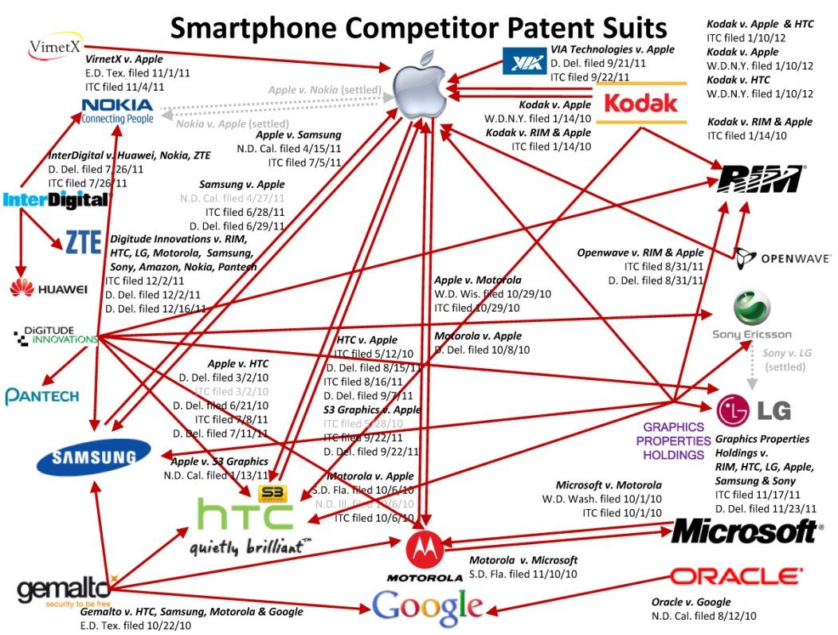
Fig 1: Patent Suites (PC Mag: Smartphone Patents War Explained)2
The current war between Apple and Samsung is the most interesting and ongoing of all smartphone patent wars being fought between Apple, Sony, Google, Samsung, Microsoft, Nokia, Motorola, and HTC. The introduction of the iPhone in 2007 jolted the entire cellular phone industry and threatened the incumbents like Nokia, Motorola, Samsung, and RIM. Nokia’s global cell phone market share fell down from 37%, in 2007, to less than 10% in 2014. Motorola mobility division got sold to Google in 2011 and then again to Lenovo in 2012 for a huge loss. Facing intense competition and falling market share, it was clear to the incumbents, that the only way to block the growth of the iPhone, or at least making money of its popularity, was by using its patents to block Apple. This started the global smartphones patent war in 2009 when Nokia sued Apple for breach of ten of its essential patents related to GSM, 3G, wireless, security, and encryption. Within three months, Apple countersued claiming infringement of thirteen of its own patents. The original lawsuit was followed by many other suits and countersuits in the following months. Since there were no workarounds Nokia’s essential patents, Apple settled the case by agreeing to pay more than $700 million upfront in fines and licensing Nokia’s technology for the future. In this case Apple used its patents, and countersuit, as a bargaining chip to reduce the damage inflicted by Nokia. The number of patents infringed by each party makes little difference when essential patents are involved because you cannot work around them and a single infringement is enough to get an injunction. The only way to minimize damage is if you hold equally potent bargaining chip.
In the following years many complaints, lawsuits, and countersuits were filed, by each player affiliated to the telecom industry, against each other many times over. For example, Apple sued HTC for infringing ten of its patents, HTC countersued Apple for infringing five of its patents, Microsoft filed an ITC complaint against Apple and Motorola, Motorola returned the favor, Motorola sued Apple, Apple countersued Motorola, Motorola sued Microsoft, Microsoft countersued Motorola, Apple sued Samsung, and Samsung countersues Apple. The list goes on. As expected many of these cases were settled with royalty payments, licensing or cross-licensing agreements, or penalties but not necessarily with the outcomes that the incumbent originally intended.
However, distinct amongst these lawsuits are Apple and Samsung lawsuit, which started in 2011. The scale of their clash is unprecedented primarily because of popularity of both their products and because of similarity between them. It spans ten countries, including the US, Korea, Japan, Germany, the U.K., France, Italy, Spain, Australia, and the Netherlands, in four different continents, with no end in sight. It is costing both companies billions of dollars in legal costs and lost opportunities. However, stakes are equally lucrative – monopoly worth $330 billion a year in the smartphone market. Nothing but a total injunction will satisfy the either company. In his biography, Steve Jobs says, “I will spend my last dying breath if I need to, and I will spend every penny of Apple's $40 billion in the bank, to right this wrong,”, “'I'm going to destroy Android, because it's a stolen product. I'm willing to go thermonuclear war on this.”
Samsung is the only company that has the potential to compete with Apple and vice versa. Usually it only takes one essential patent infringement to legally prevent the other party from carrying on their business. However, with companies like Apple, Microsoft, Motorola, Nokia, HTC, and Samsung, each of which has a portfolio of thousands of patents, it is easy to imagine how they can cross infringe on each other’s patents. As a matter of fact, when Apple first expressed their intentions to sue Samsung on their Galaxy phones, Samsung did not even have to look at their patent portfolio to suggest that they will be counter suing4.
Apple has generally found sympathy with the US jury and the courts. The first US trial verdict resulted in Apple being awarded almost a billion dollars in damages and a temporary injunction against Samsung Galaxy Nexus. Likewise, the second US trial resulted in Apple being awarded $119.6 million for two of its patents infringed and Samsung being awarded $158,400 for one of its patents infringed. Things are a different in the South Korean Courts where the verdict was neutral. The courts in South Korea found that Apple and Samsung both infringed each other’s patents and ordered them to pay damages running into tens of thousands to each other. Likewise, Australian, Dutch, and German courts initially awarded Apple injunction against selected Samsung products, the higher courts later reversed the rulings.
As is evident from all the cases, Apple might be the Olympian in this war, when it comes to the legal system, but it has failed to capture the Titan (Samsung) of this war. Even though, Apple has found some success in the legal systems of many countries, it has failed to get injunction against any of Samsung’s products. Meanwhile Samsung’s phones and tablets continue to grow in popularity and enjoy a much bigger market share than Apple due to their lower costs. If we look carefully there is no clear winner in the entire patents war that started in 2009.
However, there is a great deal of learning for the companies engaged in this patents war. Companies have realized the importance of having a strong patent portfolio; not just for protecting their intellectual property but also for defending it from external threats. A single essential patent can change the balance of power between litigants. As a result, during the time period, 2007 onwards, we have seen a lot of consolidation, mergers, and acquisitions specifically for the target company’s patent portfolio. For example, HTC purchased S3 graphics for its 235 patents, Google acquired 1029 patents from IBM, and Google also acquired Motorola for $12.5 billion again for their patents. They believe that eighteen of the Motorola’s patents can be used in their defense or for countersuit against Apple and Microsoft for patents. Likewise, a consortium of companies, with members like Apple, Microsoft, RIM, Sony, bought over 6000 patents from Nortel for $4.5 billion. Surprisingly, Google was left out from the consortium.

Case Study Questions
- Why is it important for companies to have a patent portfolio?
- Why will be the Apple vs. Samsung a long drawn war with no winner?
- What is the potential solution for Apple vs. Samsung lawsuit?
- If there are no clear winners in the patent wars of equals, why do companies still spend millions of dollars to fight it?
- Describe Samsung’s strategy to gain market share?

This case study was prepared as a basis for discussion rather than to illustrate either effective or ineffective handling of a business scenario and/or leadership/role behavior. This case study project was undertaken with the support of a research grant from NIST Measurement Science and Engineering, Standards Services Group, and the Lucas College of Business at San José State University. This case study is distributed under the Creative Commons Attribution-NonCommerical-ShareAlike (CC BY-NC-SA) license.

Case 6: E-books – Not all are created equal!

Patricia Franks
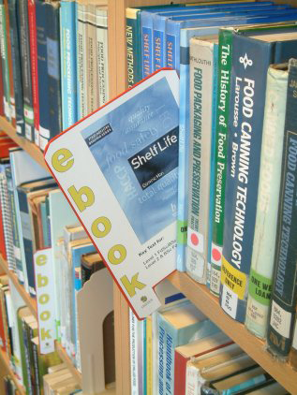
Introduction
Lester completed his master’s degree and obtained a position in a pubic library. He is aware that print books are still the most popular medium for books, but he is also aware that consumer spending on e-books rose to 14% in 2013, a one percent increase over 2012. Lester has been told that a number of library patrons have been asking to borrow e-books, and he expects demand for e-books to grow over the next few years. He also believes that adding e-books to the library’s offerings could attract new library patrons. Therefore, he was pleased to learn that the library had recently obtained funds to expand their services by acquiring both e-books and e-readers for patrons to borrow. Lester’s first major project since being hired is to make recommendations for both e-books and e-book devices to the Library Director. Before he could do that, he decided to learn more about e-book publishing formats and the technology that could be used to read the electronic publications. He quickly learned that the e-book marketplace—products, platforms, pricing models, and vendors—change constantly.
E-book Formats
Lester, like most people, was familiar with one format that could be used to provide access to digitized print materials, PDF. But PDF wasn’t intended to create e-books. This file type presents a page as captured so that the viewer does not need the original software in which the page was created to see the page as was originally intended. When viewing PDF files, although the view of the page might be increased or decreased using the zoom feature, the amount of text on each page remains the same; it is not possible to change the size of the fonts themselves and therefore there is no ‘pagination’ (automatic page-breaking decisions). This is just one reason PDF is not considered a valid e-book format and is not distributed through bookstores like Amazon and Barnes & Noble.
Lester then explored dedicated e-publishing file types and learned that not all e-book file types could be read on all e-readers. He prepared the following table of e-books readers, file formats, file extensions, and e-reader devices. The table is not exhaustive, and it contains both current and discontinued formats, but he believes the information that is included will be useful for his project and illustrate some of the challenges to be met when selecting e-book formats to support. In spite of the fact that he does not consider PDF the best choice for e-books, he includes a description in this table because he knows his library director will want this file format included in his report.
E-book File Format and Extension | Description
Amazon Kindle  File format: Amazon Kindle File Format  File extension: .AZW | AZW is the Amazon Kindle eBook File Format, a custom format for the Amazon Kindle e-reader device. Amazon offers free Kindle reading apps for Windows and MAC PCs, as well as popular tablets and smartphones. This file format can be opened with Amazon’s free Kindle Cloud Reader from any web browser on any platform. Two additional e-book viewing options are Amazon’s Kindle Previewer and Calibre. The Kindle Previewer is a graphical user interface tool that emulates how books display across Kindle devices and apps, used by publishers who wish to preview the layout of an e-book to be sure it displays properly before submitting for sale as Kindle books. And Calibre is an e-book management application developed by e-book users that contains numerous features including a comprehensive e-book viewer, e-book conversion, and an e-book editor for the major e-book formats.
Broadband eBooks (BBeB)  File Format: Sony Media  File extension: .LRF; .LRX | The .LRF and .LRX file extensions represent e-books published using Sony Corporation’s proprietary digital book format, Broadband eBooks (BBeB). As of July 2010, SONY abandoned the use of this file format in favor of the EPUB e-book format. Some reader software, including Calibre, can read and convert this file format to a more widely used format.
EPUB  File Format: IDPF/EPUB  File extension: .EPUB | .EPUB is known as the ‘universal’ e-book format, is an open standard for e-books created by the International Digital Publishing Forum (IDPF). Because it is a vendor-independent XML-based format, most ebook devices, including the Apple iPad, B&N Nook and the Kobo eReader, can open this file type. This file type can be opened on a computer using a number of free programs, including Calibre, Adobe Digital Editions, Stanza Desktop, Mobipocket Reader Desktop, and Okular. Firefox offers an Add-on, EPUBReader, to allow an EPUB file to be opened in a browser window just like any other document, and iPhone and Android apps also exist to allow viewing of EPUB files. Before using on Amazon’s Kindle, this file type will need to be converted.
EREADER (formerly Palm Digital Media/Peanut Press)  File Format:  File extension: .PDB | eReader is a freeware program for viewing Palm Digital Media electronic books, which use the pdb format used by Palm applications. Versions are available for iPhone, Android, BlackBerry, Windows Mobile Pocket PC/Smartphone, desktop Windows and Macs.
iBook (Apple)  File Format: iBook  File extension: .ibooks | The .ibooks format is a proprietary format based on the EPUB standard with some differences in the CSS tags used, making it incompatible with the EPUB open standard. A publisher using the .ibooks format must distribute their works for free or for a fee only through Apple (Apple iBooks store). However, the books can be converted to another format for sale through other venues. The software supports export to Plain text and PDF.
MobiPocket Reader  File Format: Mobipocket  File extension: .mobi | This file type was originally created by a French eBook company called Mobipocket and was distributed as a free software application for multiple devices including PDAs (personal digital assistants), smartphones and tablet devices. The company was purchased in 2005 by Amazon in 2005 and the support for the .mobi file extension was officially discontinued in 2011 in favor of the AZW format. This file type can be read by Amazon Kindle, Apple IBooks and the Mobipocket Reader Desktop. Two other free programs that can open MOBI files are Calibre and Stanza Desktop.
Plucker  File Format: Plucker  File extension: .PDB | Plucker is an open source free mobile and desktop e-book reader application for Palm OS based devices, Pocket PC, and other cellphones and PDAs. It has its own associated file format and software to automatically generate Plucker files from text, PDF, HTML, or other document file formats, websites, or RSS feeds. E-books in this file format could have been downloaded from the Plucker website and sites like Project Gutenberg and Manybooks.net. A visit to the Project Gutenberg website, which offers 45,263 free e-books, revealed that the most popular work, Pride and Prejudice by Jane Austin, could be read online as an HTML document or downloaded in the following file formats: EPUB (no images), Kindle (no Images), PDF, and Plain Text UTF-8.
Portable Document Format  File format: Portable Document Format  File extension: .pdf | The Portable Document Format (PDF) was invented by Adobe Systems and is now an open standard, ISO 32000, for electronic document exchange maintained by the International Organization for Standardization (ISO). Documents converted to the PDF file format can be viewed and printed by anyone using the free Adobe Reader software, Adobe Reader mobile app, or readers provided by third-party vendors, such as the Foxit Reader. The PDF open standard is the foundation for special-purpose PDF standards such as PDF/A for archiving and PDF/UA for accessibility. PDF is a “document” format and not an e-book file format.

e-Books and Publishers
Lester also has to consider the types of e-books his library patrons desire to borrow and the publishers that provide those e-books. Trade publishers, who view their primary market to be retail sales to individuals through bricks and motor or online booksellers, are trying to develop financially sustainable business models for both print books and e-books. They face economic threats posed by library e-book lending programs to their profits and the royalties of their authors. They are also faced with distribution challenges presented by the access control wielded by the small number of e-reader platforms like Amazon Kindle and Apple iPhone/iPad, the danger of piracy, and government investigations into pricing models and anti-competitive practices. A recent settlement of a conspiracy charge against five e-book publishers by the Minnesota State Attorneys General resulted in an automatic refund of $48.01 for one non-Minnesota resident as shown in figure 1 and underscores the reality of this type of threat.
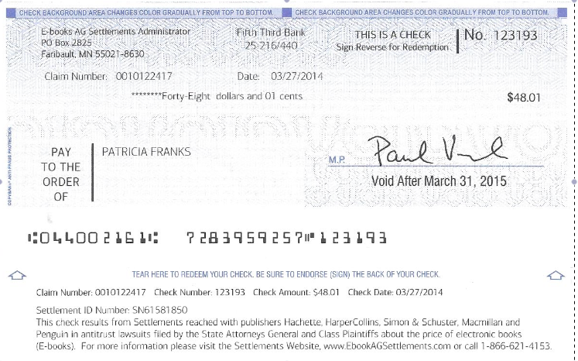
Figure 3: Refund for overcharge of e-books purchased from the publishers listed on the bottom of the image.
The five publishers named in the class action lawsuit denied any wrong doing but agreed to settle to avoid the cost and risk of a trial. Because of concerns such as these, publishers are cautions about offering e-books.
E-book Distributors
Next Lester decided to investigate the ways in which other libraries approached the issue of acquiring e-books and providing access to patrons.
The US e-book retail market
Lester is a long-time Amazon customer who downloads new e-books for recreational reading to his iPad, Kindle, and iPhone. He is aware that Amazon dominates the e-book market. The latest Consumer Attitudes Toward Ebook Reading released by BISG in 2013 reported that 51.3% of respondents purchase their e-books from the Amazon.com website, followed by 15.7% downloading e-books with an Amazon app. This gives Amazon 67% of the North American e-book market, followed by the Barnes & Noble Nook (both App and website) at 11.8%, and Apple iBooks/iTunes at 8.2%. Other was listed as 12.8% of the market, and this is where Kobo, Goggle, and SONY are to be found.
As a result of this market dominance by Amazon, Sony has announced that it is closing its US Reader store, and it has stopped introducing new e-readers to the US market. Kobo, named by SONY as the source of e-books for its former US customers, has stopped investing in the US market and closed its Chicago office. Barnes and Noble has reduced funding for its Nook by 74% and has no clear digital future. With Amazon the clear leader in the North American e-book market, the firm will be able to influence e-book pricing and “shelf-space” for new authors. This vendor must be considered when developing library e-book collections. While it is tempting to simply recommend Amazon e-books to his library director, Lester knows there is more to learn. For example, Apple fans may prefer to use the iBooks app on their favorite Apple device and read e-books purchased from Apple’s iBooks store.
The US e-book library market segment
Lester knew that libraries own their print books outright, but that is not the case with digital works. Libraries must negotiate licensing deals for each book they want to lend. The collections are stored on servers run by computer firms, such as OverDrive and 3M, that typically charge an annual fee plus a fee for each book. In the US, three-quarters of public libraries lend e-books, but each of the big six publishers have different policies. For example, HarperCollins’s e-books expire after they have been lent 26 times, and Penguin is conducting a pilot e-lending program with licenses for its books that expire after one year.
Lester was pleased to learn that OverDrive (http://www.overdrive.com/) has had success in the library market by imposing license terms and conditions that establish the policy parameters for how libraries make e-books available, including loan regulations and borrower eligibility.
OverDrive is a Cleveland-based provider of technology for managing and distributing digital content for lending libraries. It dominates the US public library market by serving over 90% of the 16,400 US public libraries, with a 99% renewal rate in that segment. Its business model is to be the most comprehensive supplier of digital material—e-books, audio books, educational materials, streaming video—for the most comprehensive collection of digital gadgets—iPads, smartphones, e-readers, and more. It also has a direct integration with Amazon, so library patrons can borrow an e-book directly to their Kindles.
Libraries can pool their resources to take advantage of the services provided by OverDrive. For example, a Four County Library System based in the Southern Tier of New York State is comprised of 43 separate libraries that provide members’ access to over 1,100 e-books using OverDrive Read, a new in-browser e-book reader. Patrons can use any computer, tablet, or mobile device using the web browsers and platforms shown in table 2.

Browser | Platform
Chrome | Android, iOS, Mac OSX+, Windows XP, Vista, 7, and 8, Linux
Firefox | Android, Mac OSX+, Windows XP, Vista, 7, and 8, Linus
Safari | iOS, Mac OSX+, Windows XP, Vista, 7, and 8
Android Browser | Android phones and tablets (v2.3+)
Internet Explorer 10 | Windows 7+
Internet Explorer 7, 8, or 9 | Windows XP, Vista, and 7
Kindle Silk | Kindle Fire and Fire HD
NOOK Browser | NOOK Color, Tablet, HD, and HD+

To bring excitement and awareness to the e-book library offerings, the OverDrive Digital Bookmobile, a 74-foot, 18-wheel tractor-trailer (Figure 2), takes to the road to work with representatives of the host library or school to show community members how to search, sample, borrow and return titles either on their own devices or on a number of tablets, computers, and smartphones available to demo on the Digital Bookmobile.
Competing with OverDrive is not easy because of its early entry into the market and overwhelming market share. But there are two competitors of note. The first is Baker & Taylor Axis 360, a legacy supplier of physical books to libraries that has gotten into the digital material business. One differentiating feature touted by Baker & Taylor Axis 360 is that Axis 360 is the only application currently capable of providing full and equal access to e-books being loaned by libraries to blind and print-disabled patrons. The second is 3M Cloud Library. 3M is hoping to take advantage of what they see is a technology gap by promoting the elegance and simplicity of the 3M app to browse, borrow, and read fiction and non-fiction e-books from public libraries. Patrons will need a library card to use the 3M Cloud Library App, and the library to which the patron belongs will need a subscription to the 3M Library service. While smaller libraries in the Four Library System took advantage of the services provided by OverDrive, at least one very large library, the New York Public Library, subscribes to the 3CM Cloud Library.
Access to Digital Materials other than e-books
Although Lester now understands e-book publication file formats, extensions, e-reader software and e-reader devices, as well as the publishing and distribution channels and challenges, he wants to study one more issue before making a decision—the needs of his patrons. E-books are not the only digital files they access. Based on a recent survey he located, he learned that respondents had a stronger preference for digital in 10 of 14 categories. They preferred print books for cookbooks, comics/graphic novels, travel books, and how-to guides/manuals. Of the ten genres preferred in e-book format, romance/erotic fiction was closely followed by mystery/thriller fiction, and general fiction. The remaining genres requested most often in digital format were religious fiction, young adult fiction, biography/autobiography, science fiction/fantasy, literary fiction, business/finance, and history/politics/social sciences. This information would be helpful in determining the genres of books that would best be provided in electronic format. But Lester was also determined to learn more about the preferences of the members of his community, both current library users and potential users and set about developing his own survey.

Case Study Questions
- What barriers exist to libraries as they consider investing in e-books? Explain how this will impact their collection policy.
- Using Porter’s Competitive Forces Model, evaluate the e-book industry. If it makes a difference in analyzing the bargaining power of buyers or suppliers, state which of the 4 viewpoints Amazon Kindle | Apple iBooks | OverDrive | 3M Cloud from the homework assignment you are using to view the industry.
- Compare the four perspectives to e-books that your team looked at in the homework assignment. Compare and contrast – which do you think is a superior device? Superior E-book format? Superior subscription service for libraries? What specific recommendation would you make to Lester related to providing access to e-books and devices to be made available through the library.
- Why is the eBook market fragmented, and why are there no clear standards? Can there ever be a single standard? If you conclude that there is an emerging standard, argue what it is.

Photo Credit:
- Holbeach e-book marker [old photo] by Paul Stainthorp Licensed under creative commons Attribution 2.0 available at https://www.flickr.com/photos/pstainthorp/5395846994

_____________________________________________________________________________________________
This case study was prepared as a basis for discussion rather than to illustrate either effective or ineffective handling of a business scenario and/or leadership/role behavior. This case study project was undertaken with the support of a research grant from NIST Measurement Science and Engineering, Standards Services Group, and the Lucas College of Business at San José State University. This case study is distributed under the Creative Commons Attribution-NonCommerical-ShareAlike (CC BY-NC-SA) license.

e-Book Take-Home Quiz – Option A (Amazon Kindle perspective)
Answer each of the following questions and upload to Canvas:
- One popular eBook provider is AMAZON. Kindle eBooks can be through the AMAZON.com website. Describe the advantages and disadvantages of purchasing Kindle eBooks from AMAZON.
- Discuss the hardware, software, and (current) vendor dependencies of this product. At a minimum, you should address the following points:
What AMAZON devices can be used to read Kindle eBooks in their native format? Can the eBooks be downloaded in their native format to devices manufactured by other vendors? If so, which ones? Can those file types be converted for use on other devices?
- How does AMAZON monetize profit from Kindle eBooks?
- Using Porter’s five-forces model, (a) what are the threats of substitute products or services, and (b) what is the threat of new entrants.
- What factors contributed to AMAZON’s ability to secure a 67% share of the US e-book retail market?
Bonus Question (2 parts):
- Compare and contrast the Amazon Kindle products. Then make a recommendation for a 38-year old individual who enjoys reading mysteries, will subscribe an electronic version of The Economist, and wishes to renew a subscription to The Wall Street Journal in electronic format. Provide your rationale.
- Consider your recommendation in part A. Would you make a similar recommendation to Lester who will supply e-books and other digital materials as well as loan out e-reader devices to patrons? If not, which Amazon Kindle device do you recommend? Provide your rationale.

Some Sources to Consider:
(Please also look for other sources.)
http://www.amazon.com/gp/product/B007HCCNJU/ref=topnav_storetab_kstore
http://www.amazon.com/Kindle-eBooks/b?ie=UTF8&node=154606011
http://best-kindle-comparison-review.toptenreviews.com/

e-Book Take-Home Quiz – Option B (Apple iBooks Perspective)
Answer each of the following questions and upload to Canvas:
- One eBook provider trying to chip away at Amazon Kindle’s market share for e-books is Apple with its iBooks app and iBooks store. If you are an Apple fan, you can purchase iBooks from the Apple iBooks website. Describe the advantages and disadvantages of purchasing Apple iBooks.
- Discuss the hardware, software, and (current) vendor dependencies of this product. At a minimum, you should address the following points:
What Apple devices can be used to read iBooks in their native format? Can the iBooks be downloaded in their native format to devices manufactured by other vendors? If so, which ones? Can those file types be converted for use on other devices?
- How does Apple monetize profit from Apple iBooks?
- Using Porter’s five-forces model, (a) what are the threats of substitute products or services, and (b) what is the threat of new entrants.
- What factors will contribute to Apple’s success or failure in competing with Amazon.
Bonus Question (2 parts):
- Compare and contrast the Apple products that can display iBooks. Then make a recommendation for a 38-year old individual who enjoys reading mysteries, will subscribe an electronic version of The Economist, and wishes to renew a subscription to The Wall Street Journal in electronic format. Provide your rationale.
- Consider your recommendation in part A. Would you make a similar recommendation to Lester who will supply e-books and other digital materials as well as loan out e-reader devices to patrons? If not, what Apple products do you recommend? Provide your rationale.

Some Sources to Consider:
(Please also look for other sources.)
http://www.apple.com/ibooks/
https://itunes.apple.com/us/app/ibooks/id364709193
http://ipod.about.com/od/iphoneebookapps/fr/ibooks-app-review.htm

e-Book Take-Home Quiz – Option C (OverDrive Perspective)
Answer each of the following questions and upload to Canvas:
- In the library e-book market, OverDrive has the largest market segment. Describe the advantages and disadvantages for a library to enter into an agreement with OverDrive to provide e-books to its patrons.
- Discuss the hardware, software, and (current) vendor dependencies of this product. At a minimum, you should address the following points:
  - What file formats are used for the e-books? What devices can be used to read the books in the formats provided? Can those file types be converted for use on other devices?
- How does OverrDrive monetize profit from their e-books services?
- Using Porter’s five-forces model, (a) what are the threats of substitute products or services, and (b) what is the threat of new entrants.
- What factors contributed to OverDrive’s ability to secure a 90% share of the US e-book library market?
Bonus Question (2 parts):
- Consider the services of OverDrive for library patrons. Would a 38-year old individual who enjoys reading mysteries, will subscribe an electronic version of The Economist, and wishes to renew a subscription to The Wall Street Journal in electronic format be satisfied with the offerings? Provide your rationale.
- Provide two examples of libraries that utilize OverDrive’s library services. Describe the community in which the library resides as far as size of population, education level, income level, and other distinguishing features. Then cite two services that OverDrive provides that fits the needs of this community.

Some Sources to Consider:
(Please also look for other sources.)
http://www.overdrive.com/
http://digitalbookmobile.com/
https://overdrive.desk.com/#devices

e-Book Take-Home Quiz – Option D (3M Cloud Perspective)
Answer each of the following questions and upload to Canvas:
- One eBook provider trying to chip away at OverDrive’s library segment market share is 3M Cloud. Describe the advantages and disadvantages of entering into an agreement with 3M Cloud.
- Discuss the hardware, software, and (current) vendor dependencies of this product. At a minimum, you should address the following points:
  - What file formats are used for the e-books? What devices can be used to read the books in the formats provided? Can those file types be converted for use on other devices?
- How does 3M Cloud monetize profit from their e-books services?
- Using Porter’s five-forces model, (a) what are the threats of substitute products or services, and (b) what is the threat of new entrants.
- What factors will contribute to 3M Cloud’s success or failure in competing with OverDrive.
Bonus Question (2 parts):
- Consider the services of 3M Cloud for library patrons. Would a 38-year old individual who enjoys reading mysteries, will subscribe an electronic version of The Economist, and wishes to renew a subscription to The Wall Street Journal in electronic format be satisfied with the offerings? Provide your rationale.
- Provide two examples of libraries that utilize 3M Cloud’s library services. Describe the community in which the library resides as far as size of population, education level, income level, and other distinguishing features. Then cite two services that 3M Cloud provides that fits the needs of this community.

Some Sources to Consider:
(Please also look for other sources.)
http://www.3m.com/us/library/eBook/
http://solutions.3m.com/wps/portal/3M/en_US/library-systems-NA/library-technologies/ebook-lending/Cloud-Library-Hardware/
http://www.zacks.com/stock/news/128806/Higher-Customer-Enthusiasm-for-3M-Cloud-Library

http://allthingsd.com/20120815/liveblogging-ciscos-fourth-quarter-results/ Retrieved May 1st, 2013.
http://www.opendaylight.org/announcements/2013/04/industry-leaders-collaborate-opendaylight-project-donate-key-technologies retrieved May 1st, 2013.
http://www.opendaylight.org retrieved May 1st, 2013.
http://en.wikipedia.org/wiki/History_of_the_electric_vehicle
http://www1.eere.energy.gov/vehiclesandfuels/pdfs/1_million_electric_vehicles_rpt.pdf
http://en.wikipedia.org/wiki/IEC_62196
https://radio.azpm.org/p/azspot/2012/5/10/1632-electric-cars/
http://en.wikipedia.org/wiki/IEC_62196
https://radio.azpm.org/p/azspot/2012/5/10/1632-electric-cars/
http://forum.hybrid-piloten.de/index.php?topic=3543.0
http://www.kpmginsiders.com/pdf/Mobile_payments.pdf
http://www.etsi.org/deliver/etsi_tr/102000_102099/102071/01.02.01_60/tr_102071v010201p.pdf
http://www.slideshare.net/victori98pt/mobile-payments-2788055
http://techcrunch.com/2013/01/16/forrester-u-s-mobile-payments-market-predicted-to-reach-90b-by-2017-up-from-12-8b-in-2012/
http://www.mobilepaymentstoday.com/blog/8105/Apple-using-Bluetooth-for-payments-the-worst-idea
http://workshop.etsi.org/2012/201201_SECURITYWORKSHOP/5_MobileWirelessSecurity/GLOBALPLATFORM_Colas.pdf
http://www.slideshare.net/victori98pt/mobile-payments-2788055
http://www.mobilepaymentstoday.com/infographic.php?id=2
http://online.wsj.com/article/SB10001424052970204571404577255261085314318.html?mod=djemalertTECH
http://hothardware.com/News/Phones-Chargers-To-Be-Standardized-In-2011/
http://www.huffingtonpost.com/2011/01/03/universal-phone-chargers_n_803664.html
http://nakedsecurity.sophos.com/2013/03/14/devices-wozniak-infographic/
http://www.gsmarena.com/makers.php3
http://www.dailymail.co.uk/news/article-2580597/All-mobile-phones-EU-charger-European-Parliament-votes-law-attempt-cut-electronic-clutter.html
http://www.anec.org/attachments/ANEC-PR-2010-PRL-019.pdf
https://www.gov.uk/government/uploads/system/uploads/attachment_data/file/239049/bis-13-1164-directive-on-radio-equipment-response.pdf
http://sindhu.ece.iisc.ernet.in/systemslab/documents/cellphone_chargers.pdf
http://chargeall.com/why-is-apple-still-using-proprietary-connectors/
http://chargeall.com/why-is-apple-still-using-proprietary-connectors/
https://www.gov.uk/government/consultations/radio-equipment-directive-proposal
http://www.statista.com/statistics/278790/number-of-us-patents-held-by-tech-companies/
http://en.wikipedia.org/wiki/Smartphone_patent_wars
http://appleinsider.com/articles/09/10/22/nokia_sues_apple_over_iphones_use_of_patented_wireless_standards.html
http://www.vanityfair.com/business/2014/06/apple-samsung-smartphone-patent-war
https://mn.ebooksagsettlements.com/
http://www.digitalbookworld.com/2013/bisg-report-a-few-more-ebook-stats/

