QUESTION:
There are two different equations listed on the equation sheet for acceleration under “linear/angular relation”; a = αr and a = v²/r. Draw a picture of these two vectors, AND explain how they are related to each other. Are they the same? If so, why? Are they different? If so, how?

Grading By Category Solution:
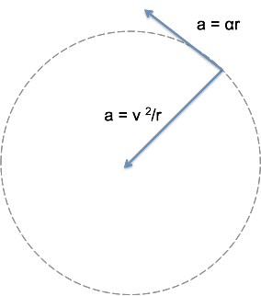
Q (4.0): Perfect: The two vectors are perpendicular to each other. a=v²/r is the centripetal acceleration and is pointed towards the center of the circle an object is rotating about. a=αr is the tangential acceleration and is pointed tangent to the circle that the object is traveling in. a_{tot}² = a_{cent}² + a_{tan}² or A_{tot} = A_{cent} + A_{tan} (where bold means vectors). Note: you did not need to include the relationship to total acceleration to receive full credit. (13 students)

M (3.5): Same as Q, but mixed up the vectors. (3 students)

L (3.2): Ideas were mostly complete and the same as in Q, but the pictures were incorrect or unclear. Must discuss the tangential and centripetal acceleration to be in this category. (5 students)

C (2.5): Some correct information was given regarding these quantities, but drawings were incorrect or unclear. The definitions of the vectors (as indicated in Q) were not given, and the fact that the vectors are perpendicular to each other was not indicated. (3 students)

P (2.0): Argued that one of the equations represented an angular acceleration and one represented a linear one. (7 students)

S (1.0): Argued that the accelerations equations were the same, but you just use them in different instances. (11 students)

N (0.5): Some thoughts shown, but did not successfully complete the question. (5 students)

Z (0.0): Blank or essentially blank (2 students)

