**Chapter 7. Joint Space Generation**

Robot Tool Trajectory – A timed sequence of a robot tool frame movement in its work space from Point A to B along a path defined by intermediate via points. Internally, a robot trajectory represents a set of dynamic joint transformations that vary with time as a result of the torque and acceleration applied to each joint.

Trajectory and Path – Often used interchangeably, both may have a temporal attribute as well as the spatial. A path may be taught by defining Point A, B, and the via points in Cartesian space. A path equation is given in joint space as a function of time, e.g. in a cubic polynomial,

 (1)

 (2)

 (3)

*Third degree polynomial angular response curves*

θf

θ0

tf

t0

With the initial and final gripper angles and velocities set, the coefficients *a0* to *a3* can be determined.

Two point path, going from Point A to Point B:



Substituting the above four conditions into Eq. (1) and (2), yields the cubic coefficients.

A segment in a path connecting two via points – A segment by segment calculation

 

Substituting the above conditions into Eq. (1) and (2), yields the cubic coefficients for the segment.

Acceleration

Velocity

Angular Position

Angular Position

Velocity

Acceleration

0

0

0

Interpolation - Movement between via points. Linear (straight line) or Polynomial (curved).

All robot joints, including the prismatic joints, are motor driven. Therefore, intuitively a linear motion with a high degree of accuracy is more difficult to achieve than a non-linear motion.

The robot arm normally pass near, not through, the via points to avoid jerky motion unless instructed to do so. If no via points are specified, the robot will take a smooth “PTP” path.

θ

t2, θ2

θ4

v

v

cv

t1, θ1

cv

θ3

T12

t

Linear Path with Parabolic Blends

**Design attributes –** Segment duration (linear and blend), velocity of the linear segment, acceleration of the blend,

*For interior points*

*where T23=t2+t23+t3*

*For end points*

Solving for t1.

θ

v

v

cv

cv

t

Linear Path with Parabolic Blends over Pseudo via points for through points

**Linear Positioning System**

**Control Resolution** Distance between two adjacent addressable points.

Set by desired control needs and constrained by mechanical limits.

**Addressable Points** Set by the step angle, the gear/pulley ratio, and the lead screw pitch.

**Accuracy** **(Maximum error)**

½ of Control Resolution + 3σ (Standard Deviation of positional variability)

**Repeatability** (**Precision**) ±3σ

Control

Resolution

Accuracy

Precision

±3σ

Max. error

Work Table TaTable

Servo

Motor

Stepper Motor

Reduction

Gear

Lead Screw

Recirculating Ball

Bearing Nut

Pulse Output

Encoder

Pulse Input

Pitch

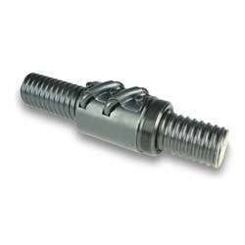 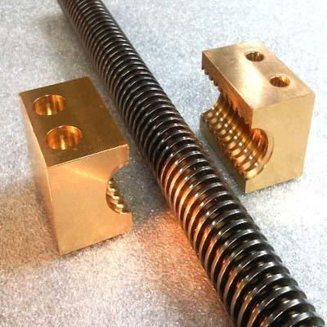 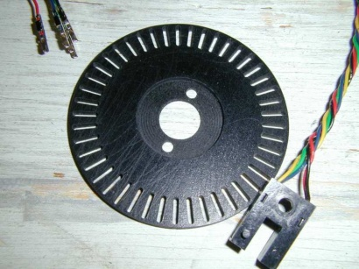

Lead Screw Nut assemblies

Encoder Disk

**Pulse (Baud) Rate = Motor RPM x 360 / Step Angle**