Crib Notes

Bringing Up Bebe Review: Why French Parenting Helps Kids Eat Normal Foods, Behave Themselves, And Sleep All Night
By Fatherly | May 1st, 2015
If you’ve recently faked your way through a conversation about the latest, greatest parenting book that you didn’t actually read, there’s a decent chance the book in question was Pamela Druckerman’s Bringing Up Bébé: One American Woman Discovers The Wisdom Of French Parenting. It recounts her experiences raising a child in Paris, where she found French kids to be way more well behaved, polite, autonomous, and willing to eat food that isn’t beige and shaped like dinosaurs than their American counterparts.
If that’s not enough to pique your curiosity, consider this: According to Druckerman, French parents have social lives and do things like sleep and have sex. Sound interesting? These Crib Notes provide the book’s main takeaways and most actionable advice.

1. How French Parents Talk To Infants
They Are Listening
The French believe that babies are not insensate blobs, but rather rational beings who can learn and (sort of) communicate what they’re thinking and how they’re feeling.
What You Can Do With This
- Observe your infant closely for long periods in order “tune in” to what they’re experiencing and learn to follow their cues. The French believe you can develop a sensitivity through this process that is a crucial caregiving quality (and may result in your wife no longer berating you for being so insensitive).
- Model good manners by being polite to your infant; don’t use a condescending sing-song voice and say things like please and thank you, even if you feel ridiculous saying things like please and thank you to an infant.
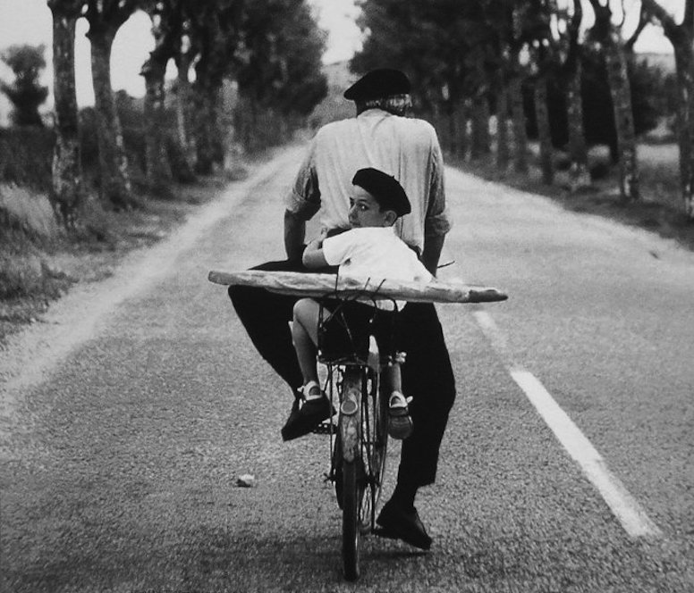

2. Why French Kids Sleep Through The Night So Easily
Babies Will “Do Their Nights” If You Let Them
At the end of each sleep cycle, babies may wake up and cry, which is part of how they learn to connect cycles into an entire night’s sleep. They can also be really active — like, thrash-all-over-the-crib active — without ever waking up. The French tend not to worry too much about this stuff.
What You Can Do With This
- Learn “the pause,” which is a five minute beat French parents take when a sleeping baby starts crying. It gives your kid a chance to get themselves back to sleep without your help.
- Let your baby nap with the blinds open, so they understand the difference between a daytime nap and night time, when they will sleep for real.
- Talk to your kid about why everyone needs to sleep at night (see that above bit about the French belief in babies’ comprehension) and tell them how confident you are in their ability to learn how to do it. Eventually, they’re going to prove you right and you’ll look like a genius.

3. How French Parents Get Their Kids To Eat So Well
There Are No “Kid Foods”
French parents feed their kids more or less the same things they eat, as do the State-run day care and schools. As a general rule, French kids are healthy, adventurous eaters who don’t act like vegetables are poisonous alien appendages.
French kids are healthy, adventurous eaters who don’t act like vegetables are poisonous alien appendages.
Lay Off The Snacks
In addition to feeding their kids the same foods, French parents also feed their kids the same meals: 3 a day, with one afternoon snack. There aren’t a lot of sweets or junk foods, and the kids don’t tend to whine about it.
What You Can Do With This
- As soon as your kid is ready for solid food, start them on flavorful vegetables, instead of the bland cereals. The French believe a sophisticated palate starts at the beginning.
- At the same time, get them on a schedule that mirrors the family’s schedule, rather than feeding them on demand — this can be challenging if you, yourself, expect to be fed on demand.
- Cut out all but one afternoon snack. It teaches kids patience and self control, and they’ll be hungrier when it’s time for a meal. Hungry kids eat better.
- Serve vegetables first, when the kid is most hungry. From there, don’t customize the menu. Everyone eats the same stuff.
- They don’t have to eat anything if they don’t like it, but they do have to try everything on the table. Pay attention to what they don’t like and reintroduce it at another meal with a different preparation.
- Get beyond “like/don’t like.” Talk to your kid about specific flavors and textures and compare them to other foods. This gives you a better understanding of why they like or don’t like things, and should spark their curiosity about other foods.
- Don’t torture them. The French keep meals short and sweet and excuse their kids after 20 minutes or so.

4. Why French Kids Are So Well Behaved
Patience Isn’t Just A Virtue — It’s An Expectation
The French believe that coping with frustration and delaying gratification are skills that kids can learn, and they teach them accordingly. Patience is valorized and a sense of calm cultivated, so kids understand what’s expected of them.
What You Can Do With This
- Don’t drop everything the moment your kid “needs” you. Calmly explain that you need to finish cooking breakfast, sending an email, brushing your teeth, whatever, before you can admire their latest picture of the dog.
- Don’t let your kid interrupt you, and don’t interrupt them. If you tell them you’ll be with them in a moment, make good on that promise and extend them the same courtesy.
- Have high expectations for their ability to control themselves. Teach them how to get their favorite toy without ransacking the entire playroom, and communicate your confidence that they can do it that way — every time.
- Don’t let them think they’re the center of the universe (even if they’re the center of your universe).

5. Two Reasons Why The French Aren’t The End-All-Be-All Of Parenting Advice
The Whole Liberté, Égalité, Fraternité Thing Doesn’t Apply To Parents
According to Druckerman, French mothers contribute 89 percent more to their families house work and child care than French fathers. American parents might be stressed out and indulgent, but mothers in the U.S. do only 25 percent more house work and child care than the fathers.
They Kind Of Have An Issue With Breastfeeding
Breastfeeding isn’t a moral imperative and happy, healthy babies are raised on formula without ever turning to ash. Nevertheless, the benefits of breastfeeding are well documented and most pediatricians recommend it for at least 6 months — except in France, which has the lowest breastfeeding rate in the western world.
Then again, one of their biggest objections to breastfeeding is that it’s hell on a couple’s sex life, so maybe they really are the end-all-be-all of parenting advice. Viva la France!
© 2016 Fatherly. All rights reserved.

About Us Fatherly is a parenting resource for men who understand that embracing what they’ve become doesn’t mean giving up who they are. Men who want to be great fathers without turning into cliches. Men who spent their formative years laughing at blogs about dads in short shorts, but who will never, ever wear short shorts themselves. Our mission is twofold: first, we aim to be the most robust source of practical parenting advice on the Internet. With a comprehensive suite of content broken down by your child’s exact age, we’ll provide you info on everything from preparing the home for a baby’s arrival, to transitioning them to solid food, to figuring out what to do with this tiny human being once he or she starts walking, talking, and demanding to be shown a good time.

