English 1A Pathways 2016 Cross-Cultural Films for Film Clubs
These films were chosen for you on the basis of their themes and their high quality. They come from many diverse cultures and reflect many different value systems and ideas. Most focus on characters who are encountering people from different cultures or from different communities within the same culture trying to understand each other.

The list includes love stories, war stories, sports stories, comedies, dramas, and documentaries. Many involve journeys and coming-of-age stories. Some are pretty gritty, and many contain scenes of intense violence and/or sex, so do a little research and choose carefully according to what interests you and what you can manage. If you have one to suggest, let me know. The list will grow. Note: The descriptions below are from the Netflix website, in most cases shamelessly stolen word for word (though on some I did a bit of editing and added a few comments). I can do this because I’m the teacher (and because I’m acknowledging the usage here).

Africa and the Middle East

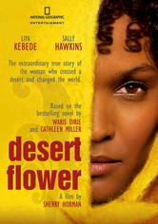 Desert Flower 2009R This drama tells the real-life story of Waris Dirie, a poor girl who flees an arranged marriage in Somalia, winds up in London and becomes one of the world's most recognizable supermodels -- who also speaks out against female genital mutilation. Film script based on a memoir written for Waris Dirie by a SJSU English professor.

Miral (2011) After rescuing children who survived a massacre in Jerusalem in 1948, a Palestinian woman establishes an orphanage that helps thousands of other children. But the success of her institution is tested when a pupil gets a taste of radical politics. Based on a true story.
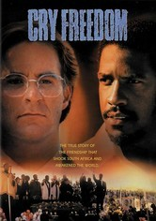 Cry Freedom In segregated 1970s South Africa, black nationalist Steven Biko (Denzel Washington) and white newspaper editor Donald Woods (Kevin Kline) are unlikely friends with a common goal -- ending apartheid -- in this true story based on Woods's books Biko and Asking for Trouble. When Biko's beliefs lead him to prison and a deadly fate, Woods rallies to expose the injustice. This film earned Washington his first Oscar nod.
Invictus (2009) This drama based on real-life events tells the story of what happened after the end of apartheid when newly elected President Nelson Mandela used the 1995 World Cup rugby matches to unite his people in South Africa. Morgan Freeman and Mat Damon star.
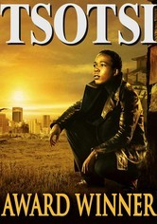 Tsotsi 2005R After shooting a woman and driving off in her car, a ruthless thug is surprised to discover he isn't alone, kept company by a crying infant in the backseat. But through his efforts to care for the baby, he slowly rediscovers his capacity to love. Academy award winner. (Set in South Africa)

The First Grader 2010PG-13 Based on a true story, this inspirational drama profiles the amazing determination of 84-year-old Kenyan Kimani N'gan'ga Maruge, a Mau Mau freedom fighter who wants to take advantage of a new universal education decree by learning how to read.

Cry, the Beloved Country Set in the dark days of apartheid, this film adaptation of South African author Alan Paton's novel tells the story of two men -- one black, one white -- who must cope with family tragedy in a climate of fierce government repression and violence. Rural minister Stephen Kumalo (James Earl Jones) travels to Johannesburg in search of his troubled son, while white landowner James Jarvis (Richard Harris) comes to the city to attend to his activist son's murder.
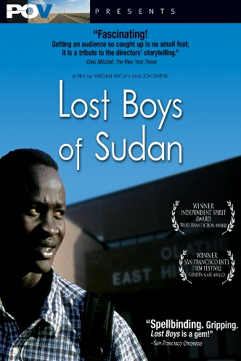 Lost Boys of Sudan As orphans living in the midst of civil war, Peter and Santino dealt with dangers like lion attacks and gunfire from militia. But even more daunting are the challenges they face in suburbia after they're chosen to start a new life in America. Megan Mylan and Jon Shenk direct this award-winning documentary that follows two Sudanese refugees throughout their intense journey from their native Africa to the United States. Note: Some of them ended up in the Bay Area, and a few at SJSU.
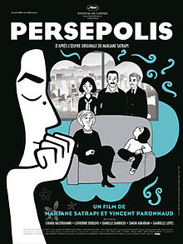 Persepolis Based on Marjane Satrapi's autobiographical graphic novel, this Oscar nominee for Best Animated Feature Film follows a young woman's childhood in repressive Iran, her adolescence in France and her return to Tehran as an adult.

Asia/ Pacific Islands
The Beautiful Country 2004R Looking to find a better life -- and his estranged American father -- a shy Vietnamese man in his 20s embarks on a personal journey with a beautiful young woman aboard a refugee ship bound for the United States.

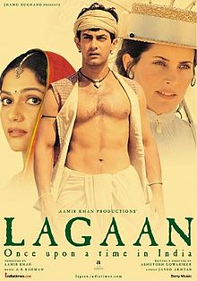 Lagaan One of the best sports movies ever and a classic of Bollywood in a historic setting. In Victorian India, an arrogant British commander challenges the harshly taxed residents of Champaner to a high-stakes cricket match. If the villagers win, they'll avoid taxation for three years; if they lose, they'll pay the tax thrice over.

Jodhaa Akbar 2008NR What begins as a strategic alliance of two cultures becomes a genuine opportunity for true love between a mighty Mughal emperor and a Hindu princess in director Ashutosh Gowariker's epic romance set in 16th-century India.
The Wind Rises (2013) Master animator Hayao Miyazaki spins a decades-spanning tale inspired by the life of Jirô Horikoshi, designer of the World War II fighter plane the Zero. Too nearsighted to become a pilot, Jirô settles for building planes, with spectacular results.

King of Masks Nearing the end of his life, Wang -- a locally renowned street performer and wizard of the venerable art of mask magic -- yearns to pass on his technique. But custom decrees that he can only hand down his craft to a male successor. Anxious to preserve his unique art, the heirless Wang buys an impoverished 8-year-old on the black market. But when the child divulges a dreaded secret, Wang faces a choice between filial love and societal tradition.

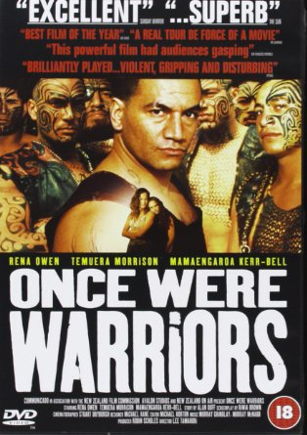 Once Were Warriors Director Lee Tamahori's powerful adaptation of author Alan Duff's best-selling novel centers on the troubled life of a Maori family crippled by poverty, bigotry, alcoholism and domestic violence. Rena Owen stars as Beth Heke, a beleaguered mother who struggles to care for her three children while battling the demons of her erratic, often violent husband, Jake (Temuera Morrison). Warning: this one is really brutal. (New Zealand)
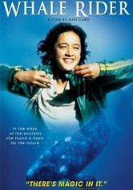 Whale Rider A Maori tribe must contend with the distinctly nontraditional concept of having a female leader when the intended heir to the throne dies during childbirth, leaving his twin sister, Paikea, to prove herself in this inspiring coming-of-age tale.

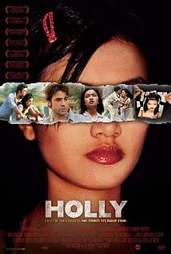 Holly In this poignant drama, Holly (Thuy Nguyen), a young Vietnamese girl sold into prostitution by her family, tries to escape her dismal life by beginning a platonic relationship with a 40-year-old American named Patrick (Ron Livingston), a stolen-artifacts dealer. Twelve-year-old Holly has been smuggled into Cambodia, becoming one of countless children exploited in the sex trade; Patrick, who has his own troubles, may be her only hope.

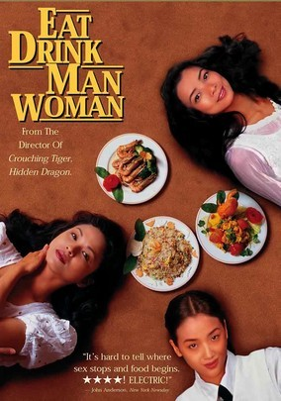 Eat Drink Man Woman Distracted by their complicated love lives and secret ambitions, three adult sisters reluctantly humor their widower father (Sihung Lung) by enduring the elaborate, traditional Taiwanese dinners he insists on having every Sunday. Ang Lee directs this charming tale that humorously examines the clash between modernity and tradition within the contemporary Taiwanese family. Yu-Wen Wang, Chien-lien Wu and Kuei-Mei Yang co-star.

Europe

The Spanish Apartment When a French college student signs on to become an exchange student and learn Spanish so he can land a coveted job, he heads to Barcelona and moves in with a host of other young Europeans who help him discover how to enjoy life.
Dirty Pretty Things 2002R Undocumented immigrants Okwe and Senay work at a posh London hotel and live in constant fear of deportation. One night, Okwe stumbles across evidence of a bizarre murder, setting off a series of events that could lead to disaster -- or freedom.
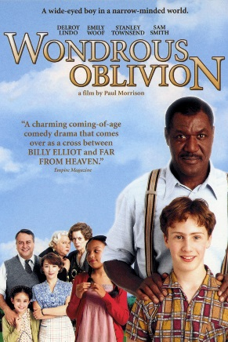 Wondrous Oblivion When his new Jamaican neighbor, Dennis Samuels, offers to coach cricket-mad adolescent David Wiseman, the gesture sparks racial hostility in this coming-of-age tale set in 1960 London. David -- who lacks the skills to play the game -- eventually earns a spot on his school's cricket squad thanks to Dennis and learns a few lessons about bigotry in the process. Emily Woof and Stanley Townsend play David's parents.

Bend It Like Beckham 2002PG-13 An ardent fan of British soccer sensation David Beckham, teenage Jess wants nothing more than to be on the field. But a proper Indian girl shouldn't be spending her time playing soccer, according to her traditional family.

The Edukators Peter, Jan, and Jule-- a trio of anti-capitalist radicals who call themselves the Edukators -- rankle Germany's elite by breaking into mansions, rearranging the possessions and leaving menacing messages that warn of an impending class war. But when Jule leaves her cell phone behind and they return to the scene to retrieve it, an unexpected visitor forces them to improvise.

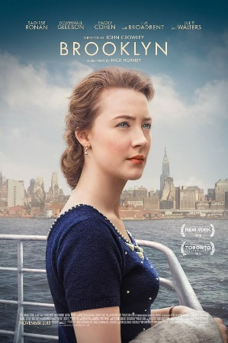 Brooklyn After emigrating from Ireland, Eilis Lacey readily adapts to the vastly different New York City, where she falls for a young Italian. But when tragedy pulls her back to her hometown, she finds her loyalties divided between two nations -- and two men.
Song of the Sea: This animated tale follows young Saoirse, the last of a magical race of beings who exist as seals in water but turn into humans on land. After she and her brother are sent to live in the city, they begin an epic quest to return to their seaside home.

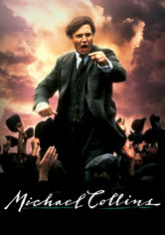 Michael Collins Neil Jordan directed this powerful biopic about the rise and fall of Michael Collins (Liam Neeson), the charismatic leader of Ireland's fight for independence. Collins and his companions de Valera (Alan Rickman), Broy, Boland and Kitty Kiernan (Julia Roberts) used guerilla warfare to attack the British empire, with historic results.
Before Sunrise This is one of the best arguments for going to Europe when you’re young. It stars Ethan Hawke as an American backpacker who strikes up a conversation with a lovely fellow traveler (Julie Delpy) on the train to Vienna and persuades her to spend his last day in Europe with him. Wandering the picturesque streets of the Austrian capital, the two share stories of their pasts and their dreams for the future. The sequel, set in Paris, is also pretty great, but they’re a bit older: Before Sunset.
Cyrano de Bergerac (Gerard Depardieu) pines for his cousin Roxanne, but won't reveal his affections for fear that she'll find his ugly features off-putting. So, Cyrano instructs the studly but stupid Christian how to woo her. Roxanne is entranced by Christian's beautiful poetry and letters -- all ghosted by Cyrano. But Christian dies in battle before he can tell Roxanne the truth. Depardieu won the Best Actor award at Cannes for his performance.

North America

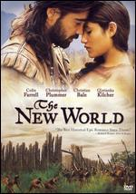 The New World Set in 1607 at the founding of the Jamestown Settlement, Terrence Malick's epic adventure chronicles the extraordinary actions of explorer John Smith (Colin Farrell) and Native American princess Pocahontas (Q'Orianka Kilcher). As English settlers and Native Americans clash, Smith and Pocahontas find their worlds colliding and their hearts entwined, but ancestral loyalty may tear them apart.

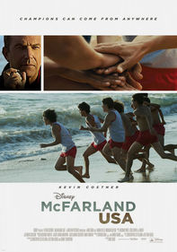 McFarland, USA Track coach Jim White's search for work leads him to a high school in California's Central Valley with a largely Latino student body. After White and his determined athletes establish a bond of trust, remarkable achievements are on the horizon. A triumphant story, based on real events.
Smoke Signals On a Coeur d'Alene, Idaho, reservation, nothing ever changes -- until the estranged father of Victor Joseph (Adam Beach) bites the dust in Arizona, and Victor must go collect the cremated remains. The problem is, Victor can't afford the fare. But annoying nerd Thomas Builds-the-Fire (Evan Adams) will float Victor a loan ... if Thomas can tag along. This tender tale of self-discovery is based on acclaimed author Sherman Alexie's short stories.

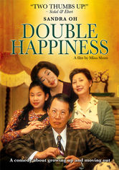 Double Happiness Old-fashioned values collide with the whims of youth in this modern romantic comedy about a dutiful Chinese-Canadian daughter who wants to please her parents without sacrificing part of herself when it comes to love. Deep down, Jade (Sandra Oh) knows her mother and father won't approve of her new boyfriend, a white college student named Mark. But that doesn't stop her from hoping for "double happiness." The other plot line involves Jade’s ambition to be a “serious” actress, not a clerk in a dress shop—another desire her parents disapprove of. No tiger mom here, but there’s pressure all the same.
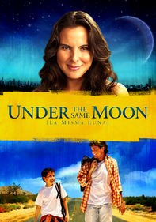 Under the Same Moon In this tale illuminating the plight of illegal aliens, Kate del Castillo plays Rosario, a woman working illegally in the United States to provide a better life for her son Carlitos, who remains at home in Mexico. Longing for his mother, Carlitos stows away on a van that's headed for the border. But an already treacherous journey becomes even more so when Carlitos is separated from his smugglers (Jesse Garcia and America Ferrera).

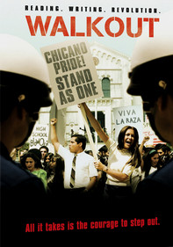 Walkout: Based on a true story, this made-for-cable drama set in East Los Angeles chronicles a March 1968 Latino student protest that was sparked by injustices and racial prejudice in the public school system. Led by devoted teacher Sal Castro (Michael Peña) and honor student Paula Crisostomo (Alexa Vega), the kids stage a walkout at five barrio schools to draw attention to their plight. But the peaceful rally gets out of hand when the cops overreact.

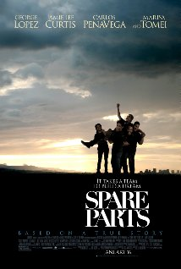 Spare Parts Four undocumented Mexican-American high school students from Phoenix, AZ, form a robotics club and are led by their teacher with nothing but spare parts and a dream to compete against MIT in a National Underwater Robotics Competition.
South and Central America

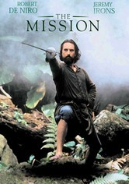 The Mission In the 18th century, a Jesuit missionary establishes a church in the hostile jungles of Brazil, but finds his work converting the indigenous Indians threatened by his superiors. Meanwhile, a slave hunter converts and joins the Father on his mission. Gorgeous film, great music, multiple award-winner, stars Robert De Niro, Jeremy Irons, Aidan Quinn.
Maria Full of Grace Maria Alvarez is a smart, independent 17-year-old from Colombia who agrees to smuggle a half-kilo of heroin into the United States for a shot at a normal existence in "El Norte" -- where she imagines the city streets are paved with gold.
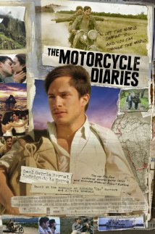 The Motorcycle Diaries This foreign-language drama tells the incredible true story of a 23-year-old medical student from Argentina -- future revolutionary Che Guevara (Gael Garcia Bernal) -- who motorcycled across South America with his friend Alberto Granado beginning in 1951. Walter Salles's film is based on Guevara's diaries of the trek, a deeply personal odyssey that ultimately crystallized the young man's budding political beliefs.
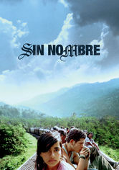 Sin Nombre Fleeing retaliation from the violent Central American street gang he's deserted, a young hood boards a northbound train, where he takes refuge atop the moving freight cars and hopes for a fresh start in a new country. The other story line features a beautiful young girl he meets while riding the freight train, who is trying to reach relatives in the US.

