The French are better parents? Excusez-moi?
By Sarah Maizes
Let me start by saying I wanted to hate “Bringing up Bebe: One American Mother Discovers the Wisdom of French Parenting” by Pamela Druckerman (UK title: "French Children Don't Throw Food"). I was already there with the publication of “French Women Don’t Get Fat” by Mireille Guiliano.
The flagrant arrogance of one culture to claim they do anything better than another is so irritating to me (ironic, coming from an American, right?). And now I’m supposed to embrace that the French are not only skinnier and better dressed - but that they are also better parents?! Excuse moi?? Next, the French are going to say they are better at sex! Oh wait…
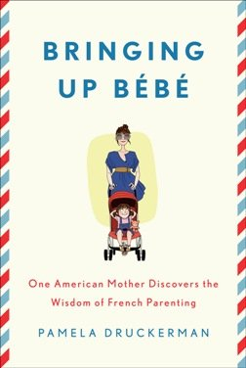
The Penguin Press
But to my surprise, Ms. Druckerman gives an enjoyable and thoughtful read that researches and explains thoroughly why she believes the French have something valuable to say about parenting. And I kind of buy it. Unlike many of the other parenting books I’ve read, Ms. Druckerman explores and questions French parenting techniques with the same journalistic professionalism and thoroughness she brings to all of her work.
The main point of the book is that French parents adhere to an unspoken “code.” Druckerman refers to a parenting strategy she calls “La Pause.” “La Pause” is the time French parents take (perhaps to take a sip of wine?) before responding to crying babies, screaming children, or the demands of tiny Napoleons.
Ms. Druckerman suggests that because French parents don’t respond immediately to their children, they learn more autonomy.
French mothers don’t hover at playdates; they don’t pack their children’s schedules with activities; and they don’t let their children be deluded into believing that they’re the center of the universe. The result is independent children who see their parents as individuals who deserve respect and privacy. How can any mother (American, Irish, Chinese, whatever…) fight with that?
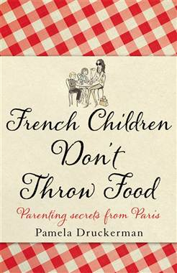
The British cover of "Bringing Up Bebe" promises that French children don't throw food. Ooh la la!
Of course, not all French parenting ways are so digestible. For example. the French take a negative view of breastfeeding and mothers are encouraged, and even pressured, to lose their baby weight immediately. I personally don’t care who gives their babies formula, or has a perpetual pooch, but I am of the mind that we need to get off each other’s backs.
Like Druckerman – and this is probably the reason she won me over so quickly – I have an older singleton and twins. Every day I am amazed at how different they are. Each one has their own quirks, challenges and strengths. One is a picky eater, one never listens unless my vocal chords are visible through my open mouth, and one gladly gives the best foot massages EVER! I didn’t foster any of this (other than perhaps the foot rubs…). It was totally out of my hands.
We are all looking for answers -- confirmation that how we are raising our children will result in success. But maybe the answer lies in a question – “How do you define success?” Do you want your child to be free-spirited? Creative? Driven? A leader? Family oriented?
Then there’s the question of “What kind of child do you have?” Sensitive? Focused? Outspoken? If I ever pulled a “Tiger Mom” on my older daughter, she’d be in an institution before she was 20. That’s not success to me.
With so many variables, how can any parenting method take credit for being the best?
I believe we can learn something about parenting from every culture. But I don’t believe there is a “recipe” for raising the perfect child.
Some kids need a bit of “this” and a heavy dose of “that.” Some need a dash of “that” and a sprinkling of “this.” But in the end, the only time-tested ingredient you can add is a heapin’ helpin’ of love, then sit back and hope your child will rise.
Sarah Maizes is the founder of www.MommyLITEonline.com, a parenting humor site, and the author of “Got Milf? The Modern Mom’s Guide to Feeling Fabulous, Looking Great and Rocking a Minivan”. She is a freelance writer, speaker, comedian and mother of three. In her spare time she… wait… she has no spare time.
"Like" TODAY Moms on Facebook, and follow us @TodayMoms
http://moms.today.msnbc.msn.com/_news/2012/02/07/10312701-the-french-are-better-parents-excusez-moi

