Ben Carson compares some refugees to 'rabid' dogs
By Eugene Scott, CNN Updated 5:23 PM ET, Fri November 20, 2015

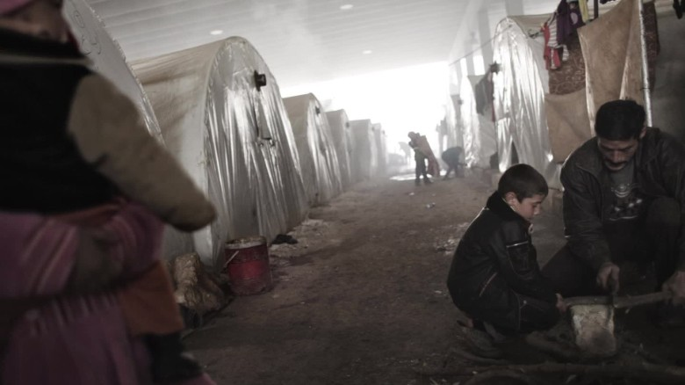

GOP candidates' positions on Syrian refugees 01:55

Story highlights
- Carson: We need systems to identify the "mad dogs"
- The Republican candidates says it would be "foolish" not to vet refugees
Washington (CNN)Ben Carson on Thursday compared safeguarding Americans from Islamic terrorists who may sneak into the country as refugees to parents protecting their children from rabid dogs.
"If there's a rabid dog running around in your neighborhood, you're probably not going to assume something good about that dog," Carson said during a campaign stop in Alabama. "And you're probably going to put your children out of the way. That doesn't mean that you hate all dogs."
How Republicans would respond to ISIS
He added, "But you're going to put your intellect into motion and you're thinking, 'How do I protect my children at the same time? ... I'm going to call the humane society and hopefully they can come and take this dog away and create a safe environment once again.'"
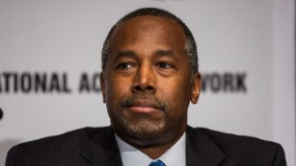

The Republican front-runner said it would be "foolish" to welcome Syrian refugees without systems in place to thoroughly vet them.
"We have to have in place screening mechanisms that allow us to determine who the mad dogs are. Quite frankly, who are the people who want to come in and hurt us and destroy us," he said.
House passes bill that could limit Syrian refugees
Carson also said that ISIS is more of a threat to America now than Al Qaeda was following the 9/11 attacks.
And he said pulling off the 9/11 attacks "really didn't require a great deal of sophistication."
"You didn't have to be all that great. You had to be able to fly some planes and get a couple people in here. That's going to be a lot more difficult to do now," he said.
Ben Carson: We need to better screen for terrorists before taking Syrian refugees
Carson later praised the House for passing a bill that could limit the intake of Syrian refugees, calling it a positive step.
"The Paris terrorist attacks have demonstrated that terrorists will pose as refugees to enter our land. We must do our utmost to thwart the terrorists' ambitions," Carson said in a statement sent out by his campaign. "The security of the American people, not politics, should be our number one priority. The bipartisan vote in the House today is a very good step in the right direction."
Sign up for CNN Politics' Nightcap newsletter, serving up today's best and tomorrow's essentials in politics.
CNN's Tal Kopan contributed to this report.
http://www.cnn.com/2015/11/19/politics/ben-carson-rabid-dogs-refugees/

Ben Carson: Refugees want to stay in Syria
By Eric Bradner, CNN Updated 5:51 PM ET, Sun November 29, 2015

Story highlights
- Ben Carson visited Jordan to shore up his foreign policy credentials
- Carson said Syrian refugees there would rather be relocated in their country than moved to the U.S.
Washington (CNN)Ben Carson said Sunday that most Syrian refugees would rather be relocated within their own country than resettled in the United States.
The Republican presidential contender made a post-Thanksgiving trip to Jordan to visit refugee camps -- an effort to shore up the foreign policy credentials that have been a weak spot in his campaign.
In an interview with CNN's Brianna Keilar that's set to air in the noon hour of Sunday's "State of the Union," Carson compared the stop in Jordan to a trip he took to the U.S.-Mexico border to learn about immigration.
And he concluded that refugees fleeing Syria's civil war and the rise of ISIS in Syria and Iraq shouldn't be resettled in the United States.
"The thing that I really learned in listening to the refugees themselves is their intense desire is to return to their country and repatriated," Carson said.
"There's so many people who think the ideal for everybody is to come to America and be resettled here but that is not the ideal for everybody," he said. "And we need to be looking at mechanisms that already exist. Why do you want to recreate the wheel when you have something that's working? Let's maximize that and then let's think about if we need recreate other wheels."
Carson implied that the United States should spend more money aiding the refugee camps, rather than resettling small numbers of those refugees.
"They don't have enough money," he said. "You look at last year, there was a $3 billion shortfall. That's the same amount of money we spent last month on Halloween candy."
He said his trip was "about fact-finding -- about getting an opportunity to see firsthand without having things reinterpreted over something that is really important."
He said refugees told him that "their desire, their true desire is to be resettled in Syria."
He continued: "But they are satisfied to be in the refugee camps if the refugee camps are adequately funded. Recognize that in these camps they have schools, they have recreational facilities that are really quite nice. And their all kind of things that make life more tolerable. Would it be better to integrate them into society? Yes, and I've certainly talked to some people about that. But you have to make progress as you go."

