Bernard Shaw
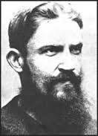
George Bernard Shaw (GBS)
In his dashing young intellectual phase.
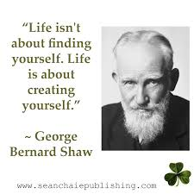
In his quotable sage phase.
Note: Most of the quotes attributed to Shaw are actually bits of dialog from his plays, including Satan. Not all of his characters can be seen as spokespeople for Shaw’s own views!

Man And Superman by George Bernard Shaw at Irish Repertory Theatre Overview, interviews, with snippets of the play https://www.youtube.com/watch?v=qFrL1VLJY6E&nohtml5=False

National Theatre: Man + Superman and Don Juan in Hell https://www.youtube.com/watch?v=VFaqAMvLUoA&nohtml5=False

International Shaw Society http://www.shawsociety.org/

