**Che, The Icon**—

[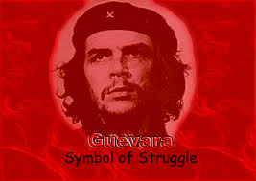](https://www.google.com/imgres?imgurl=https%3A%2F%2Fdesertpeace.files.wordpress.com%2F2012%2F10%2Fche-guevara.jpg&imgrefurl=https%3A%2F%2Fdesertpeace.wordpress.com%2F2012%2F10%2F16%2Fche-guevara-more-than-just-a-t-shirt-martyr-of-palestine%2F&docid=JiXdpHcoy9lGcM&tbnid=t9jhWxXF2AaaQM%3A&w=800&h=568&bih=724&biw=1345&ved=0ahUKEwjc7Iq25qDMAhVG52MKHagVAg0QMwhCKB4wHg&iact=mrc&uact=8)

Deified

[](https://www.google.com/imgres?imgurl=http%3A%2F%2Fwww.korsgaardscommentary.com%2Fwp-content%2Fuploads%2F2011%2F09%2FChe-Guevara-Shirt1-394x500.png&imgrefurl=http%3A%2F%2Fwww.korsgaardscommentary.com%2F2011%2F09%2Fwhy-its-time-to-hang-up-the-che-guevara-t-shirts.html&docid=njsAcj4Da63K5M&tbnid=k8WapaiodpjWUM%3A&w=394&h=500&bih=724&biw=1345&ved=0ahUKEwi50Lud5KDMAhVE-2MKHReEA9AQMwh-KEcwRw&iact=mrc&uact=8). . . and Vilified

[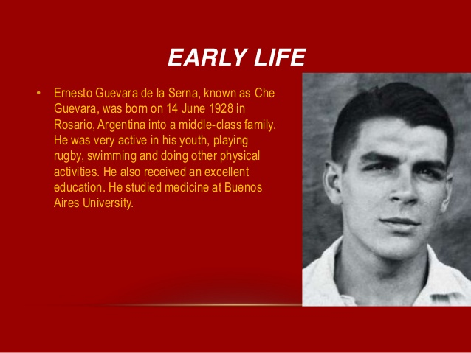](http://www.slideshare.net/baharcufadar/ernesto-che-guevara-35626758)

and only ocassionally presented as an ordinary mortal

**Other Icons, Old and New, Reinterpreted in Che’s Image**

**Search “Che icon parody” for more—they are legion!**

[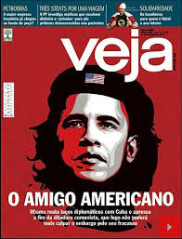](https://www.google.com/imgres?imgurl=http%3A%2F%2Fi.huffpost.com%2Fgen%2F2413868%2Foriginal.jpg&imgrefurl=http%3A%2F%2Fwww.huffingtonpost.com%2F2014%2F12%2F19%2Fobama-che-guevara_n_6354978.html&docid=mo0B_5rn5ZTlAM&tbnid=sJAgiyiHC0yy0M%3A&w=413&h=542&bih=724&biw=1345&ved=0ahUKEwj2nqmQ6qDMAhVByWMKHWVqB7AQMwhRKC0wLQ&iact=mrc&uact=8)[](https://www.google.com/imgres?imgurl=http%3A%2F%2Ffarm3.static.flickr.com%2F2417%2F1538861041_7787920d24.jpg&imgrefurl=http%3A%2F%2Fwww.flickriver.com%2Fphotos%2Fbenheine%2F1538861041%2F&docid=gj9nHXr2HJ-CSM&tbnid=9P4sJjI6fo6VbM%3A&w=375&h=500&bih=724&biw=1345&ved=0ahUKEwitrLig7aDMAhVO52MKHTSgABgQMwhAKBwwHA&iact=mrc&uact=8)[](https://www.google.com/imgres?imgurl=http%3A%2F%2Fwww.freakingnews.com%2Fpictures%2F121500%2FSanta-Che-Guevara--121903.jpg&imgrefurl=http%3A%2F%2Fwww.freakingnews.com%2FSanta-Che-Guevara-Pictures-134201.asp&docid=2NlsXPacgDbDLM&tbnid=cMjC4O4LkczM7M%3A&w=763&h=1200&itg=1&bih=724&biw=1345&ved=0ahUKEwib64WR66DMAhVP-GMKHbyzCd84rAIQMwggKB0wHQ&iact=mrc&uact=8)

[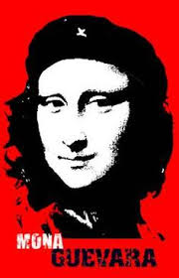](https://www.google.com/imgres?imgurl=https%3A%2F%2Fs-media-cache-ak0.pinimg.com%2F236x%2Ff4%2Fe8%2F55%2Ff4e8551b13a5f1e8f65f22f798b74827.jpg&imgrefurl=https%3A%2F%2Fwww.pinterest.com%2Falebon0087%2Fmona%2F&docid=RWayQm9r53p-NM&tbnid=1qMLIj2kcASRIM%3A&w=236&h=367&bih=724&biw=1345&ved=0ahUKEwi5uN6W6qDMAhVS4mMKHcSnBrw4ZBAzCFEoTjBO&iact=mrc&uact=8)[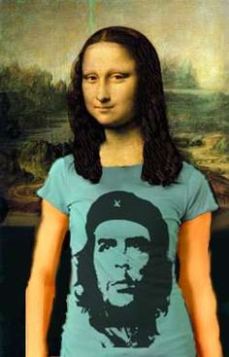](https://www.pinterest.com/explore/che-guevara/)[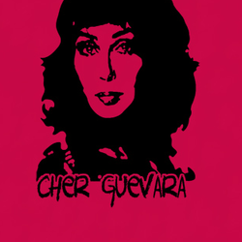](http://www.kustom-tees-4-u.com/cat/page/6) [](https://www.google.com/imgres?imgurl=http%3A%2F%2Fwww.20min.ch%2Fdiashow%2F39901%2Fcamila00-c4b2ac24ec0efdc5800b429f330faa69.jpg&imgrefurl=http%3A%2F%2Fwww.20min.ch%2Fro%2Fnews%2Fmonde%2Fstory%2FLa-Che-Guevara-sexy-qui-fait-trembler-le-Chili-27395974&docid=4Ve_XU6B6R74lM&tbnid=5Wv1qKpyBLy_DM%3A&w=600&h=446&bih=724&biw=1345&ved=0ahUKEwie2fHi6qDMAhUKy2MKHa2WCdU4yAEQMwgSKA4wDg&iact=mrc&uact=8)[](https://www.google.com/imgres?imgurl=http%3A%2F%2Fthepeoplescube.com%2Fimages%2Fvarious_uploads%2FChe_Conchita_red.png&imgrefurl=http%3A%2F%2Fthepeoplescube.com%2Fpeoples-blog%2Fche-is-dead-long-live-conchita-a-new-rebel-icon-t16671.html&docid=76KZyydXF_hHxM&tbnid=PVHH0eBcX_hEJM%3A&w=504&h=504&bih=724&biw=1345&ved=0ahUKEwil9c3e8aDMAhUY3WMKHSzEDMo4ZBAzCDwoOTA5&iact=mrc&uact=8)

Taking the Che as “Icon” part Literally

[](https://www.google.com/imgres?imgurl=http%3A%2F%2Fimg03.deviantart.net%2Fa0bd%2Fi%2F2005%2F330%2Ff%2F2%2Fche_jesus_by_ramba.jpg&imgrefurl=http%3A%2F%2Framba.deviantart.com%2Fart%2FChe-Jesus-25090693&docid=1752AdWtZn0TbM&tbnid=fBGiKiA_N27IaM%3A&w=547&h=757&bih=724&biw=1345&ved=0ahUKEwiHmrmL8aDMAhUUz2MKHVs0ASQ4yAEQMwgYKBQwFA&iact=mrc&uact=8)[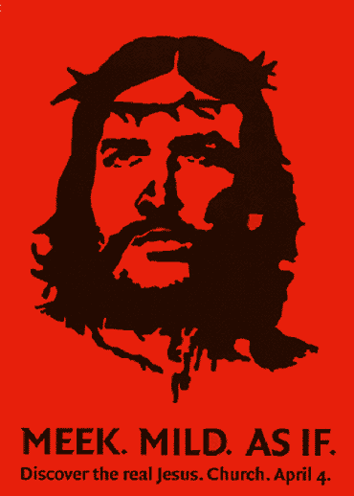](http://www.stjameskidbrooke.org/wp-content/uploads/2009/04/)[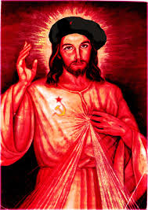](https://www.google.com/imgres?imgurl=http%3A%2F%2Fwww.nuntiare.org%2Fwp-content%2Fuploads%2F2013%2F07%2Fjesus-che.jpg&imgrefurl=http%3A%2F%2Fwww.politicsforum.org%2Fforum%2Fviewtopic.php%3Ff%3D45%26t%3D145111%26start%3D180&docid=_Km-0Hn8c7tJPM&tbnid=I7vol6Ztr0_DDM%3A&w=354&h=500&bih=724&biw=1345&ved=0ahUKEwiMgaH27qDMAhVN3WMKHVgPDsIQMwhYKDQwNA&iact=mrc&uact=8)

[](https://www.google.com/imgres?imgurl=http%3A%2F%2Fstatic.dagospia.com%2Fimg%2Fpatch%2F09-2015%2Fpapa-francesco-guevara-che-bergoglio-viva-la-resurrection-710885.jpg&imgrefurl=http%3A%2F%2Fwww.dagospia.com%2Frubrica-3%2Fpolitica%2Fnome-padre-figlio-che-domenica-papa-francesco-108856.htm&docid=EJhUbg7tlTbeLM&tbnid=GE1IH685ds-IpM%3A&w=502&h=650&bih=724&biw=1345&ved=0ahUKEwj2nqmQ6qDMAhVByWMKHWVqB7AQMwhPKCswKw&iact=mrc&uact=8)

(This is the Pope, also from Argentina)

[](http://wisdomquarterly.blogspot.com/2012/03/irish-revolutionary-che-guevara-to-get.html) [](https://www.google.com/imgres?imgurl=http%3A%2F%2Freligiopoliticaltalk.com%2Fwp-content%2Fuploads%2F2015%2F06%2FCliche-Che-Guevara.jpg&imgrefurl=http%3A%2F%2Freligiopoliticaltalk.com%2Ftag%2Fcuba%2F&docid=Ix3ytHOcDb6uiM&tbnid=gyS-LoUR5i1fNM%3A&w=380&h=234&bih=724&biw=1345&ved=0ahUKEwiMmejX76DMAhVG3WMKHaP4Cro4ZBAzCA0oCjAK&iact=mrc&uact=8)[](http://forum.nationstates.net/viewtopic.php?p=2123580)

[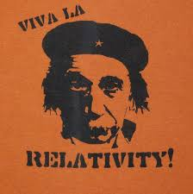](https://www.google.com/imgres?imgurl=https%3A%2F%2Fs-media-cache-ak0.pinimg.com%2F736x%2F27%2F8b%2F7a%2F278b7a2ea928f09177848822620d8cfa.jpg&imgrefurl=https%3A%2F%2Fwww.pinterest.com%2Fpin%2F155514993356935831%2F&docid=C6vWXNtGZ9pgaM&tbnid=C-9KvvpLEMWq3M%3A&w=736&h=740&bih=724&biw=1345&ved=0ahUKEwj2nqmQ6qDMAhVByWMKHWVqB7AQMwg_KBswGw&iact=mrc&uact=8) [](http://www.neogaf.com/forum/showthread.php?t=894854) [](http://www.ebay.com/itm/ANONYMOUS-CHE-GUEVARA-revolution-antifa-occupy-99-disobey-acta-hacker-T-SHIRT-/360945801414)

**Che in his own words**

(Disclaimer: I haven’t verified these quotes)

[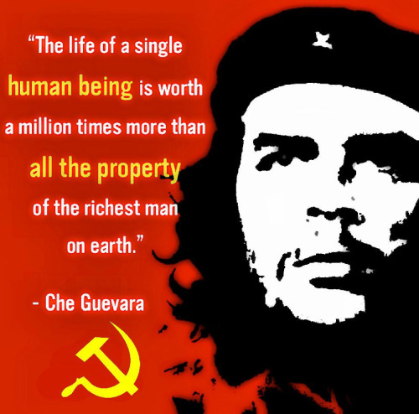](http://rebloggy.com/post/quote-quotes-communism-cuba-revolutionary-socialism-cuban-communist-marxism-marx/83596554945)[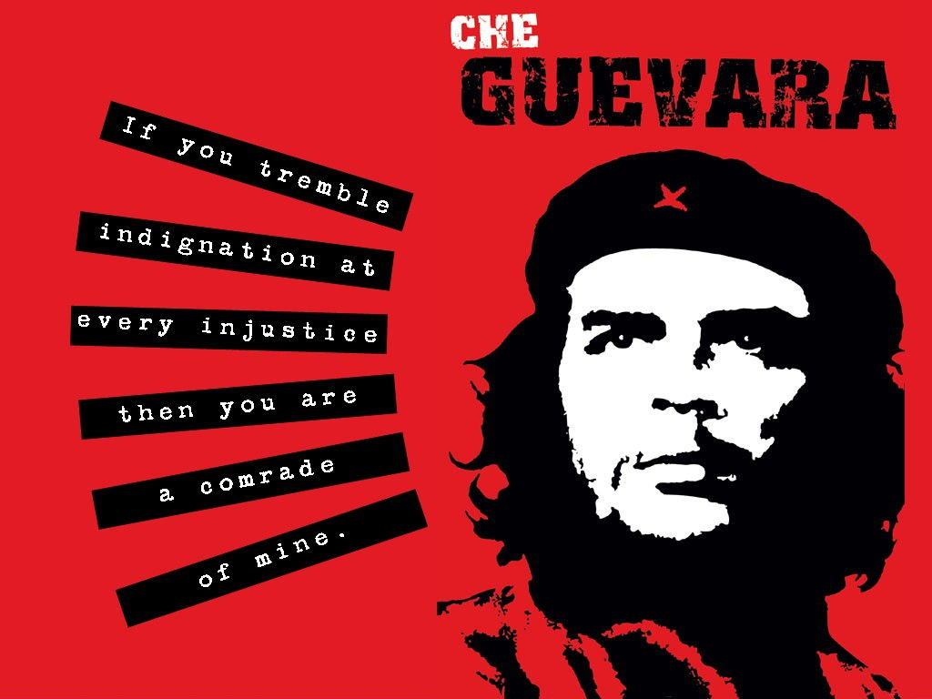](http://escapedtoperu.com/che-guevara-an-argentine-icon/)

[](http://quotesgram.com/che-guevara-quotes/)[](http://www.amazon.com/Exposing-Real-Che-Guevara-Idolize/dp/1595230521)