MPR News Notes on the news from the Twin Cities

Minnesota Nice, explained.
Laura Yuen March 15, 2012, 3:10 PM 24
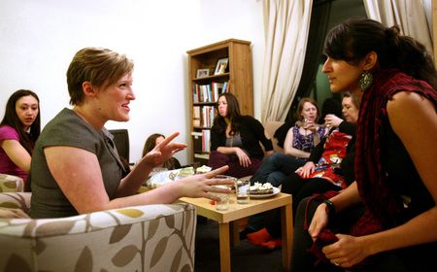
Cathy Schaefer of Minneapolis, left, chats with Rayane Alamuddin of Minneapolis during a gathering of “League of Extraordinary Women.” Schaefer said she started the group as a way to meet people in Minnesota after she moved here more than two years ago. (Photo by Jeff Thompson)
I’ve been digging out from all the responses we’ve received from our series exploring Minnesota’s polite reservedness toward newcomers.
One lengthy email came from Roger McKnight, a retired professor from Gustavus Adolphus College in St. Peter. McKnight, who taught Scandinavian studies, was disappointed we did not explain the roots of our state’s perceived standoffishness.
In a nutshell, the state’s settlers from northern or central Europe — primarily Germany and Scandinavia — had a profound impact on how the social culture here developed, McKnight contends.
“The traditional culture of Norway/Sweden was for centuries based on the concept of One People, One Language, One Religion,” McKnight writes. “Swedes’ lifelong friends were chosen from among people they went to school with and their kinship group. An individual made friends slowly, but they were friends for life — in the true sense of the term ‘for life.’”
Anyone who has lived in Scandinavia, as McKnight did for years, knows that “it’s somewhat hard to get an ‘in’ there,” he said. But once the friendship is established, “all barriers to communication break down and there results a torrent of friendship, expressions of sincerity, and even personal confidences.”
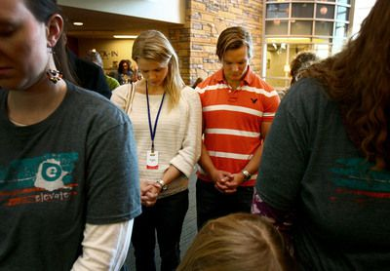
Ylwa Eklund Falk and Fredrik Eklund, who moved here from Sweden last year, pray at Eagle Brook Church in Lino Lakes. (Photo by Alex Kolyer)
The lovely young Swedish couple I met in the second part of my series, Ylwa Eklund Falk and Fredrik Eklund, also pointed out this cultural nuance. Falk once heard one of her countrymen compare Swedish stoicism to American friendliness with a clever fruit analogy.
“Americans are like peaches. They have this nice, soft outer shell that’s easy to penetrate. And there’s a tight, hard core that’s hard to get underneath,” she told me. “Swedes are kind of like oranges. It’s a thick, hard peel at first, but there’s a big soft mushy inside.”
In other words, once you get to know a Swede, “we tend to be very open about our lives,” Falk said. “With Americans, it’s easy to get to know them, but hard to make American friends.”
This interesting mix of fierce loyalty and initial aloofness apparently applies to Germans, too. That’s according to my colleague Alex Friedrich, son of a German immigrant. Alex lived in his father’s home country for five years, and says the people there tend to be more reserved.
“No one moved. Everyone already had their friends already,” he said. “They see friendship as a sort of investment, and they consider Americans shallow people who say ‘LOVE YOU!’ and then flake out when you need them. No need to bother with us unless we prove our worth.”
But the Germans — and Minnesotans — will lend a hand when it counts, Friedrich said. Not because they’re warm and loving, but because it’s the right thing to do.
“After growing up in California, I’ve come to appreciate that way of thinking,” he said. “My home state is really flaky.”
Moreover, Professor McKnight explains, there’s something in Scandinavian culture called the Law of Jante, a proverbial concept that values understatedness over backslapping. Tell me if his description sounds familiar:
“Not making a fuss of oneself, not boasting in public, not thinking a person is better than anyone else,” he says. “It says in the ten commandments: Don’t think you are better than us; don’t think you can stand out from us. In short, conform and don’t make a commotion of yourself.”
So there you have it.
Many, like McKnight, applaud Minnesotans for their sincerity.
But judging from the barrage of responses and social-media chatter our series generated, a lot of transplants to the state are having trouble moving their relationships from “acquaintance” to “friend for life.” Some have even emailed us asking for advice on where to meet people.
Here’s hoping when they do find friends, they’ll be rewarded with that big, soft mushy inside.
http://blogs.mprnews.org/cities/2012/03/minnesota-not-welcoming-blame-the-scandinavians/

The Outsiders:
Is "Minnesota Nice" to Newcomers?
March 2012
By Laura Yuen, Minnesota Public Radio News
Minnesotans take pride in their friendliness. But many transplants, from South America to South Dakota, describe an insular culture that can keep newcomers at a comfortable distance. As the state becomes more diverse, will Minnesota turn inward or welcome its newest residents?

Newcomers say it's 'nice' here, but not warm
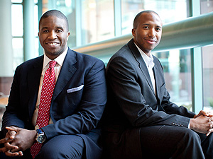
Many young transplants to Minnesota say making friends and finding a sense of community is daunting. That environment can have consequences for the state's economic future.

English-only measure still divides Lino Lakes
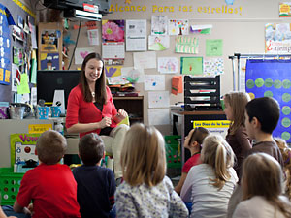
Lino Lakes Elementary School's popular Spanish-immersion program is a small island of linguistic diversity in a community where, a year and a half ago, officials passed an English-only ordinance.

Willmar is the future face of Minnesota
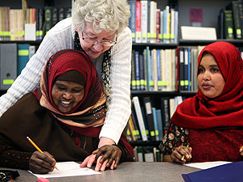
State demographers say Willmar -- with a substantial number of Latino and Somali residents -- foretells what Minnesota will look like two or three decades down the road.
Download the complete radio series

Video: Adjusting to "Minnesota Nice"
They came to Minnesota for work, for love, for family, to escape civil war. But people who shared their experiences say adjusting to life in Minnesota wasn't easy.
Commentary: A newcomer can find welcome in Minnesota. Eventually

Additional Resources
- Minnesota's state demographic center
- Immigration History Research Center
- Book: "The New Minnesotans"
- Oral histories of Minnesota immigrants
- Wilder Research's Minnesota Compass

